Pupil Academic Monitoring System (PAMS)

Overview
Pupil Academic Monitoring System (PAMS) is an offline Windows Application developed using Borland Delphi Pascal and Third-Party Components. The program and database reside in local PC and not subject to Internet threats.

PAMS has been installed in more than 50 schools in Singapore. It is SSOE2 compliance running on Windows Platform supporting up to 64-bit (Windows 10).

PAMS is a software tool for school to analyze and monitor the students’ results which are downloaded from School Cockpit System and IES. The results include WAs, Mid-Year, End-of-Year and GCE ‘O’ & GCE ‘N’ Level.

PAMS also allows you to set Target by Aggregate (EMB3, L1B5, L1R5 etc) for every student based on their PSLE Results or Previous Year Results and cascade download to subject target. And when sum by Subject, you get Department Target; When sum them by Class, you get Class Target.

PAMS supports FULL SBB.

In addition, PAMS can also do Banding, Grouping and Categorisation and retrieve the report accordingly:
- PSLE Tier
- SBB/OOS
- Laterally Transferred
- Learning Abilities
- Any other User-Defined Grouping
- Subject Teaching Group (Teachers)

More importantly, PAMS compliments School Cockpit. There are many features and functions in PAMS which are not found in School Cockpit. To name some of them:
- Target Setting
- Correlation Reports (PAMS Version)
- Comparison Reports (PAMS Version)
- Customised Banding and Grouping (PAMS Version)
- GCE Analysis including Aggregates

Outlines
The following are some of the key features incorporated in PAMS:
- Convert Data
  - Able to convert data from School Cockpit via Export Files
  - Able to convert data from I-Exam for National Examinations
- Target Setting
  - Able to set target based on school overall target such as L1B5, L1R5, EMB3 etc
  - Able to set target based on student’s actual ability and aptitude or PSLE Results
  - Able to adjust and fine-tune department target based on past year trend
  - Able to set target for each student and each subject (cascade downward from School Overall target and department target to individual students’ targets)
  - Able to generate reports supporting the above functions (please refer to Report Features)
- SBB and Out of Stream Subjects
  - Able to convert SBB Subject Marks (Lower Sec) using Fixed Mark Adjustment
  - Able to convert Out of Stream Subject Mark (Upper Sec) using Predefined Formula
- Data Trend
  - Able to track individual students from Sec 1 till they leave the school system
  - Able to compare School Exam and National Exam
  - Able to analyze trend within the year or across different cohort and years
  - Able to generate reports supporting the above functions (please refer to Report Features)
- Subject Banding
  - Able to band students by subjects and results (Previous Year Results e.g. Band of MT)
  - Able to band students by teachers
  - Able to band students by user defined groups (e.g. Learning Abilities, CCA etc)
  - Able to generate reports supporting the above functions (please refer to Report Features)
- Student Banding (up to three user defined groups)
  - Able to band students by DSA
  - Able to band students by Status such as Foreign, Scholars etc
  - Able to generate reports supporting the above functions (please refer to Report Features)
- Data Mining
  - Able to filter students who do not meet their target
  - Able to filter students who do not meet passing criteria
  - Able to generate reports supporting the above functions (please refer to Report Features)
- Export Raw Data to CSV format (accessible by Excel)
- Save reports to PDF format

Report Features
PAMS can generate many reports that are easy to read and useful in making decision. The following are some of the key reports that can be generated from PAMS:
- General Analysis
  - Subject Analysis such as Grade Distribution, percentage of Distinction, Pass and Fail, Percentiles, Target and difference between Actual MSG and Target MSG.
    - By Level
    - By Class
    - By Department
  - Subject Ranking to identify top performing students by subject
  - Level Ranking to identify top performing students
    - By MSG
    - By Average
    - By Distinction
    - By Aggregate etc
- Listing
  - Subject Allocation List (for checking and verification)
  - Class Mark List and Class Grade List
  - Previous year Mark List based on Current Class
- Target
  - Overall Target for reference
  - Department Target to be distributed to each department
  - Class Target to be distributed to Form Teacher
  - Individual Target to be distributed to each student or keep in report book
- Data Trend
  - Exam Trends such as WA1, EOY etc
  - Cohort Trend
  - Level Correlation
  - Class Correlation
- Ad-hoc
  - Poly Thru Train Analysis
  - Subject Grade Analysis by T/Scores
  - Subject Analysis by PSLE Subject Grade
  - Aggregate Analysis by T/Scores
- Teaching Groups
  - Analysis of Results by Teaching Groups
  - Analysis of Results by Teachers
- Student Groups
  - Analysis of Results by PSLE Tiers
  - Analysis of Results by SBB/OOS
  - Analysis of Results by DSA
  - Analysis of Results by Foreign, Scholars
  - Analysis of Results by User Defined Grouping
- Filters
  - List of Students by Average Marks (e.g. 0.0 to 49.0)
  - List of Students by Aggregate (L1R5= 21 to 99)
  - List of Students by Number of Subject Pass or Fails (No= 1 to 3)
  - List of Students by EPI (difference between Actual and Target MSG)
- Correlation Reports
  - By Subject
    - Target vs Results
    - T/Score vs Results
  - By Summary
    - Aggregate vs T/Scores
    - Aggregate vs Targets
- Comparison Reports
  - By Summary
    - Exam vs Exam
    - Exam vs Exam with Sorting (Target, T/Scores, Agg, MSG, AVE, Pos and Improvement)

The following is the list of schools that are using Pupil Academic Monitoring System.

1 | Ang Mo Kio Secondary School | 31 | North Vista Secondary School
2 | Bartley Secondary School | 32 | Northland Secondary School
3 | Beatty Secondary School | 33 | Outram Secondary School
4 | Bedok Green Secondary School | 34 | Paya Lebar Methodist Girls' School (Secondary)
5 | Bedok South Secondary School | 35 | Pei Hwa Secondary School
6 | Bedok View Secondary School | 36 | Ping Yi Secondary School
7 | Broadrick Secondary School | 37 | Presbyterian High School
8 | Bukit Panjang Govt High School | 38 | Riverside Secondary School
9 | Catholic High School | 39 | School of Science and Technology
10 | Cedar Girls' Secondary School | 40 | Seng Kang Secondary School
11 | CHIJ St. Joseph's Convent | 41 | Singapore Chinese Girls' School
12 | CHIJ St. Nicholas Girls' School | 42 | St. Anthony's Canossian Secondary School
13 | CHIJ St. Theresa's Convent | 43 | St. Gabriel's Secondary School
14 | Damai Secondary School | 44 | Tanjong Katong Girls' School
15 | Dunman Secondary School | 45 | Tanjong Katong Secondary School
16 | East Spring Secondary School | 46 | Victoria School
17 | Geylang Methodist School (Secondary) | 47 | Woodlands Ring Secondary School
18 | Greendale Secondary School | 48 | Yio Chu Kang Secondary School
19 | Greenridge Secondary School | 49 | Yishun Secondary School
20 | Guangyang Secondary School | 50 | Yishun Town Secondary School
21 | Hai Sing Catholic School | 51 | Yusof Ishak Secondary School
22 | Holy Innocents' High School | 52 | Yuying Secondary School
23 | Hougang Secondary School | 53 | Zhenghua Secondary School
24 | Hua Yi Secondary School | 54 | Zhonghua Secondary School
25 | Loyang View Secondary School | 55
26 | Marsiling Secondary School | 56
27 | Meridian Secondary School | 57
28 | Montfort Secondary School | 58
29 | Nan Chiau High School | 59
30 | Naval Base Secondary School | 60

Report Interface

PAMS has improved on the Report Interface. It allows you to have different possible combination of Criteria. For example:
- List of Top Performing Students
- List of Most Improved Students
- List of students qualified for SBB or OOS
- List of Students to be promoted from Sec 4NA to Sec 5NA
- List of Students at Risks (You may define you criteria)
Plus many others

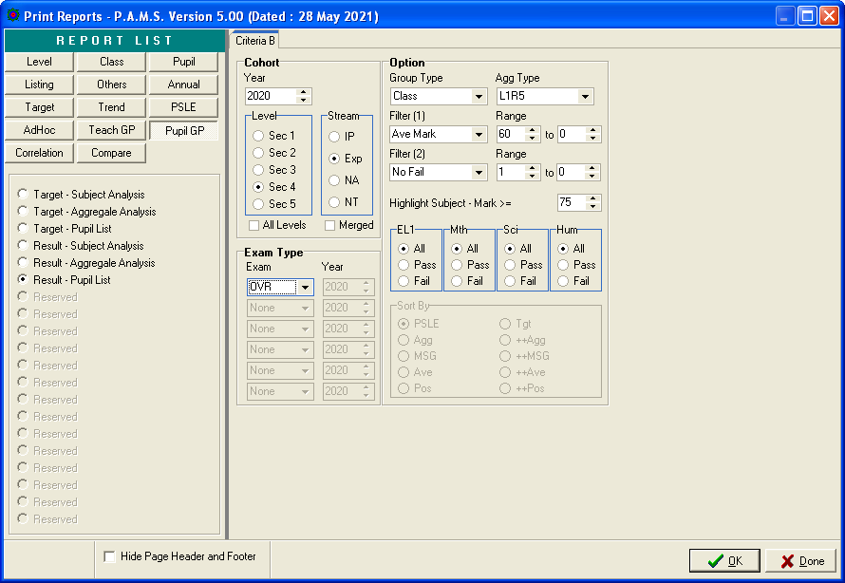

Sample Reports

List of Students with Average Marks (>=60) and Fail (>=1)

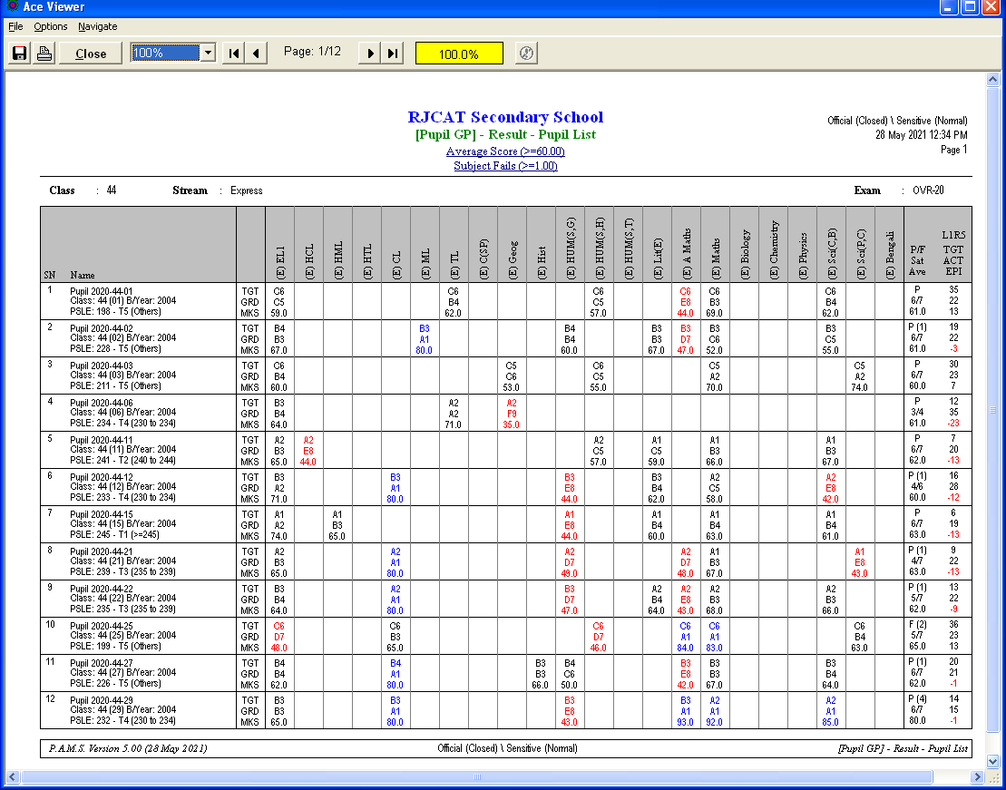

Shortlist for Subject Based Banding (SBB) or Out-of-Stream (OOS)

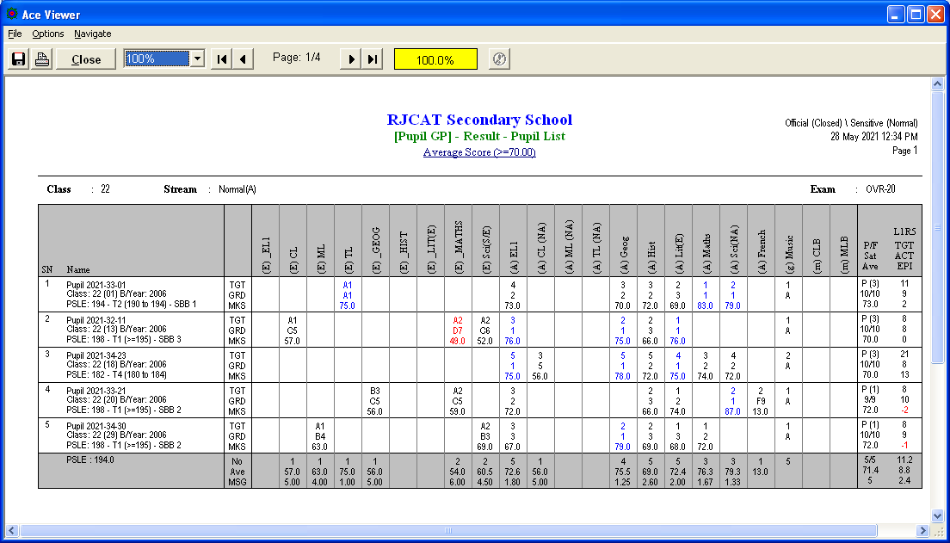

List of Students qualified for Promotion to Sec 5NA

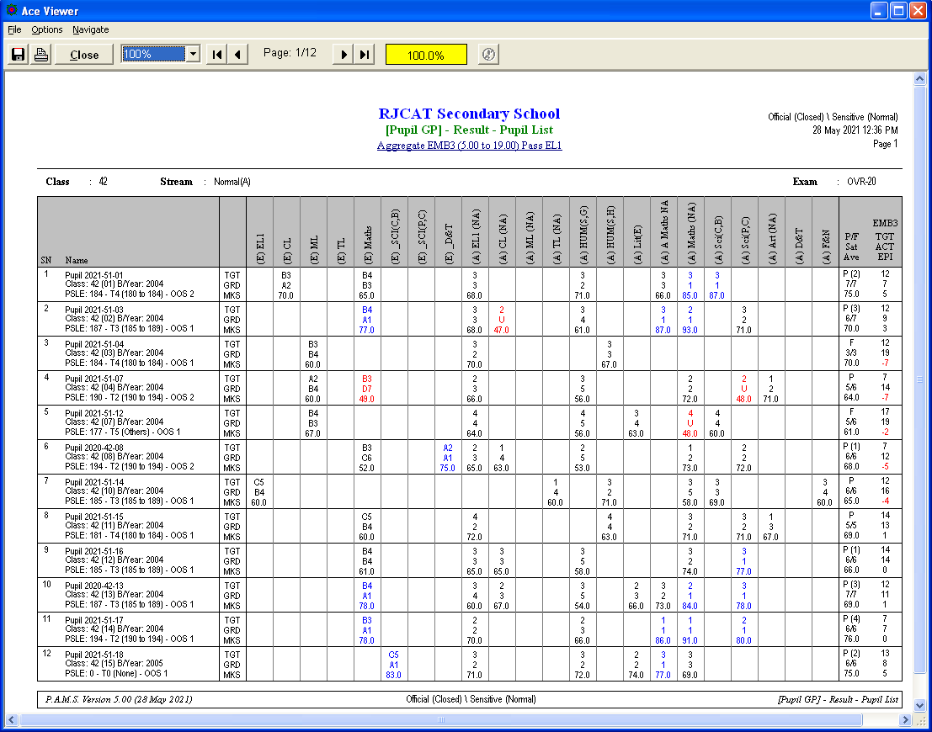

Top Performance List by L1R5

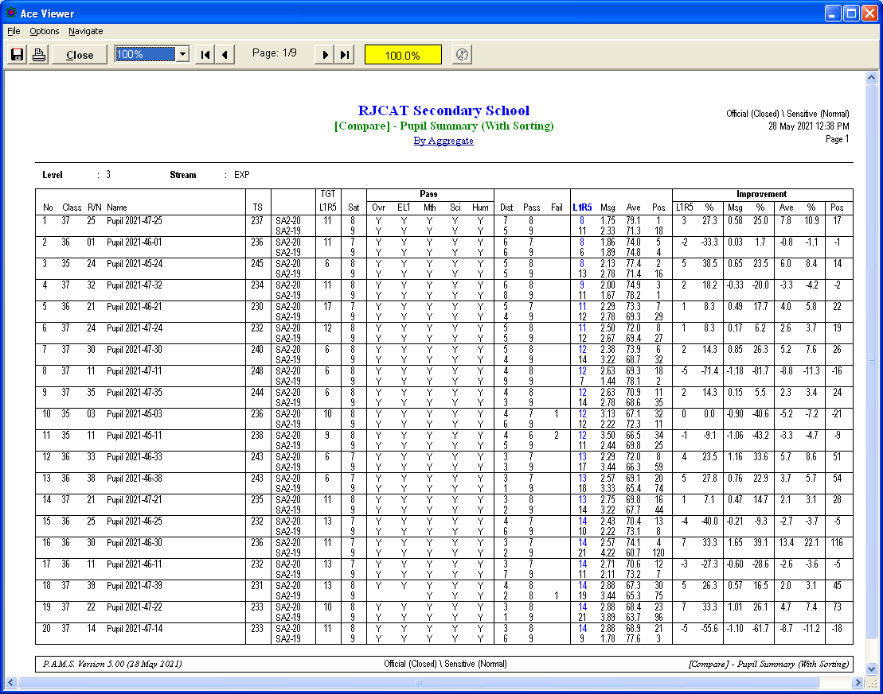

Most Improved List by L1R5 (Percentage)

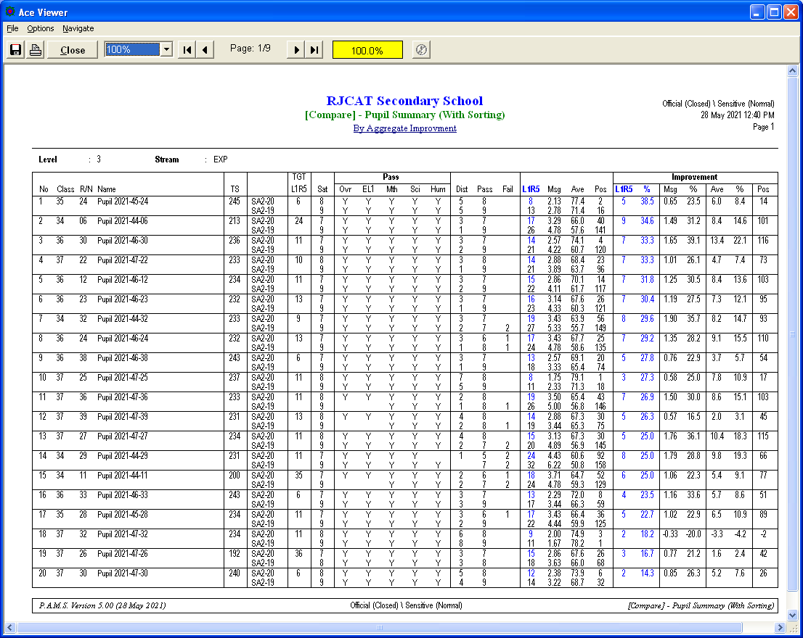

Correlation between Target and Results

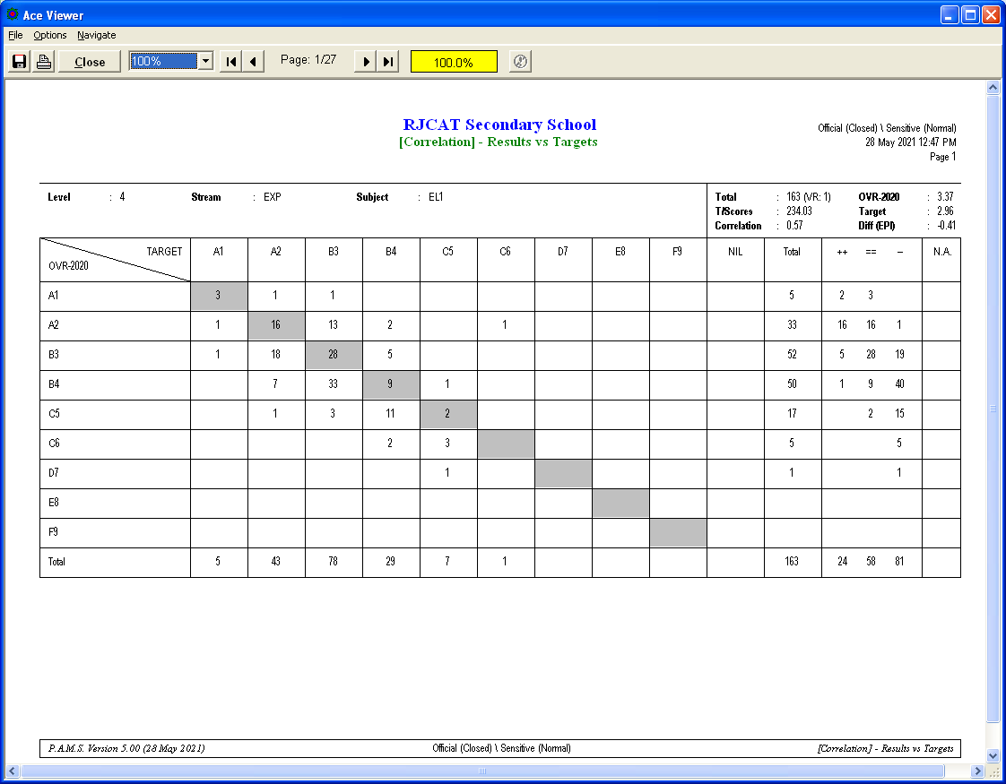

Correlation between Results and Results

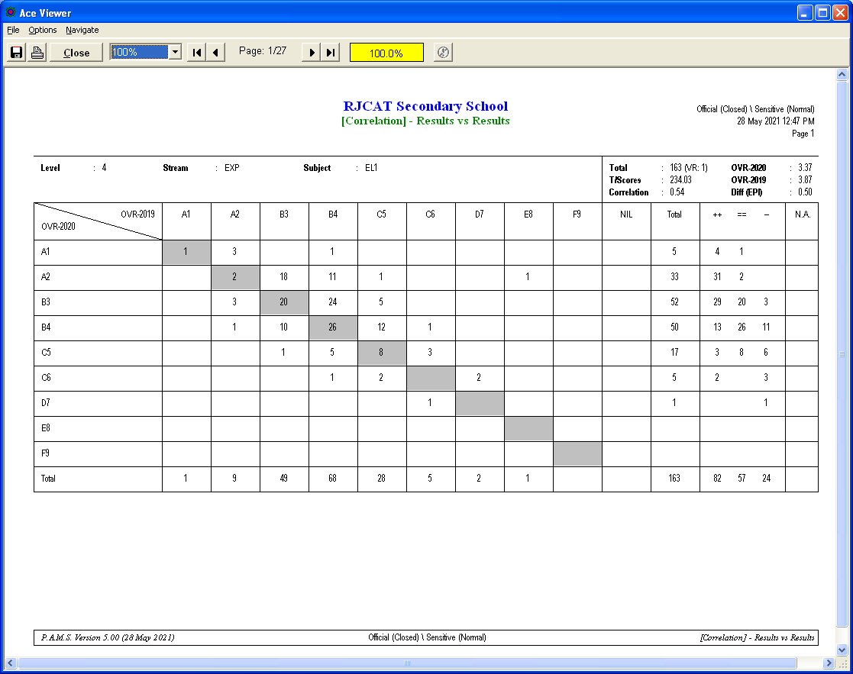

Correlation between Results (L1B5) and Results (L1B5)

