PUPIL ACADEMIC MONITORING SYSTEM
Temporary Solution to replace EXDET

Cockpit has provided a new Report:
RE_RES_106 - Subject Ranking Report

You should “SAVE AS” old Excel Format (xls) as follow
Sec 1 - RE_RES_106_S1.xls
Sec 2 - RE_RES_106_S2.xls
Sec 3 - RE_RES_106_S3.xls
Sec 4 - RE_RES_106_S4.xls
Sec 5 - RE_RES_106_S5.xls

RE_RES_106 (Content)
Note:
It seems that Type I will control what Subjects to be included. This is important especially if Subject is done at modular.

For example, if D&T or FCE is done at 1st Semester only

As such, for Semester 2, Type I should be OVERALL to Force the Subject done only in Semester 1 to be included.
Suggestion for Semester 1:
- Type I - 1st Combined
- Type II - T1WA
- Type III - T2WA/MYE

Suggestion for Semester 2:
- Type I - OVERALL
- Type II - T3WA
- Type III - EYE/Prelim

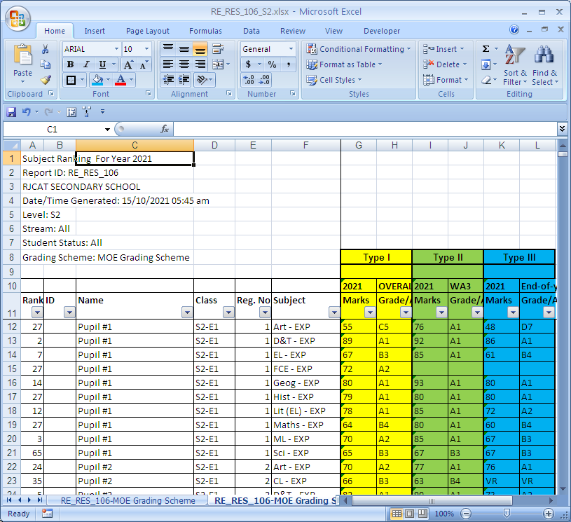
Freeze at this Cell for easy scrolling

You may sort the column by
Class, RegNo and Subject for easy viewing

There 3 Types of Results. You need to map to PAMS accordingly.

Convert Cockpit Data – RE_RES_106
Menu Access: System Admin Menu – Convert Cockpit Data
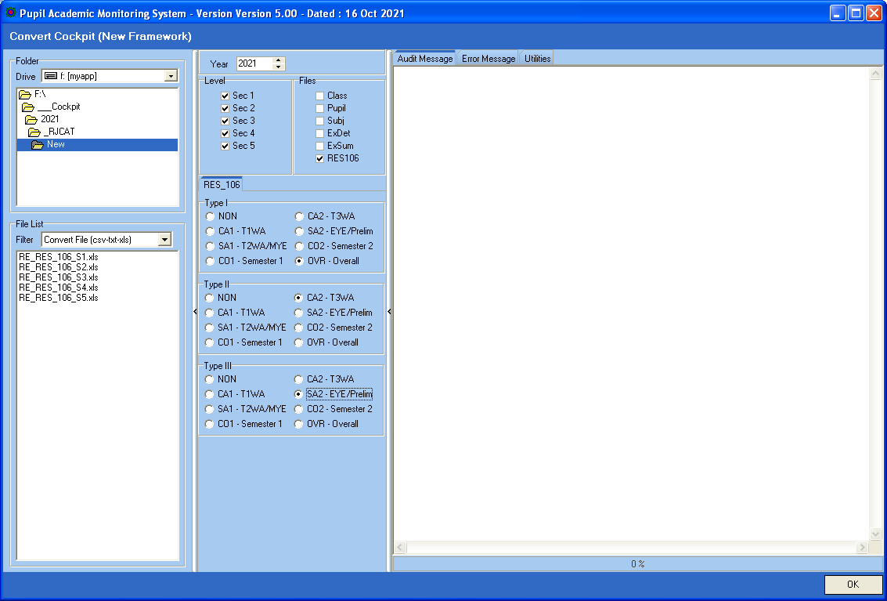
Select ExamType
Map to RES 106 TYPE I, II, III
NON means skip
Select Level
Tick RES106

Steps
- Select your Directory where you stored your Cockpit Excel Files
- Select Level
- Tick RES106
- Select the Exam Type for Type I to Type III (NON mean Skip)
- Click OK Button

After you have converted RES106, you may proceed to Process Results….

Overall Pass Criteria (MOE Criteria)

Pass - Promoted to the next higher level in the same course
Laterally Transferred to a more academically demanding course
Fail - Advanced to the next higher level in the same course
Laterally Transferred to the next higher level in a less academically demanding course
Retained at the same level
There is no Pass/Fail for Sec 4 and 5

Abbreviation Used |  | Overage (Local Students)
TSP  PM  AD  LT  RT | Total Subject Pass  Promote  Advance  Laterally Transferred  Retained | Sec 1 - 16+  Sec 2 - 17+  Sec 3 - 18+  Sec 4 - 19+  Sec 5 - 20+
 |  | Minus 2 Year for International Students

LV | Passing Criteria | Pass | Fail
1Exp | Pass EL1 and Ave>=50 | PM to 2Exp | LT to 2NA  RT at 1 Exp
1NA | Pass EL1 AND TSP>=3  or  TSP>=4 | PM to 2NA  LT to 2Exp (Ave>=70) | AD to 2NA (Overage)  LT to 2NT  RT at 1NA
1NT | Pass EL1 or Maths  and  TSP>=2 | PM to 2NT  LT to 2NA (Ave>=70) | AD to 2NT (Overage)  RT at 1NT
2Exp | Pass EL1 and Ave>=50 | PM to 3Exp | LT to 3NA  RT at 2Exp
2NA | Pass EL1 AND TSP>=3  or  TSP>=4 | PM to 3NA  LT to 3Exp (Ave>=70) | AD to 3NA (Overage)  RT at 2NA
2NT | Pass EL1 or Maths  and  TSP>=2 | PM to 3NT  LT to 2NA (Ave>=70) | AD to 3NT (Overage)  RT at 2NT
3Exp | Pass EL1 and TSP>=3 | PM to 4Exp | AD to 4Exp (TSP>=5)  LT to 4NA (Overage)  RT at 3Exp
3NA | Pass EL1 AND TSP>=3  or  TSP>=4 | PM to 4NA | AD to 4NA (Overage)  RT at 3NA
3NT | Pass EL1 or Maths  and  TSP>=2 | PM to 4NT  LT to 3NA (Ave>=70) | AD to 4NT (Overage)  RT at 3NT
4Exp
4NA | Pass EL1 and Maths  EMB3<=19 | PM to 5NA
4NT | Ave>=70 | LT to 4NA
5NA

Let me know if the RULES are not the same for your school.

Reports – Pupil GP

Pupil GP reports are very versatile. You can “Mix-and-Match” different criteria to get what you want.
Please see Examples in the following pages.

Group Type
- Level - Whole Cohort
- Class - Each Class
- PSLE Tier - Base on PSLE Tier (If you have defined them)
e.g. Analyze Students with High T/Scores but not doing well
- SBB/OOS - (NA and NT only) Number of SBB/OOS
e.g. SBB 1 – Take 1 SBB Subject
e.g. SBB 2 – Take 2 SBB Subjects
e.g. SBB 3 – Take 3 SBB Subjects

Others: Pupil GP 1 to Pupil GP5, if you have defined them.

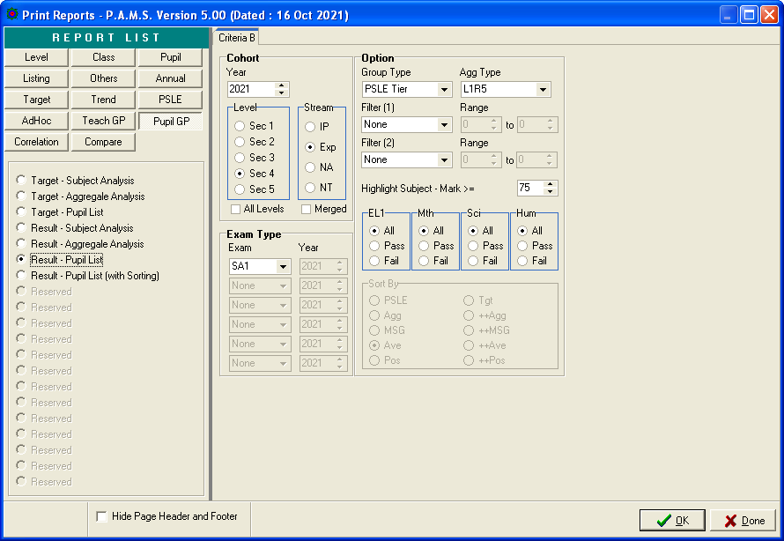
These 2 are same report.
By Class/RegNo
or By Sorting

Reports - Class Overall Ranking

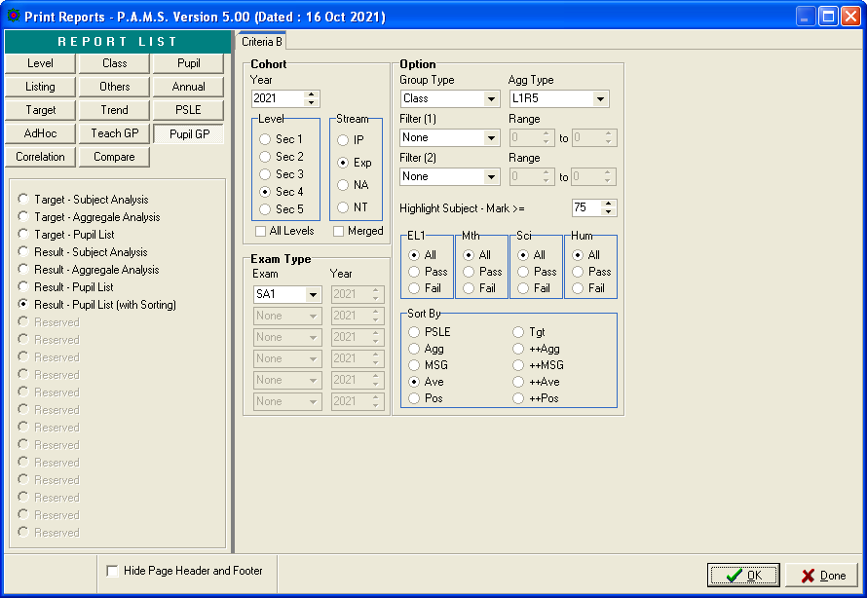
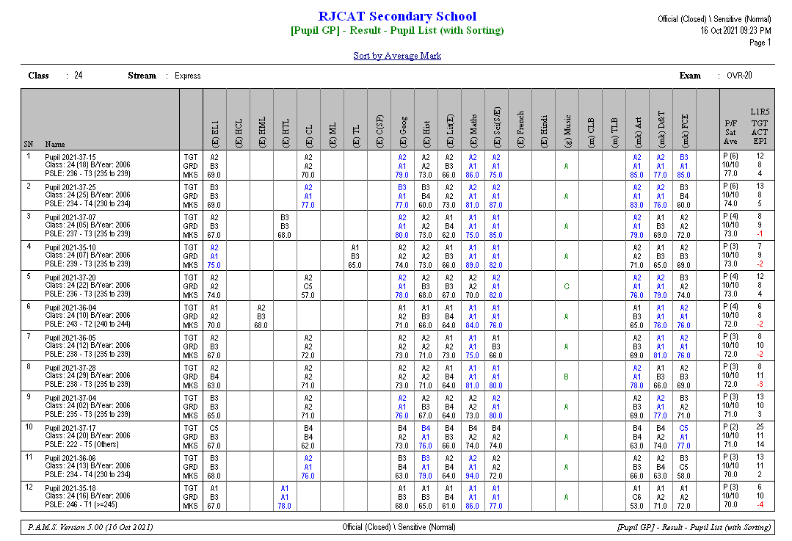

Reports - Level Overall Ranking

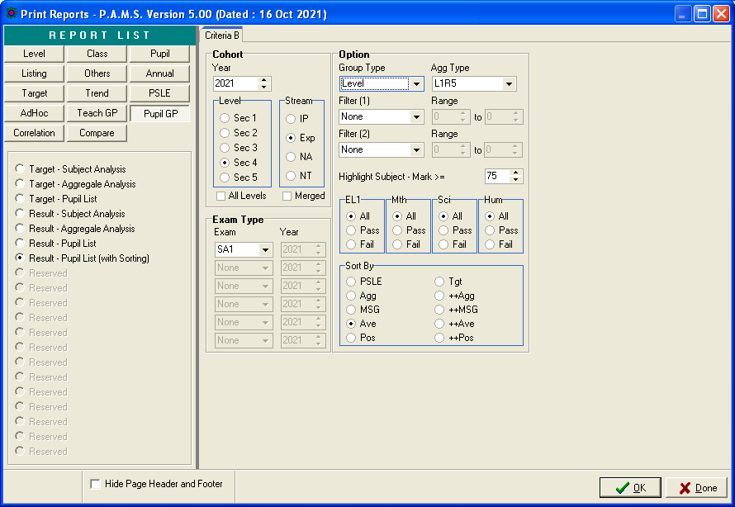
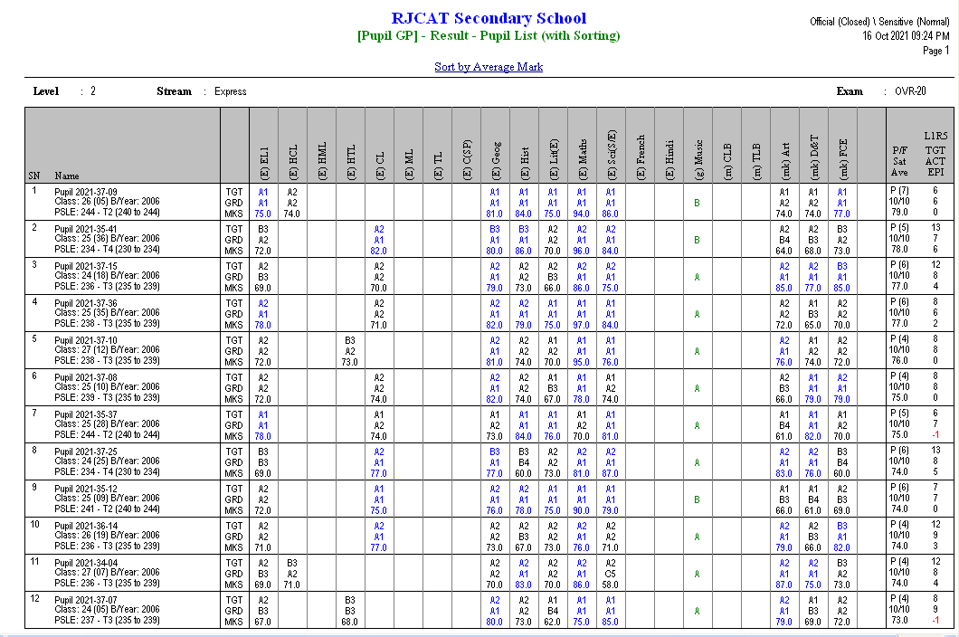

Reports - Level Overall Pass (Based on MOE Criteria)

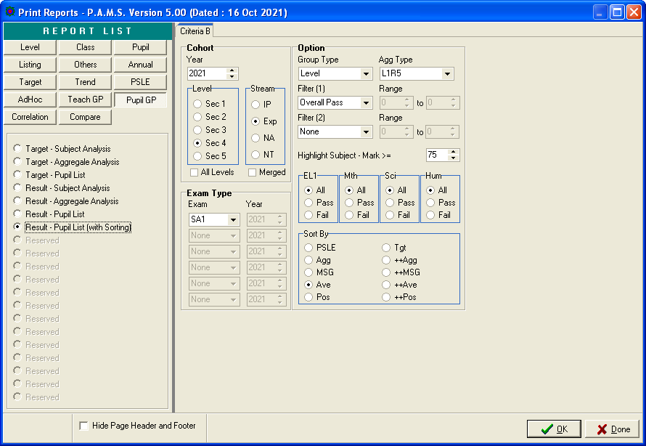

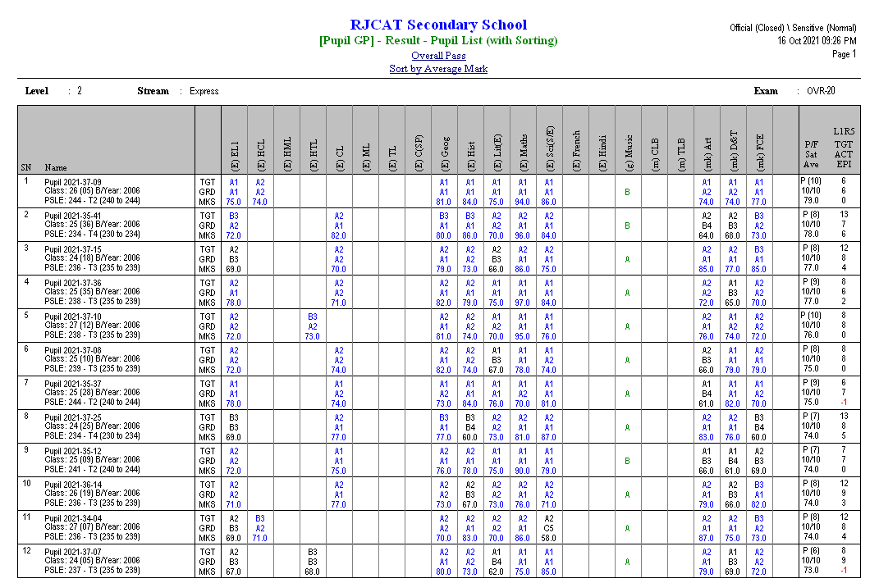

Reports - Level Overall Fail (Based on MOE Criteria)

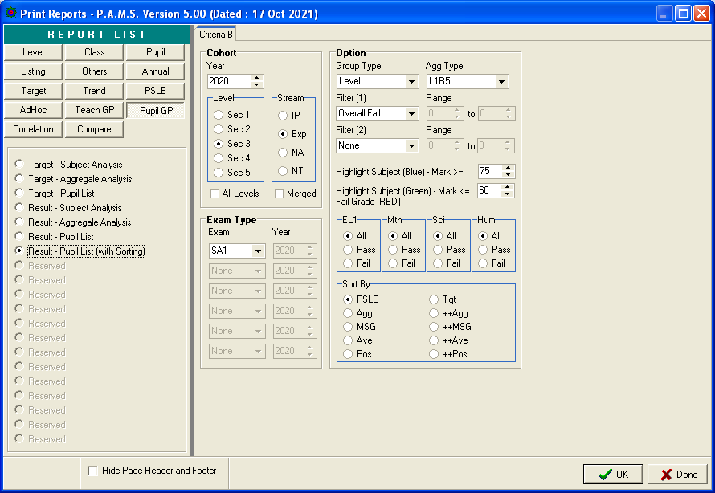

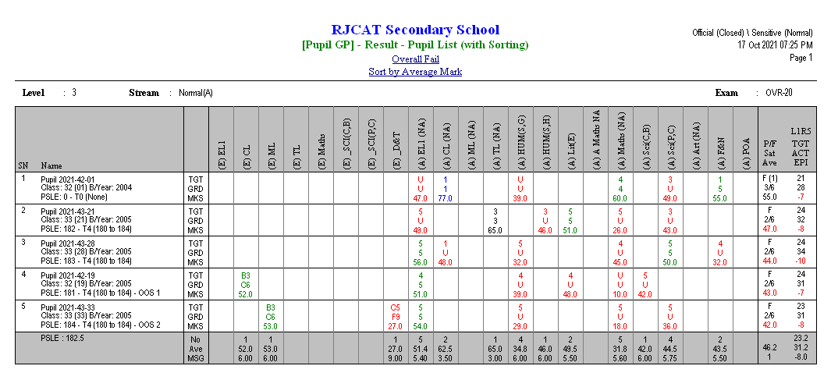

Reports – PSLE Tier

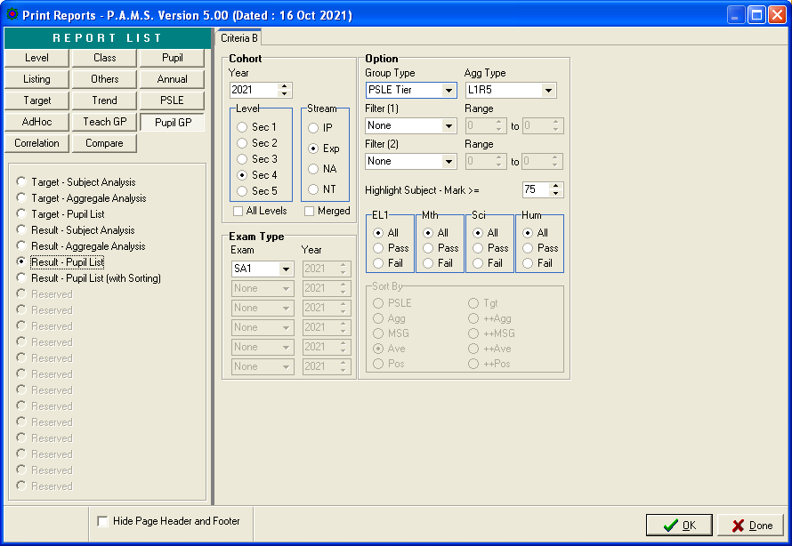
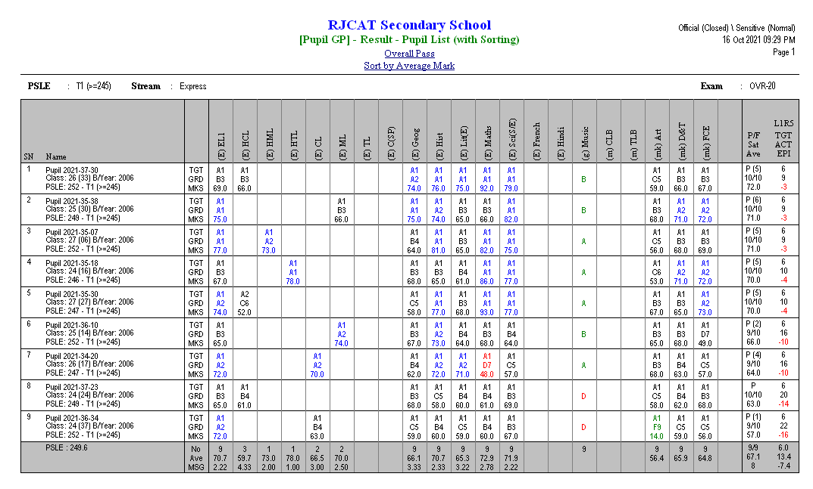
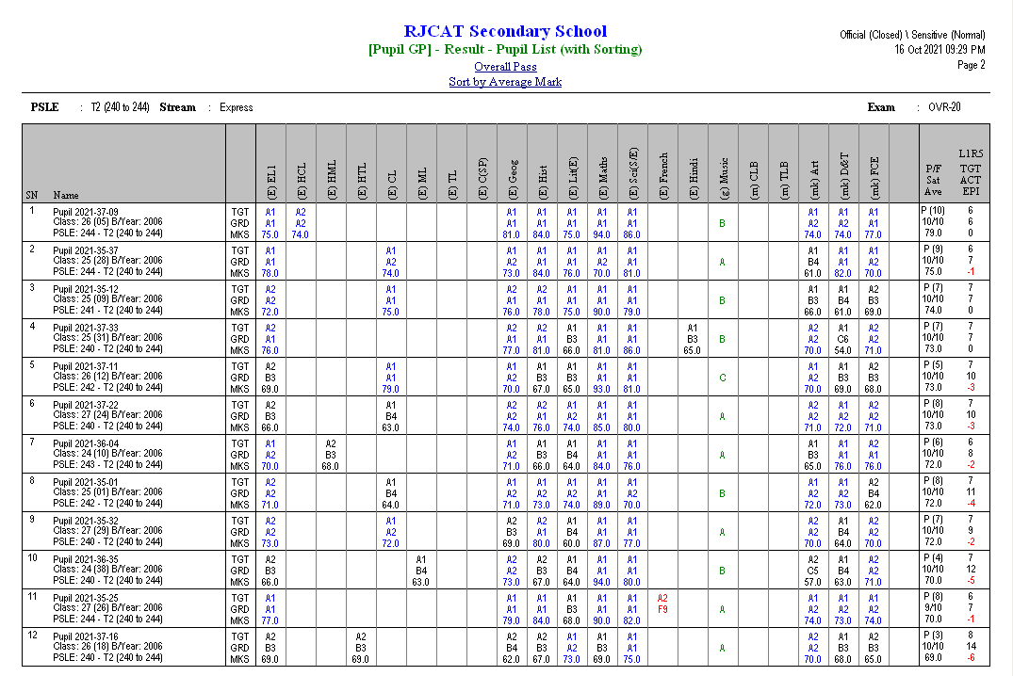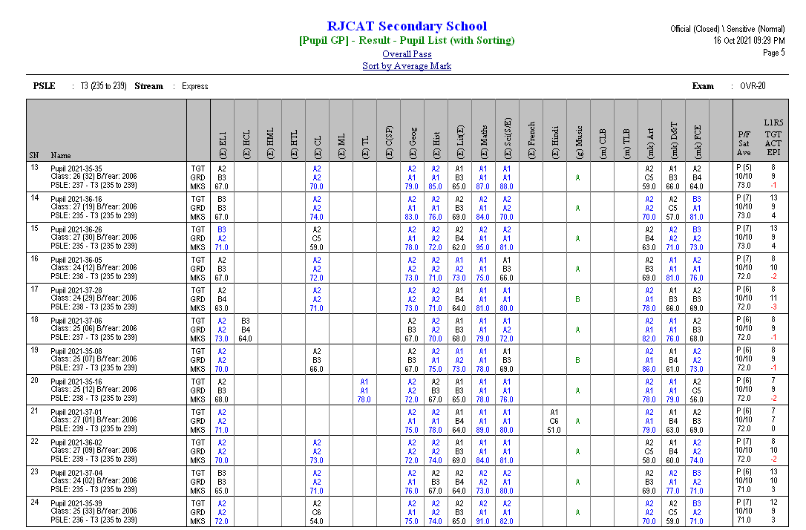

Reports – SBB/OOS
You may want to review students who are offered SBB/OOS Subjects.

If the SBB/OOS results are not very good, may need to discuss if opt to return to normal Subject.

Lower Secondary
SBB 1 – Student takes 1 SBB Subject
SBB 2 – Student takes 2 SBB Subjects
SBB 3 – Student takes 3 SBB Subjects

Upper Secondary
OOS 1 – Student takes 1 SBB Subject
OOS 2 – Student takes 2 SBB Subjects
OOS 3 – Student takes 3 SBB Subjects

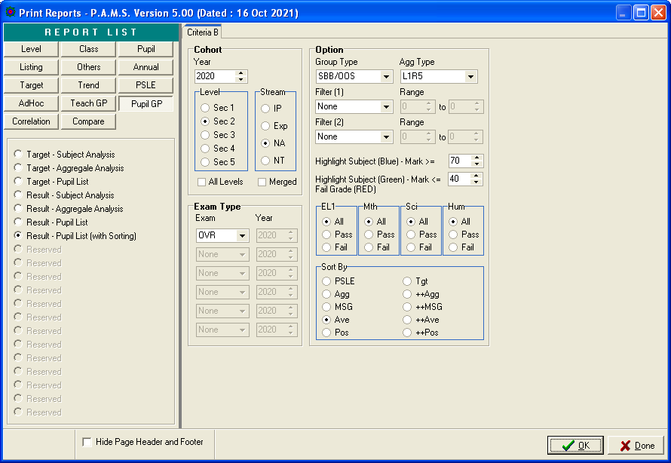
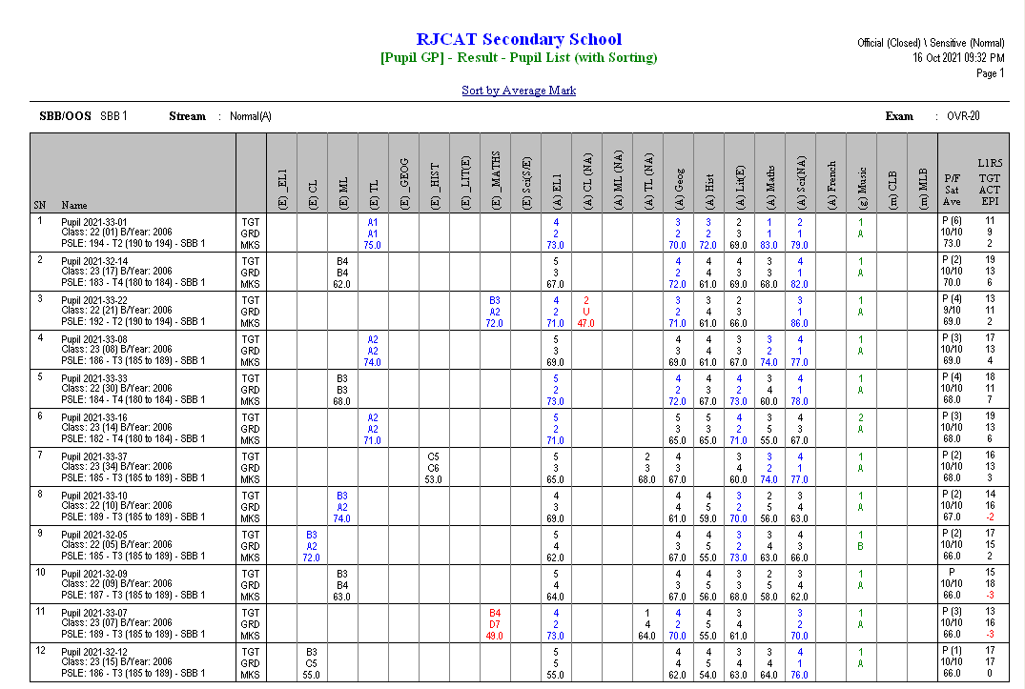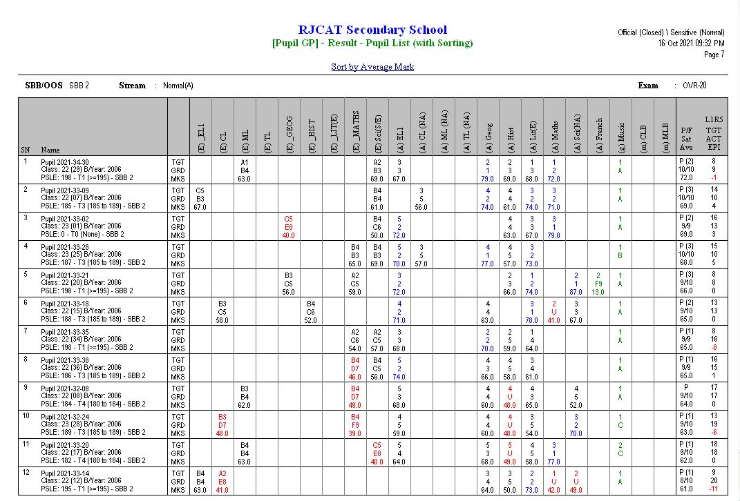

Reports – Laterally Transferred to More Demanding Stream
Normal (A) to Express or Normal (T) to Normal (A)
Obtain Pass and Average >=70

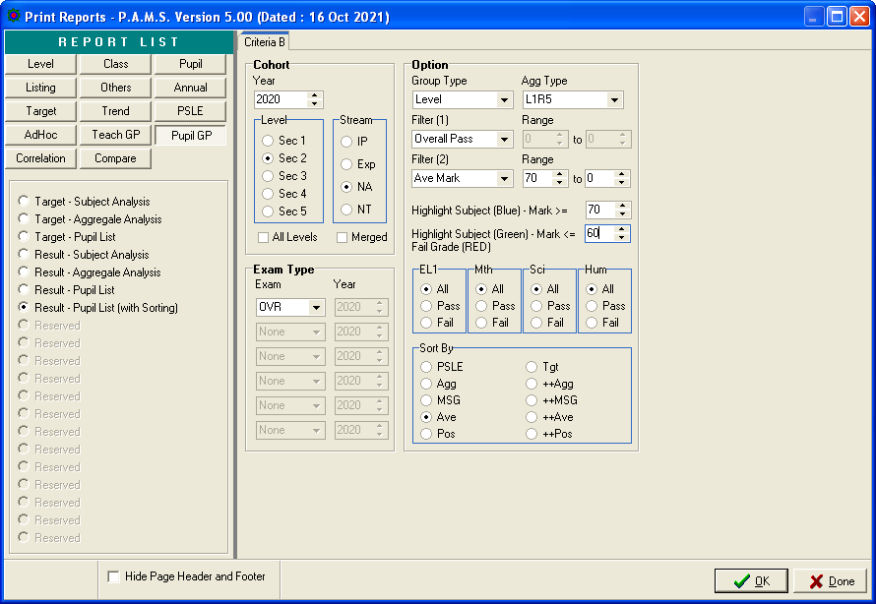
May leave as “0”

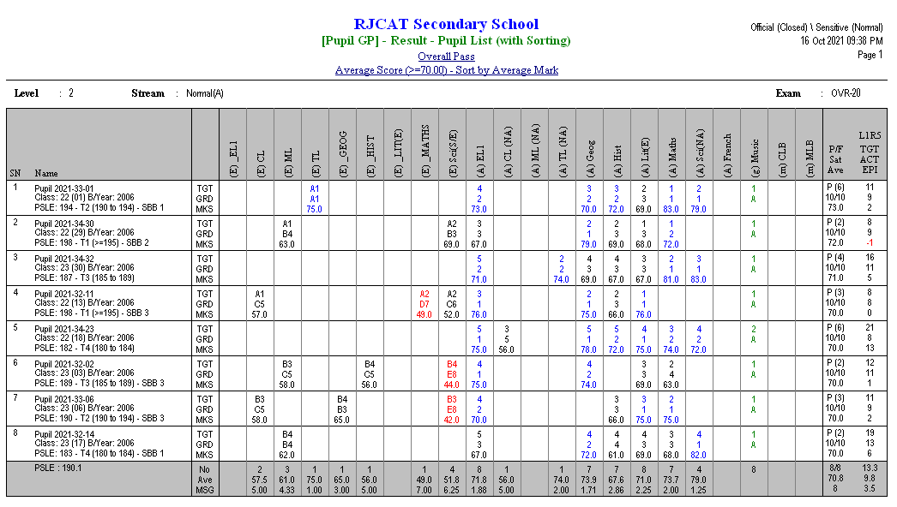

Reports – SBB Inserts

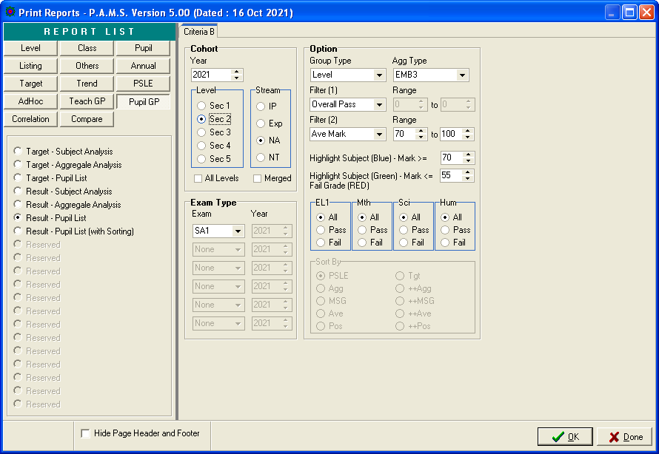

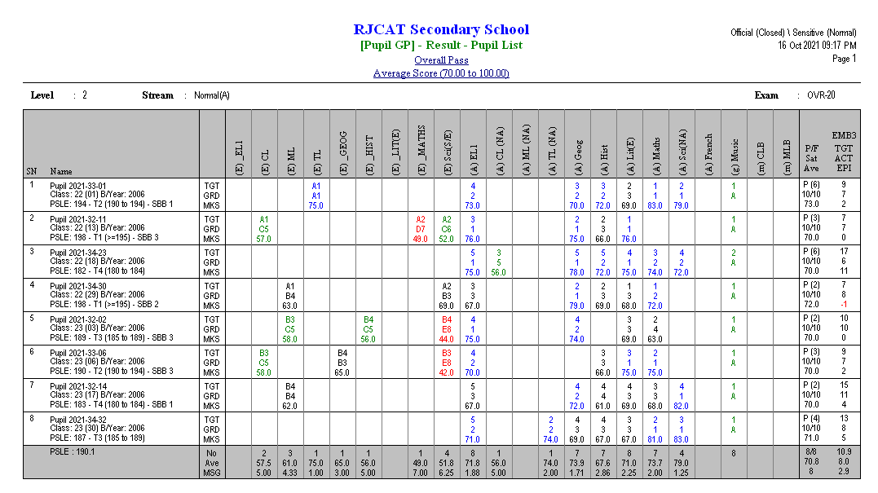
(6) – Number of Subject >=70
(A) - Normal (A) Grading Scheme

Subject>=70 will be highlighted in Blue

