PUPIL ACADEMIC MONITORING SYSTEM
Temporary Solution to replace EXDET

Cockpit has provided a new Report:
RE_RES_078 - Mark Sheet Report
RE_RES_106 - Subject Ranking Report

Converting RE_RES_078

RE_RES_078 is exported by Stream. You should “SAVE AS” old Excel Format (xls) as follow under each Stream Folder:
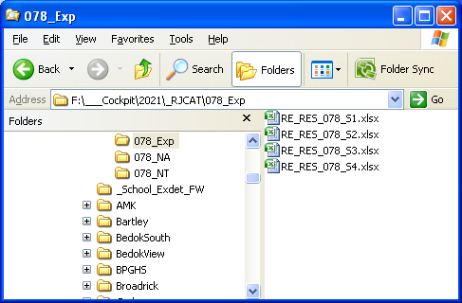
Sec 1 - RE_RES_078_S1.xls
Sec 2 - RE_RES_078_S2.xls
Sec 3 - RE_RES_078_S3.xls
Sec 4 - RE_RES_106_S4.xls
Sec 5 - RE_RES_106_S5.xls

The filename will be the same for each Stream.

RE_RES_078 (Content)
The column will depend on what Exam Type you Export.

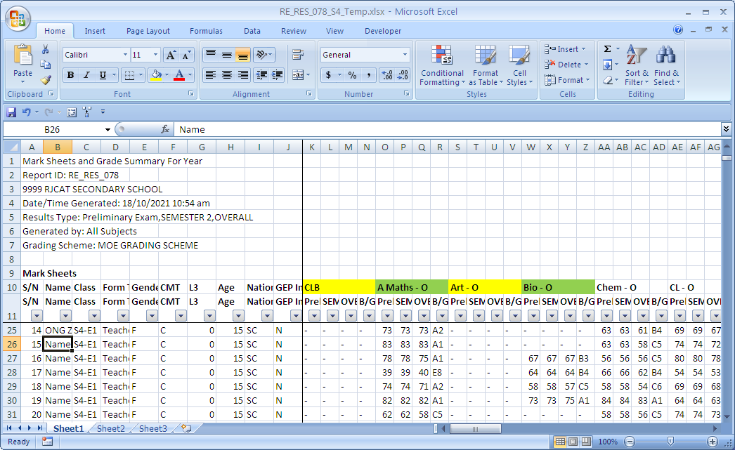
There are different Exam Types. You need to map to PAMS accordingly.
Freeze at this Cell for easy scrolling

Convert Cockpit Data – RE_RES_078
Menu Access: System Admin Menu – Convert Cockpit Data
Select Level
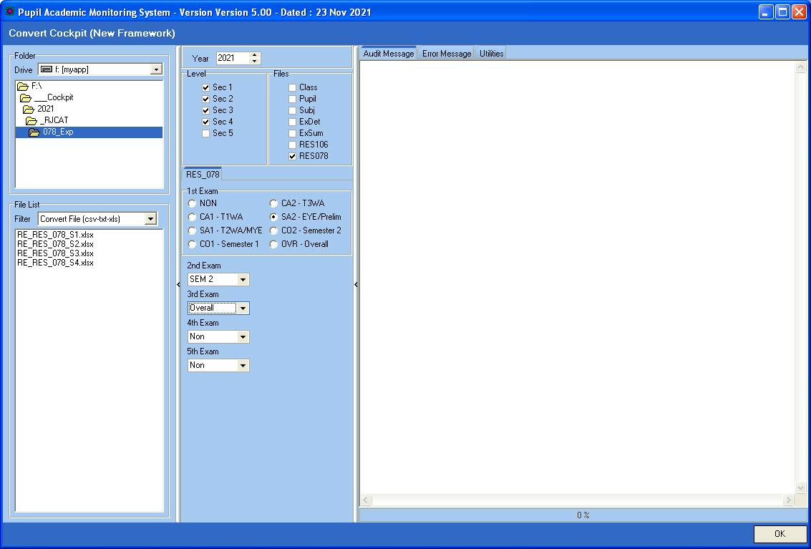
NON means skip
Tick RES078
Select ExamType
Map to RES 078 Columns

Steps
- Select your Directory where you stored your Cockpit Excel Files
- Select Level
- Tick RES078
- Select the Exam Type (NON mean Skip)
- Click OK Button

After you have converted RES078, you may proceed to Process Results….

Converting RE_RES_106

You should “SAVE AS” old Excel Format (xls) as follow
Sec 1 - RE_RES_106_S1.xls
Sec 2 - RE_RES_106_S2.xls
Sec 3 - RE_RES_106_S3.xls
Sec 4 - RE_RES_106_S4.xls
Sec 5 - RE_RES_106_S5.xls

RE_RES_106 (Content)
Note:
It seems that Type I will control what Subjects to be included. This is important especially if Subject is done at modular.

For example, if D&T or FCE is done at 1st Semester only

As such, for Semester 2, Type I should be OVERALL to Force the Subject done only in Semester 1 to be included.
Suggestion for Semester 1:
- Type I - 1st Combined
- Type II - T1WA
- Type III - T2WA/MYE

Suggestion for Semester 2:
- Type I - OVERALL
- Type II - T3WA
- Type III - EYE/Prelim

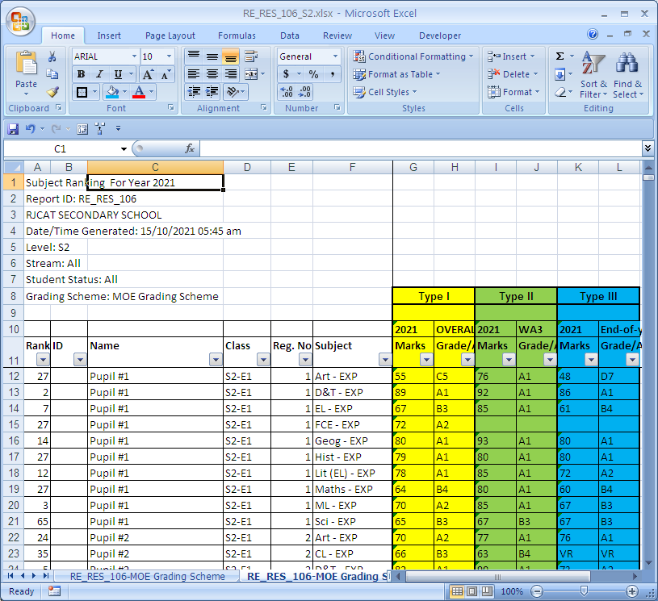
Freeze at this Cell for easy scrolling

You may sort the column by
Class, RegNo and Subject for easy viewing

There 3 Types of Results. You need to map to PAMS accordingly.

Convert Cockpit Data – RE_RES_106
Menu Access: System Admin Menu – Convert Cockpit Data
Select Level
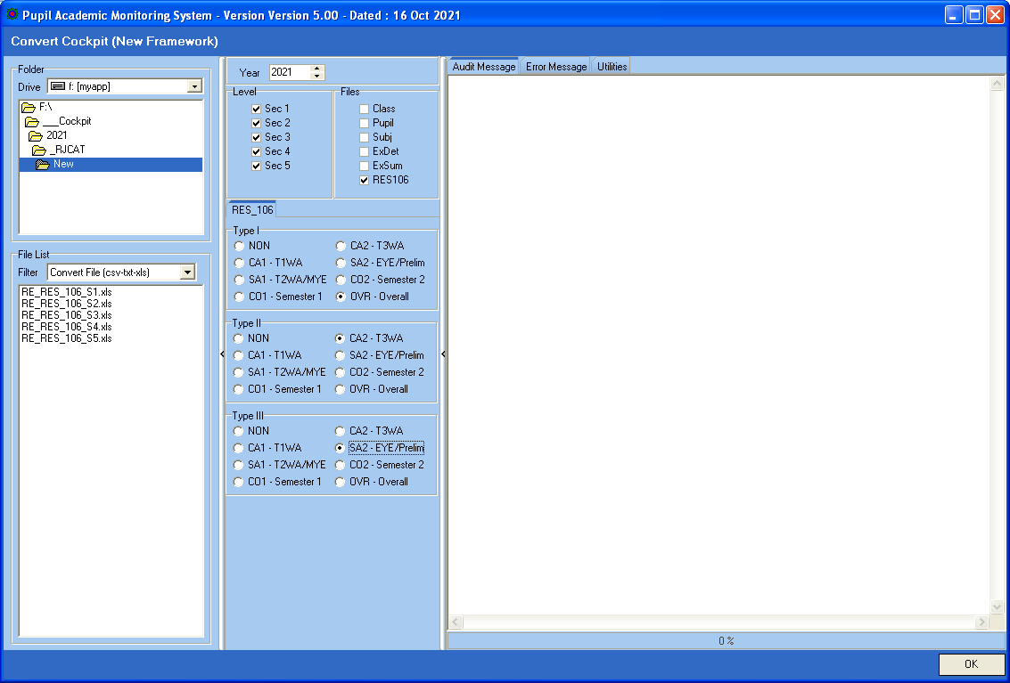
Tick RES106
NON means skip
Select ExamType
Map to RES 106 TYPE I, II, III

Steps
- Select your Directory where you stored your Cockpit Excel Files
- Select Level
- Tick RES106
- Select the Exam Type for Type I to Type III (NON mean Skip)
- Click OK Button

After you have converted RES106, you may proceed to Process Results….

Overall Pass Criteria (MOE Criteria)

Pass - Promoted to the next higher level in the same course
Laterally Transferred to a more academically demanding course
Fail - Advanced to the next higher level in the same course
Laterally Transferred to the next higher level in a less academically demanding course
Retained at the same level
There is no Pass/Fail for Sec 4 and 5

Abbreviation Used |  | Overage (Local Students)
TSP  PM  AD  LT  RT | Total Subject Pass  Promote  Advance  Laterally Transferred  Retained | Sec 1 - 16+  Sec 2 - 17+  Sec 3 - 18+  Sec 4 - 19+  Sec 5 - 20+
 |  | Minus 2 Year for International Students

LV | Passing Criteria | Pass | Fail
1Exp | Pass EL1 and Ave>=50 | PM to 2Exp | LT to 2NA  RT at 1 Exp
1NA | Pass EL1 AND TSP>=3  or  TSP>=4 | PM to 2NA  LT to 2Exp (Ave>=70) | AD to 2NA (Overage)  LT to 2NT  RT at 1NA
1NT | Pass EL1 or Maths  and  TSP>=2 | PM to 2NT  LT to 2NA (Ave>=70) | AD to 2NT (Overage)  RT at 1NT
2Exp | Pass EL1 and Ave>=50 | PM to 3Exp | LT to 3NA  RT at 2Exp
2NA | Pass EL1 AND TSP>=3  or  TSP>=4 | PM to 3NA  LT to 3Exp (Ave>=70) | AD to 3NA (Overage)  RT at 2NA
2NT | Pass EL1 or Maths  and  TSP>=2 | PM to 3NT  LT to 2NA (Ave>=70) | AD to 3NT (Overage)  RT at 2NT
3Exp | Pass EL1 and TSP>=3 | PM to 4Exp | AD to 4Exp (TSP>=5)  LT to 4NA (Overage)  RT at 3Exp
3NA | Pass EL1 AND TSP>=3  or  TSP>=4 | PM to 4NA | AD to 4NA (Overage)  RT at 3NA
3NT | Pass EL1 or Maths  and  TSP>=2 | PM to 4NT  LT to 3NA (Ave>=70) | AD to 4NT (Overage)  RT at 3NT
4Exp
4NA | Pass EL1 and Maths  EMB3<=19 | PM to 5NA
4NT | Ave>=70 | LT to 4NA
5NA

Let me know if the RULES are not the same for your school.

Reports – Pupil GP

Pupil GP reports are very versatile. You can “Mix-and-Match” different criteria to get what you want.
Please see Examples in the following pages.

Group Type
- Level - Whole Cohort
- Class - Each Class
- PSLE Tier - Base on PSLE Tier (If you have defined them)
e.g. Analyze Students with High T/Scores but not doing well
- SBB/OOS - (NA and NT only) Number of SBB/OOS
e.g. SBB 1 – Take 1 SBB Subject
e.g. SBB 2 – Take 2 SBB Subjects
e.g. SBB 3 – Take 3 SBB Subjects

Others: Pupil GP 1 to Pupil GP5, if you have defined them.

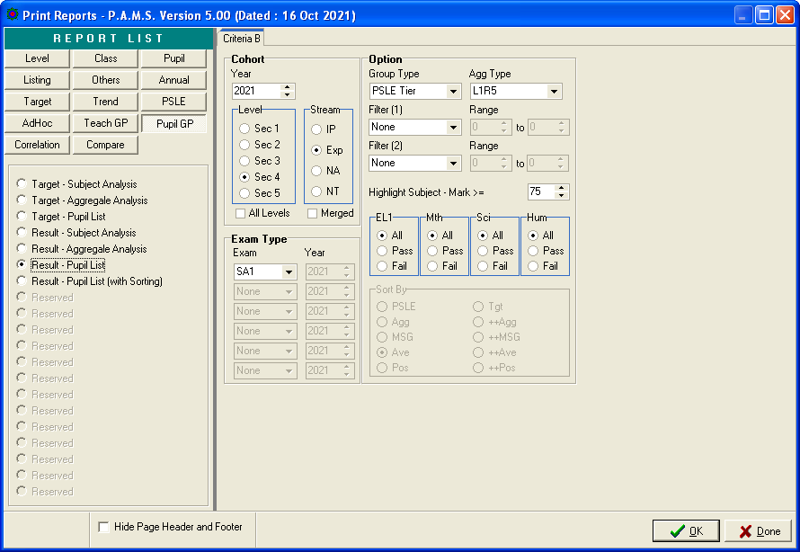
These 2 are same report.
By Class/RegNo
or By Sorting

Reports - Class Overall Ranking

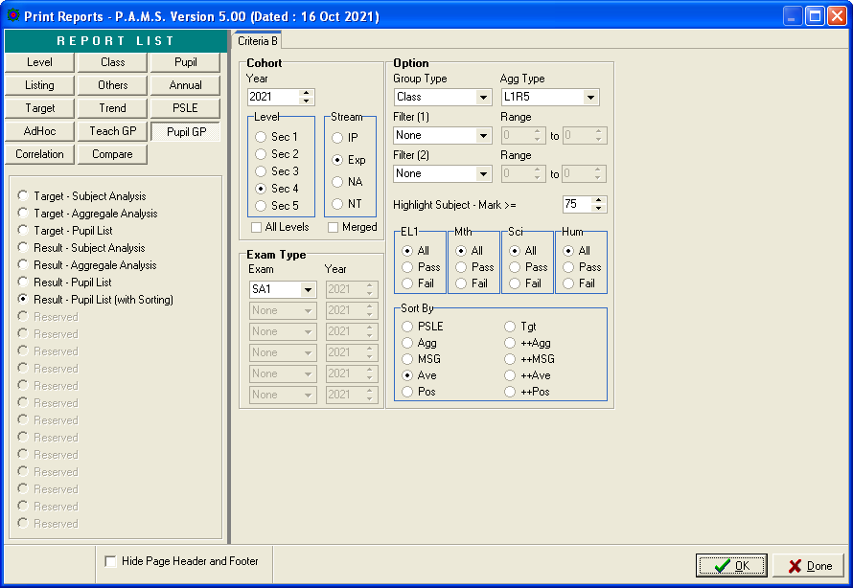
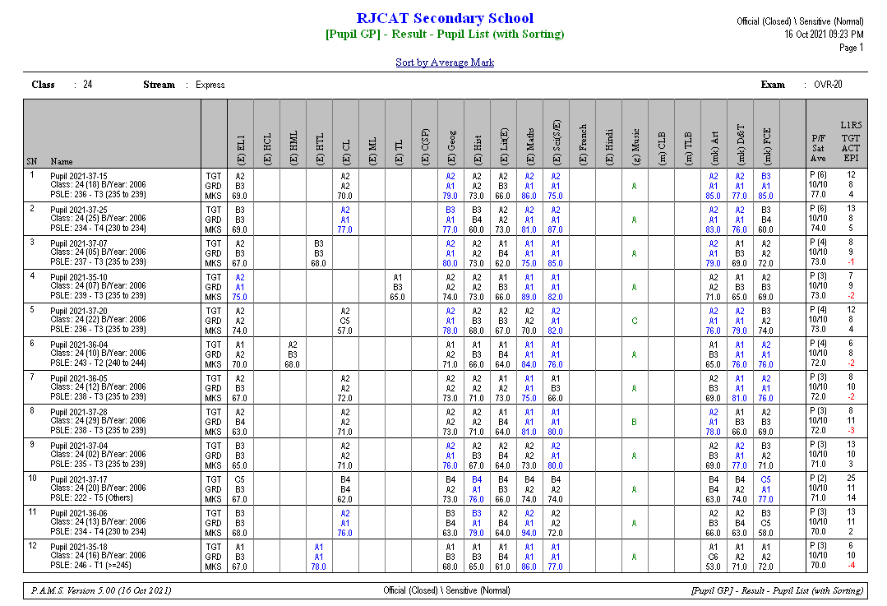

Reports - Level Overall Ranking

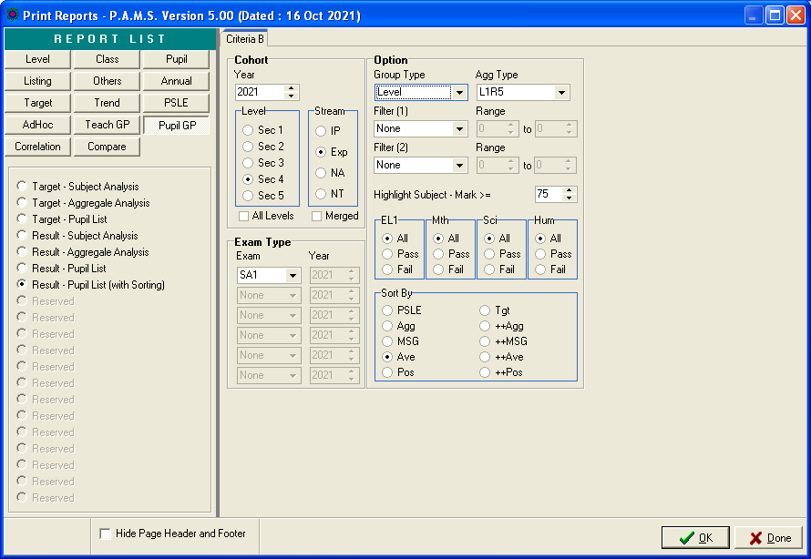
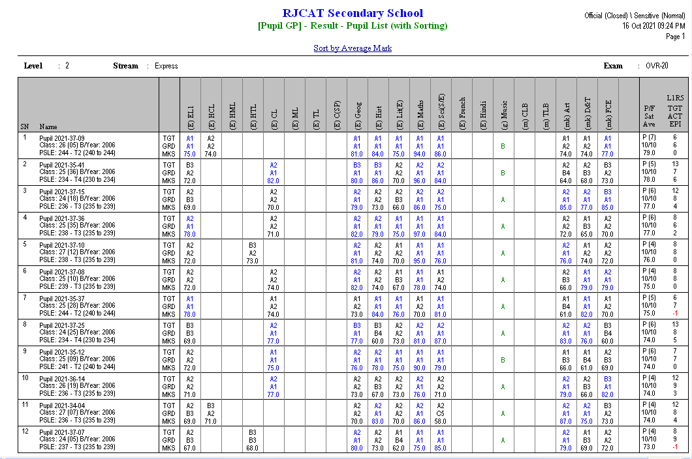

Reports - Level Overall Pass (Based on MOE Criteria)

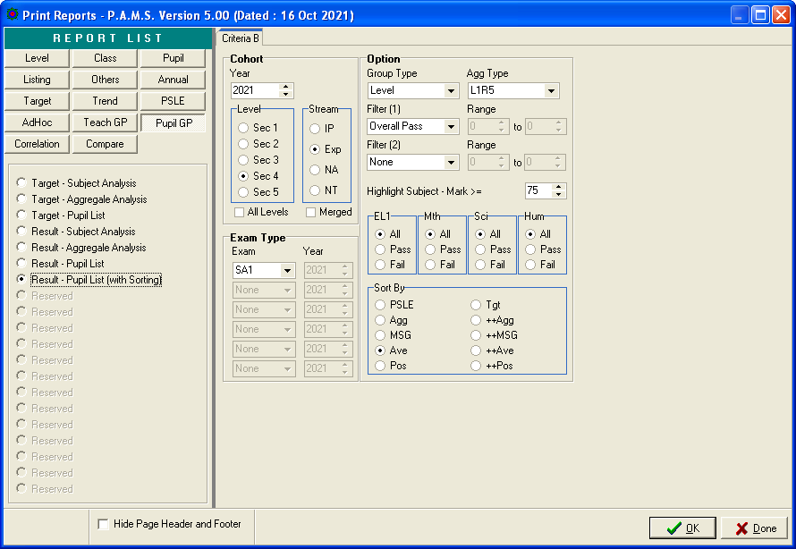

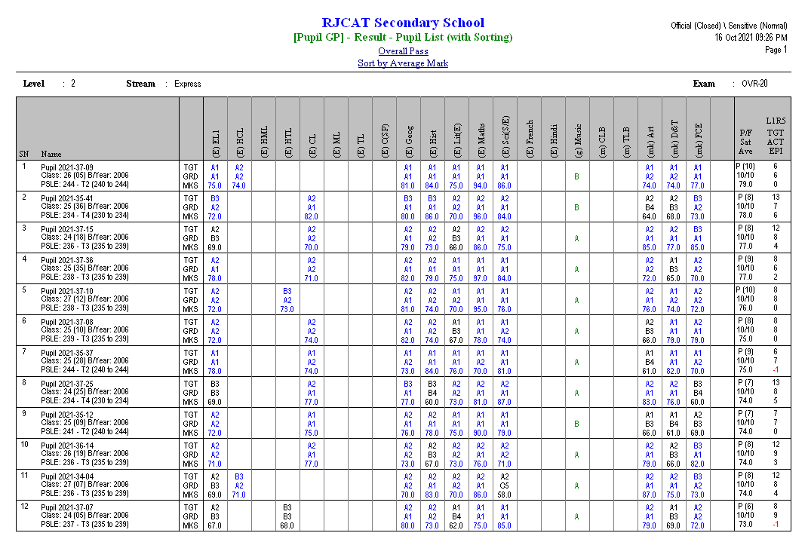

Reports - Level Overall Fail (Based on MOE Criteria)

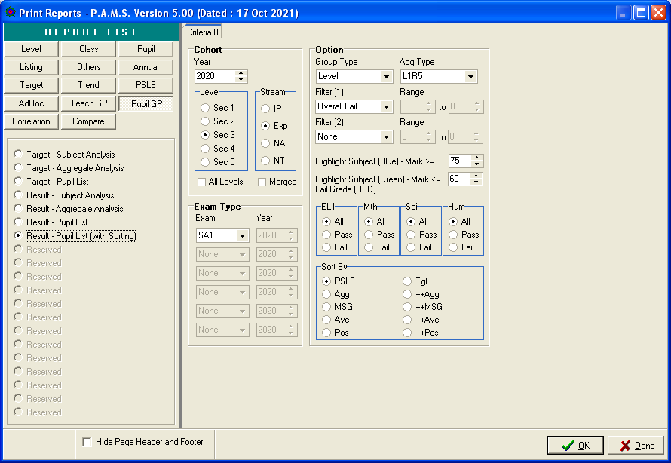

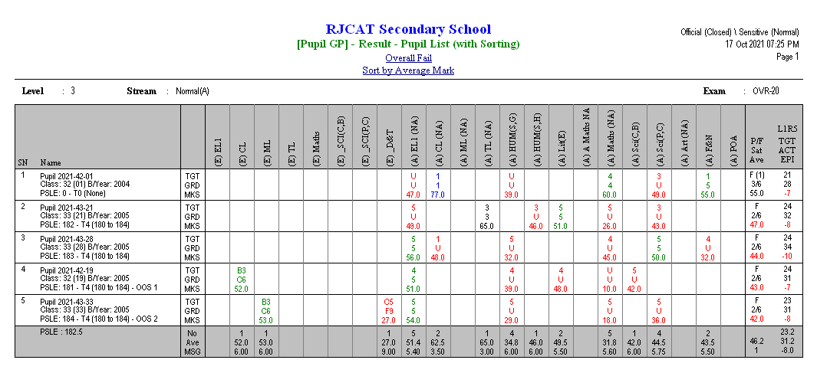

Reports – PSLE Tier

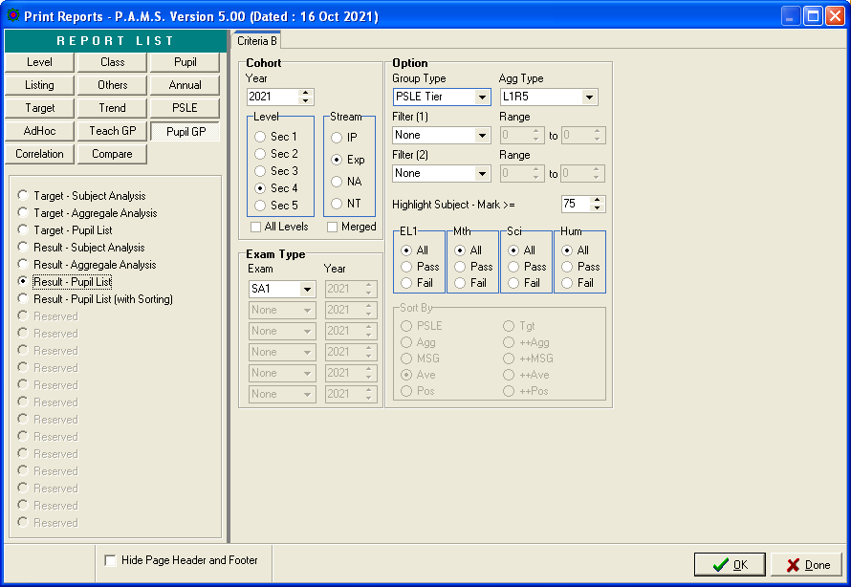
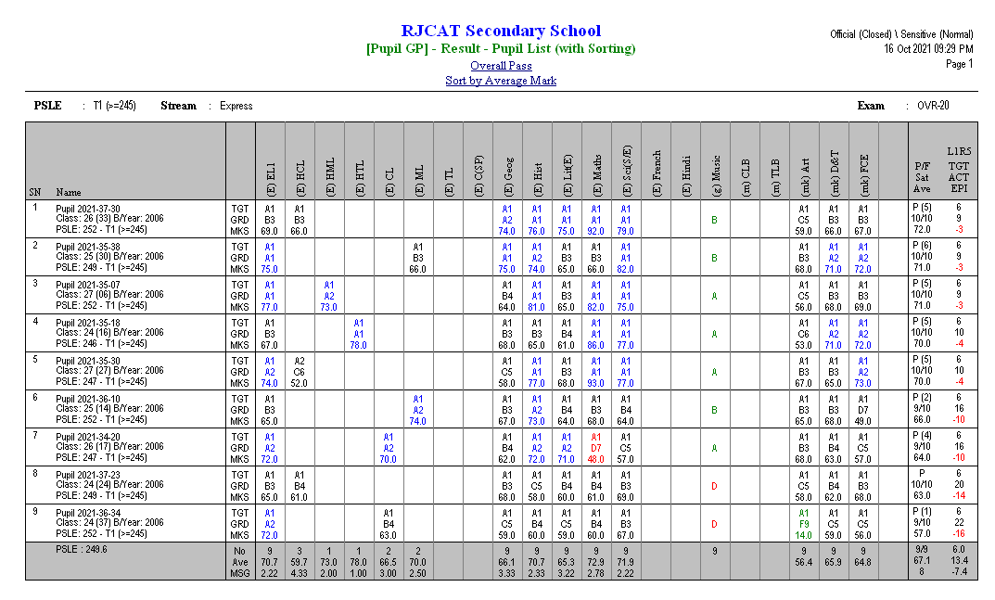
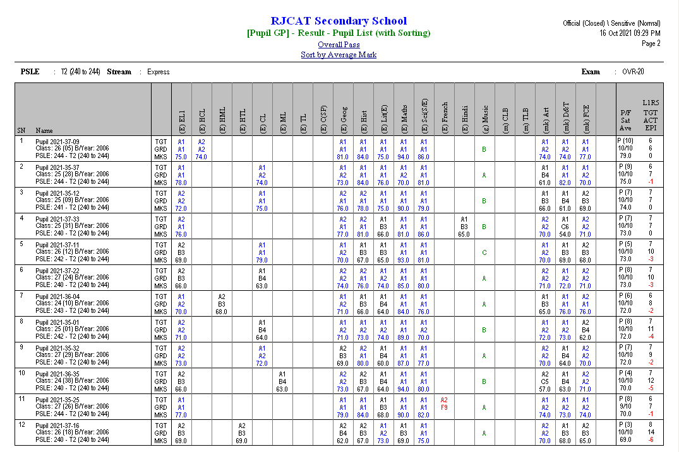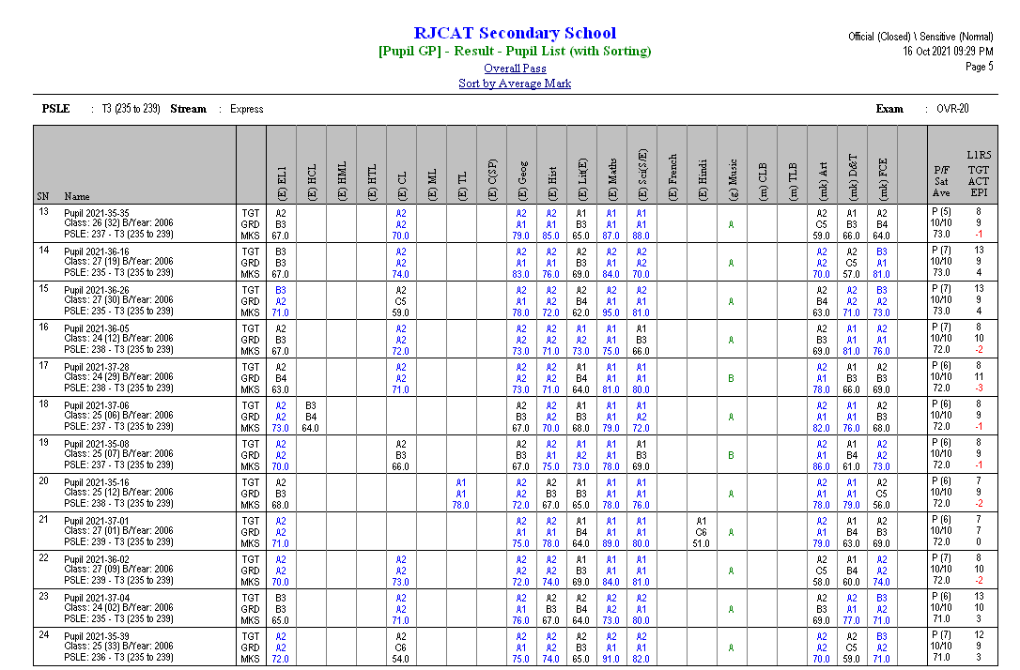

Reports – SBB/OOS
You may want to review students who are offered SBB/OOS Subjects.

If the SBB/OOS results are not very good, may need to discuss if opt to return to normal Subject.

Lower Secondary
SBB 1 – Student takes 1 SBB Subject
SBB 2 – Student takes 2 SBB Subjects
SBB 3 – Student takes 3 SBB Subjects

Upper Secondary
OOS 1 – Student takes 1 SBB Subject
OOS 2 – Student takes 2 SBB Subjects
OOS 3 – Student takes 3 SBB Subjects

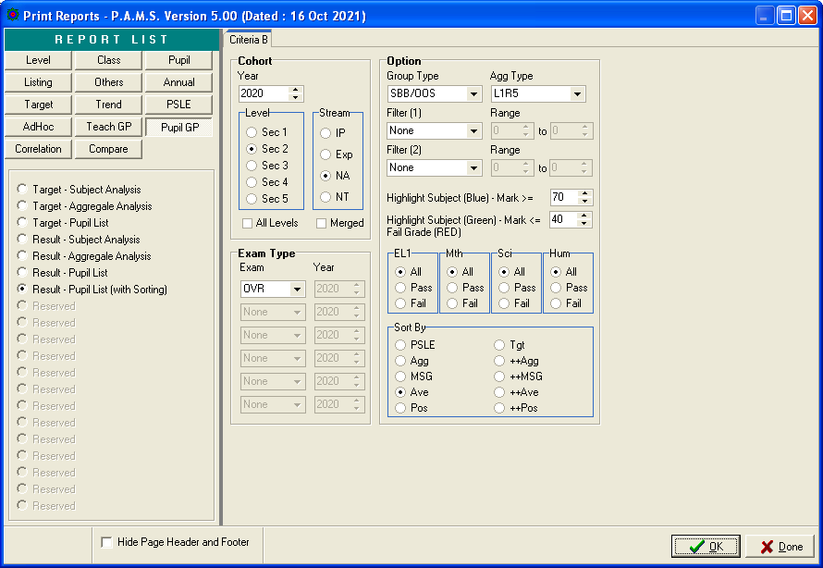
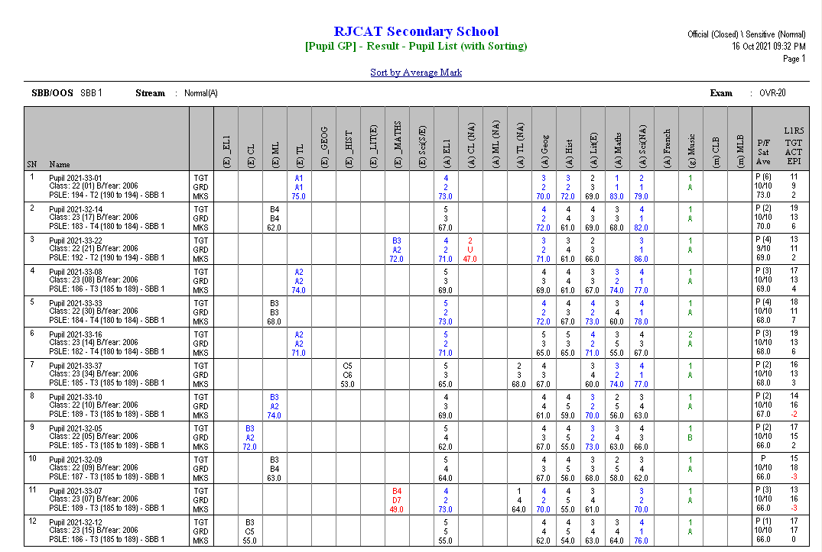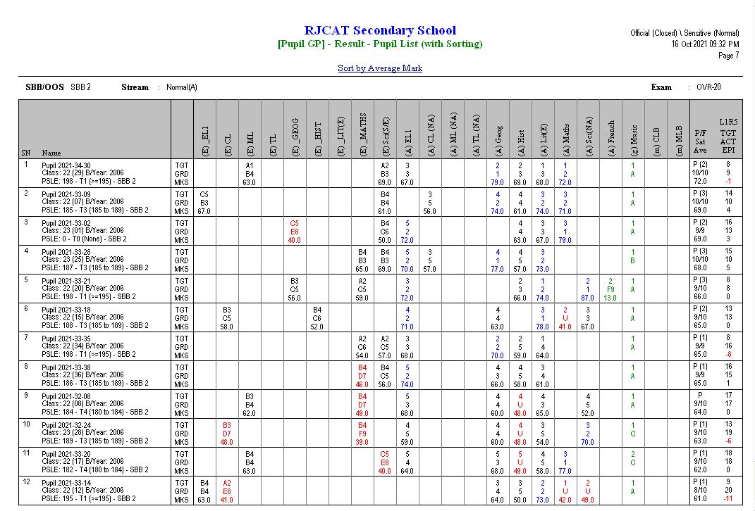

Reports – Laterally Transferred to More Demanding Stream
Normal (A) to Express or Normal (T) to Normal (A)
Obtain Pass and Average >=70

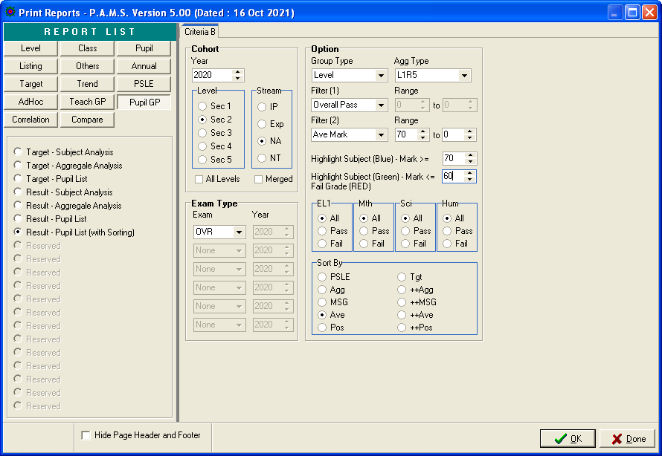
May leave as “0”

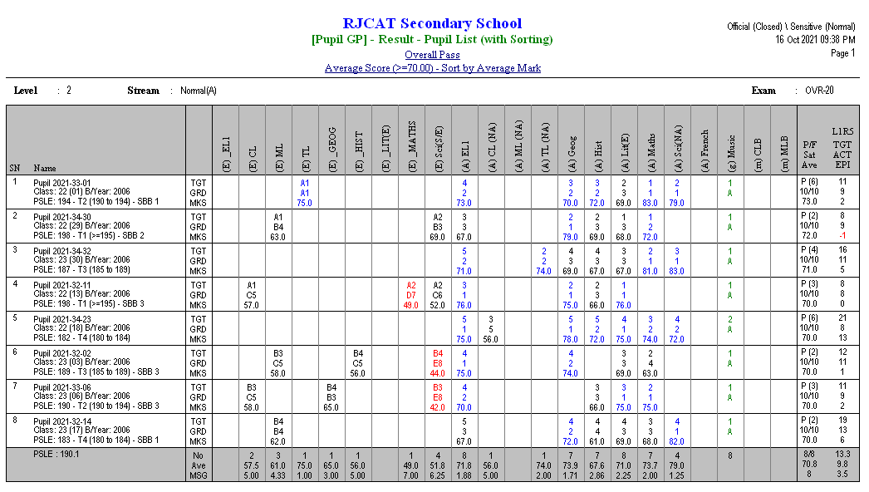

Reports – SBB Inserts

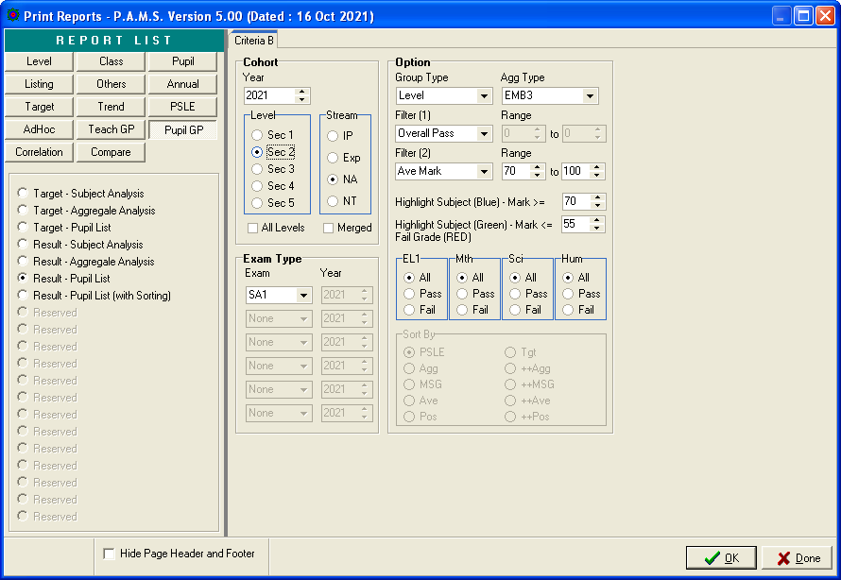

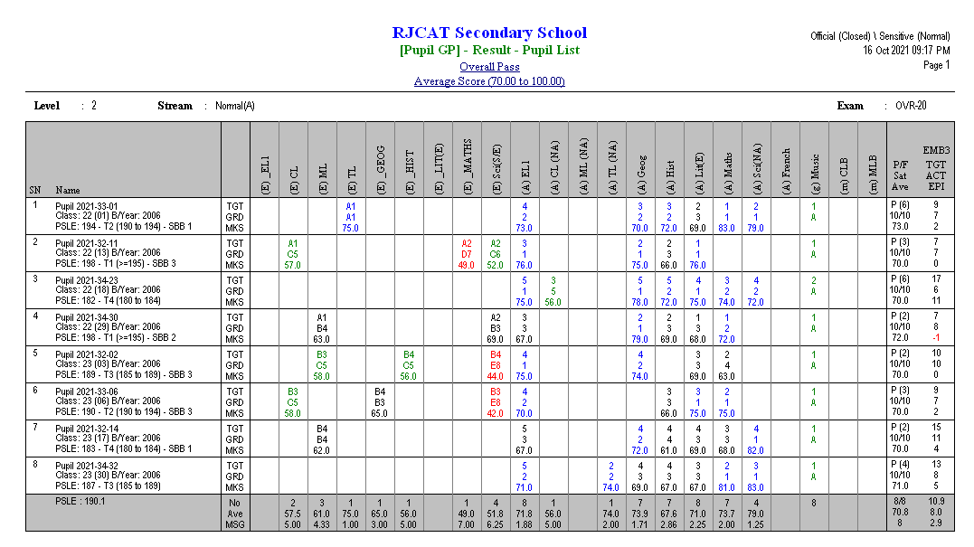
(6) – Number of Subject >=70
(A) - Normal (A) Grading Scheme

Subject>=70 will be highlighted in Blue

