PUPIL ACADEMIC MONITORING SYSTEM

Target Setting by Aggregate

(Updated on 18 Jun 2020)

Contents

Work Flow 1
Convert Cockpit Data 2
Out of Stream Subject or Subject Based Banding 3
Load SBB & Teaching Group 4
Loading RE_SAL_017 Files 6
Loading RE_SDT_009 Files 7
Loading RE_TMT_010 Files 8
Manage SBB and Teaching Group 9
Features 10
Updating SBB Subject 11
Update Teaching Group/ Teachers 12
Check Subject Allocation List 16
Check Subject Grading Scheme 17
Target Setting by Aggregate (Using Previous Year Results) 18
Check Prev Subjects 19
Subject Mapping 21
Target Option 22
Target Generated 23
More Statistics 24
Print Target Reports 25
Setup Aggregate Target Based on T-Scores 26
Analyzing Results 29
Convert Results 29
Process Results 30
Print Reports 31
Level Analysis 31
Class Analysis 33
Listing 34
Teaching Group 35
Correction 36
EXCEL Import/Export 37

Work Flow

Part 1 - Beginning of Year
- Convert Cockpit Data
- Load SBB and Teaching Group
- Manage SBB and Teaching Group
- Subject Grading Scheme
- Setup Aggregate Target

Part 2 – Analyzing Results
- Convert Cockpit Data (with Exam Results)
- Process Results

Convert Cockpit Data
You will need to export the following text file from School Cockpit:
- Class (Text File)
- Pupil (Text File)
- ExDet (CSV File)
- Subj (Text File)

Menu Access: System Admin Menu || Convert Cockpit (New Framework)

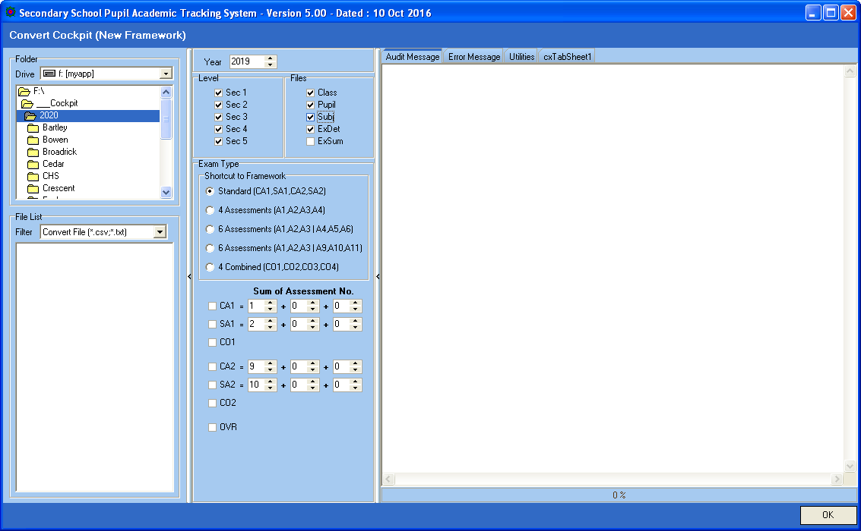
No need for Exam Type as there are no results

Steps
- Select your Directory where you stored your Cockpit Text Files
- Select Level
- Select the Files to be Converted
- Click OK Button

Out of Stream Subject or Subject Based Banding
Out of Stream (OSS)
Subject Based Banding (SBB)

Cockpit EXDET file does not distinguish the following Subject Codes for SBB or Out of Stream:
Lower Sec
- EL1
- MATH
- GEOG, HIST, LIT(E)

Upper Sec (Except NT)
- SCI(P/C), SCI(C/B), SCI(P/B)
- SS+GEOG, SS+HIST, SS+LIT
- POA, D&T, F&N

All Mother Tongue and Lower Sec Sciences are distinguished:
- CL, CL(NA), BCL
- SCI(S/E), SCI(N/A), SCIENCE(T)

PAMS will need to change them as follow:
- From NA to Express, PAMS will prefix “_” in the subject Code (example: _EL1, _MATHS)
- From NT to NA, PAMS will prefix “@” in the subject Code (example: @EL1, @MATHS)

Load SBB & Teaching Group

Menu Access: System Admin Menu || Load SBB & Teaching Group

There are 3 types of Excel Files that can be loaded into PAMS. All of them need to be save as OLD Excel Format (.xls)

RE_SAL_017 : This is Subject Allocation Files. PAMS can change the Subject Codes accordingly for SBB and OOS. (One file per level)
RE_SDT_009 : This is Pupil Subject Teaching Group File. There will be many files.
RE_TMT_010 : This is Teacher Teaching Group File. (Only one file for whole school)

Important: You will need to load RE_SAL_017 prior to Target Setting. RE_SDT_009 and RE_TMT_010 can be loaded at later stage before analyzing results.

RE_SAL_017

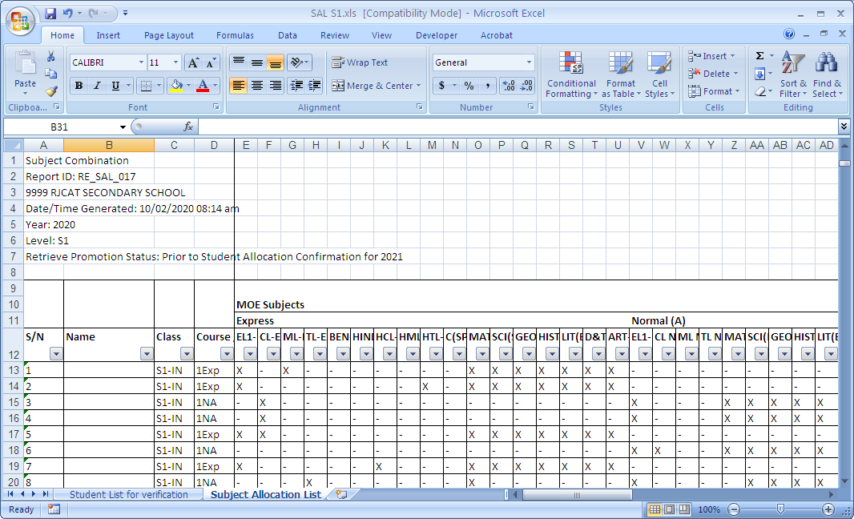

RE_SDT_009

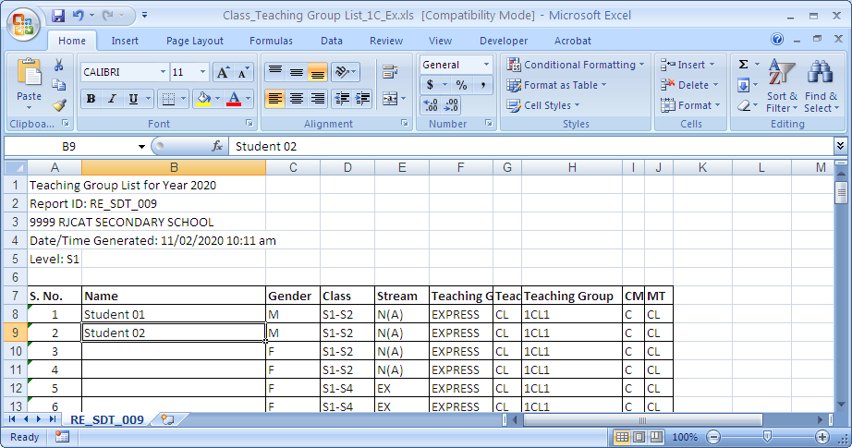

RE_TMT_010

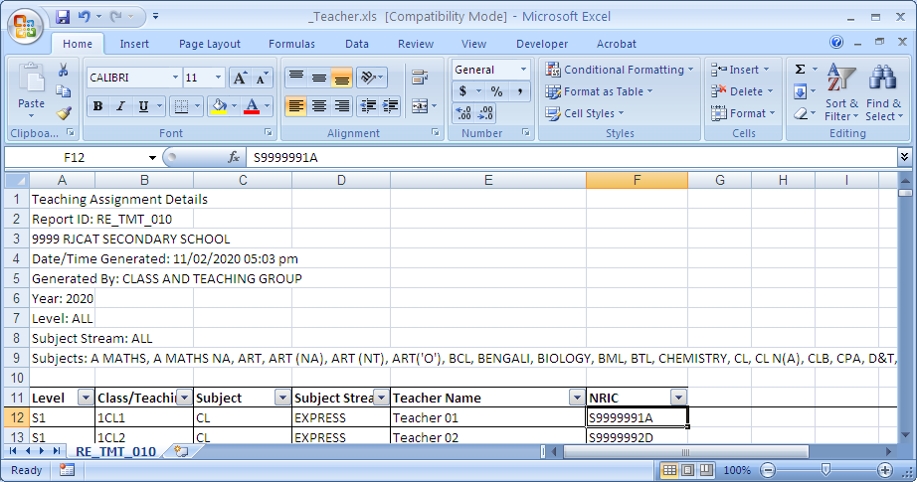

Loading RE_SAL_017 Files

This is the Pupil Subject Allocation List. It will auto convert the Subject Code for SBB Subjects which are not distinguished.

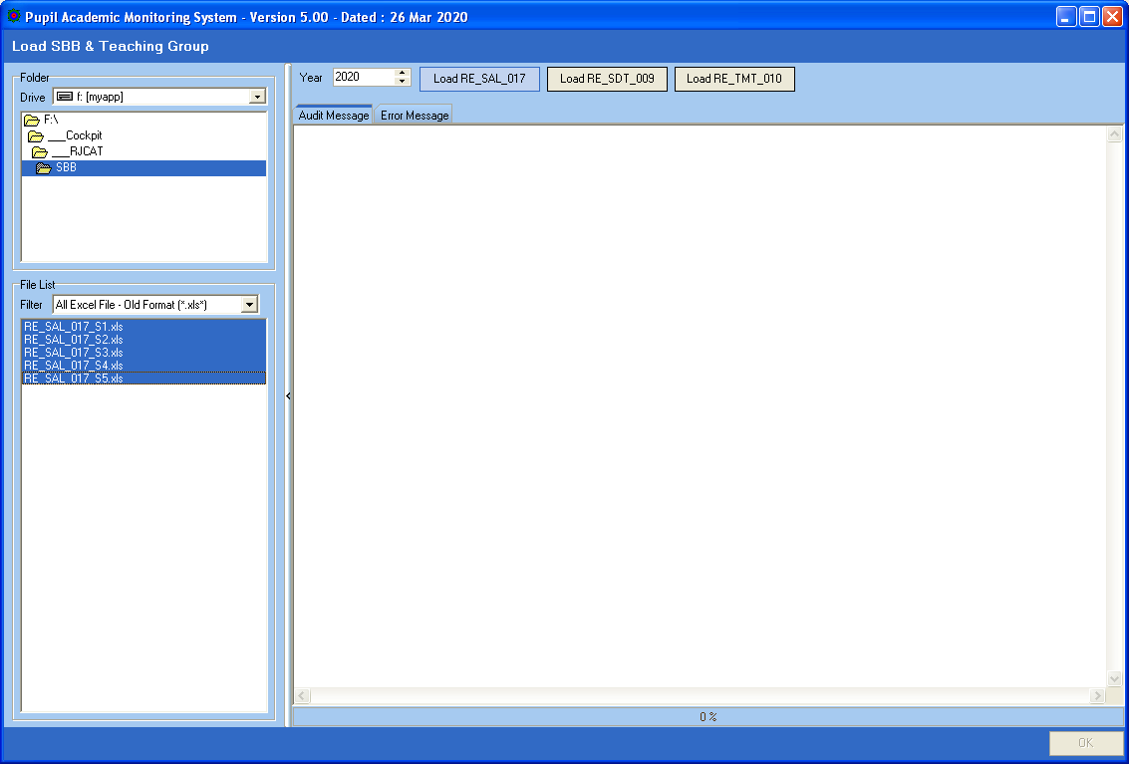
Click
Load RE_SAL_017

Steps
- Select your Directory where you stored your Cockpit Excel Files
- Select the SAL_017 Files
- Click Load RE_SAL_017 Button

Loading RE_SDT_009 Files
This is the Pupil Subject Teaching Group

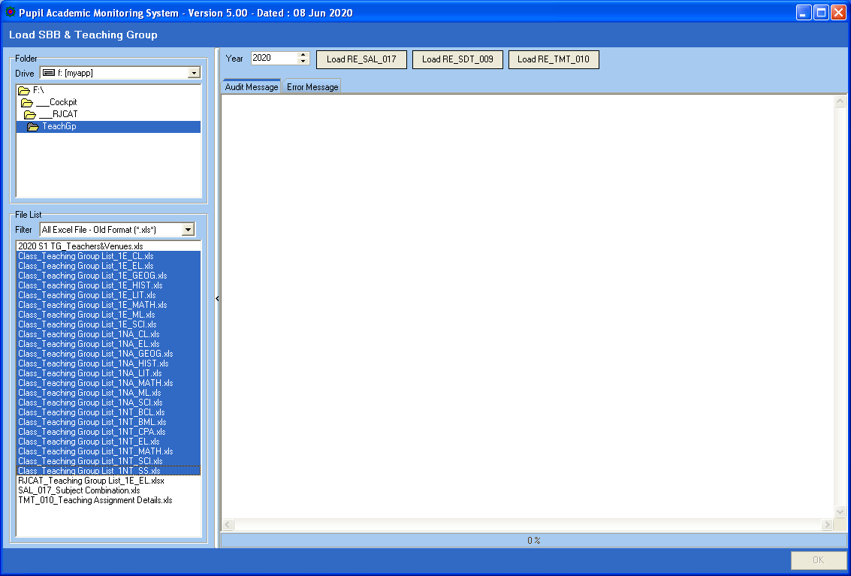
Click
Load RE_SDT_009

Steps
- Select your Directory where you stored your Cockpit Excel Files
- Select the Teaching Group Files
- Click Load RE_SDT_009 Button

Loading RE_TMT_010 Files
This is the Teacher Teaching Group

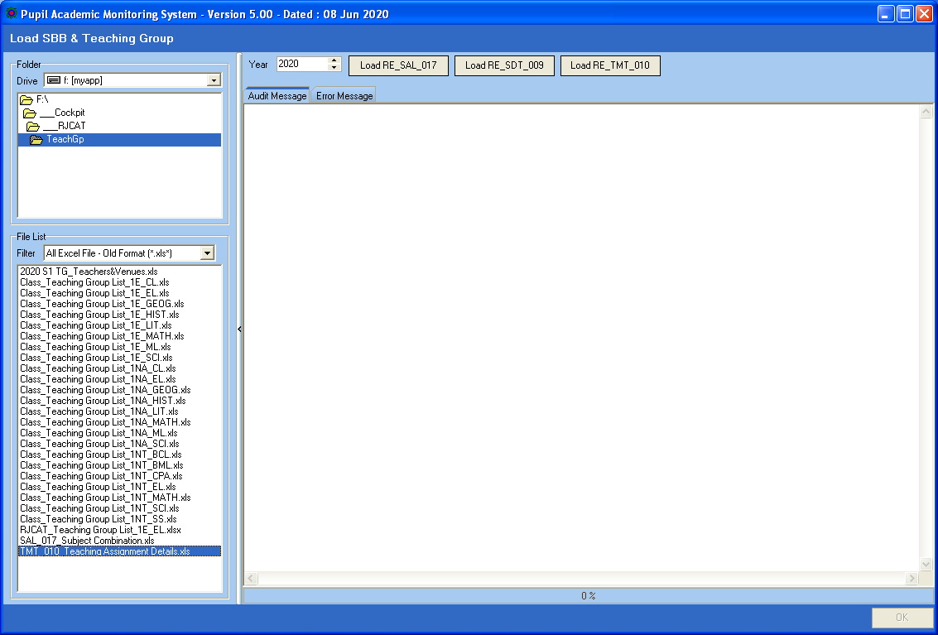
Click
Load RE_TMT_010

Steps
- Select your Directory where you stored your Cockpit Excel Files
- Select the Teaching Group File
- Click Load RE_TMT_010 Button

Manage SBB and Teaching Group
Most of the SBB and Teaching group are handled by the LOAD function. However, if you need to change manually, you may do so here.

Menu Access: System Admin Menu || Manage SBB & Teaching Group

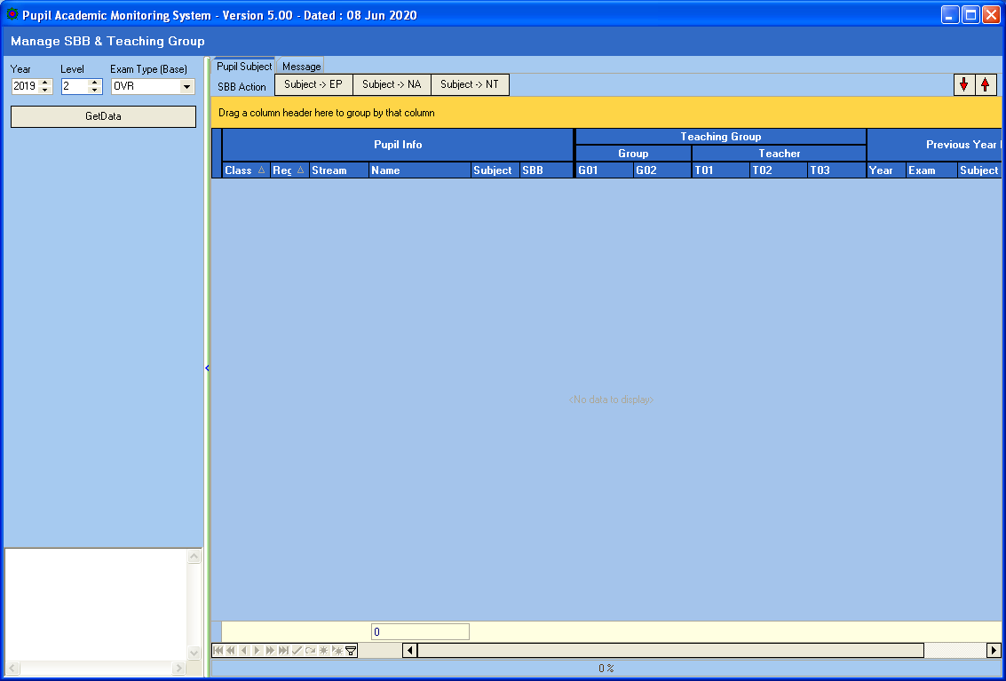

Steps
- Select Year
- Select Level
- Select Exam Type (Previous Year Results)
- Click Get Data button

Features
The grid on the right panel has features like Sorting, Filtering and Pivoting

Manage SBB

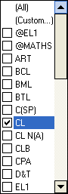
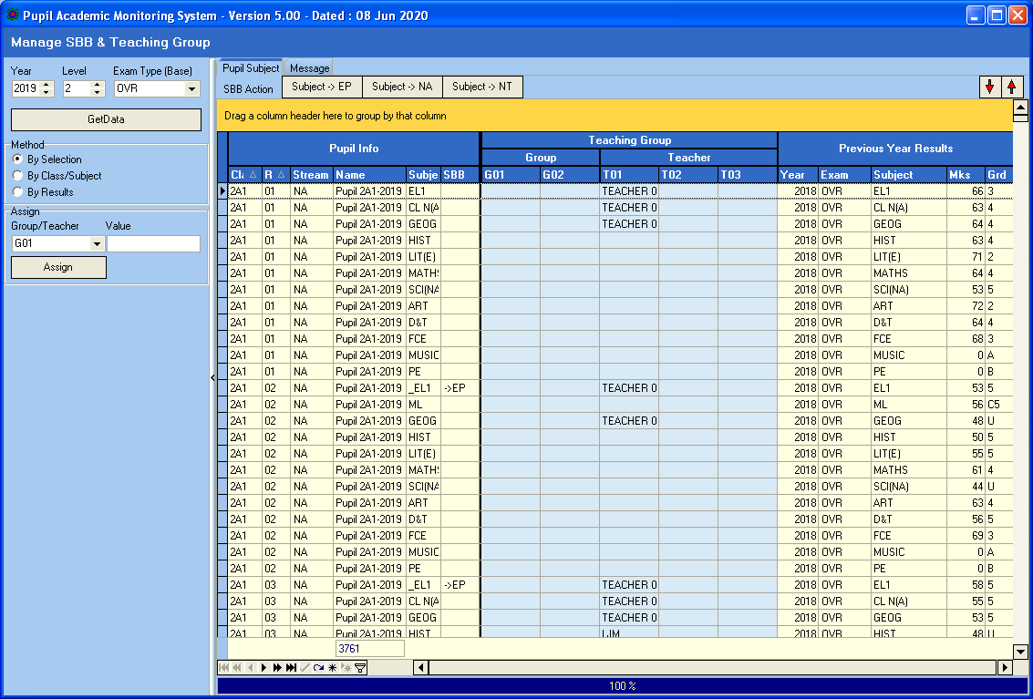
Drag any column to the Orange Panel to Pivot (Group) by the Column.
Move Cursor to column to Filter.
Previous Year Subject and Results

Updating SBB Subject

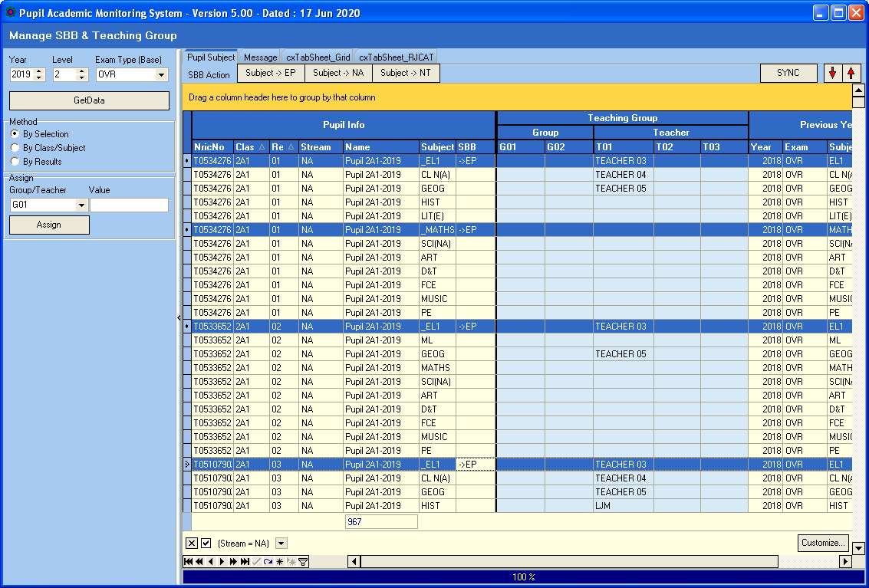
Move Cursor to column to Filter.

Steps
- Click Student (CTRL+Click)
- Click SBB Action Button (e.g. Subject->EP)

Update Teaching Group/ Teachers
Most of the teaching group will be assigned during the “Load SBB & Teaching Group”.
However, if you need to change any record manually, you can do it here.

By Selection

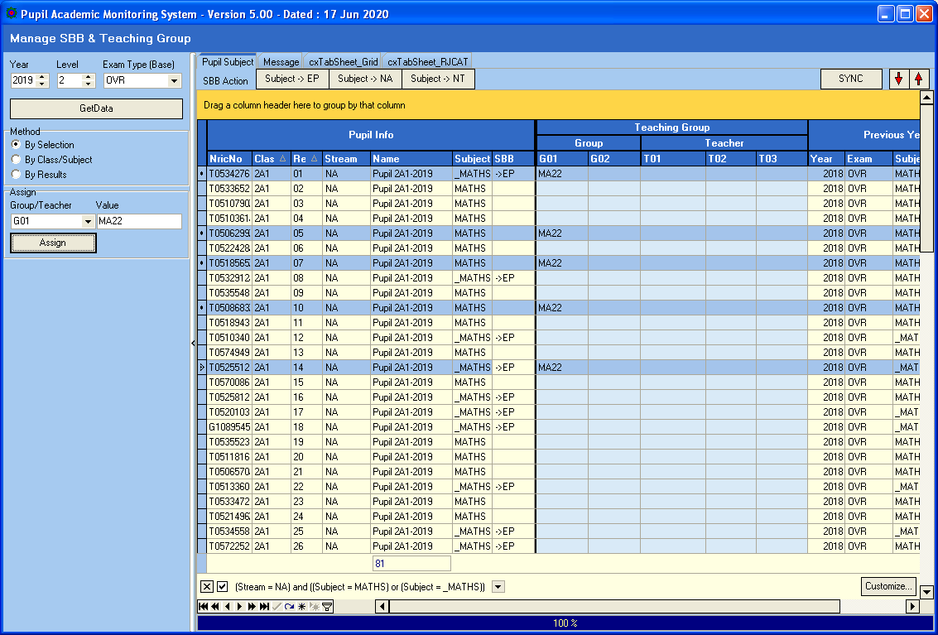

Steps
- Click Method – By Selection
- Select Assign Group/Teacher (G01, G02, T01, T02 or T03)
- Enter the Value
- Select Students (Use CTRL+Click)
- Click Assign Button

By Class/Subject

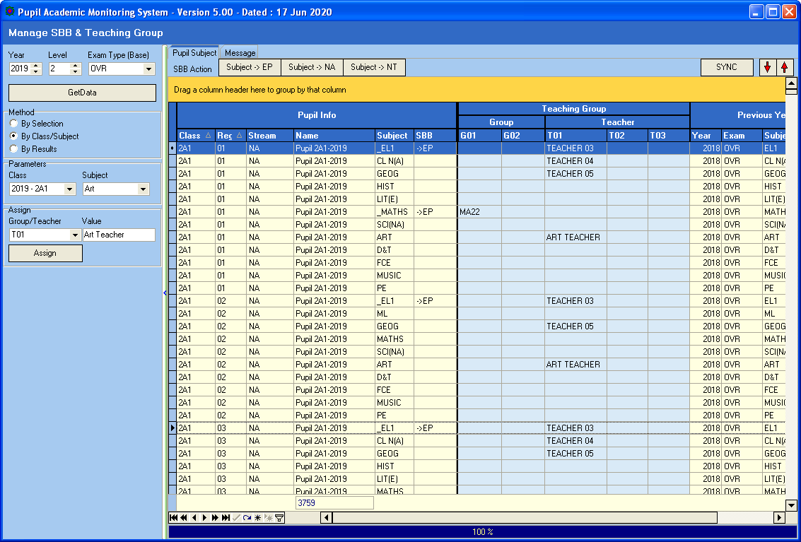

Steps
- Click Method – By Class/Subject
- Select Class and Subject
- Select Assign Group/Teacher (G01, G02, T01, T02 or T03)
- Enter the Value (e.g. Art Teacher)
- Click Assign Button

By Results

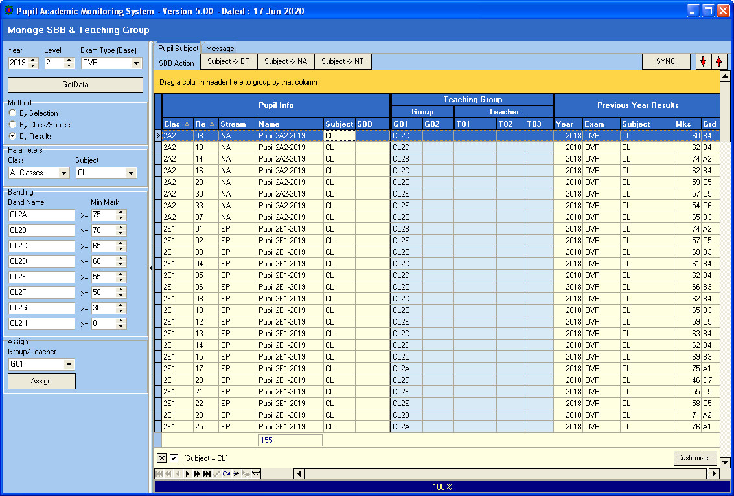
Click SYNC once you have finished updating all the teachers.

Steps
- Click Method – By Results
- Select Class and Subject
- Assign Band Names
- Select Assign Group/Teacher (G01, G02, T01, T02 or T03)
- Enter the Value
- Click Assign Button

Once you have finished Assigning Teachers, you will need to click SYNC to Update to Class-Subject Teachers. This will take quite a while.

Review Summary

You can GROUP, FILTERED and SORT to review the Allocation summary
GROUP
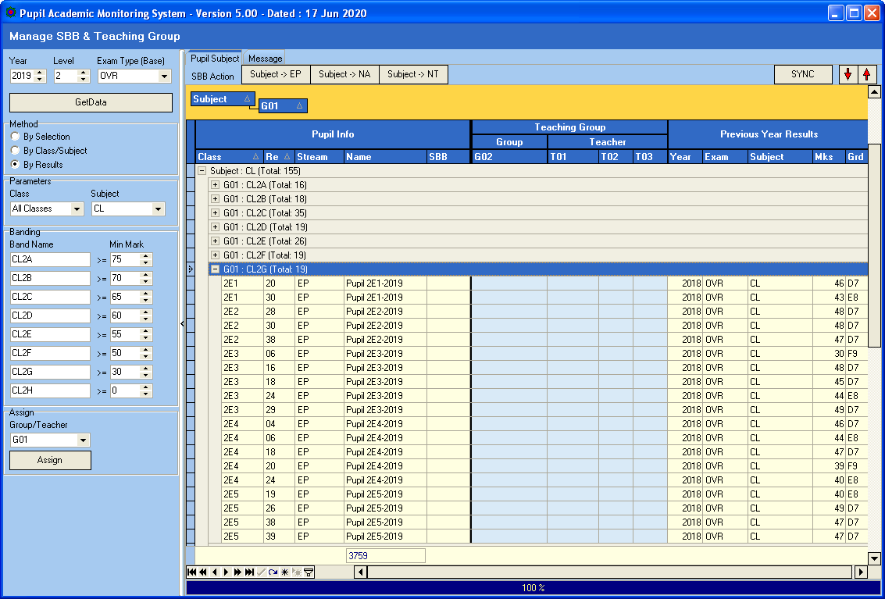
Expand and Collapse

Check Subject Allocation List
After you have converted, you will need to check the subject allocated to the students to ensure that the allocation is correct and complete. You may print a copy to get the students to check.

Menu Access: Main Menu || Print Reports

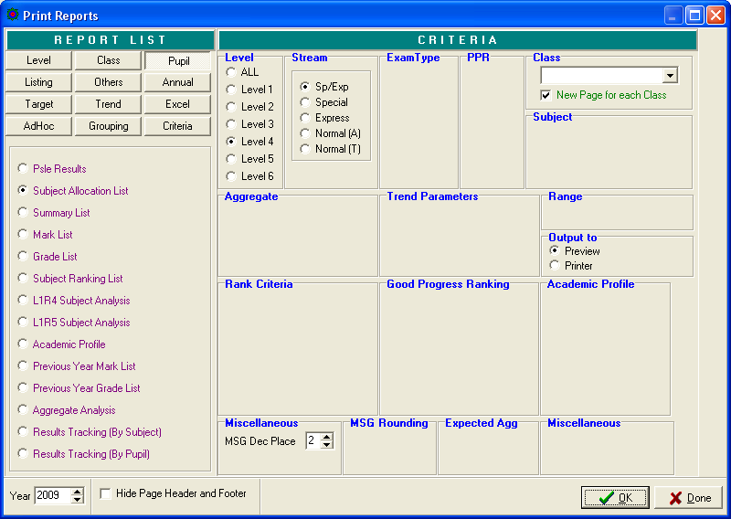

Steps
- Select Pupil Tab
- Select Subject Allocation List
- Select Criteria (Level and Stream)
- Click OK Button

Check Subject Grading Scheme

Menu Access: System Admin Menu || Subject Grading Scheme

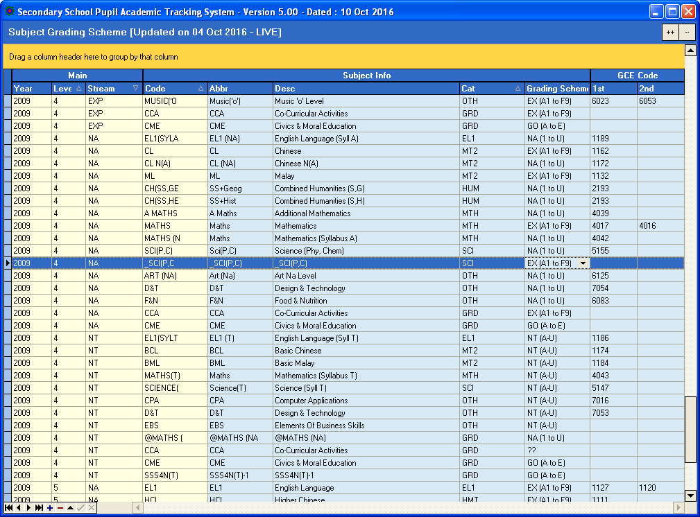
This is NA
This is Express

Steps
- Select Subject
- Check the Cat (Category) and Grading Scheme especially for Cross-Stream Subjects and the necessary changes accordingly
- Click another record to save

Target Setting by Aggregate (Using Previous Year Results)

Menu Access: Main Menu || Setup Aggregate Target

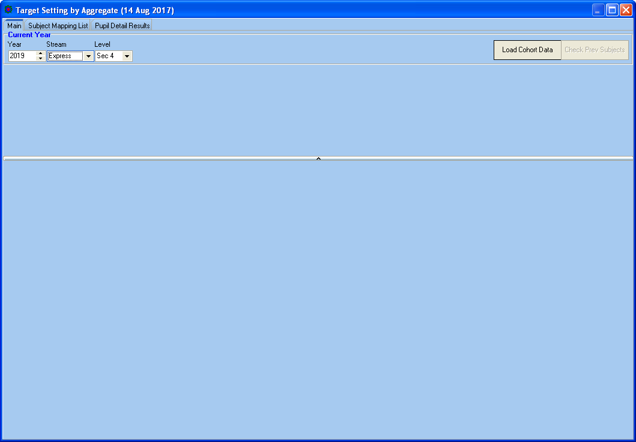

Step
- Enter Current Year Parameters (Year, Stream, Level)
- Click Load Base Data Button

Check Prev Subjects
Since the Target Setting is based on previous year results, we need to ensure that every student has a corresponding previous year results for each of the subject. This is especially crucial for Sec 3 Students (Sec 2 Subject Codes are different from Sec 3 Subject Codes) and students who are lateral transferred. For example:
Sec 3 Subjects | Possible Corresponding Subject (Sec 2 Subjects)
SS+Geog | Geog
Chemistry | Sci(S/E) | Sci(NA) | Science(T)
A Maths | Maths | Maths (NA) | Check Prev Subjects

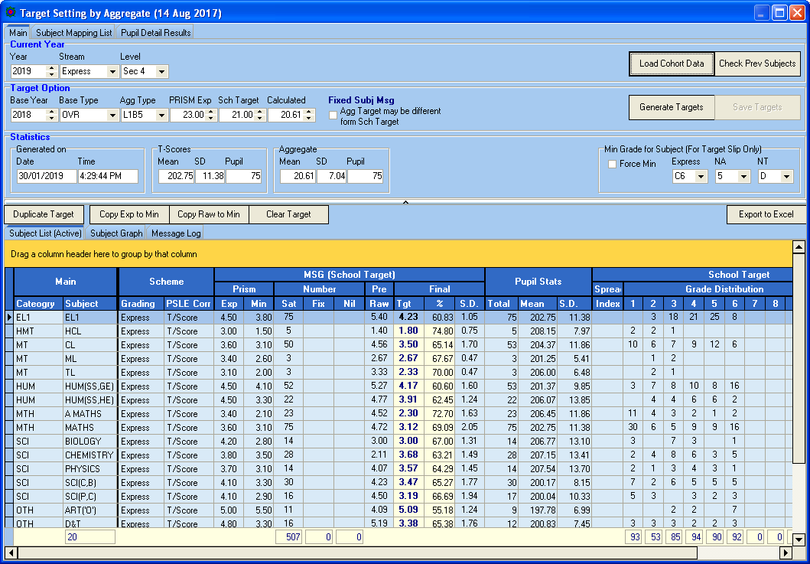
Number of student without previous year results

Here are some of the acceptable cases where Previous Results are not applicable:
New Student - System will assign average marks
VR Grade - System will assign average marks

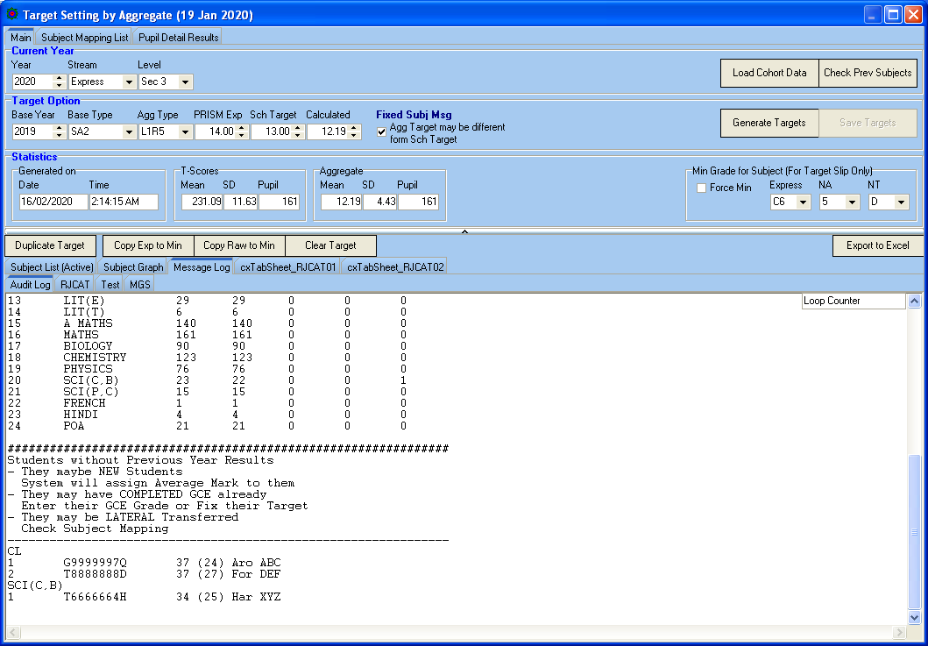

Subject Mapping
The purpose of Subject Mapping is to link the Upper Sec subjects to the Lower Sec subject.

For example, when the system search for previous year result for A MATHS, it should be looking for MATHS or MATHS NA

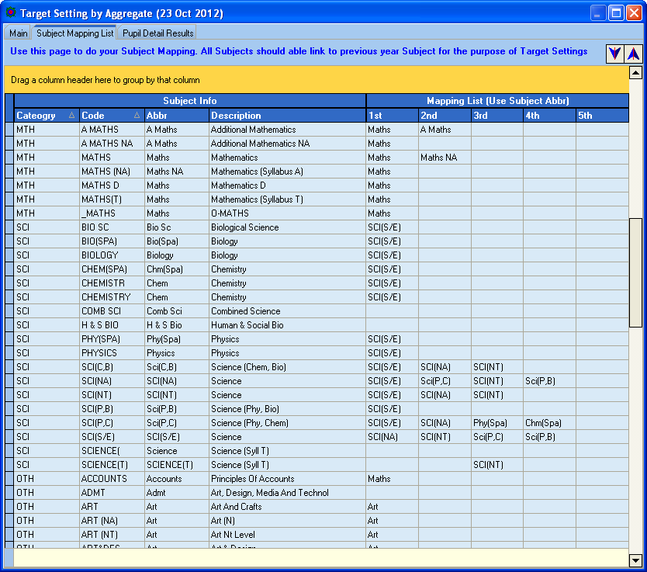

Steps
- Enter Corresponding Subjects under Mapping List
- To Save, select another record

Target Option
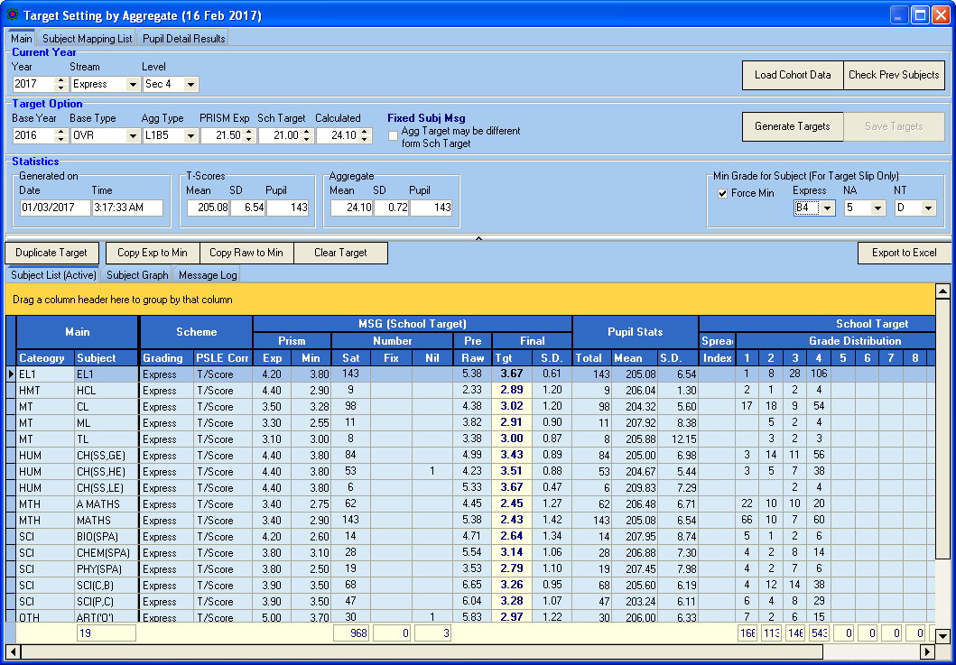
Minimum Grade to Achieve.
If you do not FORCE, PAMS still able to Print PASS Target for Target Slip,
PRISM Min
Act MSG from PRISM.
What your school is actually capable of achieving (or Achieved).
PRISM Exp
For reference only

Step
- Under Target Option
  - Select Base Year
  - Select Base Type
  - Select Agg Type
  - Enter PRISM Expected (for reference only)
  - Enter School Target to Achieve
- Under Subject List (Active)
  - Enter PRISM Exp (for reference only)
  - Enter PRISM Min (Capable of achieving)
- Click Generate Targets Button

Target Generated

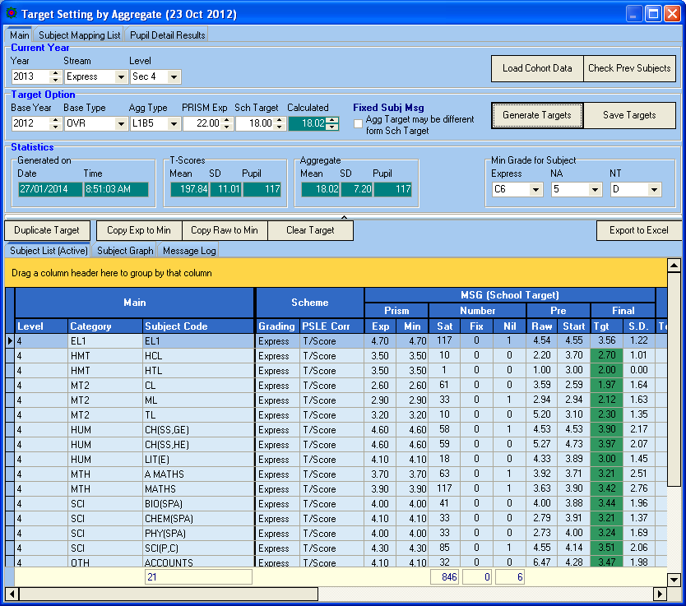
Statistics
Generated by PAMS.

Step
- Review all the Targets.
- If OK, click Save Targets Button to save the targets to the student database.

More Statistics

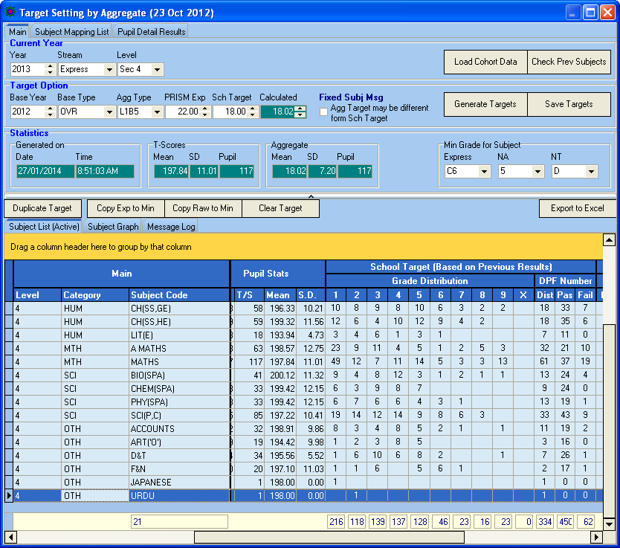
Statistics
Distribution of Target Grades

Note:
Based on Previous Year Results, some of the students “are” expected to fail. This is the realistic scenario. However, when you print the target slip for student, it will show at least a Min Pass Grade.

Print Target Reports

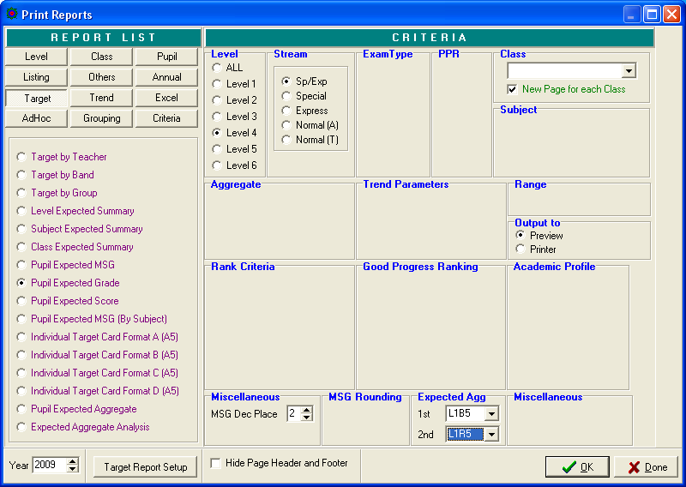

Reports you may use:
- Level Expected Summary
- Subject Expected Summary
Some basic Layout for Individual Target Card
- Class Expected Summary
- Pupil Expected Grade
- Individual Target Card (Format A to D)

Setup Aggregate Target Based on T-Scores

Menu Access: Main Menu || Setup Aggregate – T/Scores

Click Load Cohort Data

Enter TARGET OPTION Parameters:
- Agg Type
- PRISM Exp (for reference only)
- Sch Target (for reference only)

Enter PRISM Exp and Min:
- Exp (for reference only)
- Min (Min MSG for each Subject)

Enter Min Grade for Subject:
- Min Grade for each Stream
- Tick “Force Min” if you
Exp and Min MSG
Enter Spread for Target Grade
- Internal default is 0.05
- If you want More distinction (More spread out for Target Grades), increase the spread to more than 0.05

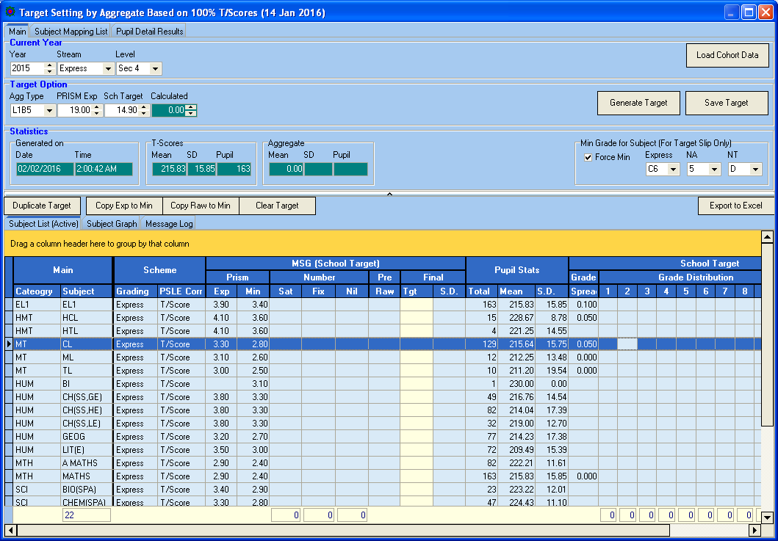
Spread for Target.
If it is empty (ZERO), the default is 0.05
Min Grade
Target Option Parameters

Click Generate Target button

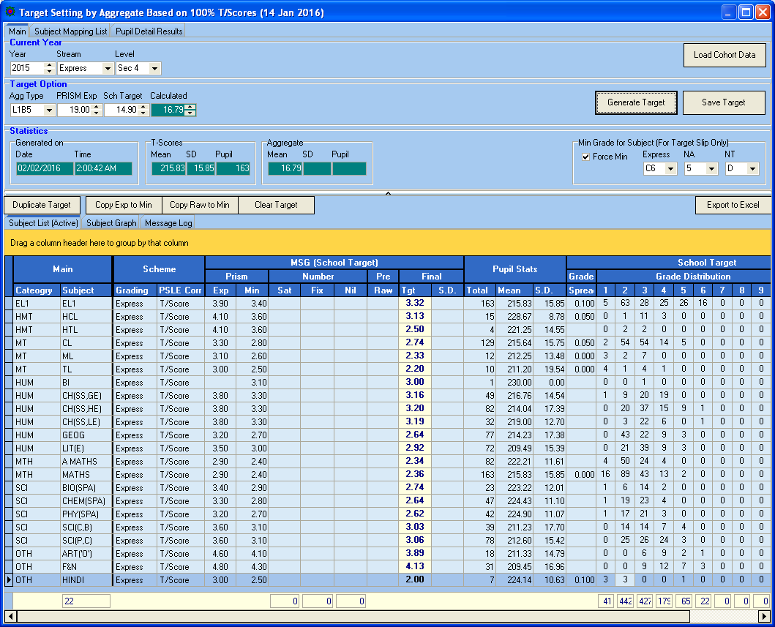
Target Grade Distribution
Target MSG
Calculated Aggregate Target

If you like the Target, click Save Target button.

Analyzing Results

You will need to export the following file from School Cockpit:
- Pupil (Text File)
- ExDet (CSV File)

Convert Results
Menu Access: System Admin Menu || Convert Cockpit (New Framework)

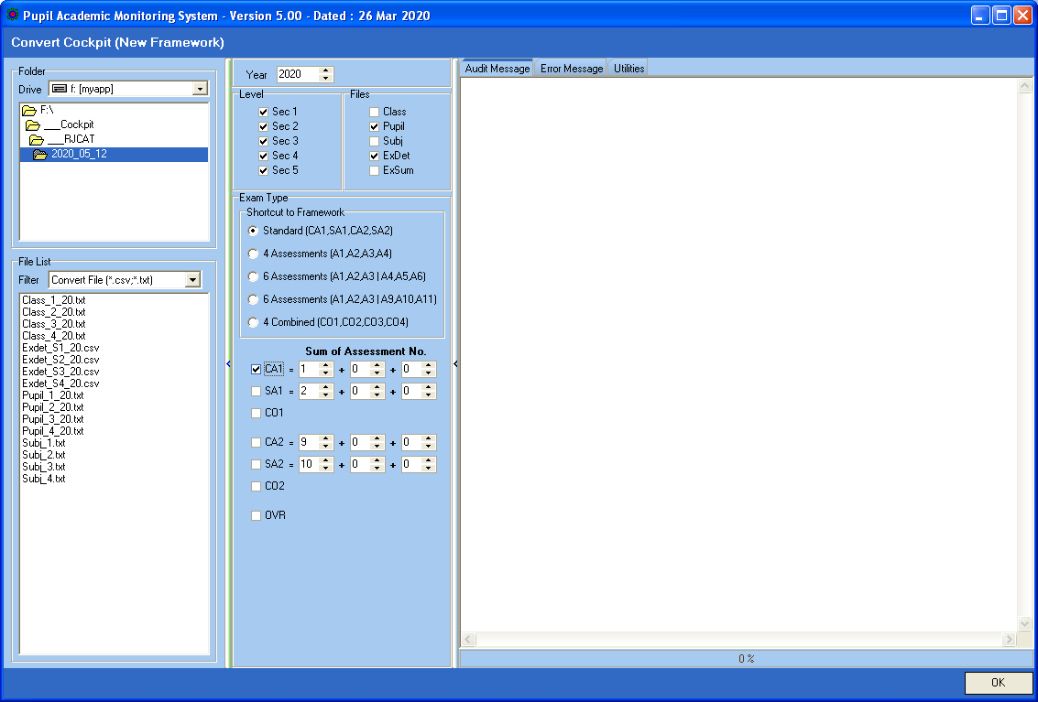
Select Exam Type
Only Pupil and Exdet are needed at this time

Steps
- Select your Directory where you stored your Cockpit Text Files
- Select Level
- Select the Files
- Select the ExamType (For now is just CA1)
- Click OK Button

Process Results

Menu Access: System Admin Menu || Process Results

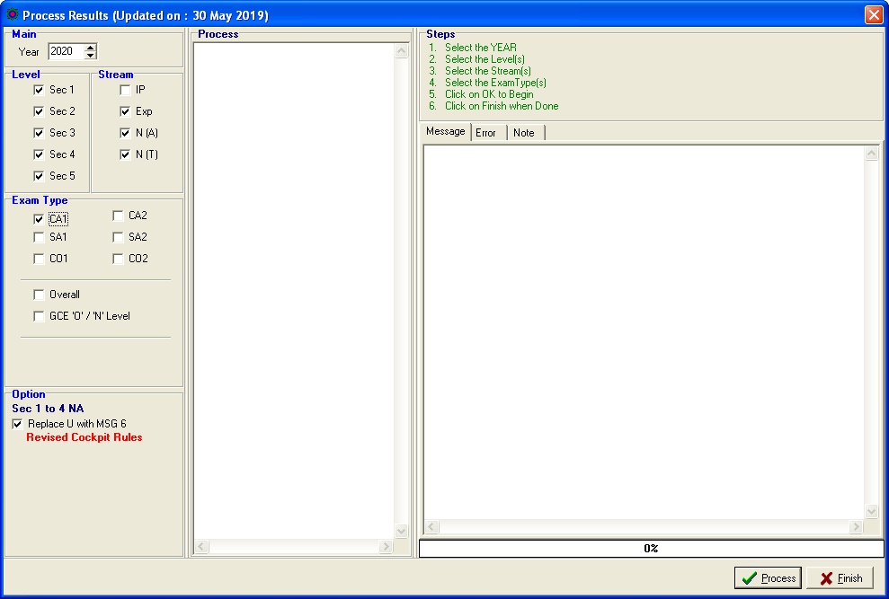

Steps
- Select Level and Stream
- Select ExamType
- Click Process Button

Note: You may check the Results via VIEW Results.

Print Reports

There are some key reports which are informative.

Level Analysis

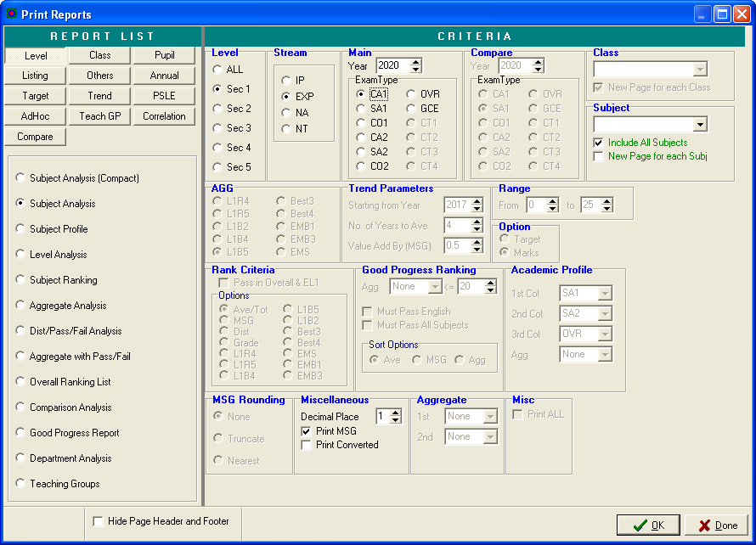

Sample
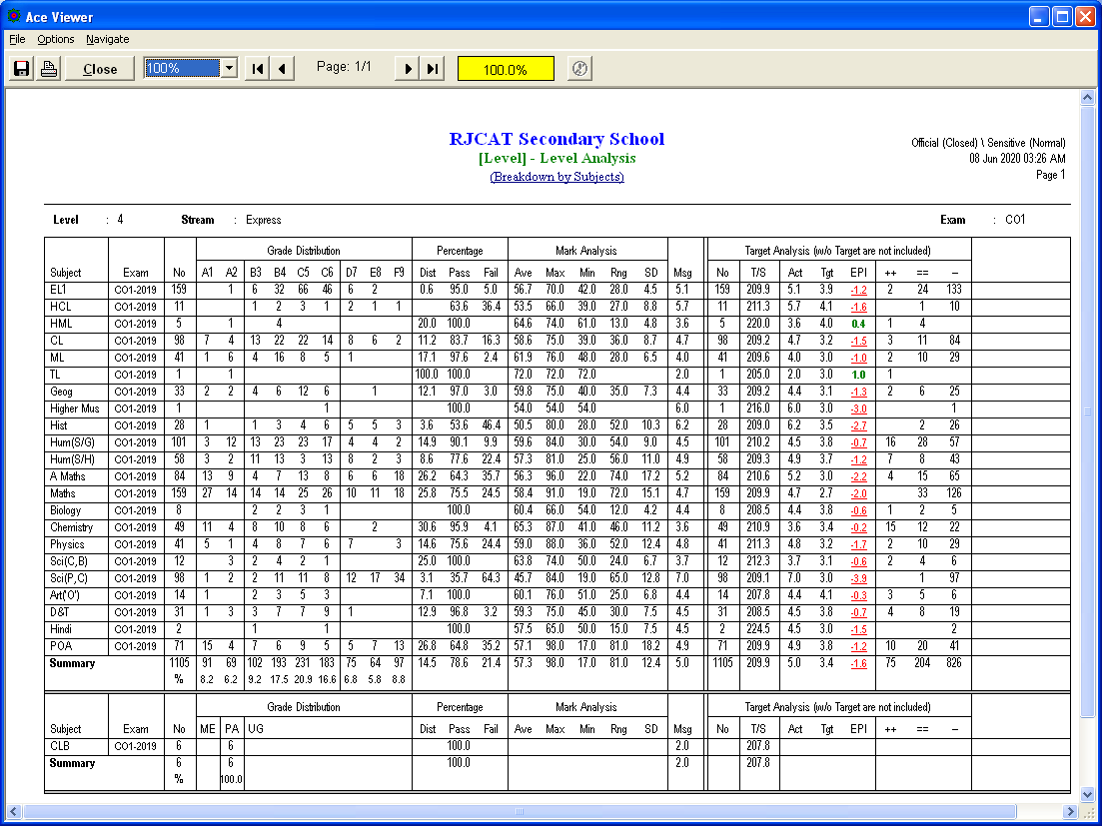
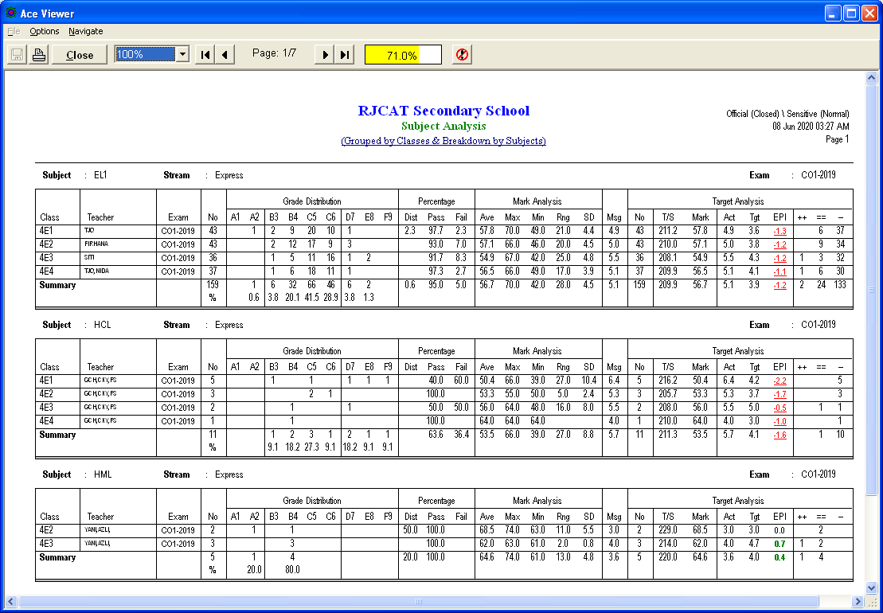

Class Analysis

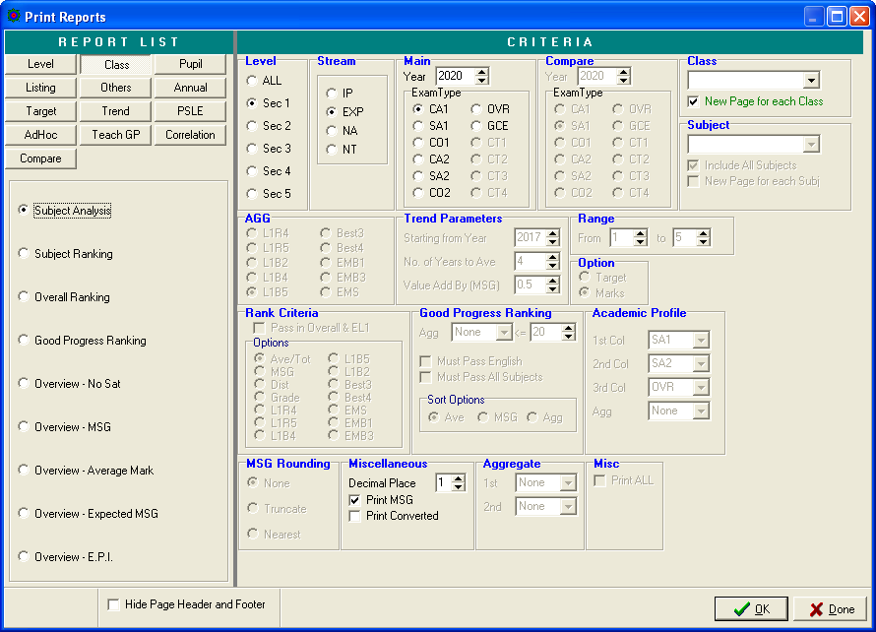

Listing

Students who did not meet targets

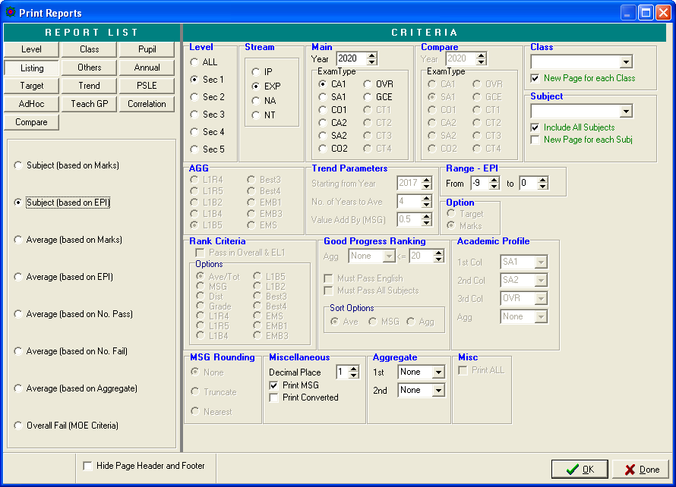

Teaching Group
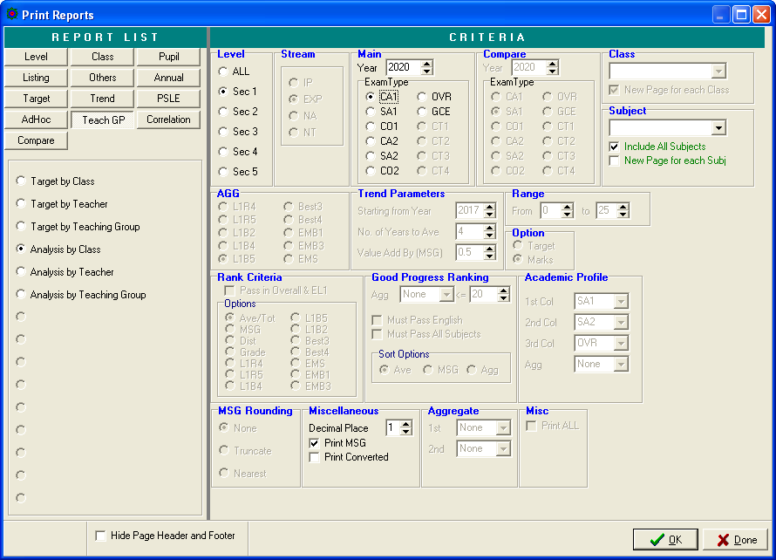

Sample
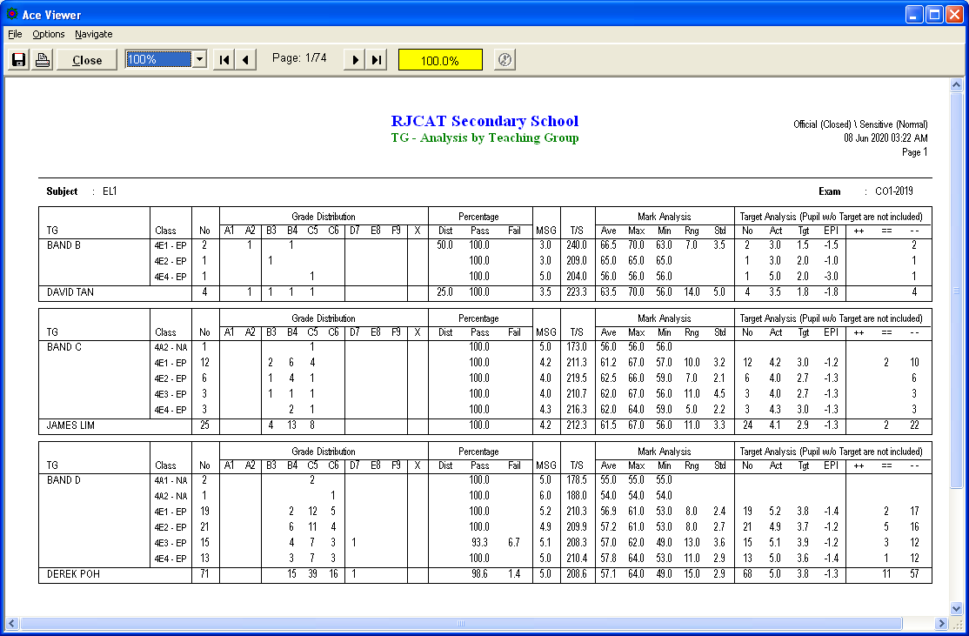

Correction

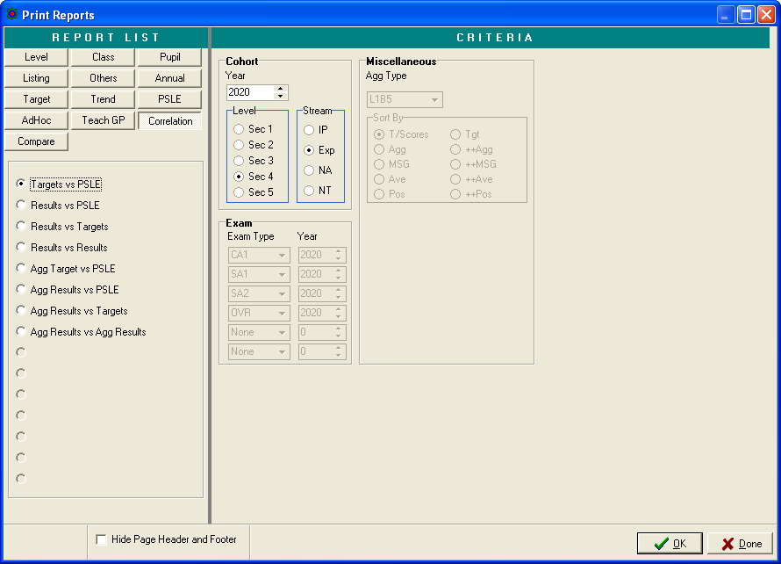
Sample
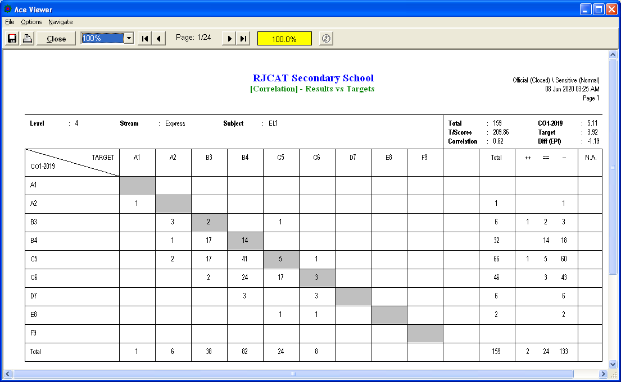

EXCEL Import/Export

Menu Access: System Admin Menu || Excel Import/Export

There are 3 Excel Template needed. They must be stored in C:\APPS\RJCAT\PAMS\Excel
_Template_Analysis.xlsx
_Template_ListPupil.xlsx
_Template_ListTutor.xlsx

You may download the templates from RJCAT website.

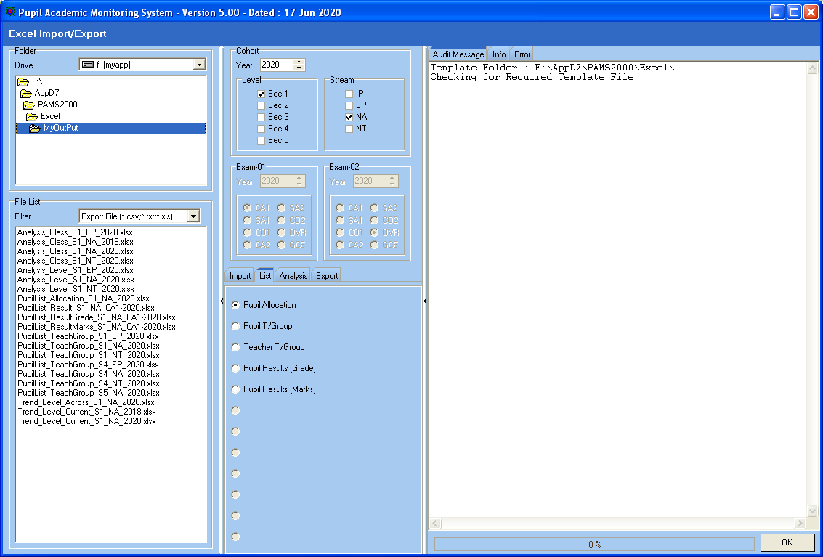
You can create your own folder with My Computer before exporting.

Steps
- Select Year (Cohort Year)
- Select Level and Stream
- Exam Type (If needed)
  - Select Exam
  - Select Exam Year
- Click OK Button

Note:
IMPORT Pupil Target will work with EXPORT Pupil Target
IMPORT Pupil T/Group will work with LIST Pupil T/Group
IMPORT Teacher T/Group will work with LIST Teacher T/Group

