PUPIL ACADEMIC MONITORING SYSTEM

User Guide
Analyzing Results

(Updated on 31 May 2021)

Contents

Work Flow 1
Exam Label 2
Cockpit Files 3
EXDET 3
Manage SBB and Teaching Group 5
Features 6
Updating SBB Subject 7
Update Teaching Group/ Teachers 8
Manage Pupil Group 12
Assigning PSLE Tier 13
Assigning SBB/OOS Count 14
Assigning Laterally Transferred 15
Assigning Group 16
Check Subject Allocation List 17
Check Subject Grading Scheme 18
Convert Cockpit Data 19
Process Results 20
Print Reports 21
Level Analysis 21
Class Analysis 23
Listing 24
Teach Gp (NEW) 25
Pupil GP (NEW) 26
Correlation (Revised) 27
Compare (Revised) 28

Work Flow

Part 1 - Beginning of Year
- Convert Cockpit Data
- Manage SBB and Teaching Group
NEW
- Subject Grading Scheme
- Setup Aggregate Target

Part 2 – Analyzing Results
- Convert Cockpit Data (with Exam Results)
- Process Results

New Features and Reports
The new features are Pupil Group Allocation:
PSLE Tier - Each Cohort is divided into Tier based on PSLE Results. Analysis based on Tier
OOS/SBB - Identify students offered SBB/OOS (1, 2 3 or 4). Analysis based on Total OSS/SBB Offered
User Defined Group - There are up to 5 Groups you can tag to students. For example, DSA, Scholars, Laterally Transferred etc. Analysis based on these Groups
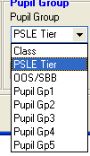
There are a series of Reports based on Pupil Grouping. In addition, you can also filter out pupils based on Average Mark, EPI, No Pass, No Fail, Aggregate, Overall Pass and Overall Fail. Please explore.

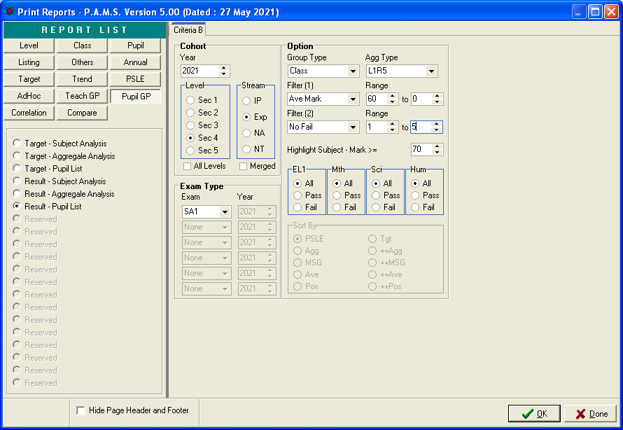
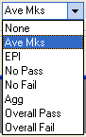
Range of Value to be included

Exam Label
Now you may rename the Exam Label to WA1, SA1 etc or any customized Label. Please note that the length should be kept at 4 characters or less.

Important Note: You need to download SysCode.DB and SysCode.PX from our website into C:\APPS\RJCAT\PAMS2000\DATABASE

Menu Access: System Table Menu | Exam Label Table

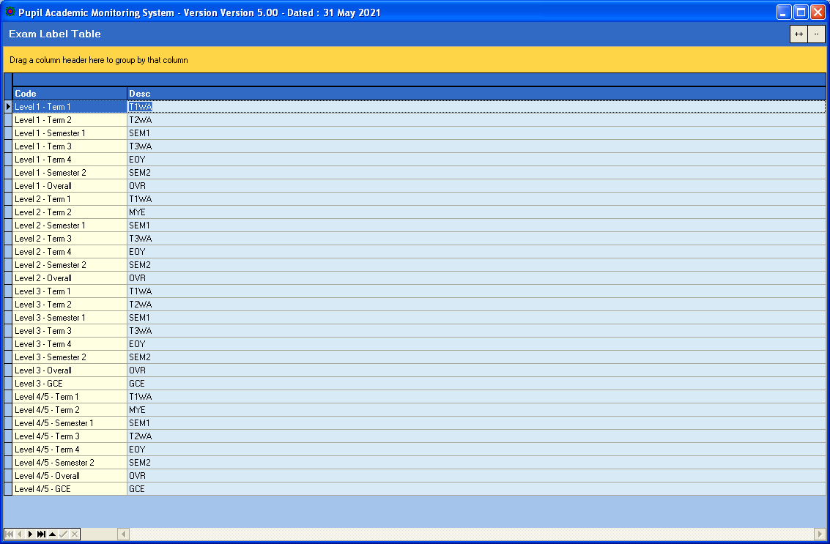

Cockpit Files
There are some changes to the Cockpit Files especially the EXDET (CSV) and Subject Combination (Excel)

EXDET
The subject Code column includes “Stream” as part of Subject Code. For example, for NA student offering Express Maths:
Lower Sec NA - MATHS – EXP
Upper Sec NA - MATHS – O

Some of the Subject Codes are different from previous years. PAMS will map them accordingly. For example EL:
Lower Sec Express - EL – EXP map to EL1
Lower Sec NA - EL – N(A) map to EL1
Lower Sec NA SBB - EL – EXP map to _EL1

Assessment Number
You need to check the column with “No. of components for Assessment ..” to see what Number to map to CA1, SA1, CA2 and SA2 when converting Cockpit Data.
Different Schools have different Assessment Numbering System.

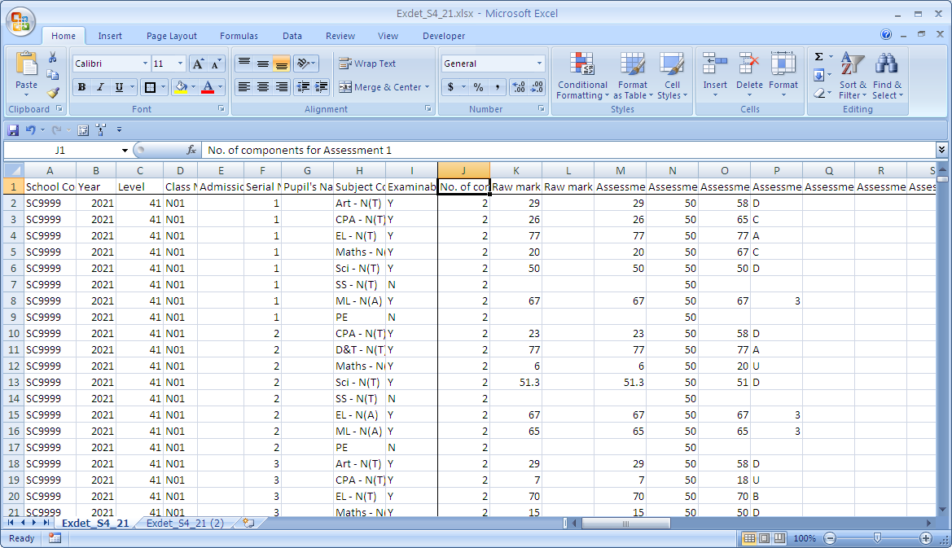
Check what Assessment Number to use for CA1, SA1, CA2 and SA2.

Check Subject Grading Scheme
After conversion, you need to check through the Subject Parameters such as Category, Grading Scheme etc. to ensure that they are correct.

Menu Access: System Admin Menu – Subject Grading Scheme

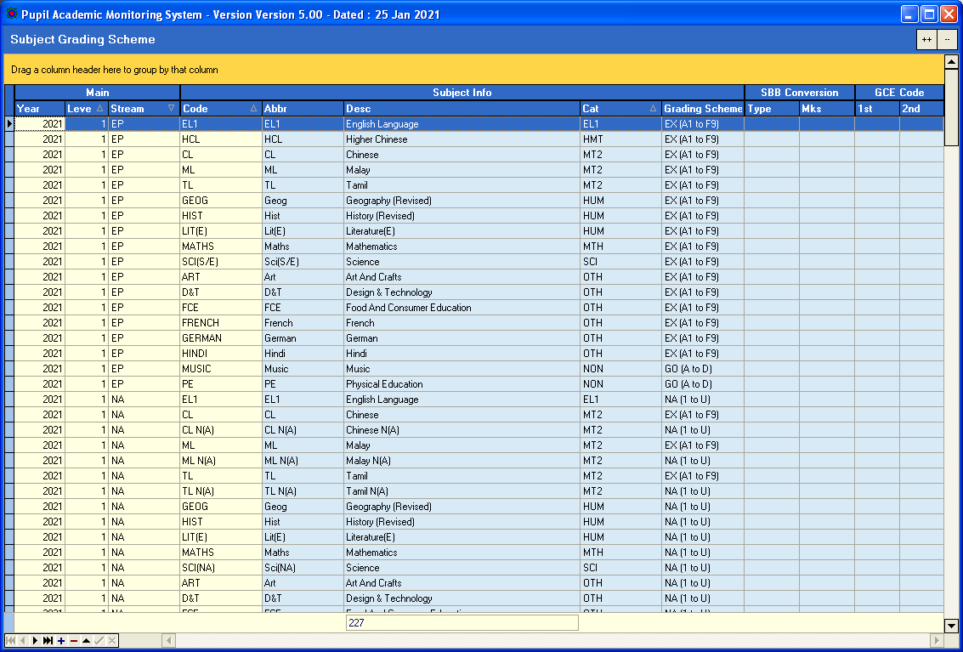
Grading Scheme
Subject Category

Manage SBB and Teaching Group
Most of the SBB and Teaching group are handled by the LOAD function. However, if you need to change manually, you may do so here.

Menu Access: System Admin Menu || Manage SBB & Teaching Group

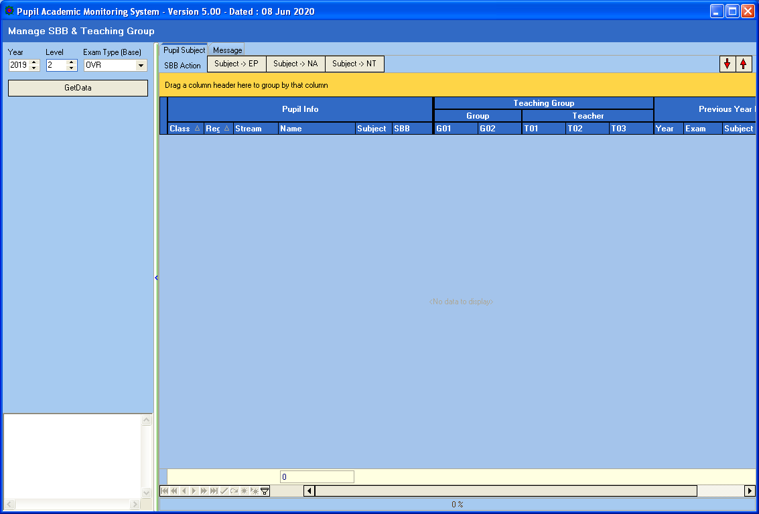

Steps
- Select Year
- Select Level
- Select Exam Type (Previous Year Results)
- Click Get Data button

Features
The grid on the right panel has features like Sorting, Filtering and Pivoting

Manage SBB

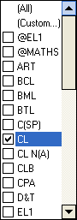
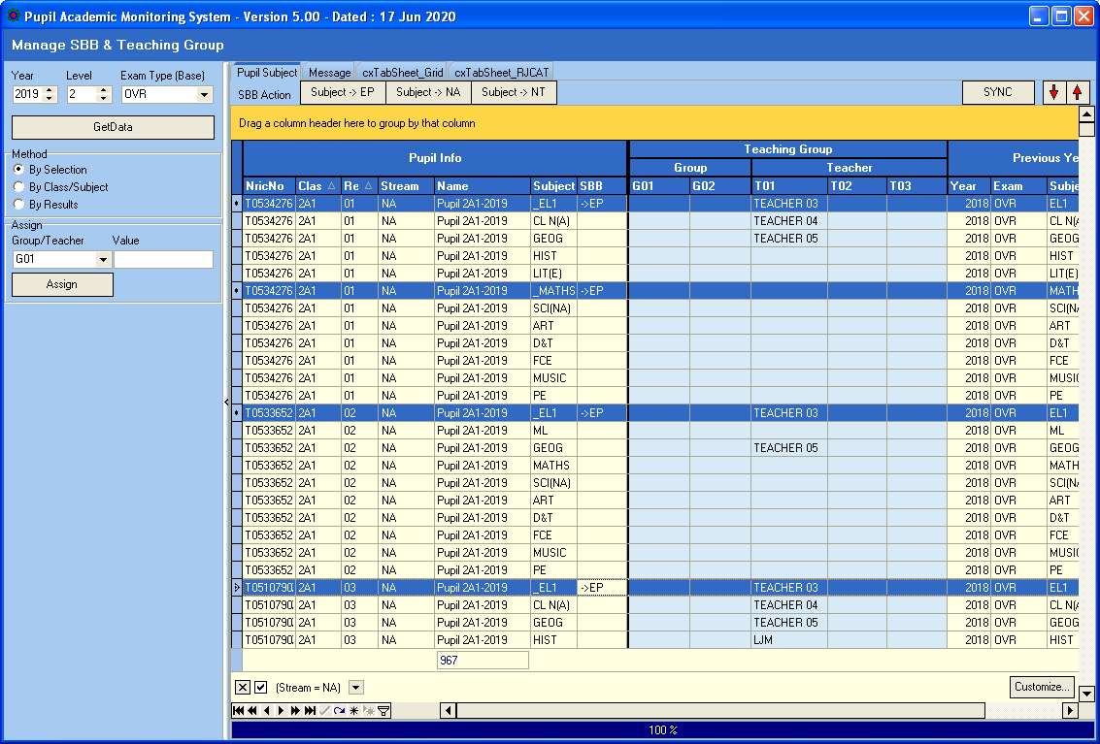
Drag any column to the Orange Panel to Pivot (Group) by the Column.
Move Cursor to column to Filter.
Previous Year Subject and Results

Updating SBB Subject

Move Cursor to column to Filter.

Steps
- Click Student (CTRL+Click)
- Click SBB Action Button (e.g. Subject->EP)

Update Teaching Group/ Teachers
Most of the teaching group will be assigned during the “Load SBB & Teaching Group”.
However, if you need to change any record manually, you can do it here.

By Selection

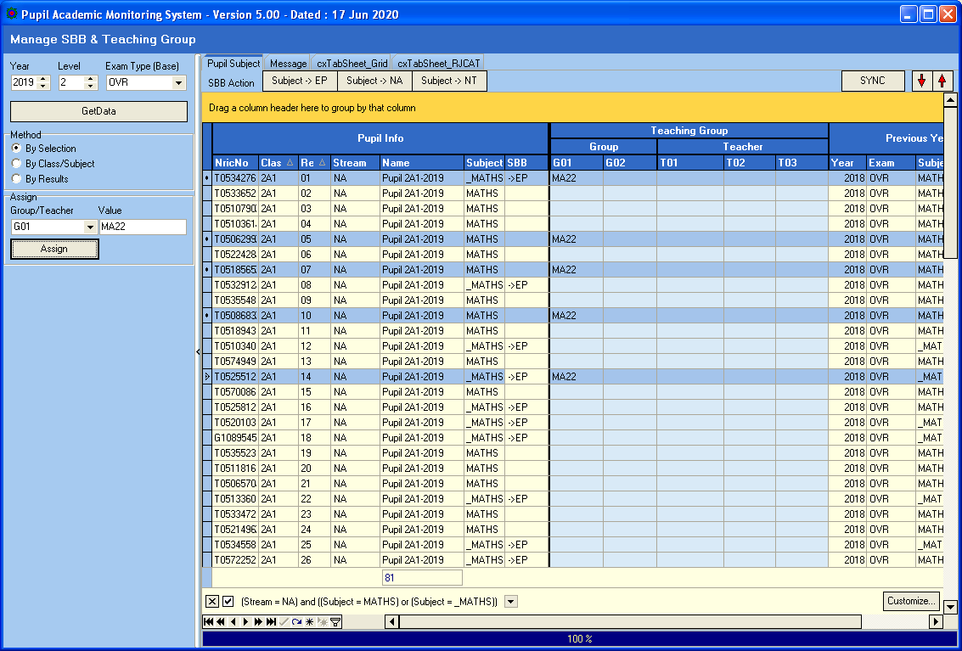

Steps
- Click Method – By Selection
- Select Assign Group/Teacher (G01, G02, T01, T02 or T03)
- Enter the Value
- Select Students (Use CTRL+Click)
- Click Assign Button

By Class/Subject

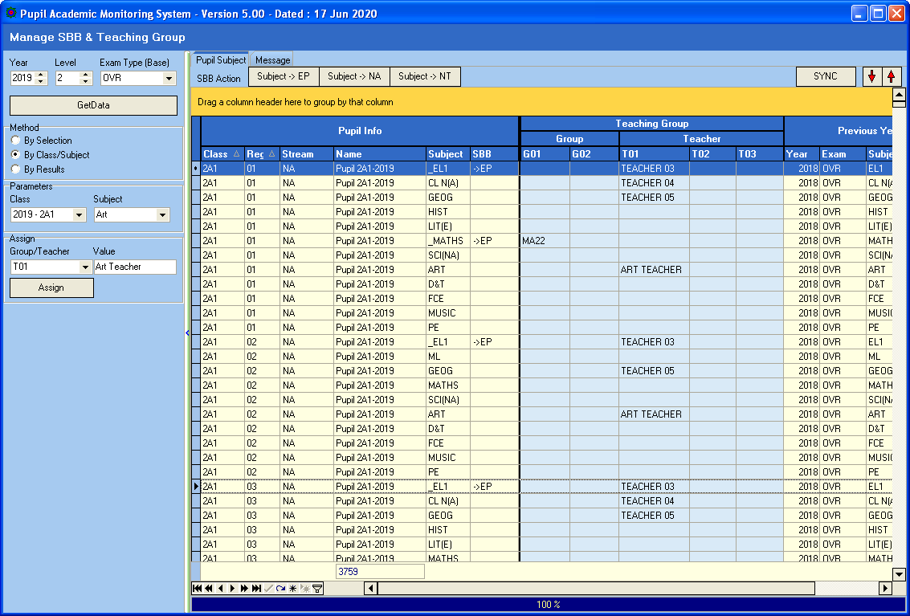

Steps
- Click Method – By Class/Subject
- Select Class and Subject
- Select Assign Group/Teacher (G01, G02, T01, T02 or T03)
- Enter the Value (e.g. Art Teacher)
- Click Assign Button

By Results

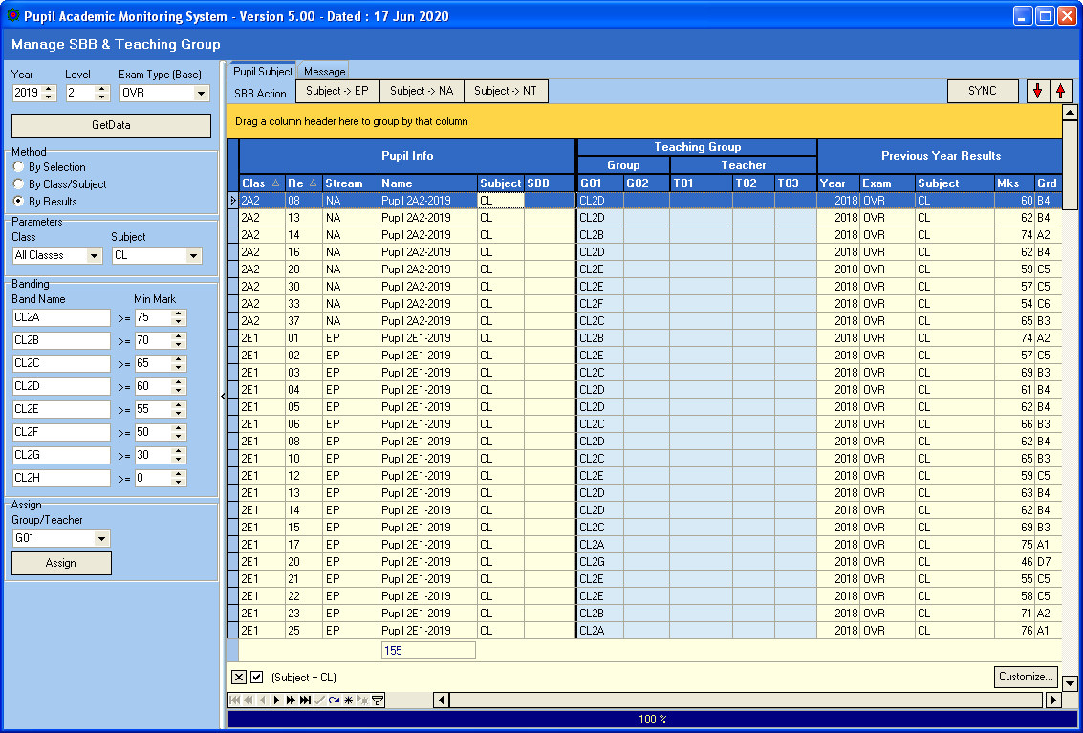
Click SYNC once you have finished updating all the teachers.

Steps
- Click Method – By Results
- Select Class and Subject
- Assign Band Names
- Select Assign Group/Teacher (G01, G02, T01, T02 or T03)
- Enter the Value
- Click Assign Button

Once you have finished Assigning Teachers, you will need to click SYNC to Update to Class-Subject Teachers. This will take quite a while.

Review Summary

You can GROUP, FILTERED and SORT to review the Allocation summary
GROUP
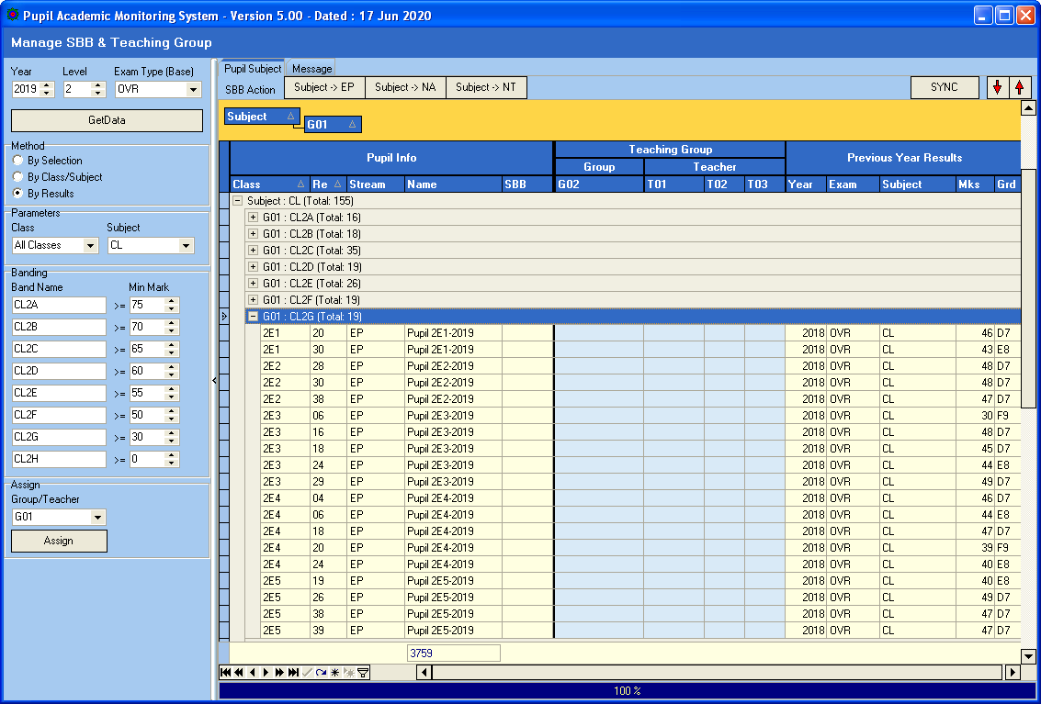
Expand and Collapse

Manage Pupil Group
You may assign Groups (Up to 3 Groups) to Pupils regardless of Subjects offered to them. These Groups will remain with them throughout all the years. For example: DSA, Scholars etc.

Menu Access: System Admin Menu || Manage Pupil Group

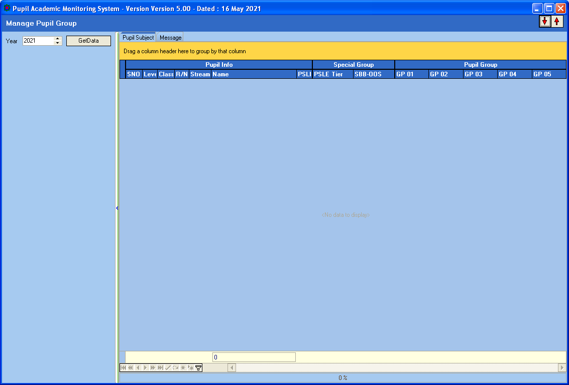

Steps
- Select Year
- Click Get Data button

Assigning PSLE Tier
Now you can assign Pupils to PSLE Tiers Group according to their PSLE T/Scores or AL Scores. PAMS can analyze based on this Group. For example, Top PSLE Tier students who have not performed well.

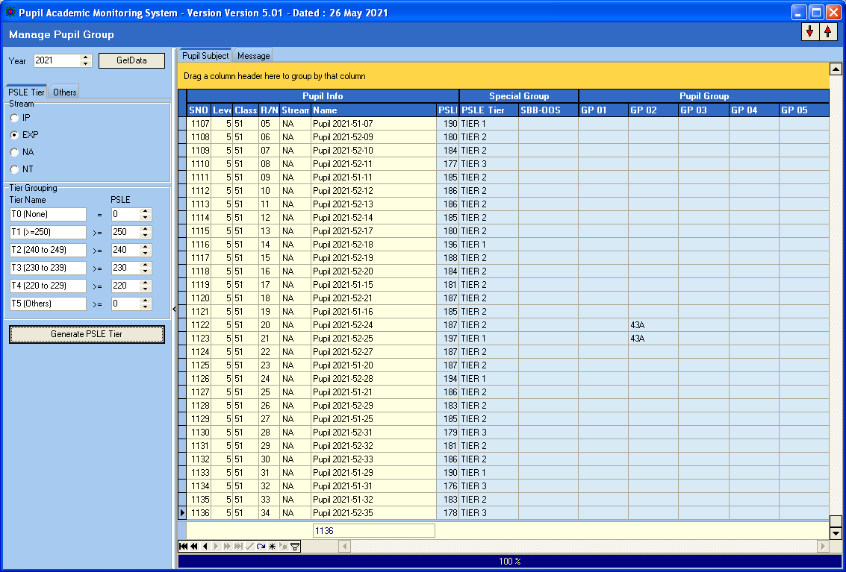
Click Generate PSLE Tier

Steps
- Select Stream
- Enter the Tier Name and PSLE Value
- Click Generate PSLE Tier

Assigning SBB/OOS Count
Now you can assign Pupils SBB/OOS group based on the Number of SBB or OOS Subjects Offered. PAMS can analyze based on this Group. For example, students with 2 OOS who have not performed well.

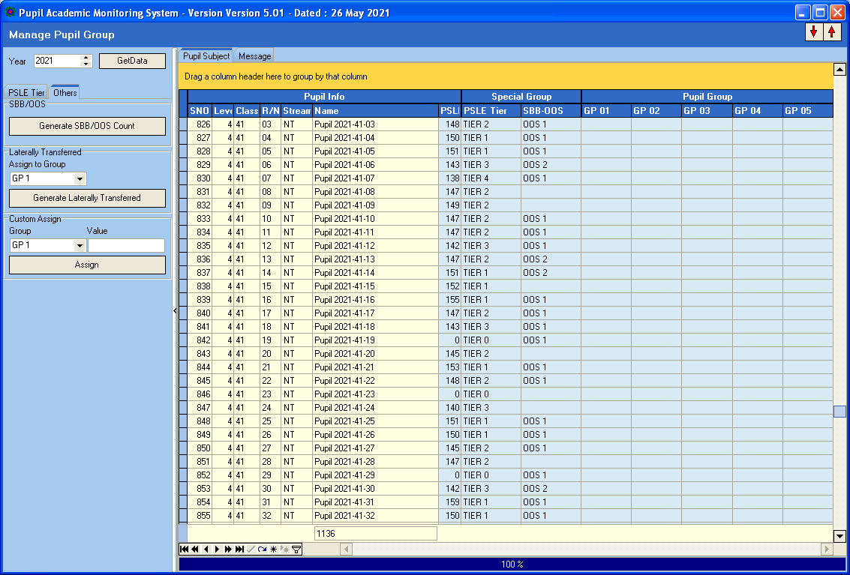
Click Generate SBB/OOS Count

Steps
- Click Generate SBB/OOS Count

Assigning Laterally Transferred
Now you can assign Pupils who are Laterally Transferred and Analyze them.

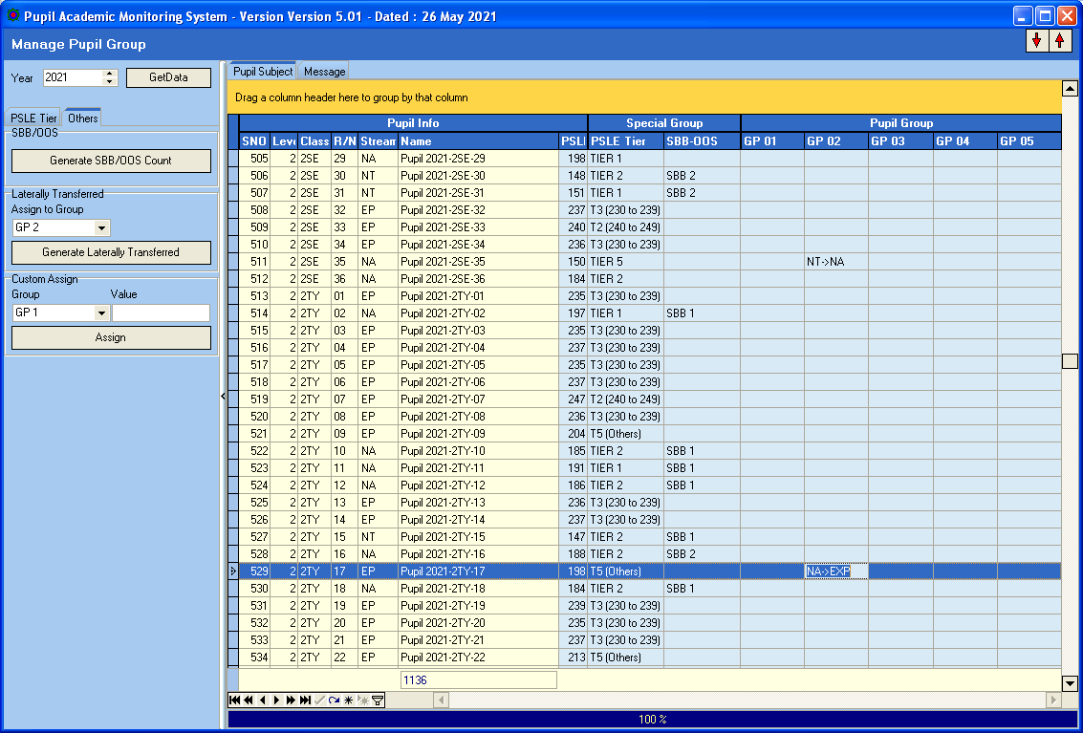
Click Generate Laterally Transferred
Steps
- Select Group No to Assign to
- Click Generate Laterally Transferred

Assigning Group
In Addition, you can assign Pupils to Various Group (Up to 5 Groups) which you can analyze later.
For example: Learning Ability Group, DSA, Scholars etc.

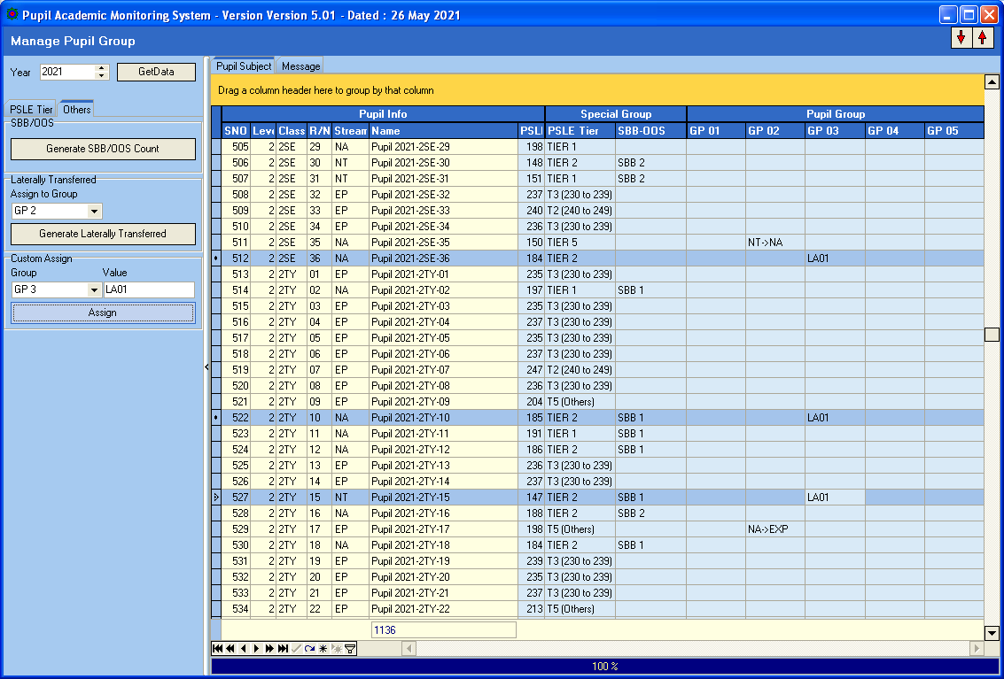
Click Assign
Steps
- Select Assign Group (G01, G02, G03, G04 or Gp5)
- Enter the Value
- Select Students (Use CTRL+Click)
- Click Assign Button

Check Subject Allocation List
After you have converted, you will need to check the subject allocated to the students to ensure that the allocation is correct and complete. You may print a copy to get the students to check.

Menu Access: Main Menu || Print Reports

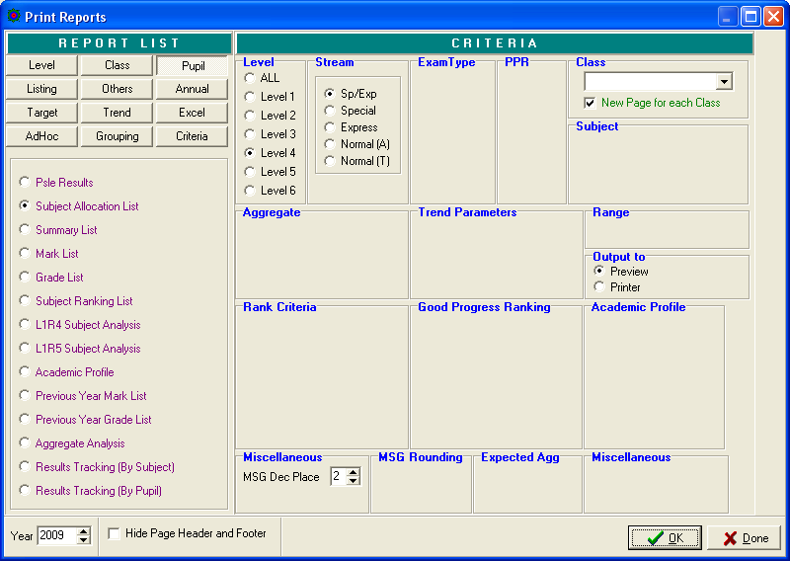

Steps
- Select Pupil Tab
- Select Subject Allocation List
- Select Criteria (Level and Stream)
- Click OK Button

Check Subject Grading Scheme

Menu Access: System Admin Menu || Subject Grading Scheme

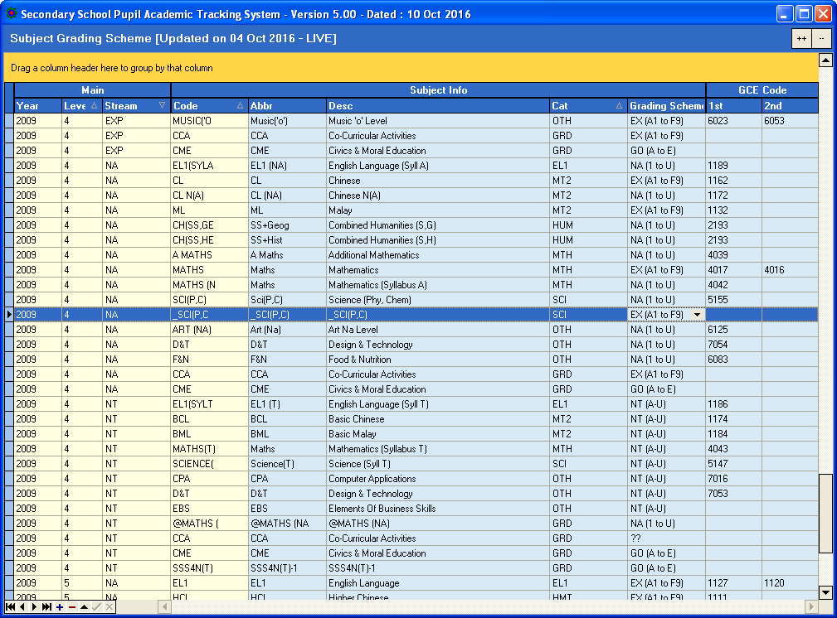
This is NA
This is Express

Steps
- Select Subject
- Check the Cat (Category) and Grading Scheme especially for Cross-Stream Subjects and the necessary changes accordingly
- Click another record to save

Convert Cockpit Data
You only need to export the following files from School Cockpit:
- Pupil (Text File)
- ExDet (CSV File)
Menu Access: System Admin Menu || Convert Cockpit (New Framework)

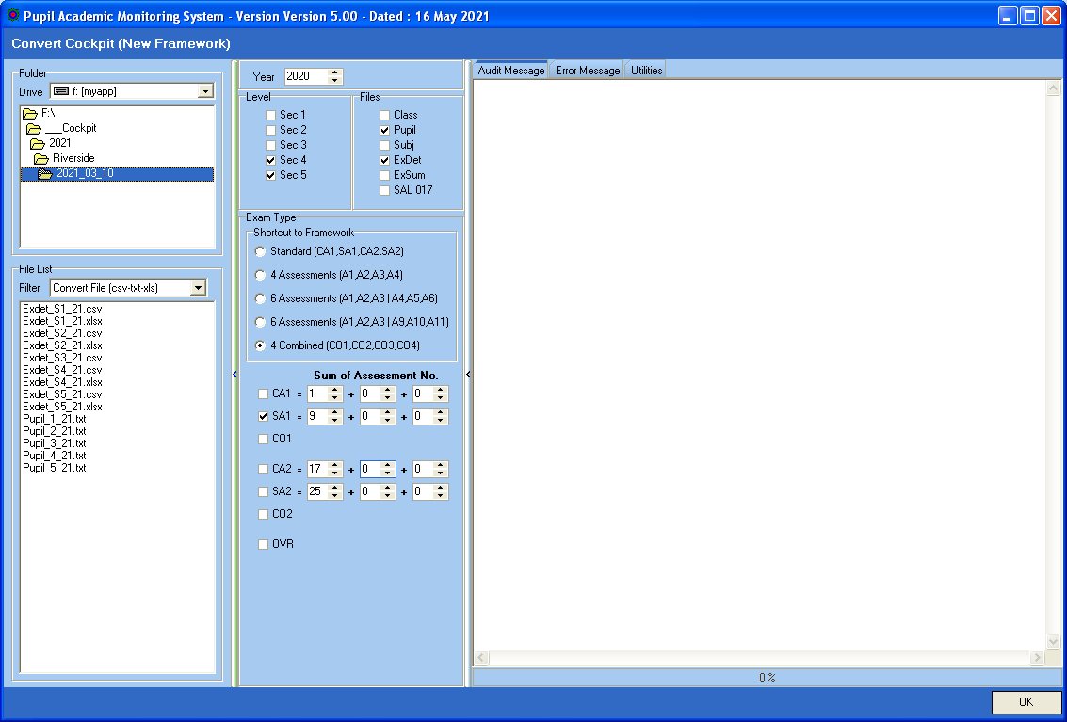
Enter the correct Assessment Number for CA1, SA1, CA2 and SA2.

Steps
- Select your Directory where you stored your Cockpit Text Files
- Select Level
- Select the Files to be Converted
- Select the Exam Type to convert and enter the correct Assessment No.
- Click OK Button

Process Results

Menu Access: System Admin Menu || Process Results

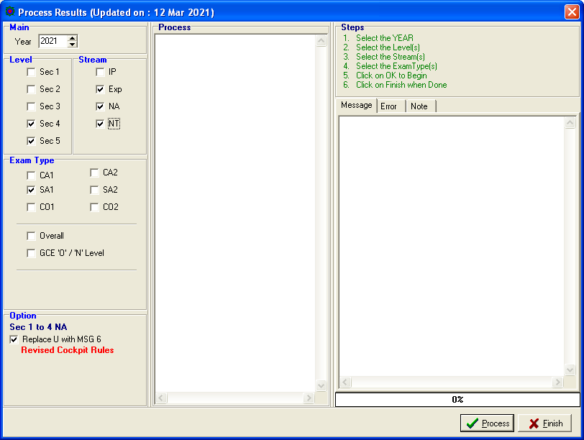

Steps
- Select Level and Stream
- Select ExamType
- Click Process Button

Note: You may check the Results via VIEW Results.

Print Reports

There are some key reports which are informative.

Level Analysis

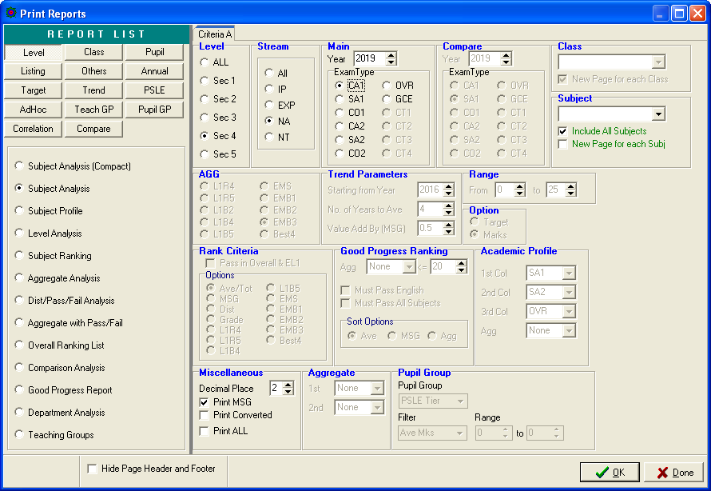

Sample
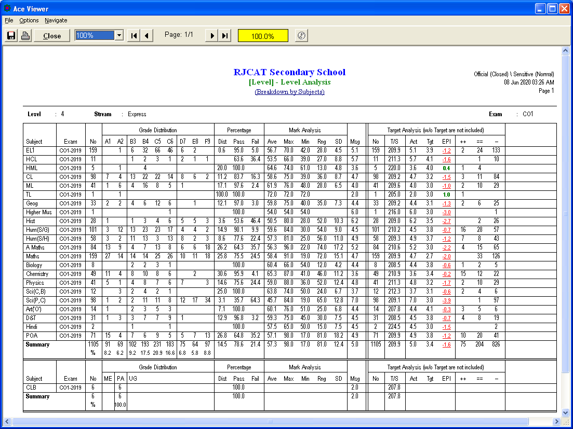
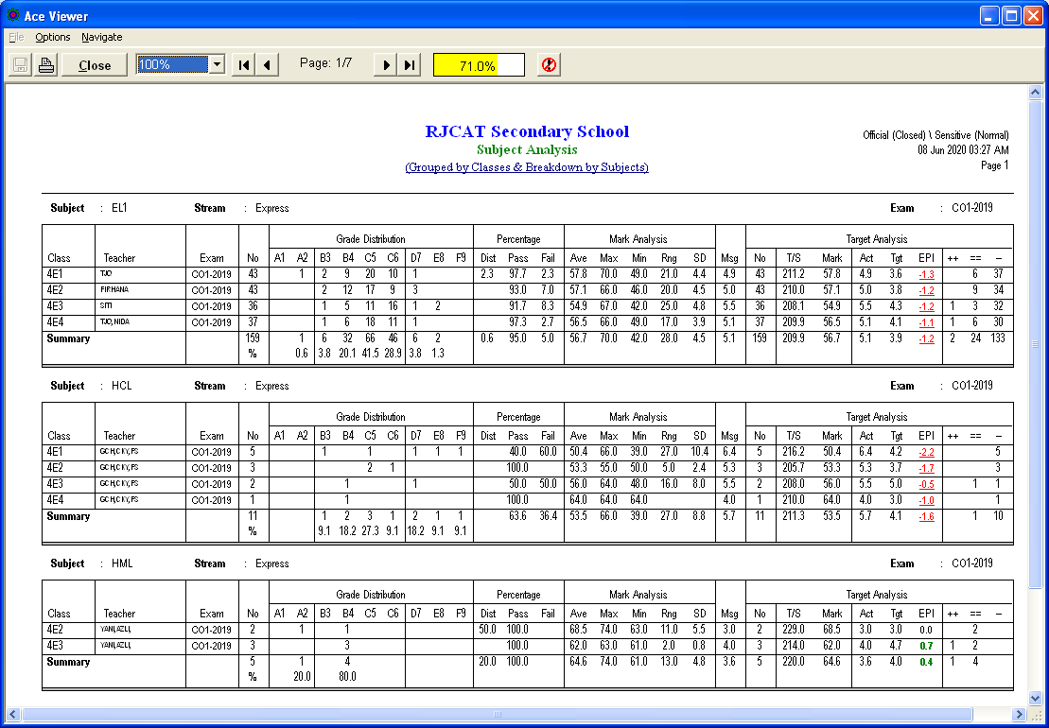

Class Analysis

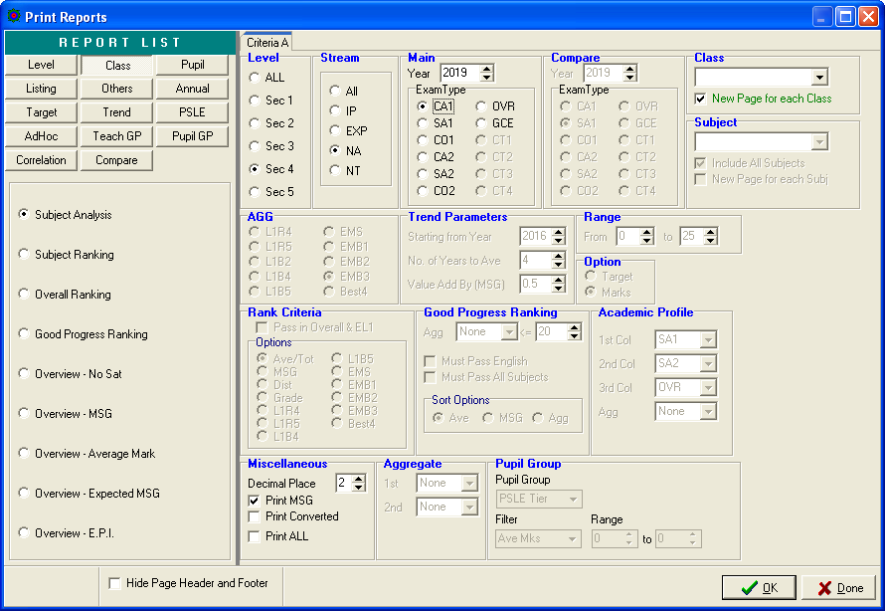

Listing

Students who did not meet targets

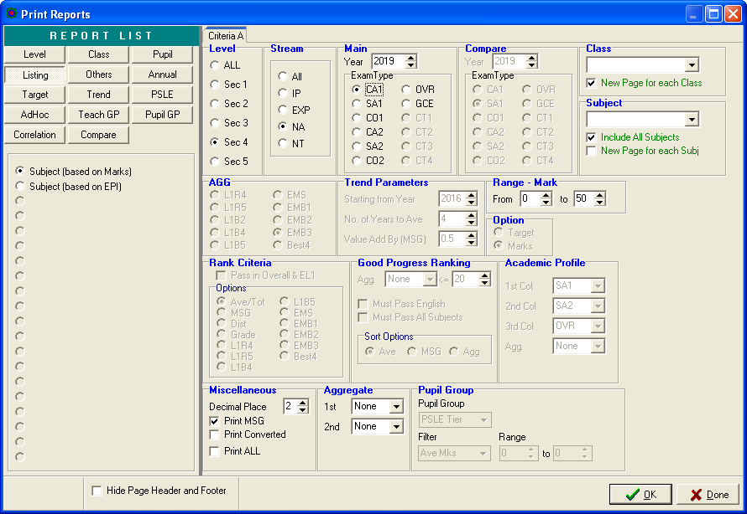

Teach Gp (NEW)
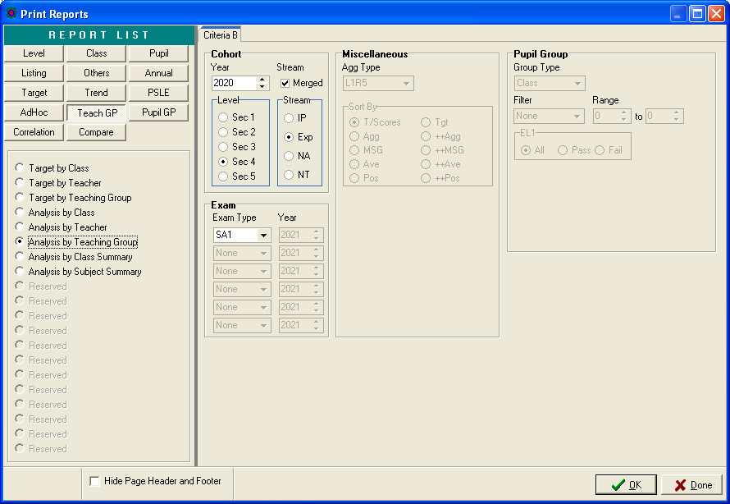

Sample
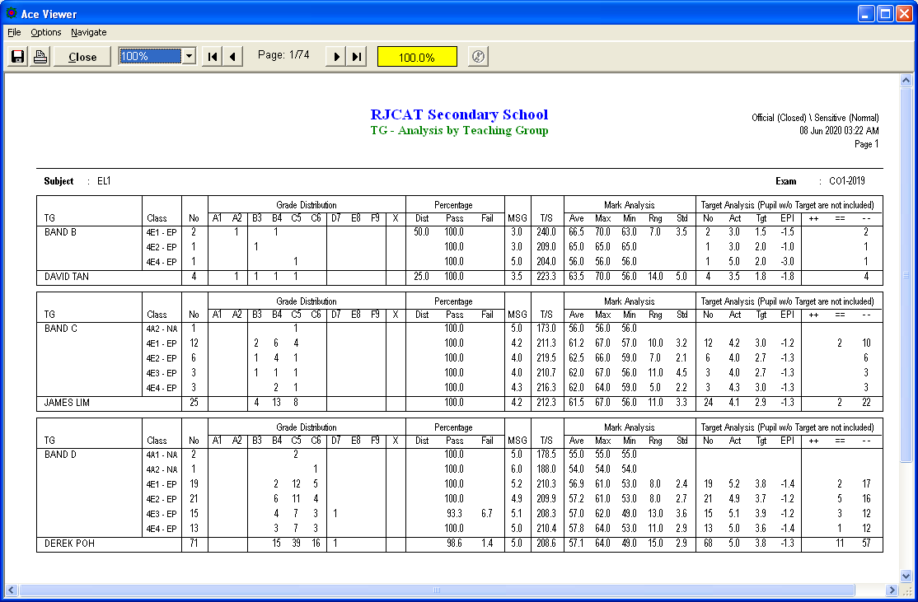

Pupil GP (NEW)
This is a new set of reports. You can analyze by PSLE Tier, OOS/SBB, Pupil Groups defined and Class.
In addition, you can filter out students based on criteria such as AVE Mks, EPI, Subject Passes, Aggregate etc.

For example:
Top Students (PSLE Tier) with L1R5 Greater than 20 (as illustrate below)

Please explore ….

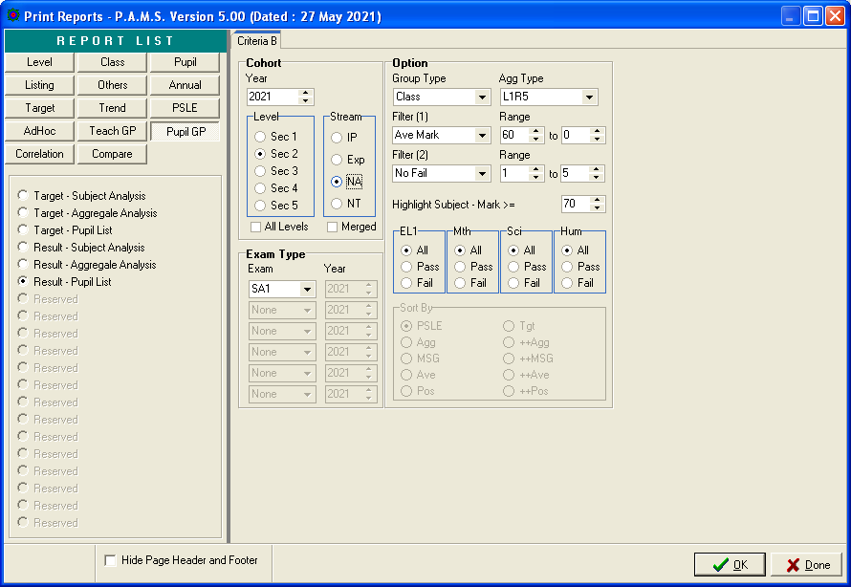
Different possible combinations

Hints:
For SBB Insert
- Filter (1) Ave Mks>60
- Highlight Subject Mark >=70

Correlation (Revised)
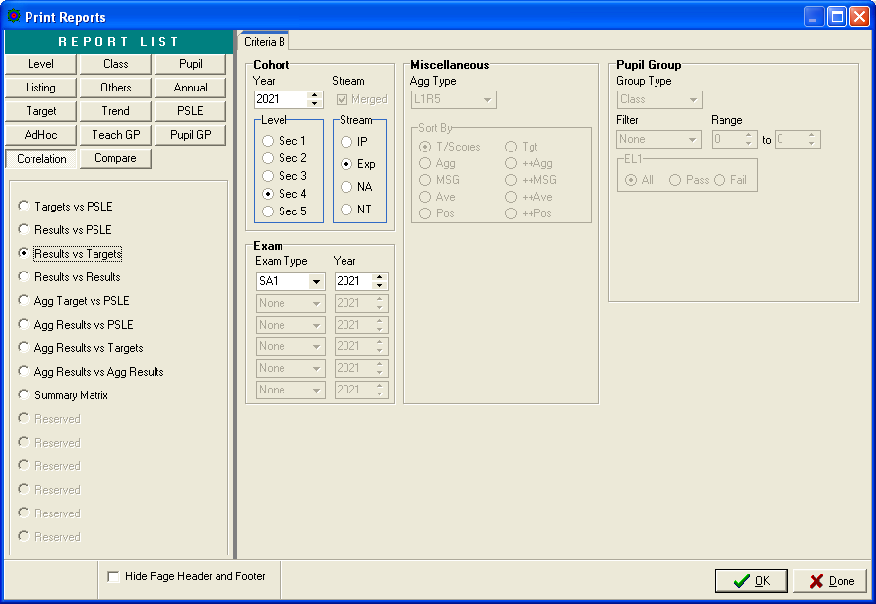

Sample
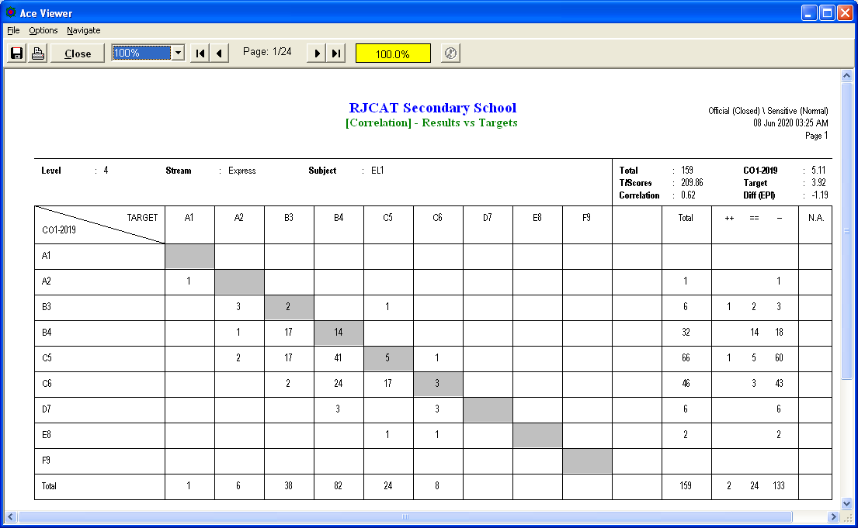

Compare (Revised)

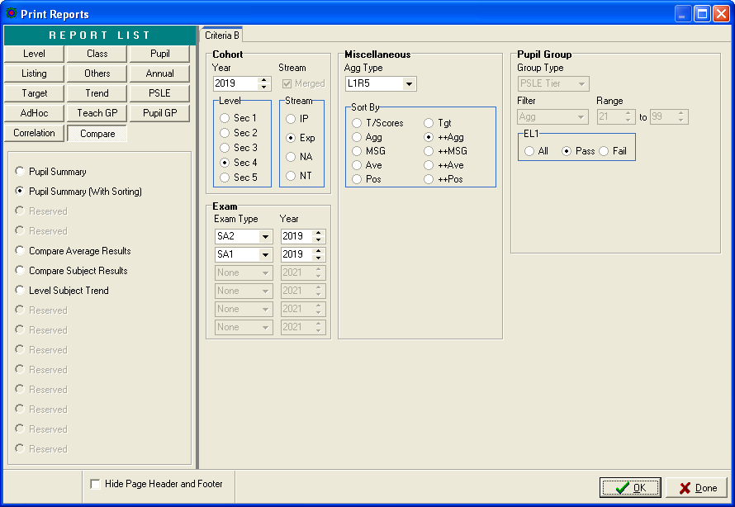

Best Performance based on L1R5

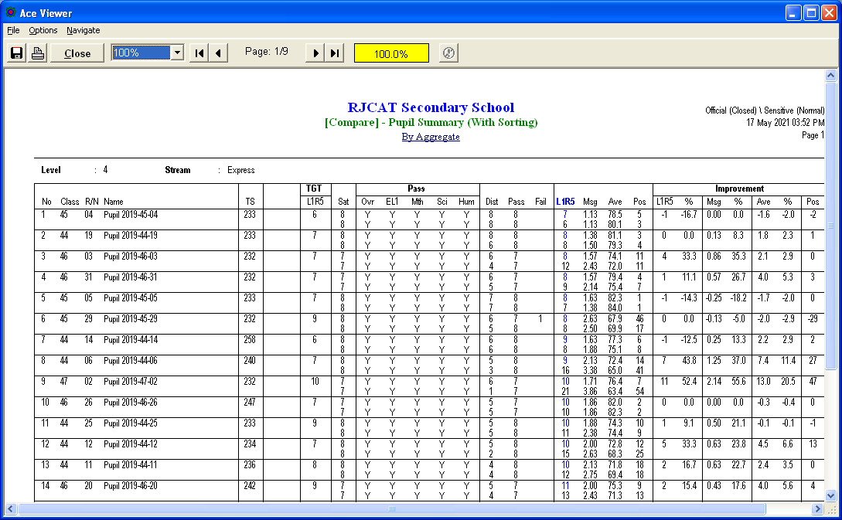

Most Improvement based on L1R5

