PUPIL ACADEMIC MONITORING SYSTEM

User Guide
Analyzing Results

(Updated on 30 Mar 2024)

Contents

Work Flow 1
Cockpit Files Needed 2
File Naming Convention 6
Convert Cockpit Data – SDT006 7
Convert Cockpit Data – PPS010 8
Convert Cockpit Data – SAL017 9
Convert Cockpit Data – RES090 10
Load Subject Teaching Group 11
Manage Teaching Group 12
Features 13
Updating SBB Subject 14
Update Teaching Group/ Teachers 15
Manage Pupil Group 19
Assigning PSLE Tier 20
Assigning SBB/OOS Count 21
Assigning Laterally Transferred 22
Assigning Group 23
Load Subject Teachers’ Name 24
Check and Verify Subject Combination 25
Check and Verify Subject Info 26
Print Trend Report 27
3-Year Trend Overall Results 28
3-Year Trend Aggregate (L1B5) 28
Setup Aggregate Target (AL) 29
Target Setting by Aggregate (Using Previous Year Results) 31
Check Prev Subjects 32
Subject Mapping 34
Target Option 35
Target Generated 36
Setup Aggregate Target Based on T-Scores 37
Manage SBB/OOS Qualifier 40
Print SBB/OOS Qualifier 43
Print Target Reports 45
Verify Generated Targets 46
Exam Label 47
Analyzing Results 48
Verify Converted Results 49
Process Results 50

Work Flow

Part 1 – Jan, Feb
To prepare PAMS for Target Setting
- Convert Cockpit Data
- Convert and Manage SBB and Teaching Group
- Check Subject Pairing and Grading Scheme
- Setup Aggregate Target

Part 2 – Mar, May, Aug, Sep, Oct
To Analyzing Results (WAs, MYE, EYE, PRELIM)
- Convert Cockpit Data (with Exam Results)
- Process Results
- Print Reports

Part 3 – Dec, Jan (next year)
To Analyzing Results (GCE “N” and “O”)
- Convert GCE Text Files (I-EXAM)
- Process Results
- Print Reports

Cockpit Files Needed
While waiting for SAL017 and RES078 from Cockpit, PAMS will explore using these 4 files:
- RE_SDT_006 (Class Registration File) - Basic student Info
- RE_PPS_010 (Posting) - PSLE Results
- RE_RES_090 (Component Mark Sheet) – Subject Offered to students. It also include Subject Teaching Group and Subject Teachers (Subject Teachers at the moment are still not correct)
- RE_SDT_009 (Teaching Group) – There will be many files (Not crucial for now). If RE_RES_090 are correct, then these files may not be needed.
- RE_TMT_010 (Teaching Assignment) – If RE_RES_090 are correct, then this file may not be needed.

1. RE_SDT_006 (Class Registration File)
This is the main File and MUST be converted first.
Keep Column A to Q, BM to BO. Column R to BL will not be needed. You may blank out the “confidential data” such as parents/guardian info, but DO NOT DELETES any columns.

Column |  | Header | Remark
1 | A | S/N | Registration Number
2 | B | Class
3 | C | Class Name
4 | D | Form Teacher | As there may be more than 1 Form Teacher, this field will be ignore
5 | E | Student Name
6 | F | Hanyu Pinyin Name | Ignore
7 | G | Chinese Name | Ignore
8 | H | Sex
9 | I | Stream | Ignore
10 | J | Admission No. | This will be unique and will determine who the student is
11 | K | NRIC/FIN/UIN | Masked. We will not use this anymore
12 | L | ID Type
13 | M | Age on 1-Jan
14 | N | DOB
15 | O | Place of Birth
16 | P | Citizenship
17 | Q | Race
65 | BM | School Admitted From/  Previous Class | May need this field to identify the primary school for sec 1

2. RE_PPS_010 (S1 Posting File)
This is the PSLE Results. Selected Columns will be used. But do not delete any columns.

Column |  | Header | Remark
4 | D | Name
11 | K | PSLE Aggregates
22 | V | L1 Grade
23 | W | L2 Grade
24 | X | Science Grade
25 | Y | Math Grade

3. RE_SAL_017 (Subject Combination)
All columns will be used. This is a very complicated Excel File.

Column |  | Header | Remark
1 | A | Reg# | Registration Number
2 | B | Name
3 | C | Mask NricNo
4 | D | Sex
5 | E | Level
6 | F | Civics Group
7 | G | Subject List | “Verification” will be the indicator for END of RECORD

4. RE_RES_090 (Component Mark Sheet)
This will be temporarily used until RES_SAL017 and RE_RES_078 are available.
All columns will be used. This is a very complicated Excel File (Still have errors…though).

Column |  | Header | Remark
1 | A | Reg# | Registration Number
2 | B | Name
3 | C | Sex
4 | D | Form Teacher | As there may be more than 1 Form Teacher, this field will be ignore
5 | E | Class
6 | F | Teaching Group | If this is correct, then RE_SDT_009 may not be needed
7 | G | CMT
8 | H | Weightings, Base Mark, L3 | Ignore
9 | I | Subject/Subject Teacher

5. RE_RES_078 (Mark Sheet)
All columns will be used.

Column |  | Header | Remark
1 | A | Reg# | Registration Number
2 | B | Name
3 | C | Class
4 | D | Form Teacher
5 | E | Sex
6 | F | CMT | Ignore
7 | G | L3 | Ignore
8 | H | Age | Ignore
9 | I | Nationality
10 | J | GEP Indicator
11 | K | 1st Subject | Exam1, Exam 2 …depend on what you include in the Export
12

6. RE_SDT_009 (Teaching Group)
This is the teaching group files. There will be many files. One file per cohort per subject.
From now on, all analysis will be in teaching groups
These files can be converted later just before the analysis is needed.

Column |  | Header | Remark
1 | A | S.No. | Registration Number
2 | B | Name
3 | C | Gender
4 | D | Class
5 | E | Stream
6 | F | Teaching Group Stream
7 | G | Teaching Group Subject
8 | H | Teaching Group
9 | I | CMT
10 | J | MT

7. RE_TMT_010 (Teaching Assignment)
This is the teaching assignment (Subjects, Teaching Groups and Teachers). There is only 1 file for the whole school. This file can be converted later just before the analysis is needed.

Column |  | Header | Remark
1 | A | Level
2 | B | Class/Teaching Group
3 | C | Subject
4 | D | Subject Level
5 | E | Teacher Name
6 | F | NRIC/FIN/UIN | Mask

Note:
If you need assistance to do the conversion, please send the following info to me:
- PAMS Database (Zip up all the files under C:\APPS\RJCAT\PAMS2000\DATABASE)
- RE_SDT_006 - Class Registration File
- RE_PPS_010 - Posting File
- RE_RES_090 - Component Mark Sheet
- RE_RES_078 - Mark Sheet
- RE_SDT_009 - Teaching Group
- RE_TMT_010 - Teaching Assignment

File Naming Convention
The File naming convention is as followed:

SN | Cockpit Files | Remark | File name Convention
1 | RE_SDT_006.xlsx | This file contains the basic pupil Info. | RE_SDT_006_S1_24.xlsx  ..  RE_SDT_006_S5_24.xlsx
2 | RE_RES_090.xlsx | This file contains the Subject pupil are offered and Teaching Group, Subject Teachers and Results.  It this file is OK (No error), then we may not need RE_SAL_017 and RE_RES_078. | RE_RES_090_S1_24.xlsx  ..  RE_RES_090_S5_24.xlsx
3 | RE_PPS_010.xlsx | This file contains the PSLE Results. PAMS will only load the PSLE Results. Only Sec one need to be loaded. | RE_PPS_010_S1_24.xlsx
4 | RE_SDT_009.xlsx | This file contains the Subject Teaching Group Assignment. The will be a lot of files. One file for each Level and Subject.  Export by Teaching Group. Not by Class | Any name is fine.  Can follow G1, G2, G3 format.  RE_SDT_009_S1_24_G1EL  RE_SDT_009_S2_24_G2CL  RE_SDT_009_S3_24_G3SSGEOG
5 | RE_TMT_010.xlsx | This file contains the Teacher Teaching Assignment. Only one file for the whole school. | RE_TMT_010_24.xlsx
6 | RE_SAL_017.xlsx | This file contains the Subjects Pupils are offered. | RE_SAL_017_S1_24.xlsx  RE_SAL_017_S2_24.xlsx  RE_SAL_017_S3_24.xlsx  RE_SAL_017_S4_24.xlsx  RE_SAL_017_S5_24.xlsx
7 | RE_RES_078.xlsx | This file contains the Results. You should export all the Exam Types (T1WA, MYE, T2WA, EYE, SEM1, Sem2, Overall)  Note: The Export is by Level and Stream. So there will be 3 files for each level:  E – Express  A – Normal (A)  T – Normal (T) | RE_RES_078_S1_24.xlsx  RE_RES_078_S1_24.xlsx  RE_RES_078_S1_24.xlsx  RE_RES_078_S2_24_EXP.xlsx  RE_RES_078_S2_24_NA.xlsx  RE_RES_078_S2_24_NT.xlsx
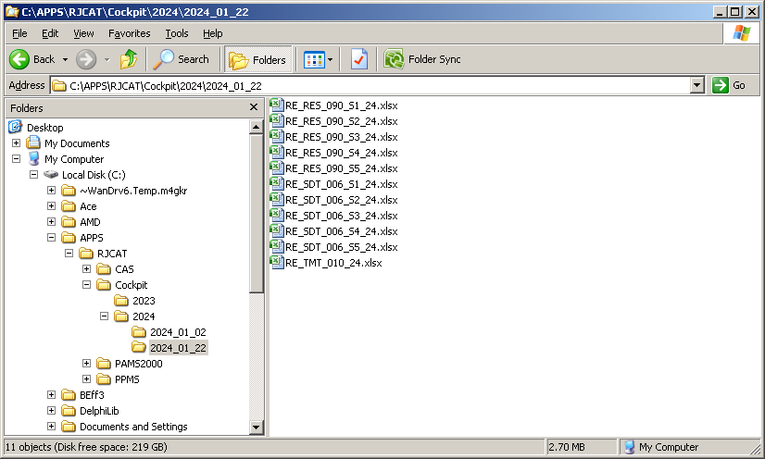
You may store the files anywhere in your PC.
But I will recommend somewhere that is easily located.
e.g. C:\APPS\RJCAT\PAMS2000\Cockpit\2024

Convert Cockpit Data – SDT006
Objective : Load Pupil basic info
Menu Access : System Admin Menu – Convert Cockpit Data

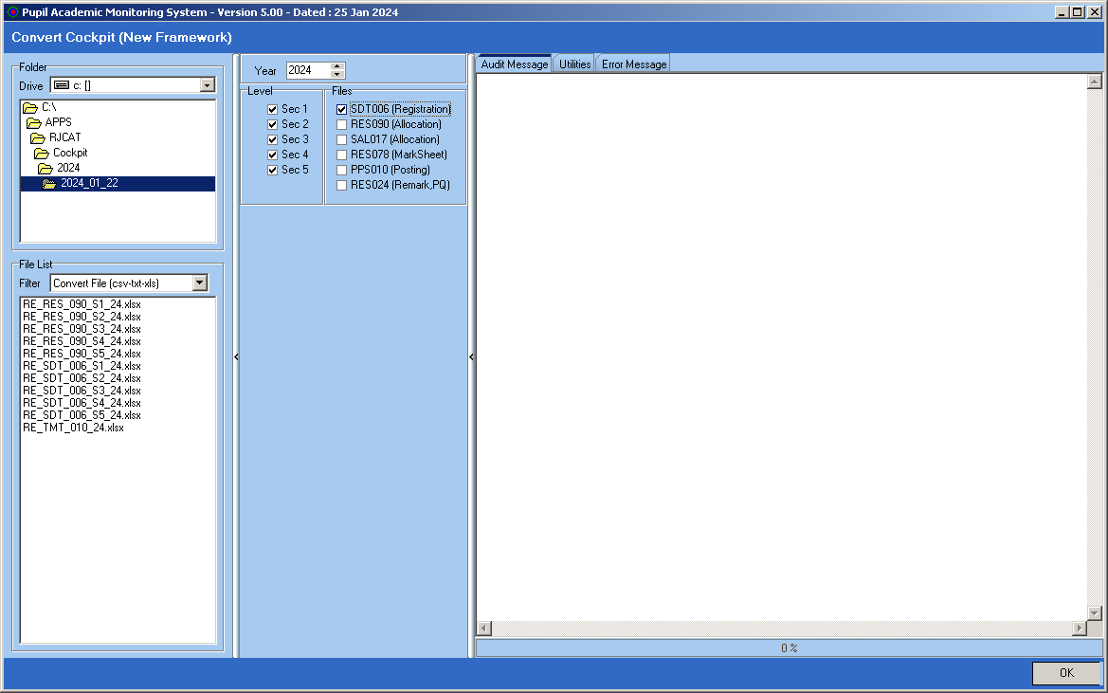

Steps
- Select the folder where you save the Cockpit Files
- Select the Levels
- Tick SDT006
- Click OK Button

Convert Cockpit Data – PPS010
Objective : Load Primary School Info and PSLE Results (For Sec 1 Only)
Menu Access : System Admin Menu – Convert Cockpit Data

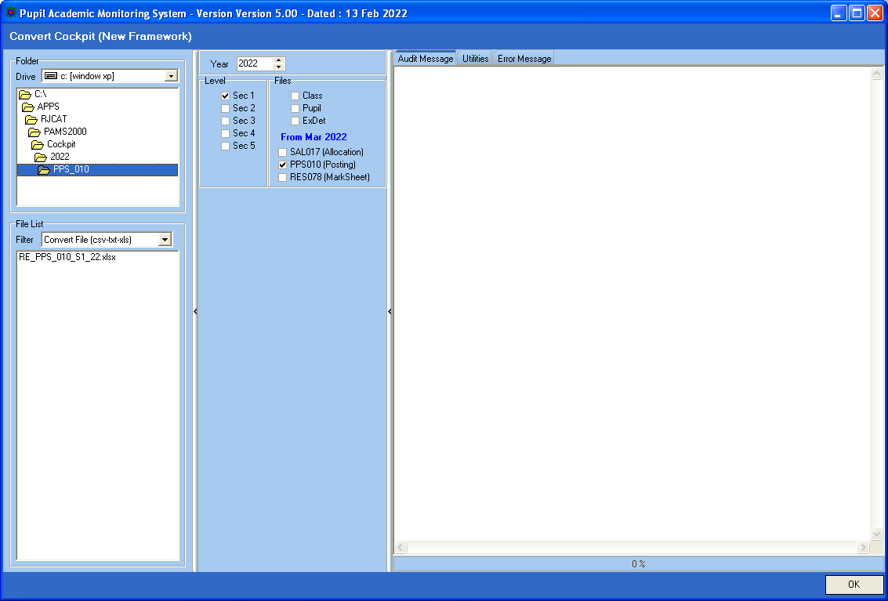

Steps
- Select the folder where you save the Cockpit PPS010 Files
- Select Sec 1
- Tick PPS010
- Click OK Button

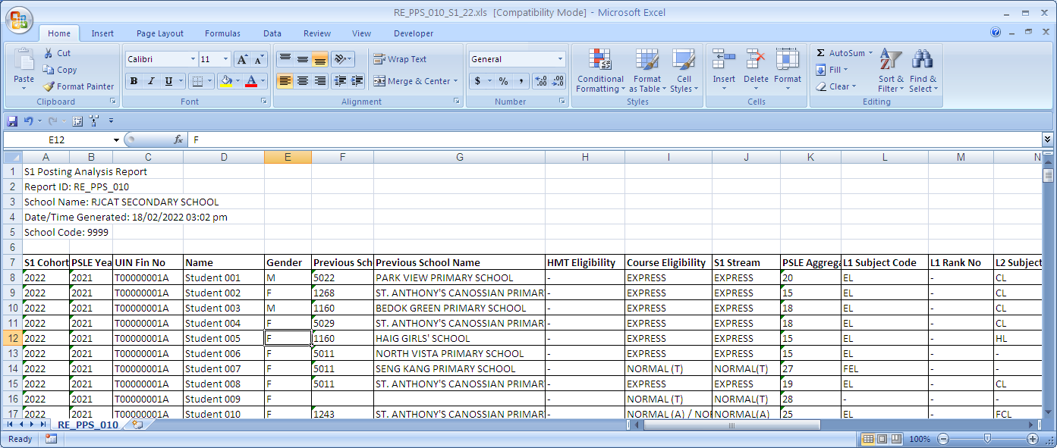

Convert Cockpit Data – SAL017
Objective : Load Pupil basic info
Menu Access : System Admin Menu – Convert Cockpit Data

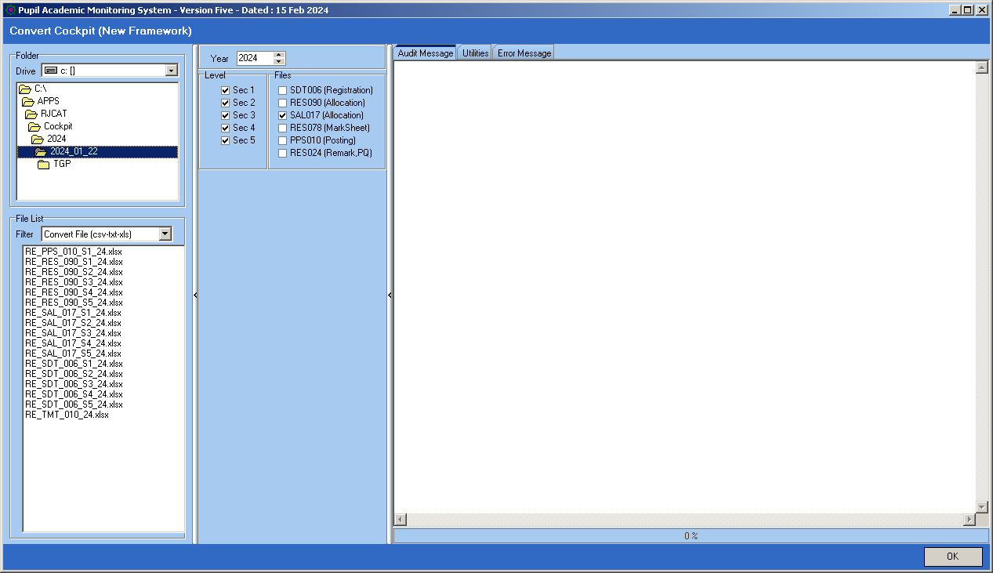

Steps
- Select the folder where you save the Cockpit Files
- Select the Levels
- Tick SAL017
- Click OK Button

Note: You either convert SAL017 or RES090 (RES090 includes Teaching Groups)

Convert Cockpit Data – RES090
Objective : Load Pupil Subject Offered
Menu Access : System Admin Menu – Convert Cockpit Data

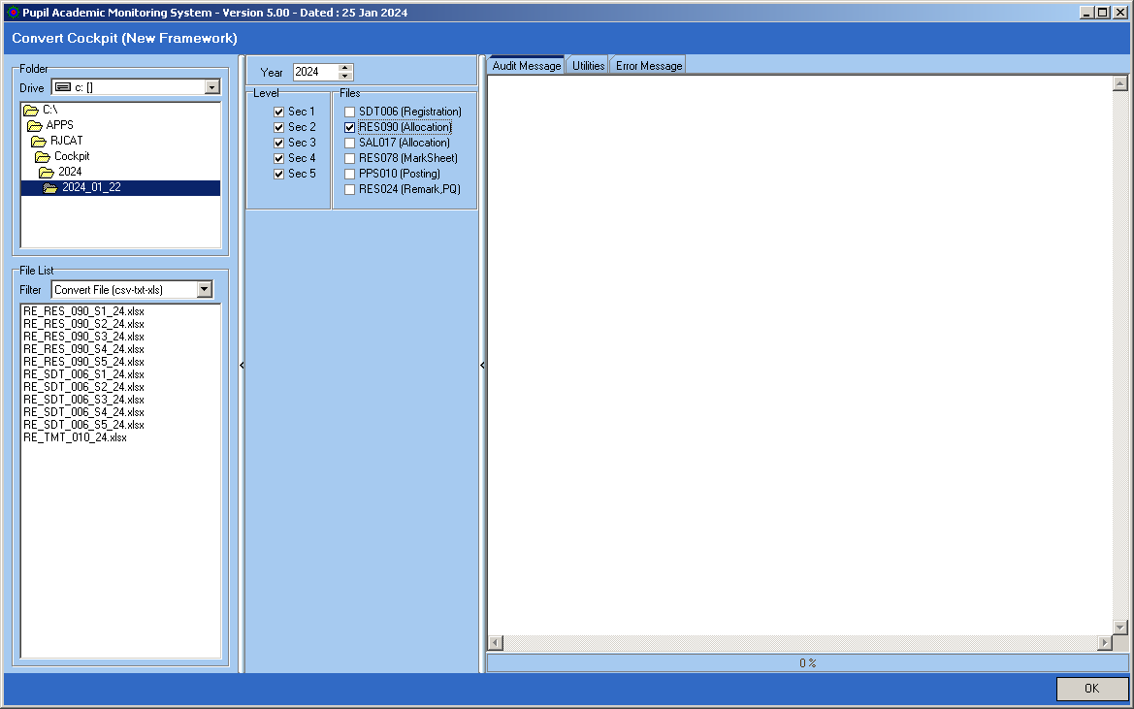

Steps
- Select the folder where you save the Cockpit Files
- Select the Levels
- Tick RES090
- Click OK Button

Note: You either convert SAL017 or RES090 (RES090 includes Teaching Groups)

Load Subject Teaching Group
Objective : To Load Subject Teaching Group Assign in Cockpit
Menu Access : System Admin Menu – Load Teaching Group

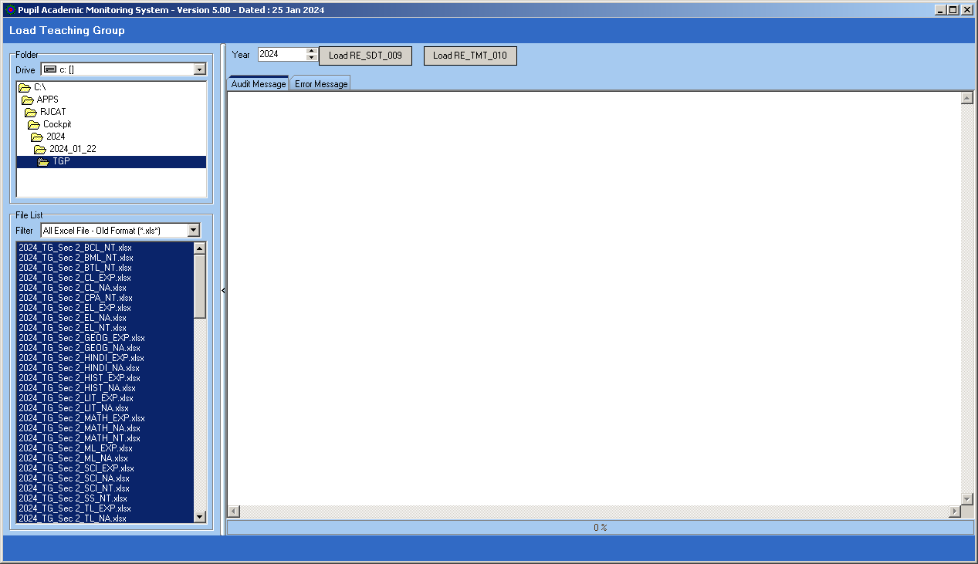

Steps
- Select the folder where you save the Cockpit Files
- Select the Files (Use Shift+Click)
- Click Load RE_SDT_009 Button

Manage Teaching Group
Most of the SBB and Teaching group are handled by the LOAD function. However, if you need to change manually, you may do so here.

Menu Access: System Admin Menu || Manage SBB & Teaching Group

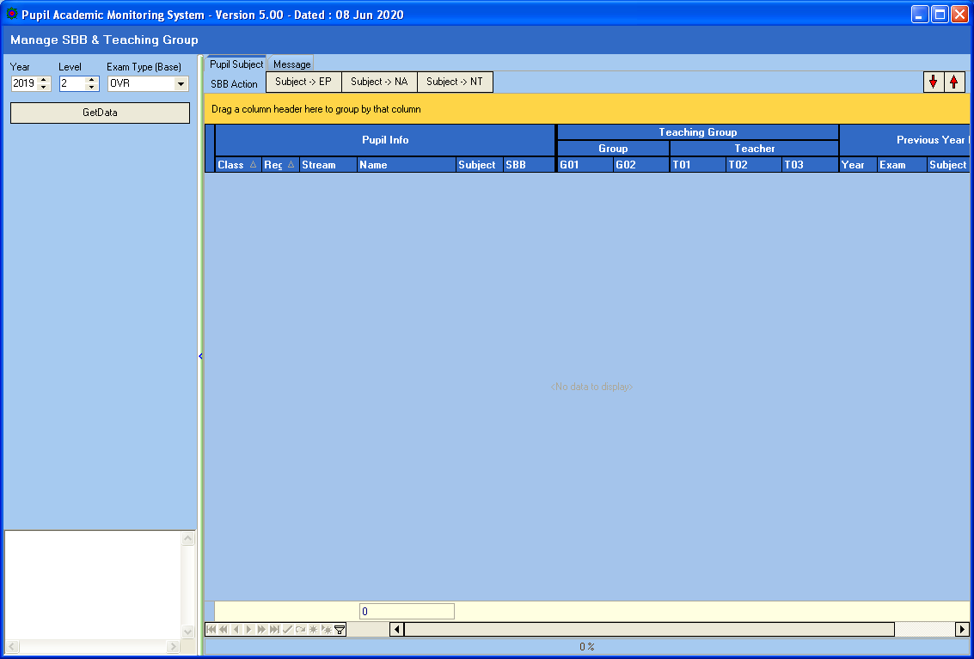

Steps
- Select Year
- Select Level
- Select Exam Type (Previous Year Results)
- Click Get Data button

Features
The grid on the right panel has features like Sorting, Filtering and Pivoting

Manage SBB

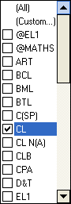
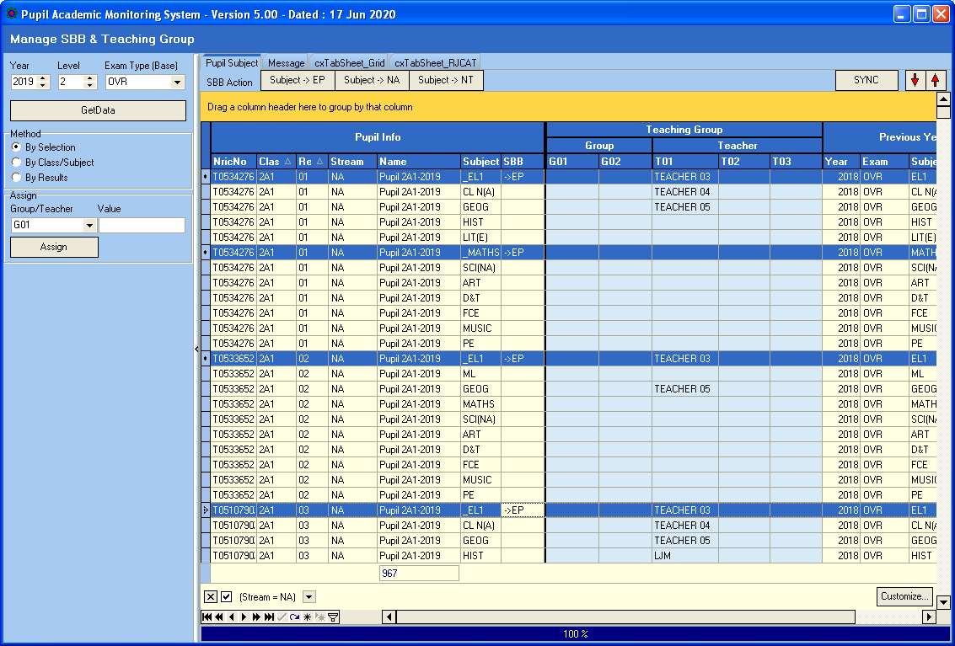
Drag any column to the Orange Panel to Pivot (Group) by the Column.
Move Cursor to column to Filter.
Previous Year Subject and Results

Updating SBB Subject

Move Cursor to column to Filter.

Steps
- Click Student (CTRL+Click)
- Click SBB Action Button (e.g. Subject->EP)

Update Teaching Group/ Teachers
Most of the teaching group will be assigned during the “Load SBB & Teaching Group”.
However, if you need to change any record manually, you can do it here.

By Selection

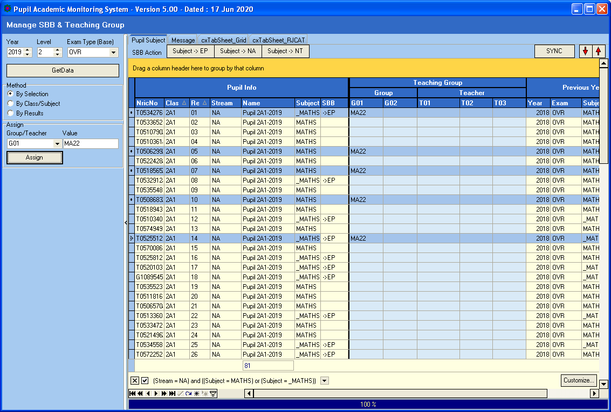

Steps
- Click Method – By Selection
- Select Assign Group/Teacher (G01, G02, T01, T02 or T03)
- Enter the Value
- Select Students (Use CTRL+Click)
- Click Assign Button

By Class/Subject

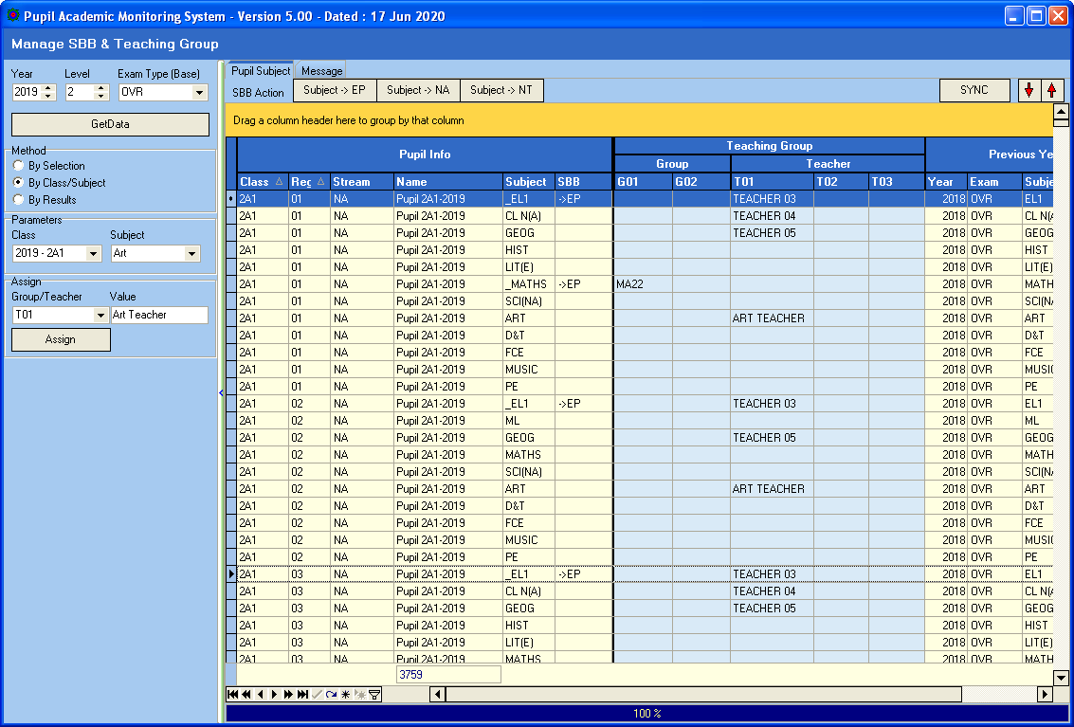

Steps
- Click Method – By Class/Subject
- Select Class and Subject
- Select Assign Group/Teacher (G01, G02, T01, T02 or T03)
- Enter the Value (e.g. Art Teacher)
- Click Assign Button

By Results

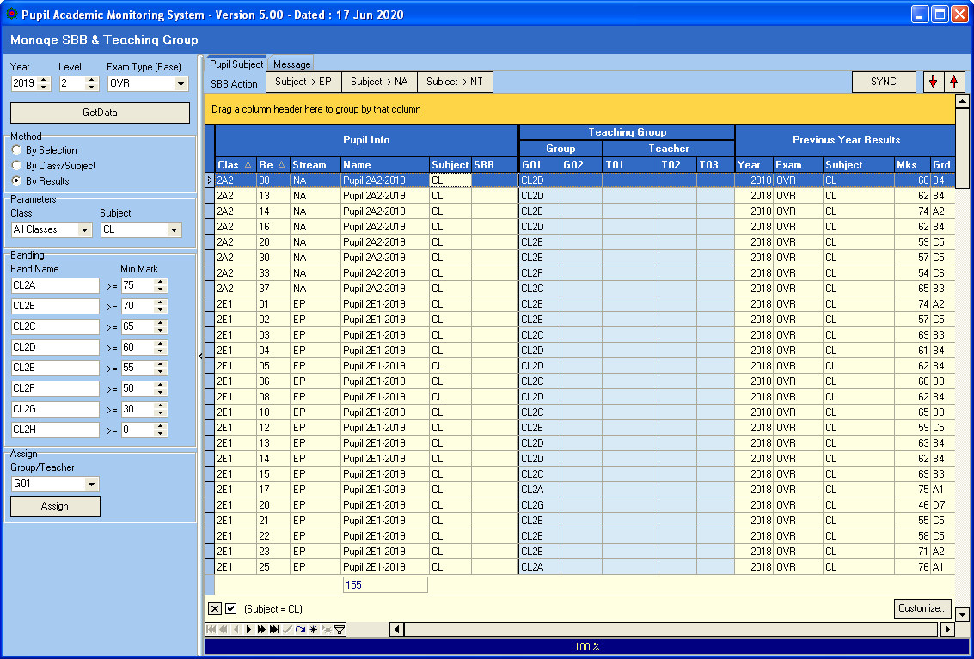
Click SYNC once you have finished updating all the teachers.

Steps
- Click Method – By Results
- Select Class and Subject
- Assign Band Names
- Select Assign Group/Teacher (G01, G02, T01, T02 or T03)
- Enter the Value
- Click Assign Button

Once you have finished Assigning Teachers, you will need to click SYNC to Update to Class-Subject Teachers. This will take quite a while.

Review Summary

You can GROUP, FILTERED and SORT to review the Allocation summary
GROUP
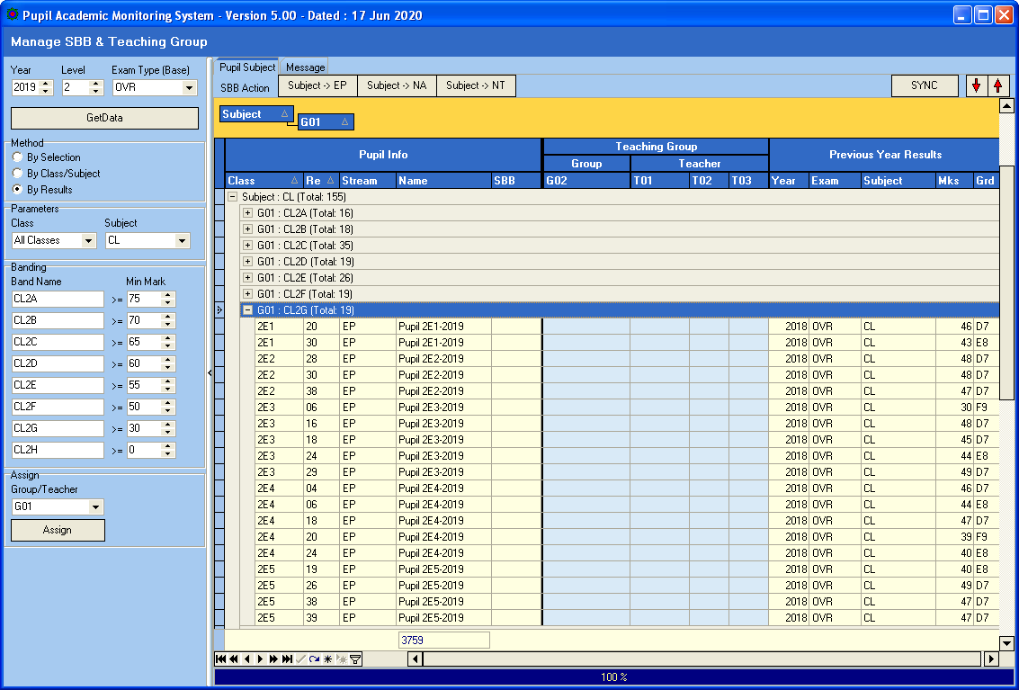
Expand and Collapse

Manage Pupil Group
You may assign Groups (Up to 3 Groups) to Pupils regardless of Subjects offered to them. These Groups will remain with them throughout all the years. For example: DSA, Scholars etc.

Menu Access: System Admin Menu || Manage Pupil Group

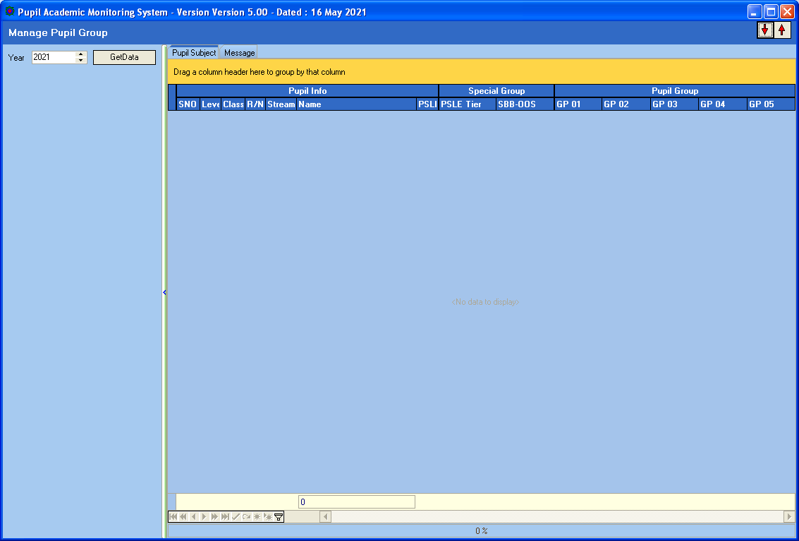

Steps
- Select Year
- Click Get Data button

Assigning PSLE Tier
Now you can assign Pupils to PSLE Tiers Group according to their PSLE T/Scores or AL Scores. PAMS can analyze based on this Group. For example, Top PSLE Tier students who have not performed well.

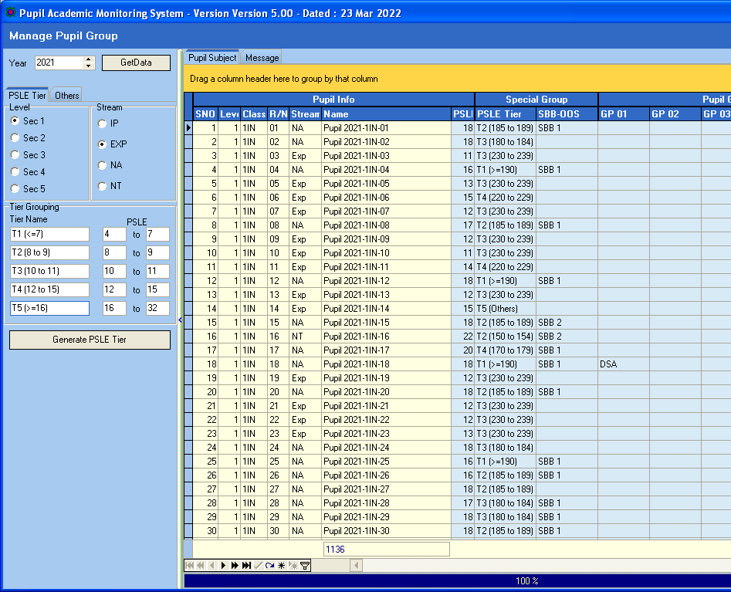
Click Generate PSLE Tier

Steps
- Select Stream
- Enter the Tier Name and PSLE Value
- Click Generate PSLE Tier

Assigning SBB/OOS Count
Now you can assign Pupils SBB/OOS group based on the Number of SBB or OOS Subjects Offered. PAMS can analyze based on this Group. For example, students with 2 OOS who have not performed well.

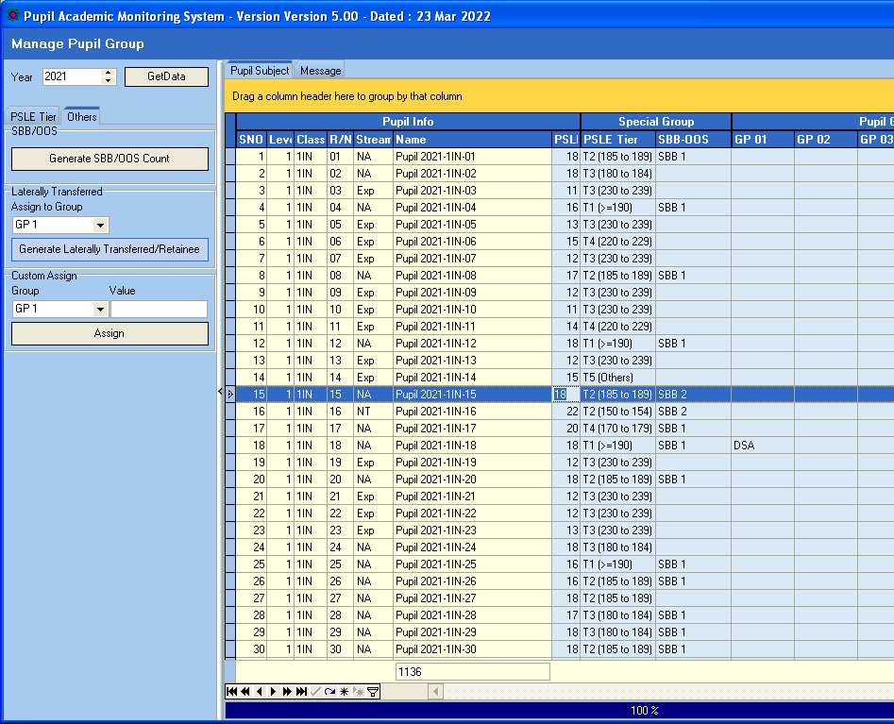
Click Generate SBB/OOS Count

Steps
- Click Generate SBB/OOS Count

Assigning Laterally Transferred
Now you can assign Pupils who are Laterally Transferred and Analyze them.

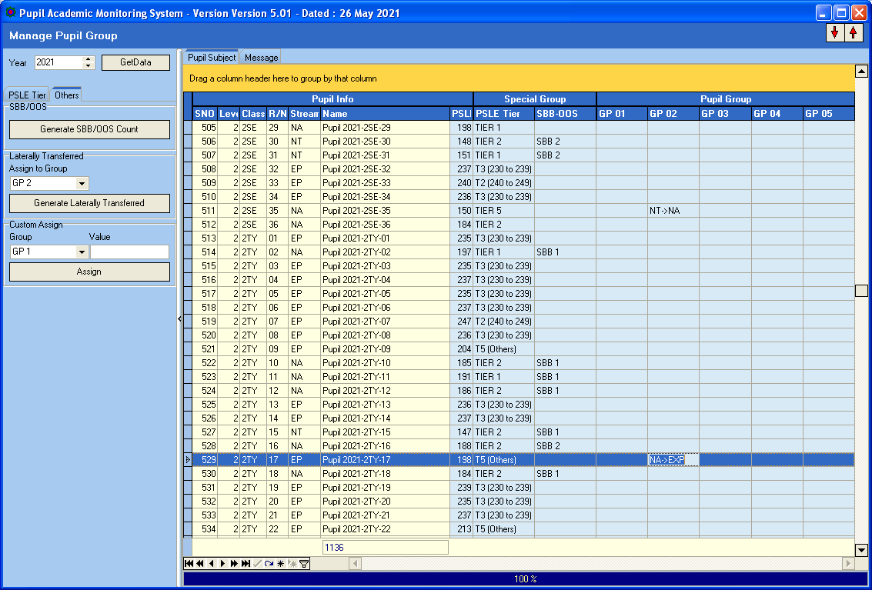
Click Generate Laterally Transferred
Steps
- Select Group No to Assign to
- Click Generate Laterally Transferred

Assigning Group
In Addition, you can assign Pupils to Various Group (Up to 5 Groups) which you can analyze later.
For example: Learning Ability Group, DSA, Scholars etc.

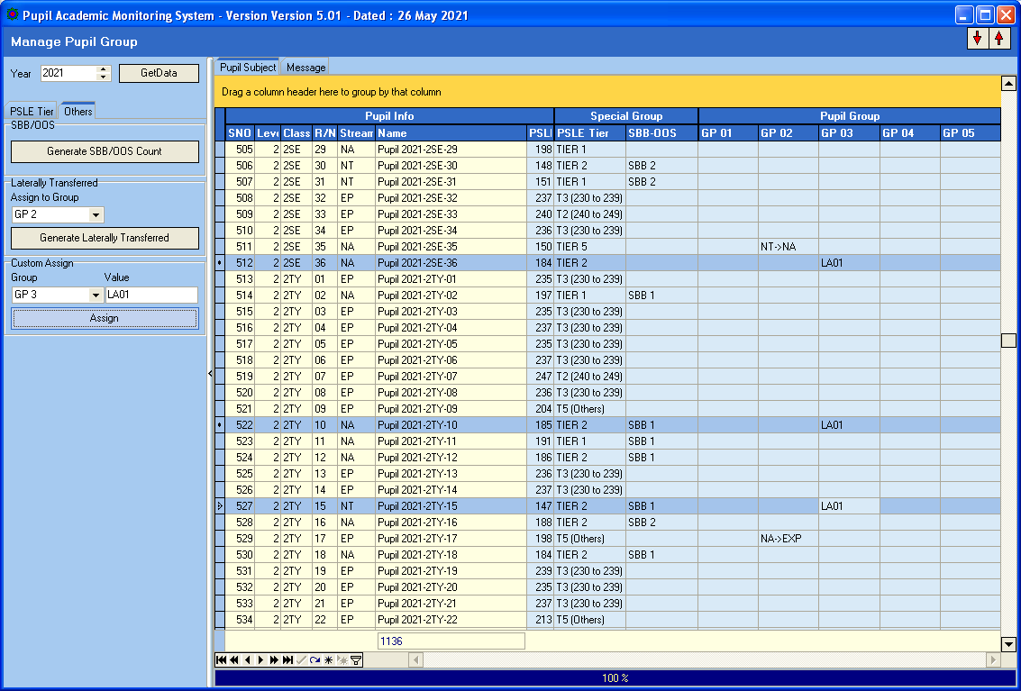
Click Assign
Steps
- Select Assign Group (G01, G02, G03, G04 or Gp5)
- Enter the Value
- Select Students (Use CTRL+Click)
- Click Assign Button

Load Subject Teachers’ Name
Objective : To Load Subject Teachers’ Name
Menu Access : System Admin Menu – Load Teaching Group

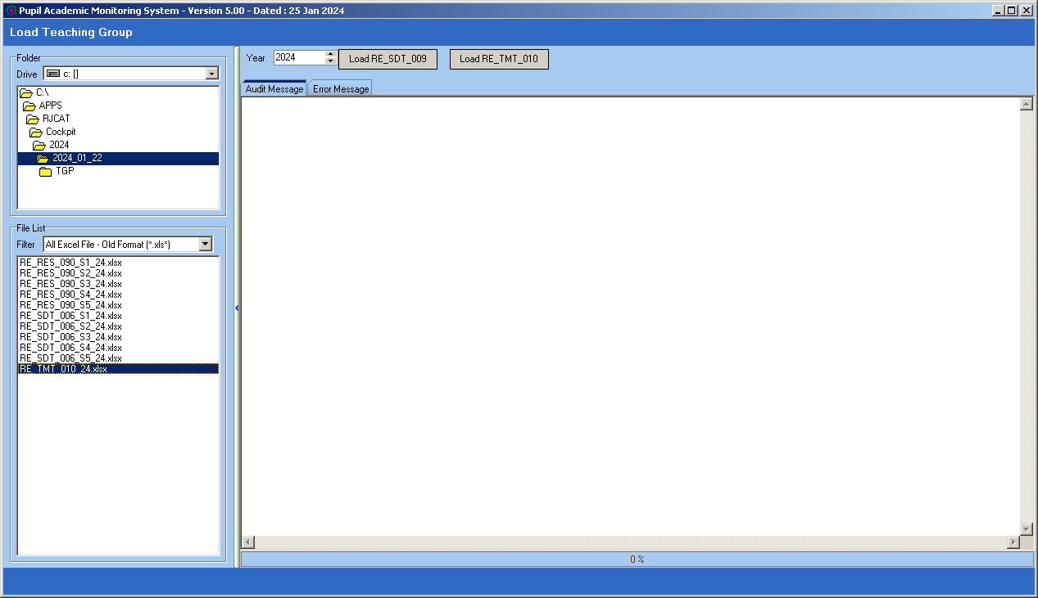
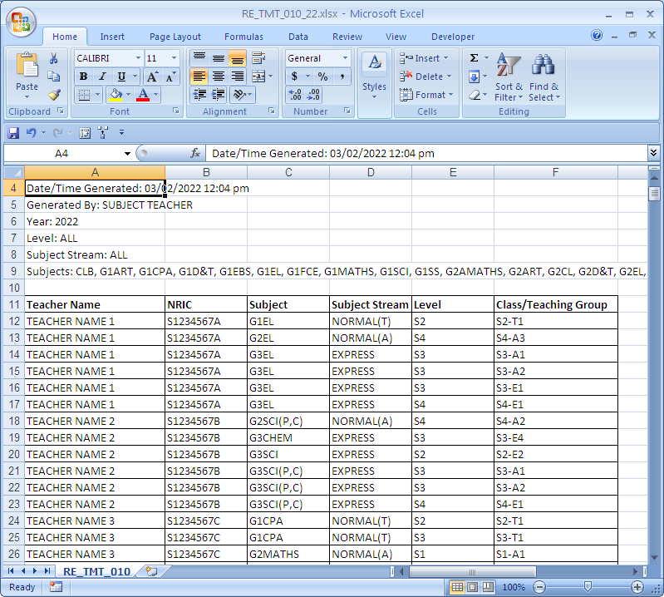
Steps
- Select the folder where you save the Cockpit Files
- Select the File
- Click Load RE_TMT_010 Button

Cockpit uses FULL NAME. You may sort the column by Teachers’ Name and edit (shorten) the name first before loading. Max Character is 20.

Check and Verify Subject Combination
Objective : To check and verify that the Subjects are allocated correctly
Menu Access : Main Menu – View Results

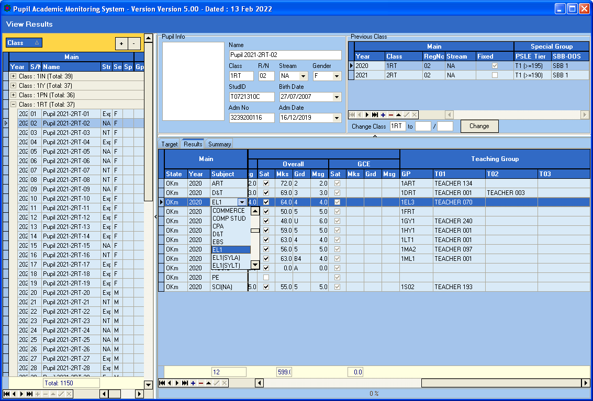
Subject Teaching Group
Change Subject. To add New Subject, click INSERT
Subject Allocated to students
Subject Teacher

You may also PRINT the Subject Allocation List to check and verify.

PRINT REPORT - PUPIL - Subject Allocation List.

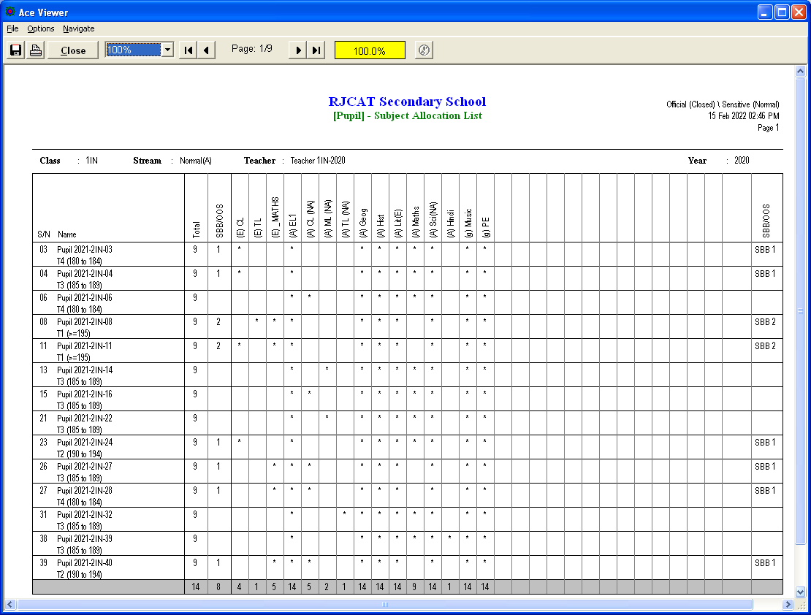

Check and Verify Subject Info
Objective : To check and verify that the Subject Info is correct (Cat, Grading Scheme, SBB Conversion)
Menu Access : System Admin Menu – Subject Grading Scheme
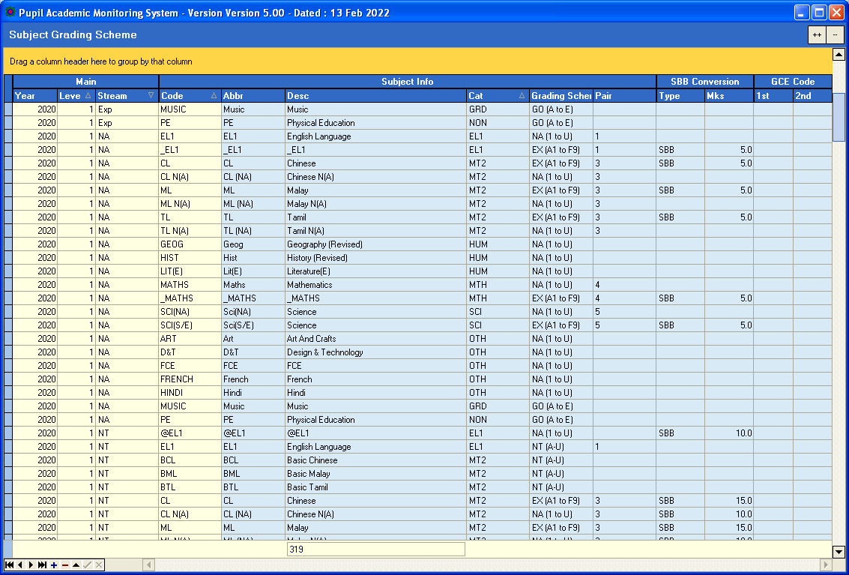

Notes
- Scroll through the Subject List and ensure all Subjects have the correct grading Scheme
- For Subjects that are not required to be analyzed, you can set the CAT to “NON”
- For SBB/OOS, Pair the Subject so that only one of them can be considered if students take both Subjects. For example, Maths (NA) and Math (Exp) are paired as 4. You may use any numeric integer for the pairing.
- For Lower Sec SBB, ensure that the mark adjusts are set accordingly.
- For Upper Sec OOS, the mark adjustment will be preset in PAMS based on the Conversion Table.

Grading Scheme
- EX (A1-F9) - For Express
- NA (1 to 6) - For Normal (A) – No more Grade U
- NT (A to E) - For Normal (T) – No more Grade U
- IP (A+ to F) - For IP
- GO (A-D) - For Grade only Subject with A to D
- GO (MPU) - For CLB, MLB, TLB
- GO (DMP) - For SS N(T), GCE Oral
- Common (P1-P9) - Common Curriculum Subjects

Sec 1 Common Curriculum Subjects (ART, D&T and FCE)
- Common (P1 to F9) - Cockpit use P/F. But it is better to differentiate how well a student pass or how bad a student fails.

Print Trend Report
You may print the trend reports to decide the Expected and Min MSG for target setting.
It is recommended to use your internal Exam to set the Expected and Min MSG instead of PRISM which is the National Exam.
The Year will be
“FROM”

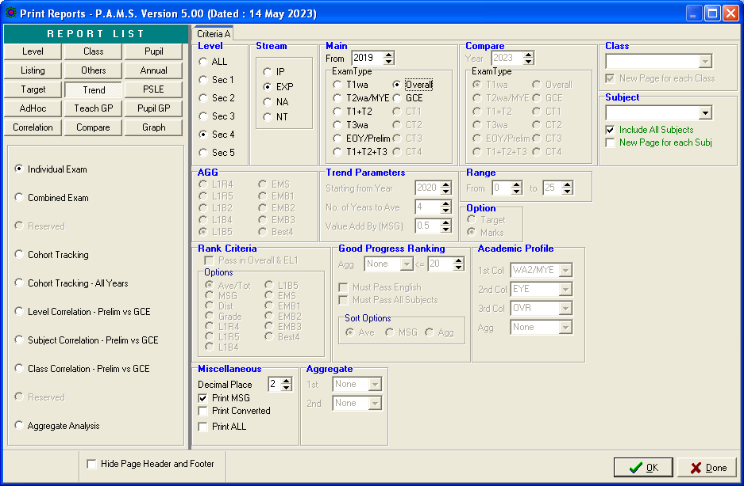

3-Year Trend Overall Results

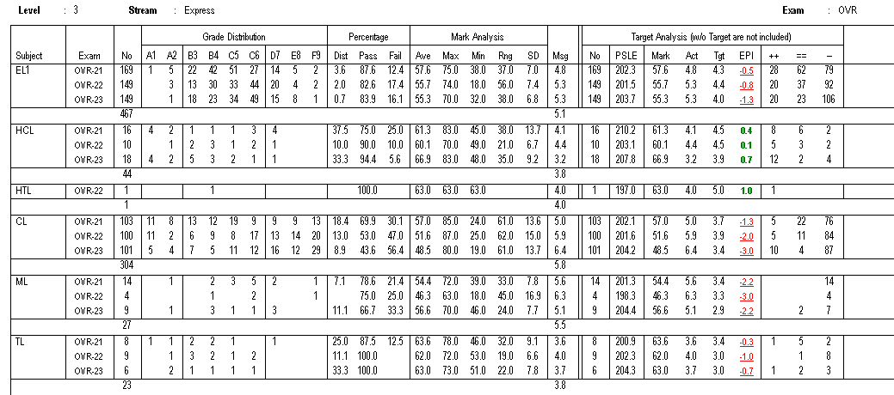
Min MSG=5.3 (2023) or better
Exp Agg=29.1
For reference
Exp MSG=5.1
For reference

3-Year Trend Aggregate (L1B5)

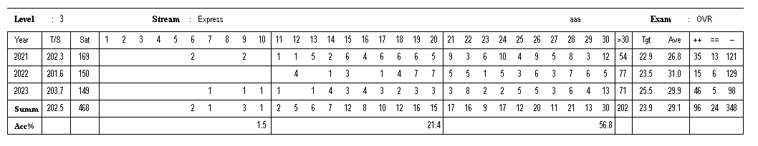
Target AGG = You decide after looking at the trend for the last 3 years

Setup Aggregate Target (AL)
Objective : To Setup Target for Sec 1 using AL Scores
Menu Access : Main Menu – Setup Aggregate Target (AL)

Steps
- Select Year
- Select Stream (NIL)
- Select Level
- Click Load Cohort Data

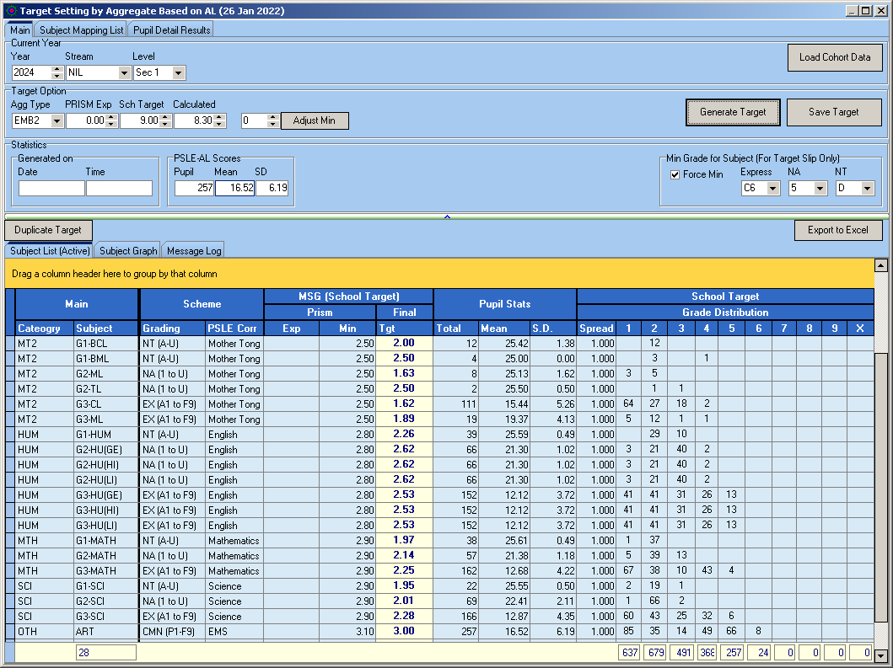
This is calculated by PAMS
You may adjust the “Spread” to spread out the Grade
This is adjust the MIN for all Subjects
This is to adjust the MIN for all Subjects

Steps
Target Option
- Select Agg Type (Recommend EMB2)
- Enter PRISM Exp for reference. For Lower Sec, the “PRISM” Exp will the Previous Year Results
- Enter Sch Target. This is the Start MSG for each Subject. You may use Last Year MSG or Subject Trend for the last 3 to 5 Years. You may print this Report from TREND.
- Click Generate Target
- If the Aggregate Target is not you want, Adjust the MIN for each Subject
- Repeat Step 1 and 2 until you get the Target you need
- Click Save Target

Note:
The final target may be “Far” from the PRISM Min as the AL Grades are very close and discreet.
For 2024 Sec 1 (Stream=NIL), the focus is on Subject MSG rather than the AGG.

Target Setting by Aggregate (Using Previous Year Results)

Menu Access: Main Menu || Setup Aggregate Target

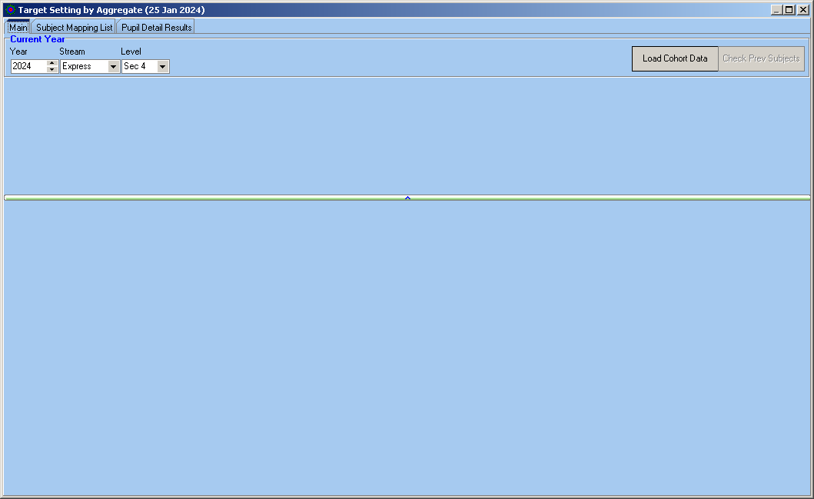

Step
- Enter Current Year Parameters (Year, Stream, Level)
- Click Load Base Data Button

Check Prev Subjects
Since the Target Setting is based on previous year results, we need to ensure that every student has a corresponding previous year results for each of the subject. This is especially crucial for Sec 3 Students (Sec 2 Subject Codes are different from Sec 3 Subject Codes) and students who are lateral transferred. For example:
Sec 3 Subjects | Possible Corresponding Subject (Sec 2 Subjects)
SS+Geog | Geog
Chemistry | Sci(S/E) | Sci(NA) | Science(T)
A Maths | Maths | Maths (NA) | Check Prev Subjects

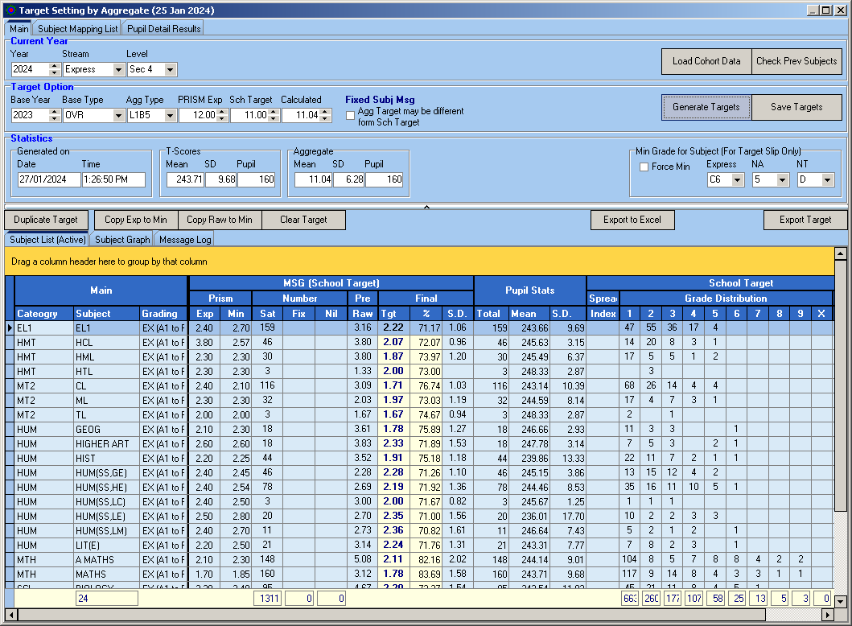
Number of student without previous year results

Here are some of the acceptable cases where Previous Results are not applicable:
New Student - System will assign average marks
VR Grade - System will assign average marks

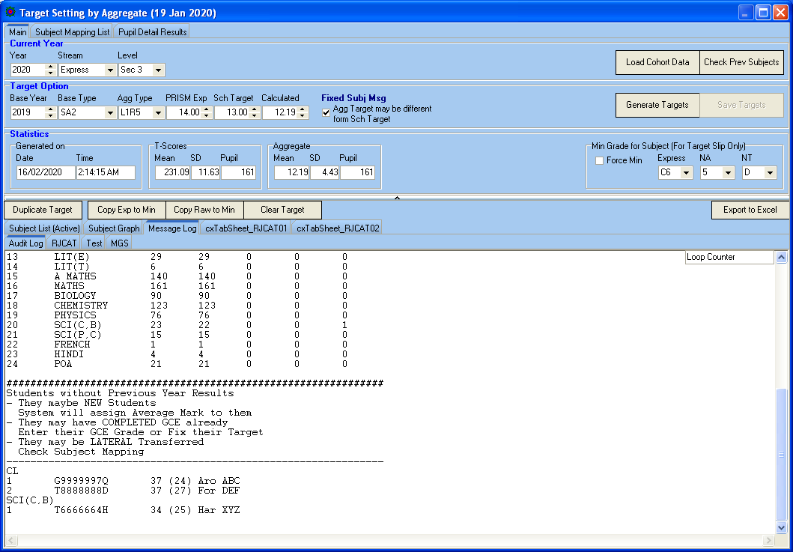

Subject Mapping
The purpose of Subject Mapping is to link the Upper Sec subjects to the Lower Sec subject.

For example, when the system search for previous year result for A MATHS, it should be looking for MATHS or MATHS NA

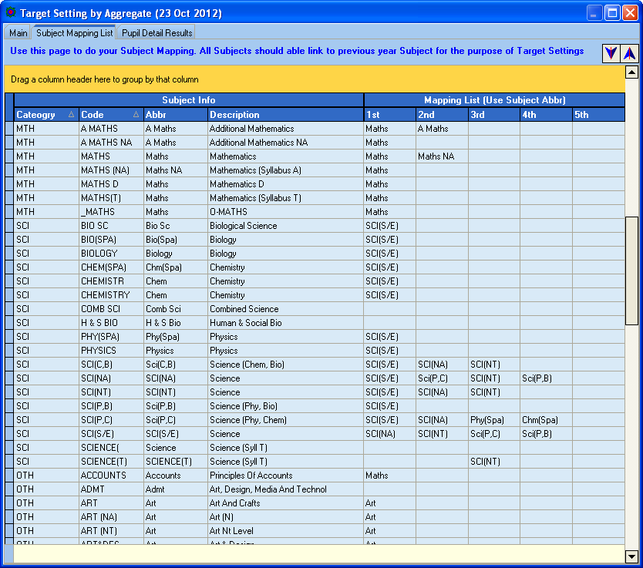

Steps
- Enter Corresponding Subjects under Mapping List
- To Save, select another record

Target Option
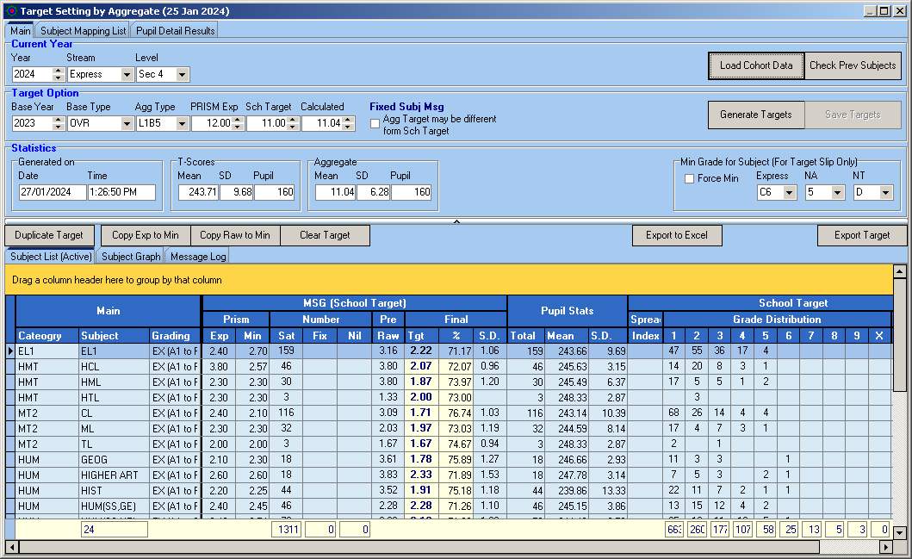
PRISM Exp
For reference only
Minimum Grade to Achieve.
If you do not FORCE, PAMS still able to Print PASS Target for Target Slip,
PRISM Min
Act MSG from PRISM.
What your school is actually capable of achieving (or Achieved).
Step
- Under Target Option
  - Select Base Year
  - Select Base Type
  - Select Agg Type
  - Enter PRISM Expected (for reference only)
  - Enter School Target to Achieve
- Under Subject List (Active)
  - Enter PRISM Exp (for reference only)
  - Enter PRISM Min (Capable of achieving)
- Click Generate Targets Button

Target Generated

Statistics
Generated by PAMS.

Step
- Review all the Targets.
- If OK, click Save Targets Button to save the targets to the student database.

Setup Aggregate Target Based on T-Scores

Menu Access: Main Menu || Setup Aggregate – T/Scores

Click Load Cohort Data

Enter TARGET OPTION Parameters:
- Agg Type
- PRISM Exp (for reference only)
- Sch Target (for reference only)

Enter PRISM Exp and Min:
- Exp (for reference only)
- Min (Min MSG for each Subject)

Enter Min Grade for Subject:
- Min Grade for each Stream
- Tick “Force Min” if you
Exp and Min MSG
Enter Spread for Target Grade
- Internal default is 0.05
- If you want More distinction (More spread out for Target Grades), increase the spread to more than 0.05

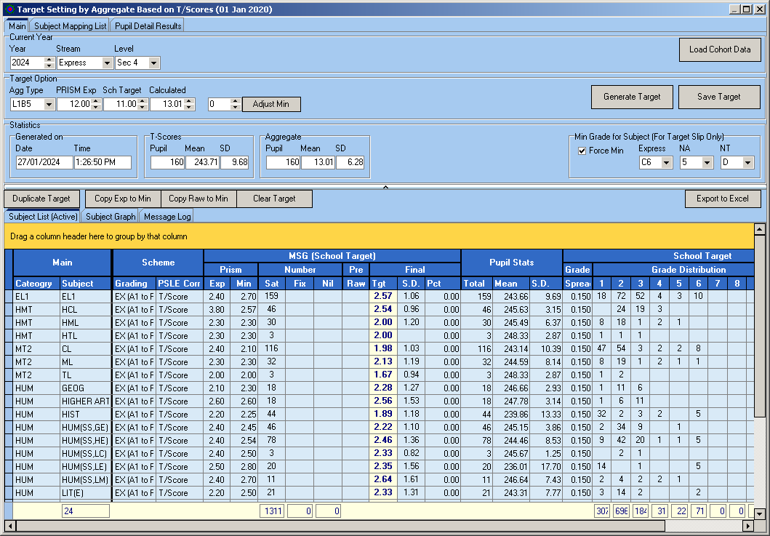
Min Grade
Target Option Parameters
Spread for Target.
If it is empty (ZERO), the default is 0.05
Click Generate Target button

Target Grade Distribution
Calculated Aggregate Target
Target MSG

If you like the Target, click Save Target button.

Manage SBB/OOS Qualifier
Objective : To Identify students for SBB INERTS or OOS
Menu Access : System Admin Menu – Manage SBB/OOS Qualifiers

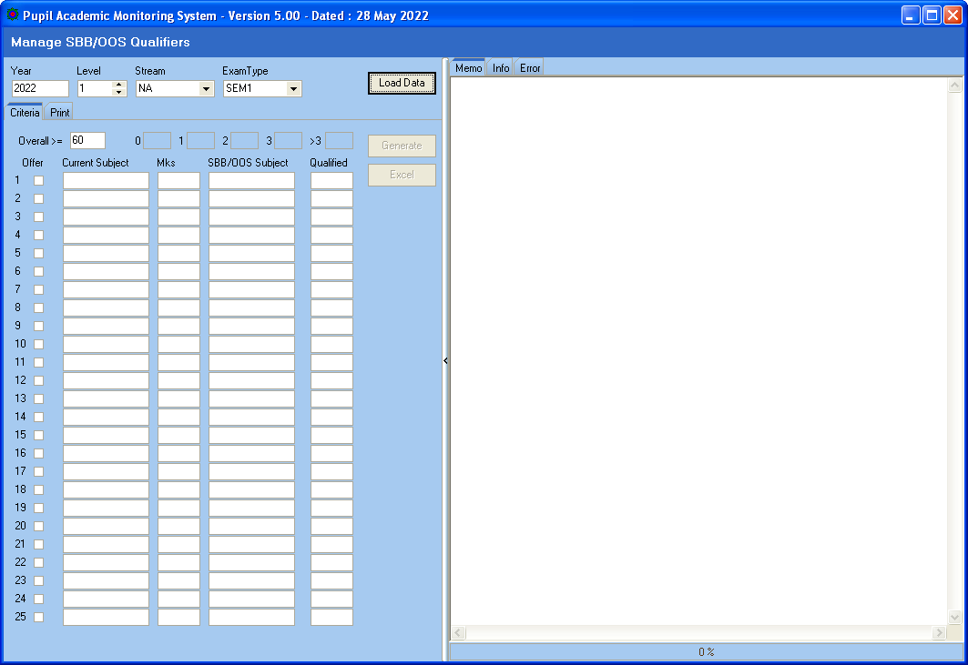

Steps
- Select Year, Level, Stream and Exam Type
- Click Load Data

Min Overall Average Mks
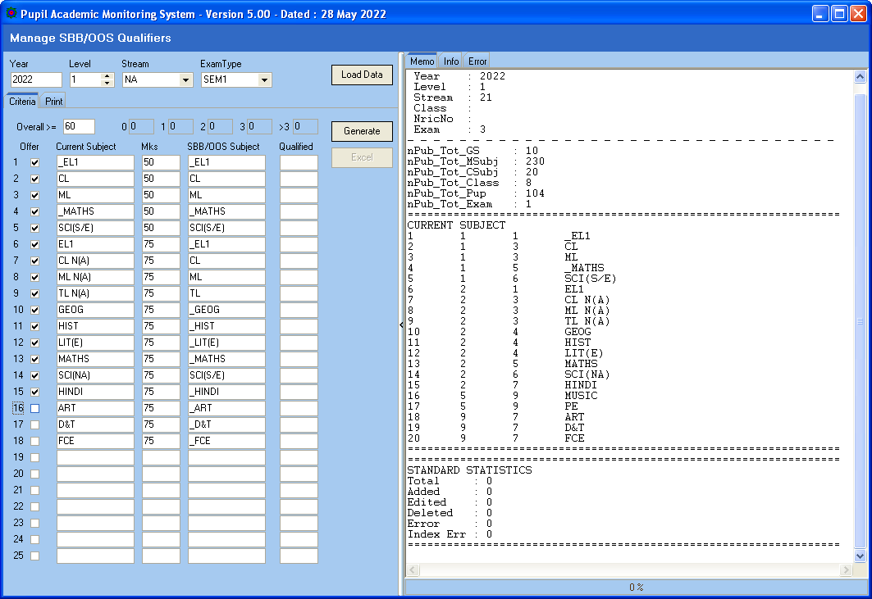
Current SBB/OOS Subjects
Not Offered

Steps
- Tick “Offer” for subjects that will be offered at SBB/OOS
- Update the corresponding SBB/OOS Subject
- Update the Mks (Min) to qualify
- Click Generate

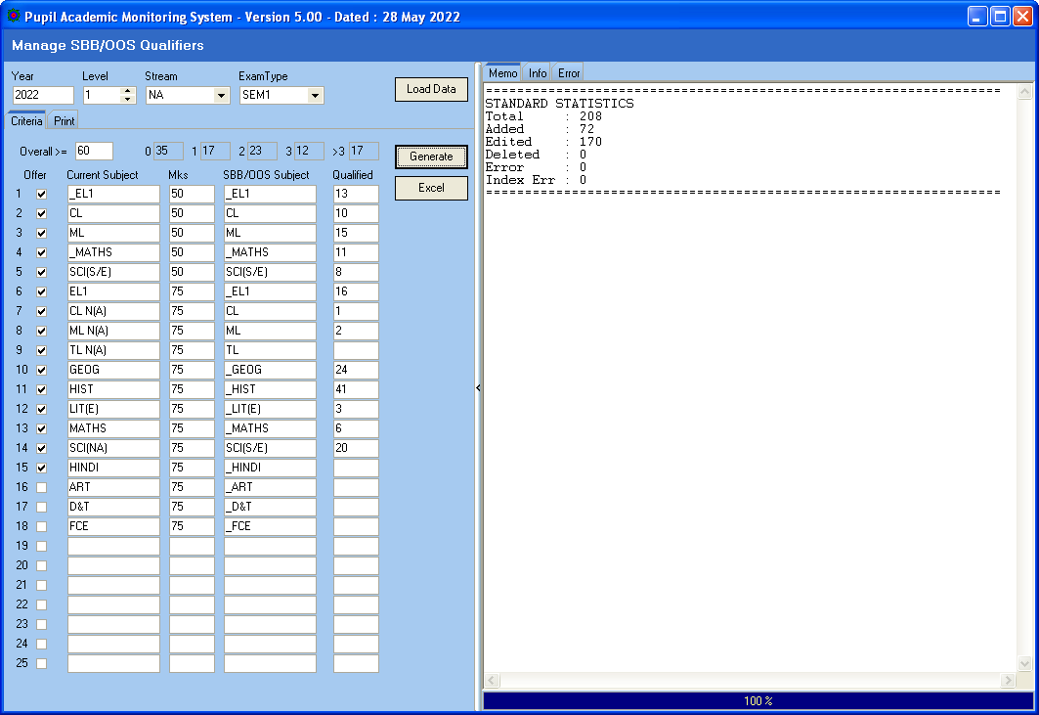

Total Pupil Qualified for Maths:
SBB=11
STD=6
Total Pupil Qualified for more than 3 SBB/OOS

Steps
- Click Excel to Export Data to Excel

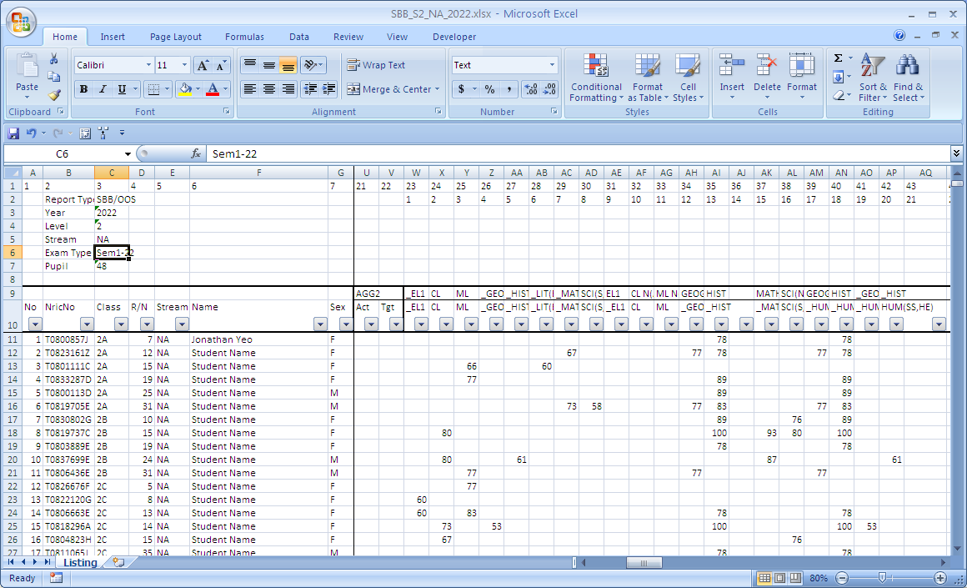
SBB/OOS Subject
Current Subject

Print SBB/OOS Qualifier

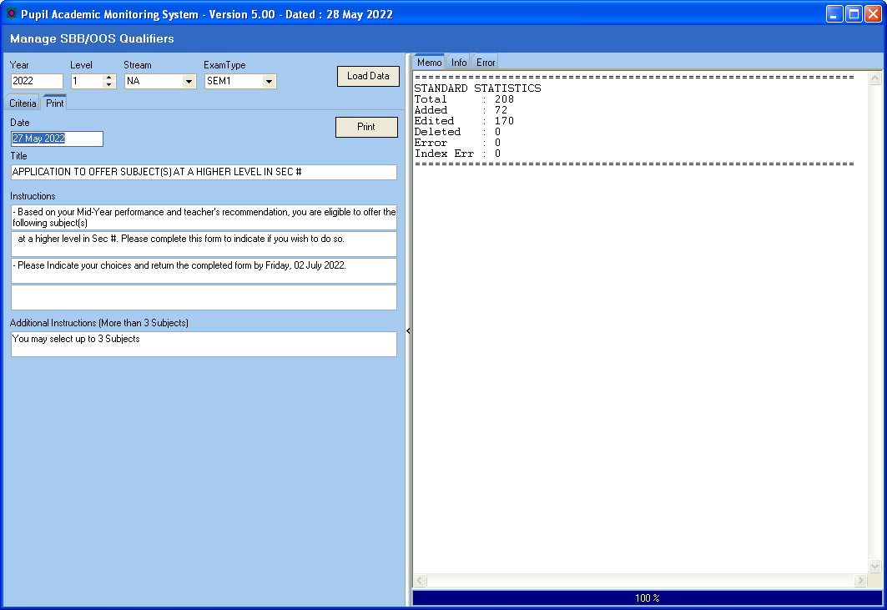
Content to be printed
# will be replace with Level

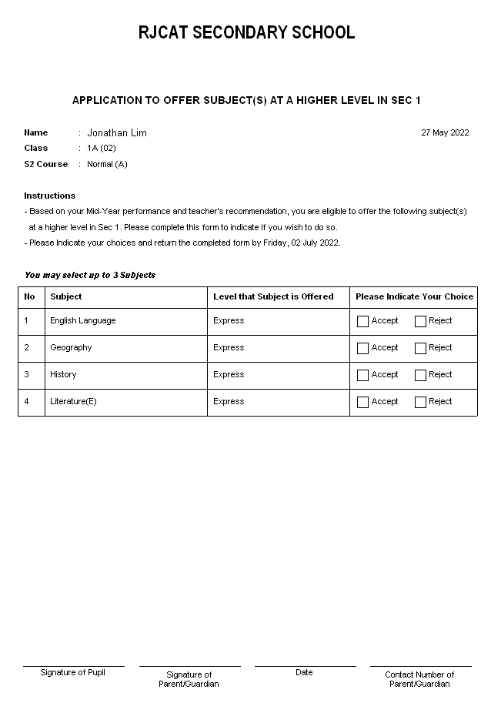
To Edit the description,
go to System Table Menu - Subject Table

Print Target Reports

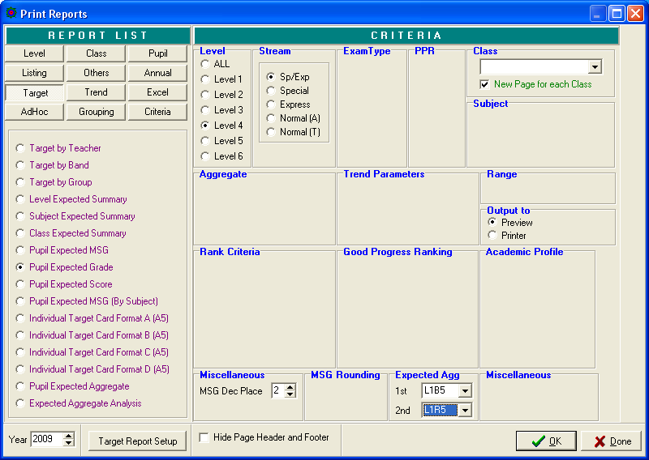

Reports you may use:
- Level Expected Summary
- Subject Expected Summary
Some basic Layout for Individual Target Card
- Class Expected Summary
- Pupil Expected Grade
- Individual Target Card (Format A to D)

Verify Generated Targets
Objective : Ensure Targets are stored
Menu Access : Main Menu – View Results

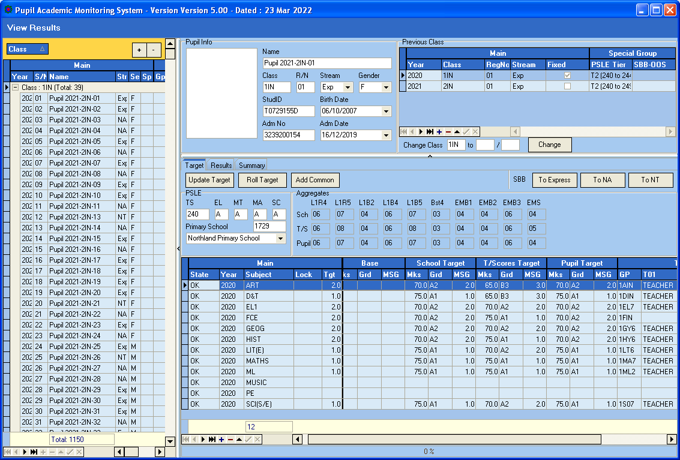

Exam Label
Now you may rename the Exam Label to WA1, SA1 etc or any customized Label. Please note that the length should be kept at 4 characters or less.

Important Note: If you have not download You need to download SysCode.DB and SysCode.PX from our website into C:\APPS\RJCAT\PAMS2000\DATABASE

Menu Access: System Table Menu | Exam Label Table

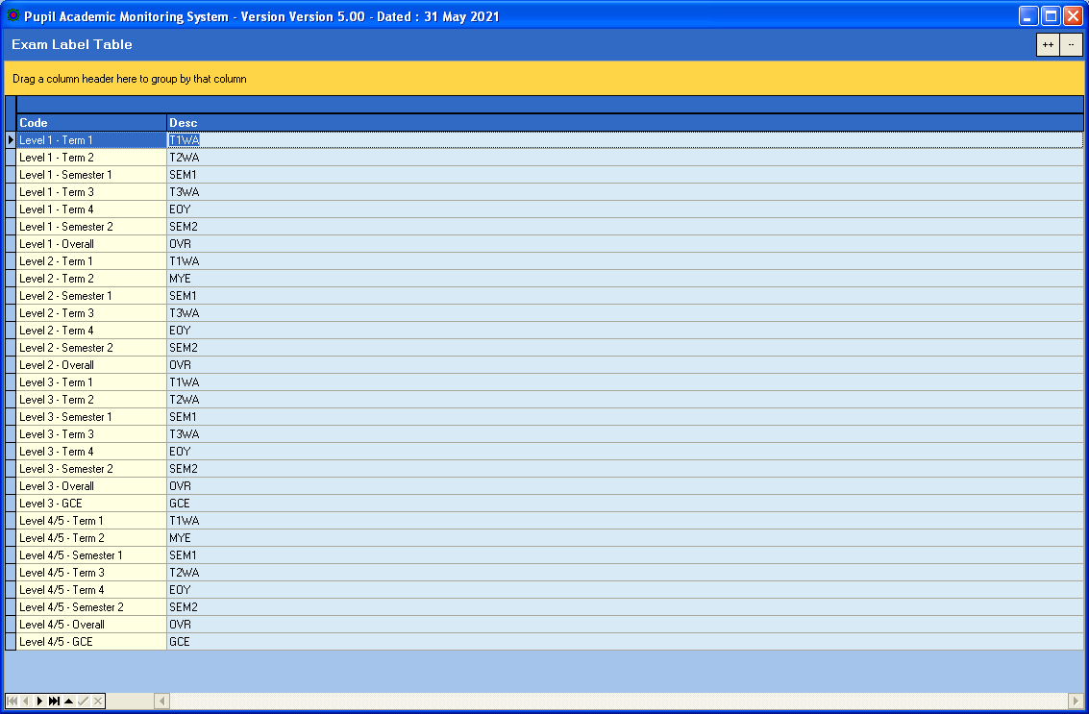

Analyzing Results
Objective : Load Results for Analysis
Menu Access : System Admin Menu – Convert Cockpit Data
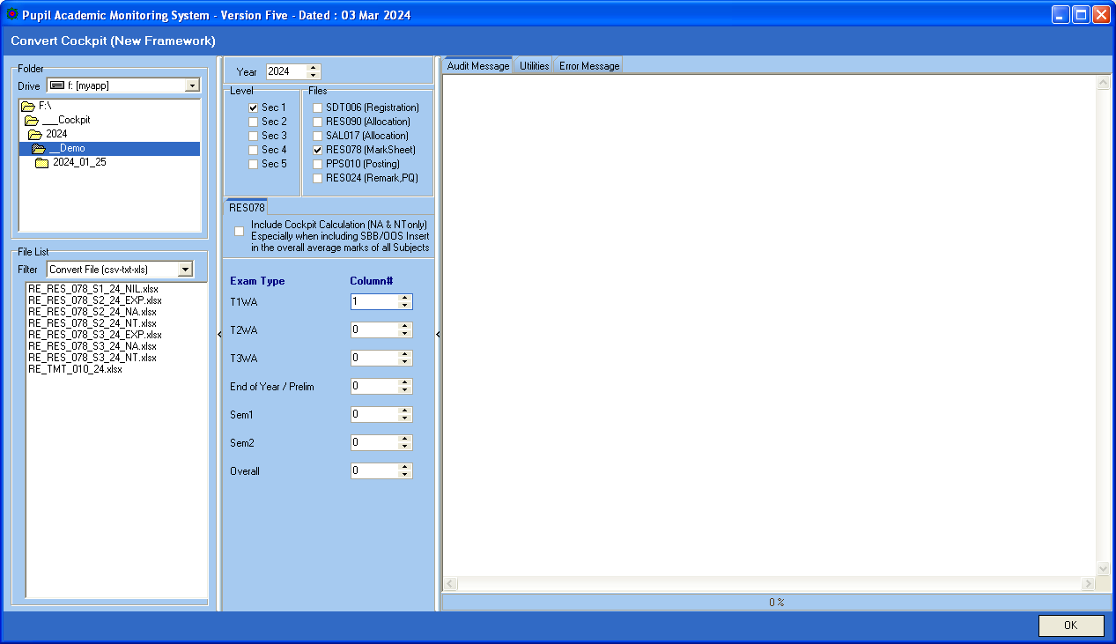
No need to select File. PAMS will auto detect the file based on Level Selected
Zero means Ignore
Col 1
File Naming Convention for RES078

Sec 1 – RE_RES_078_S1_24_NIL.XLSX

Sec 2 Exp - RE_RES_078_S2_24_EXP.XLSX
Sec 2 NA - RE_RES_078_S2_24_NA.XLSX
Sec 2 NT - RE_RES_078_S2_24_NT.XLSX

Sec 3 Exp - RE_RES_078_S3_24_EXP.XLSX
Sec 3 NA - RE_RES_078_S3_24_NA.XLSX
Sec 3 NT - RE_RES_078_S3_24_NT.XLSX

Sec 4 Exp - RE_RES_078_S4_24_EXP.XLSX
Sec 4 NA - RE_RES_078_S4_24_NA.XLSX
Sec 4 NT - RE_RES_078_S4_24_NT.XLSX

Sec 5 NA - RE_RES_078_S5_24_NA.XLSX

Steps
- Select the folder where you save the Cockpit Files
- Select Level
- Tick RES078
- Indicate Column # (based on what you export in RES078) Zero means ignore.
- Click OK Button

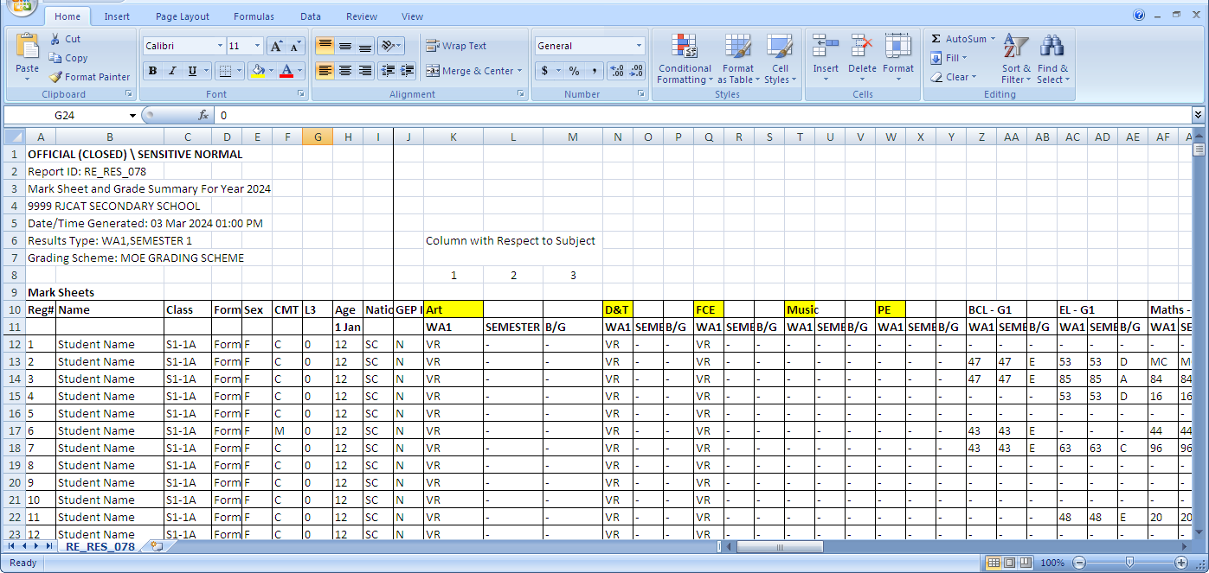
Col 3
Col 2
Col 1

Verify Converted Results
Objective : Ensure Converted Results are correct
Menu Access : Main Menu – View Results

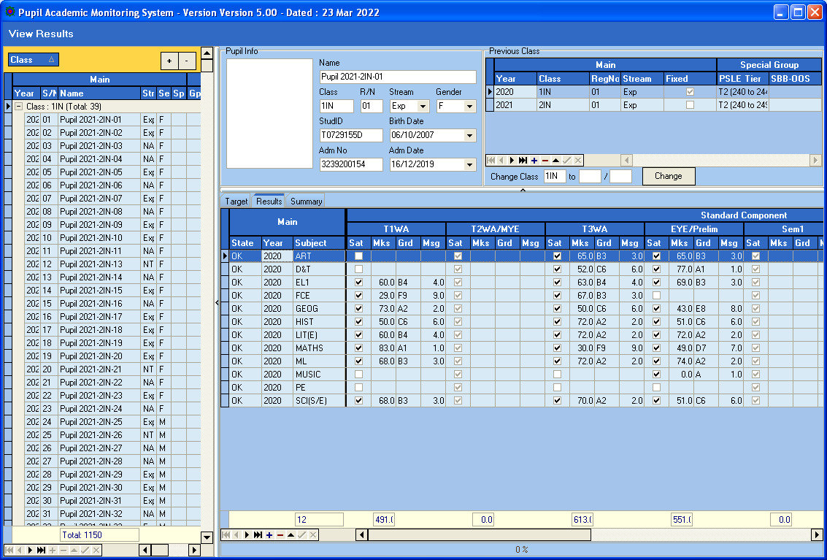
Col 2
Col 1

Process Results
Objective : Ensure Converted Results are correct
Menu Access : Main Menu – View Results

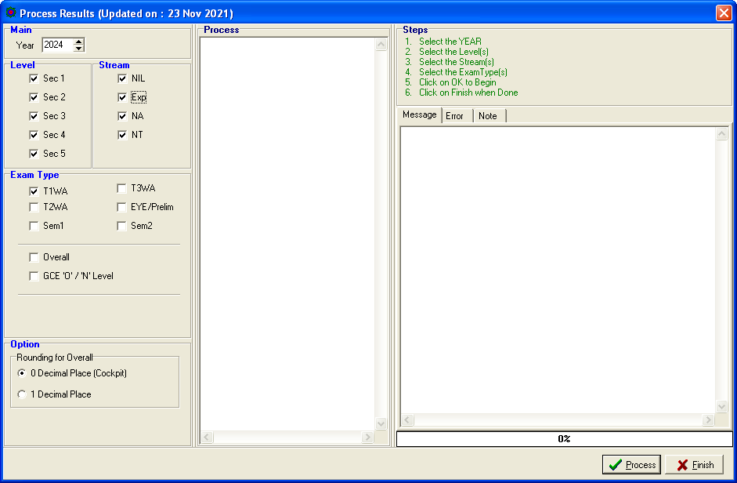

Steps
- Select Level
- Select Stream
- Select Exam Type
- Click Process Button
- Click Finish when done

Proceed to Print Reports (from the Main Menu)

