**PUPIL ACADEMIC TRACKING SYSTEM**

**Quick Guide**

***Dated 08 Sep 2024***

TABLE OF CONTENTS

Login 1

Main Screen 2

Analysis of Results 3

Cockpit Data 4

Convert Cockpit Data 5

RES-078 6

Check what are Converted 7

Process Results 8

Print Report 9

Set Target 10

Load Base Results 11

Calibrate Target 12

Setup AL Target 13

Top-Down Approach 14

Bottom-Up Approach 15

Print Target 16

Change Target Manually 17

Reports 18

Reports - Filter 19

# Login

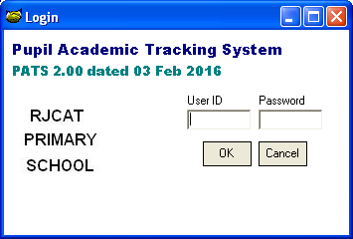

Double-Clock on the Logo to bypass the login

Step

* Enter User ID (system)
* Enter Password (system)
* Click on OK button

# Main Screen

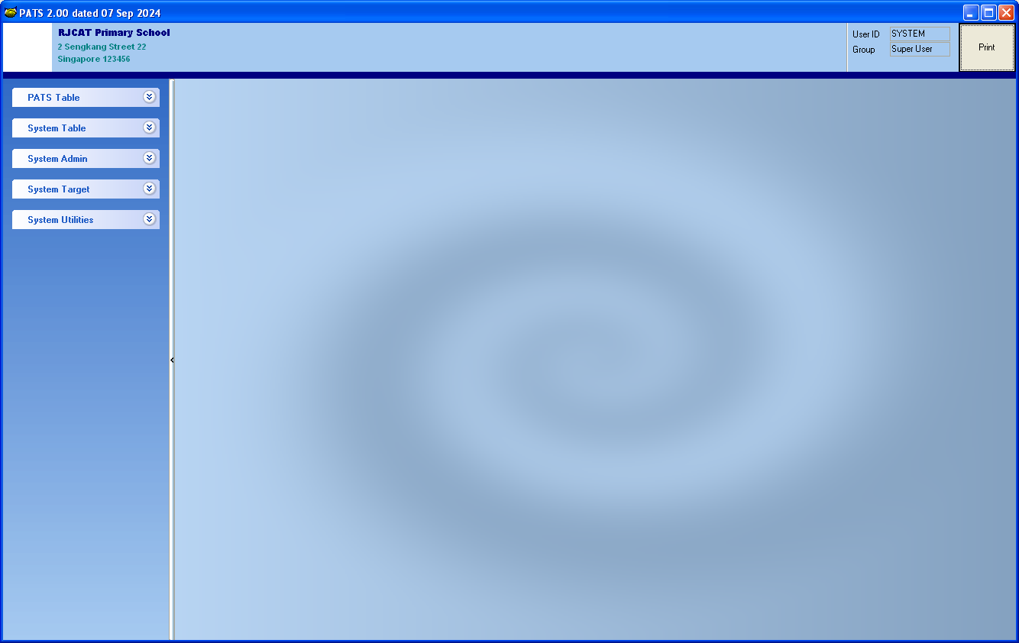

Print Reports

User Info

Menu List

# Analysis of Results

Workflow:

* System Admin - Convert Cockpit Data
* System Admin - Process Results
* Print Reports

For this time round, you will need the following files from Cockpit:

Class Register - You need to rename them as follow:

* RE_SDT_006_P1_24.xlsx
* RE_SDT_006_P2_24.xlsx
* RE_SDT_006_P3_24.xlsx
* RE_SDT_006_P4_24.xlsx
* RE_SDT_006_P5_24.xlsx
* RE_SDT_006_P6_24.xlsx

Subject Combination - You need to rename them as follow:

* RE_SAL_017_P1_24.xlsx
* RE_SAL_017_P2_24.xlsx
* RE_SAL_017_P3_24.xlsx
* RE_SAL_017_P4_24.xlsx
* RE_SAL_017_P5_24.xlsx
* RE_SAL_017_P6_24.xlsx

Mark Sheets and Grade Summary - You need to rename them as follow:

* RE_RES_078_P1_24.xlsx
* RE_RES_078_P2_24.xlsx
* RE_RES_078_P3_24.xlsx
* RE_RES_078_P4_24.xlsx
* RE_RES_078_P5_24.xlsx
* RE_RES_078_P6_24.xlsx

I suggest you convert and process ONE level first to get familiar with the system

# Cockpit Data

RE_SDT_006

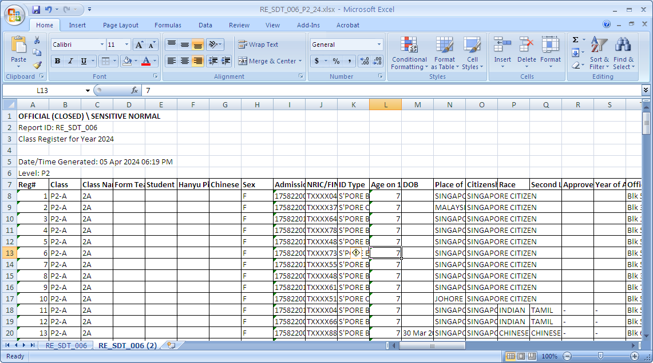

RE_SAL_017

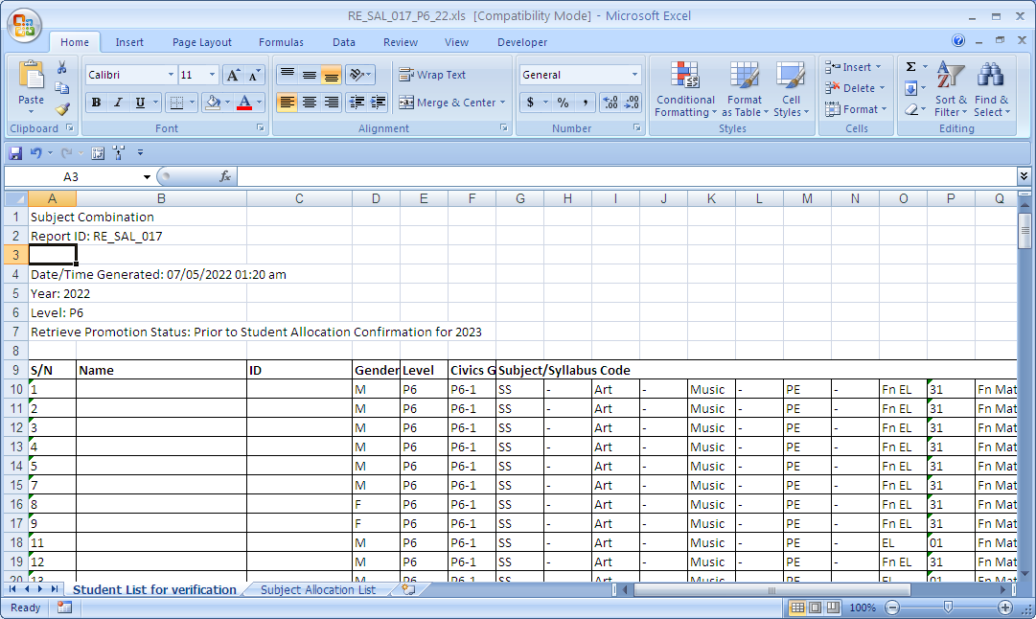

RE_RES_078

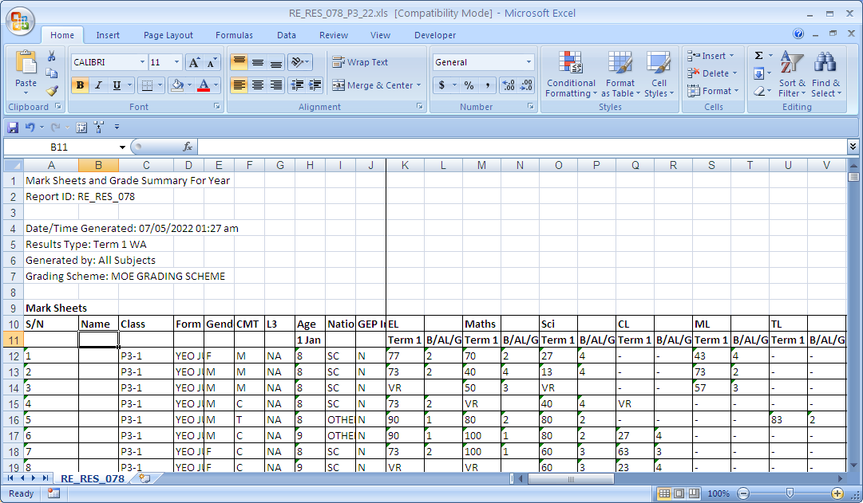

Other Columns will appear after 1st Exam & before B/AL/G

Column  
1st Exam

The column# may be different for different levels depending upon what Exam Type you export.

# Convert Cockpit Data

To load cockpit data into PATS.

Menu Access: System Admin – Convert Cockpit Data

You may convert one file type at a time. Order of conversion:

* SDT006
* SAL017
* RES017

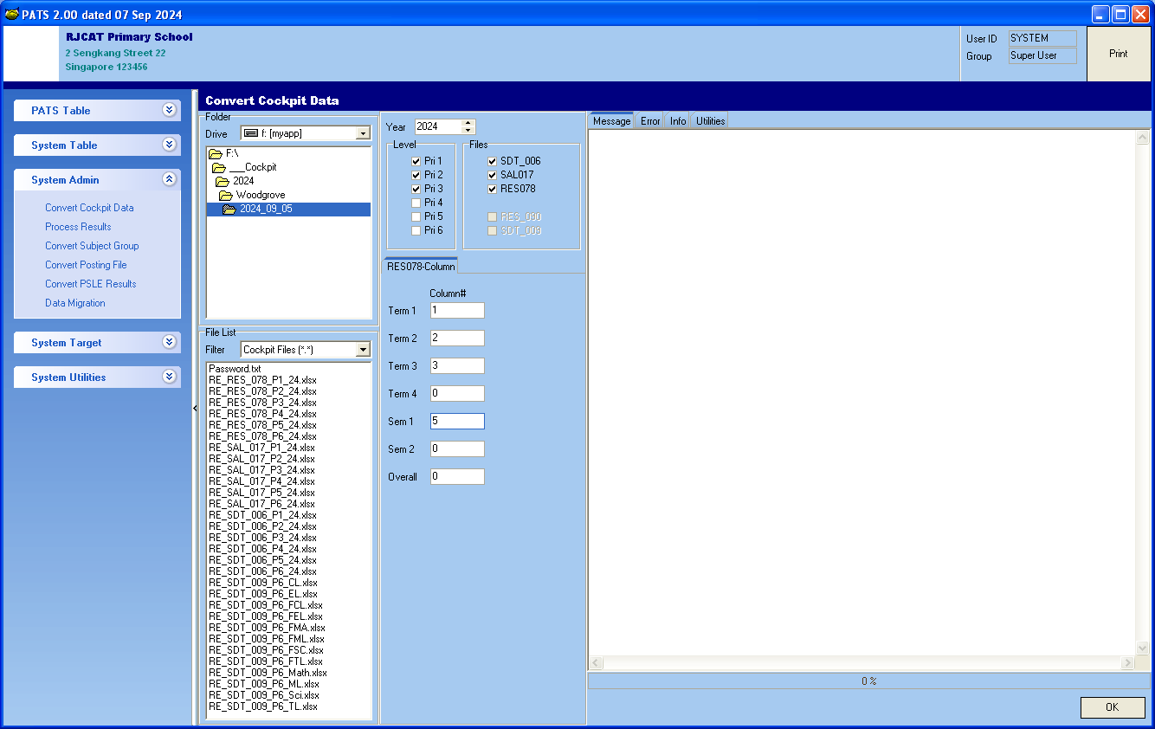

Based on the Column in 078

Steps

* Point the folder to the place where you store the cockpit files
* Select the Year
* Tick the Level
* Tick the Files (SDT006, SAL017 & RES078)
* Select the Exam Type (for RES078)
* Click OK

### Check what are Converted

Menu Access: System Table – Pupil Table

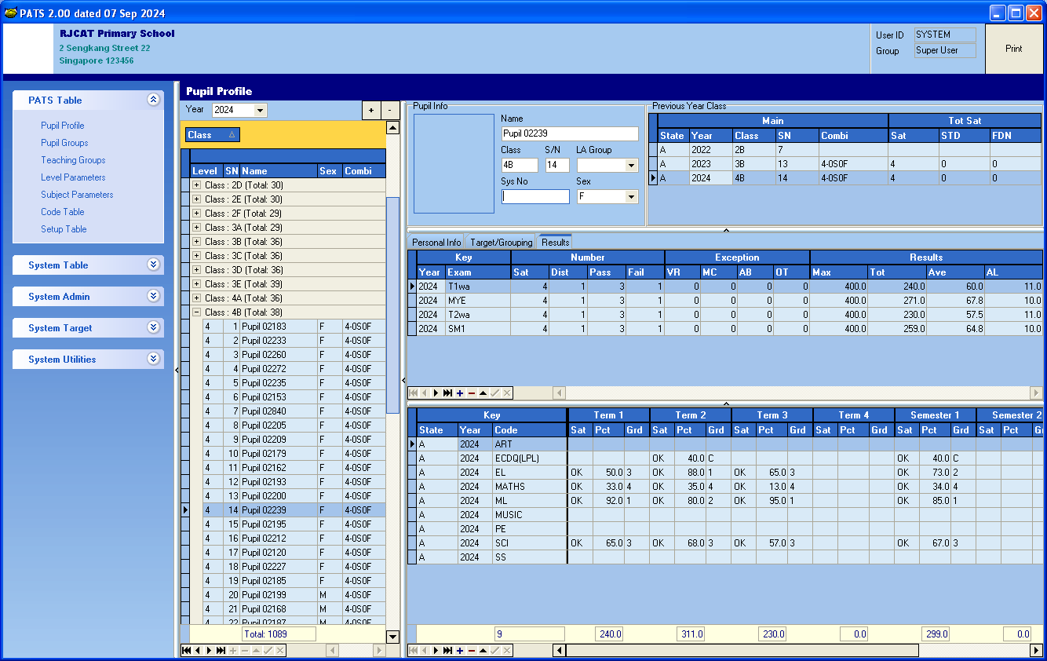

Mark Converted from RES078

You may check what have been converted.

# Process Results

To prepare PATS Data for printing.

Menu Access: System Admin – Process Results

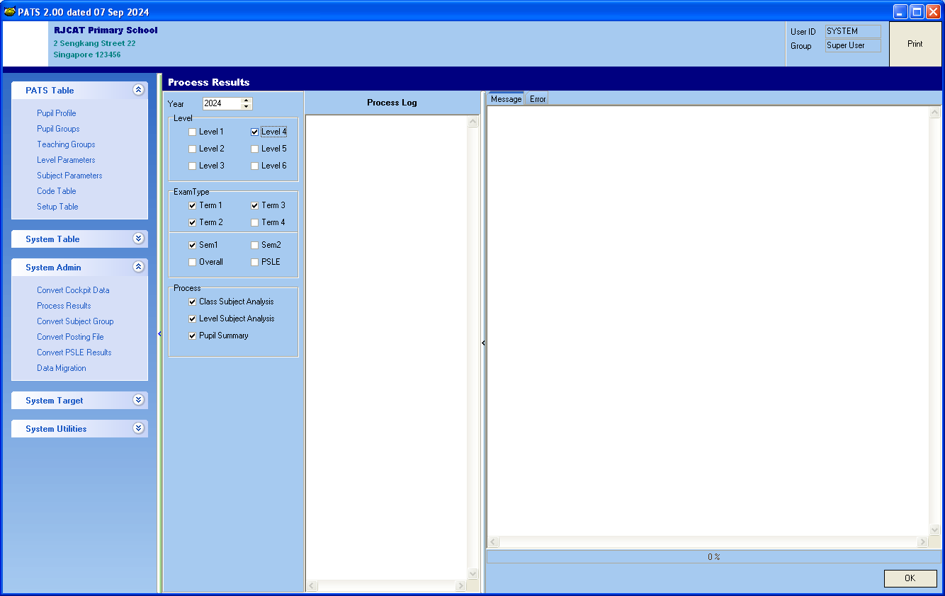

Leave as Tick

Steps

* Select the Year
* Tick the Level
* Tick the Exam Type
* Tick all the Processes
* Click OK

# Print Report

Menu Access: Top Right – Print

The reports are divided into various categories:

* Analysis -
* Pupil -
* Filter -
* Target -

Report Criteria

Report Category

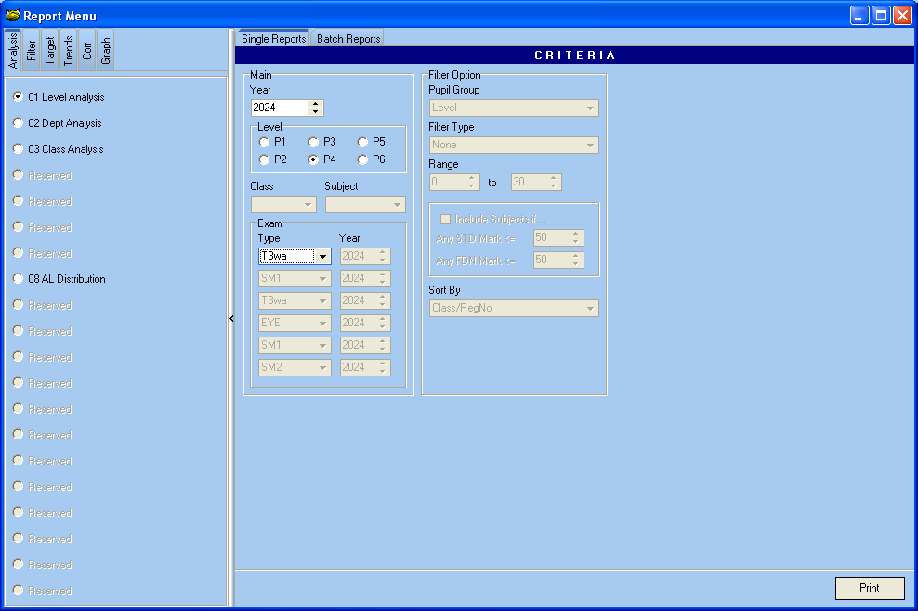

Steps

* Select the Category
* Select Report
* Under the CRITERIA, input the criteria
* Click Print

# Set Target

The sequent for Setting Target

1. Load Base Results
2. Calibrate Target
3. Setup Target AL

## Load Base Results

Previous Year Corresponding Subject and Result

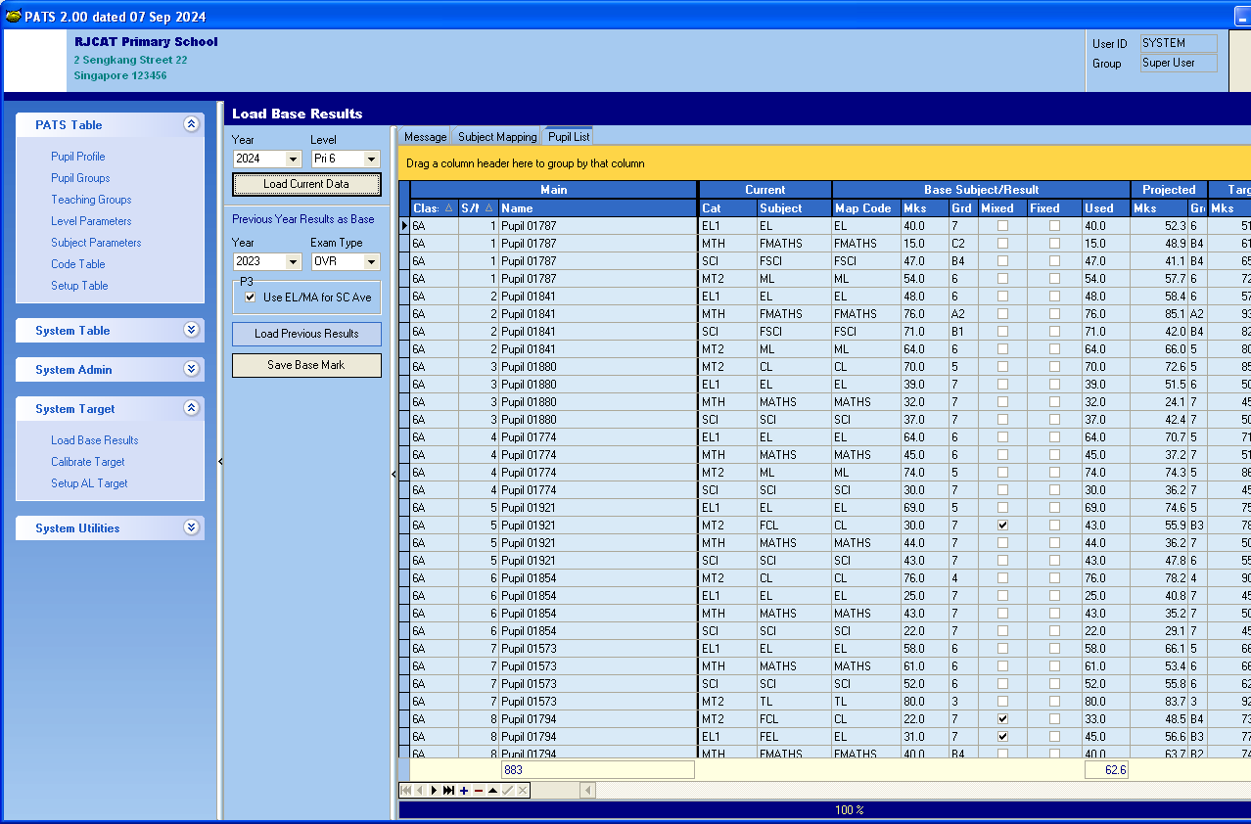

This is the Base Mark USED for Target Setting.

If you need adjust the Target, just change the USED mark accordingly.

By Default, then USED is the same as Previous Year Result.

In this highlighted example, the USED is 67 (Changed from 57) as I want to adjust the target upward.

Steps

* Select Year and Level
* Click Load Current Data Button
* Select Previous Year Results as Base

If you have already Setup Target, you will be able to view these Two Columns:

**PROJECTED:**

These are based on previous P5 cohort and what they obtain for P6  
  
**TARGET:**

These are Target based on your “AIM” Target

* + Year
  + Exam Type
* Click Load Base Mark button
* Clear Save Base Mark button

## Calibrate Target

To obtain the Regression Formula for each Subject.

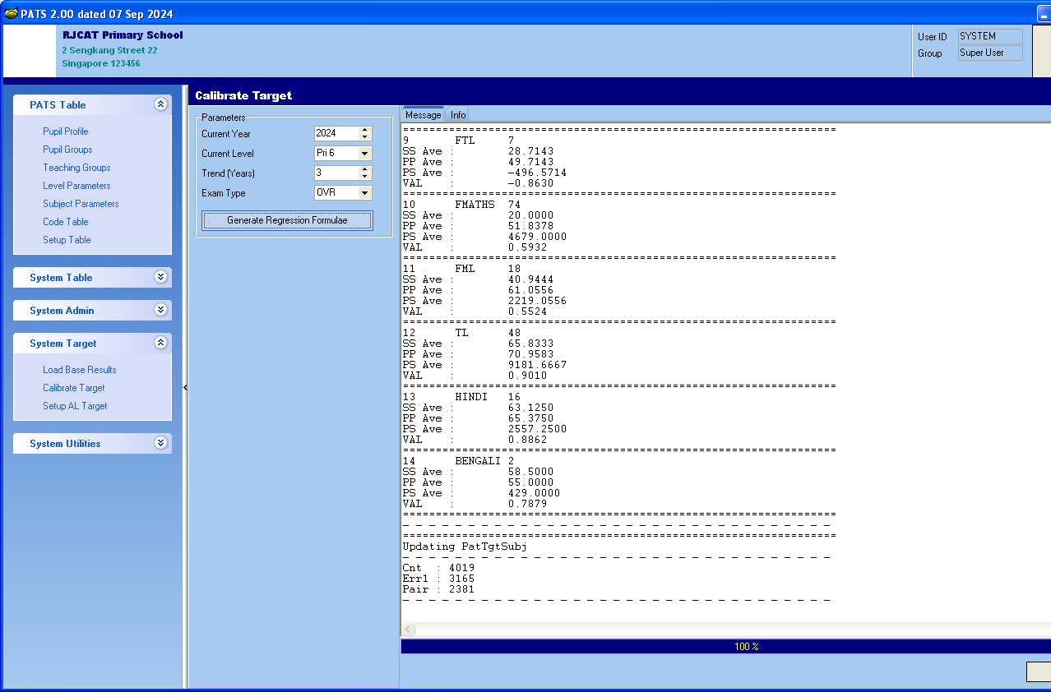

Steps

* Select the Year and Level
* Select Total Year for Trend (Recommend 3-Year Trend)
* Click Generate Regression Formulae

## Setup AL Target

Now we are ready to set target.

There are 2 ways you can set target:

* Top-Down Approach – Set the AL Scores to achieve and PATS will determine the MSG for each Subject
* Bottom-Up Approach – Set the MSG for each Subject (Mean) and PATS will determine the final AL Scores that can be achieve. This approach will give you direct control on the Subject MSG.

In addition, you may also set the min marks for STANDARD and FOUNDATION Subjects.

Force School (Target) - Marks that are below the min mark will be forced to the respective min marks

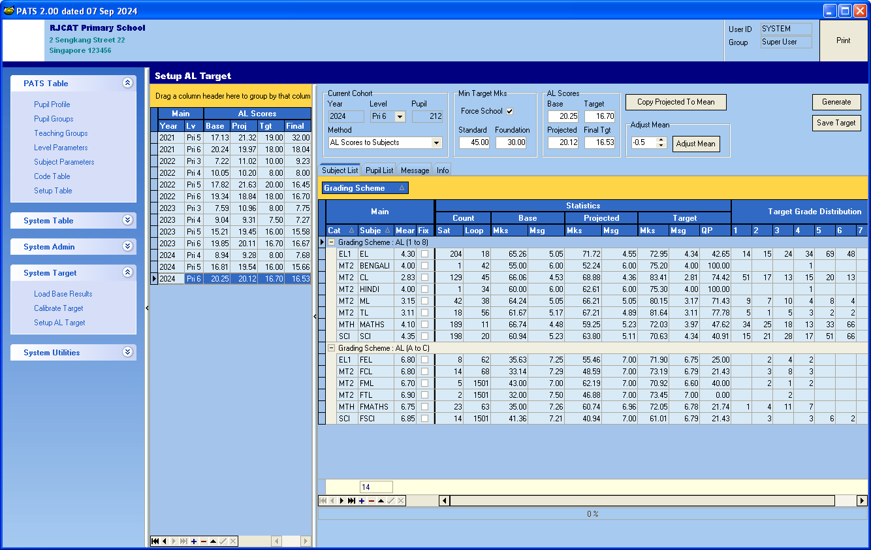

## Top-Down Approach

AL Scores to Subject

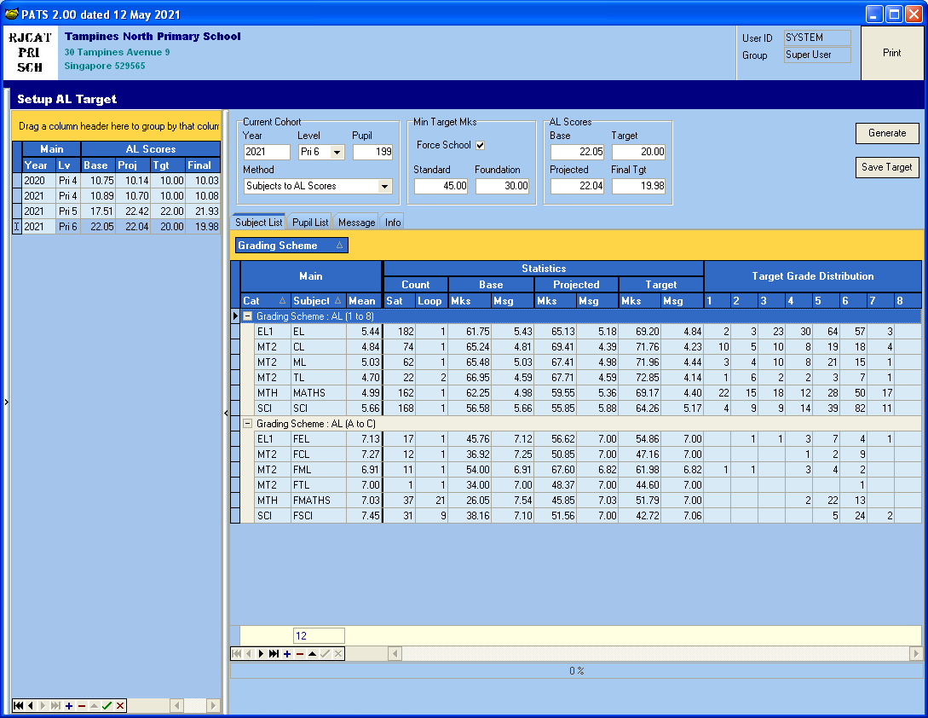

**FINAL TATGET**Target Computed by PATS

Enter the Min Marks

**Subject MEAN**Enter the Mean for each Subject. You may refer to previous year Results for reference

**AL Scores TARGET**Enter the AL Scores Target

Select AL Scores to Subject

Steps

1. Select “AL Scores to Subjects”
2. Tick Force School if you want analyze based on Min Targets
3. Enter the Min Marks for STANDARD and FOUNDATION
4. Enter the AL Scores Target to achieve
5. Enter the MEAN for each Subject
6. Click Generate button
7. Review “FINAL Tgt” and adjust MEAN and AL Scores TARGET
8. Click Save Target button to save the target to student database

## Bottom-Up Approach

Subjects to AL Scores

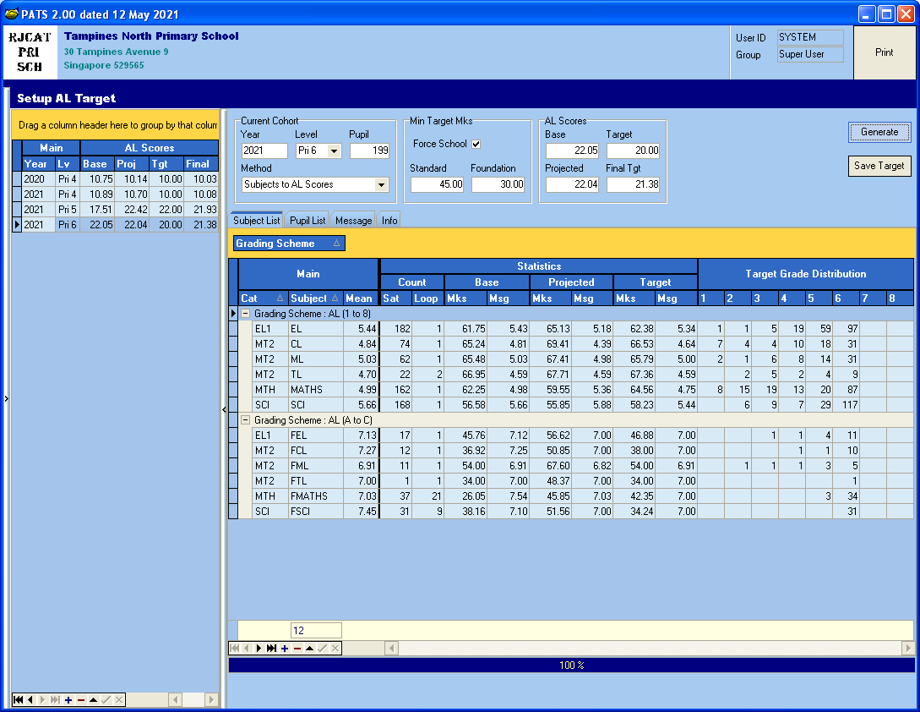

**FINAL TATGET**Target Computed by PATS

**Subject MEAN**Enter the Mean for each Subject.

**AL Scores TARGET**Enter the AL Scores Target

Enter the Min Marks

Select Subject to AL Scores

Steps

1. Select “Subjects to AL Scores”
2. Tick Force School if you want analyze based on Min Targets
3. Enter the Min Marks for STANDARD and FOUNDATION
4. Enter the AL Scores Target to achieve (Only for your own reference)
5. Enter the MEAN for each Subject
6. Click Generate button
7. Review “FINAL Tgt”
8. Repeat “step 5 to 7” until the “FINAL Tgt” is achieved.
9. Click Save Target button to save the target to student database

## Print Target

There are 10 different Target Reports. Print and Preview to see what they provide.

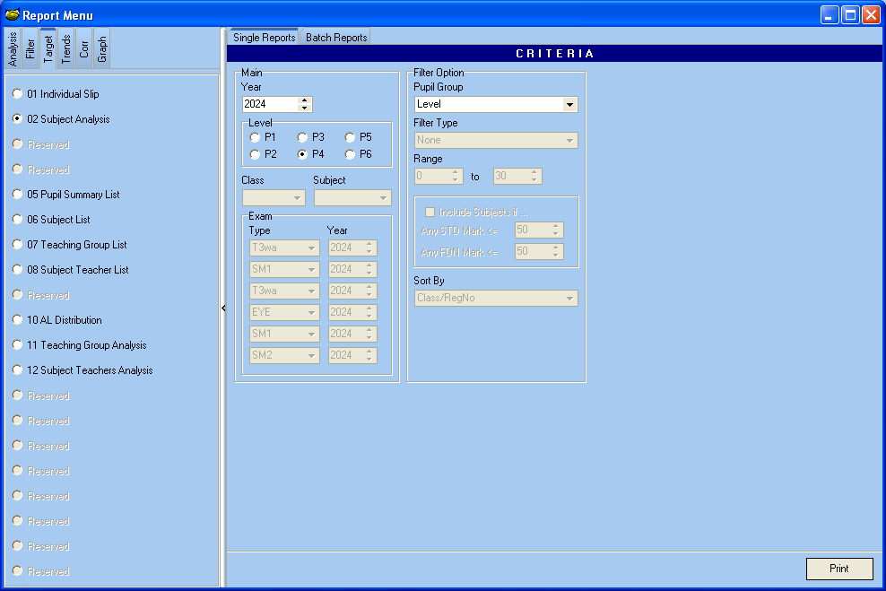

## Change Target Manually

Menu Access: PATS Table | Pupil Profile

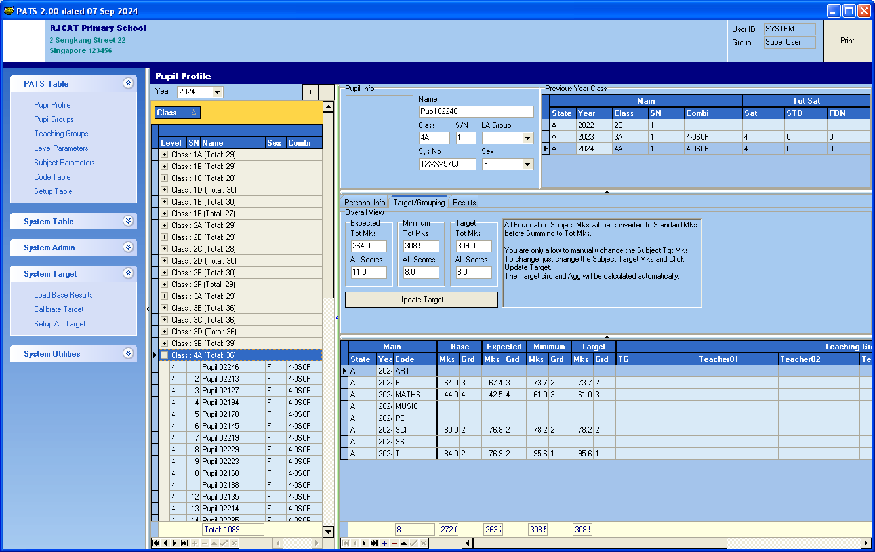

Change the Target Mks and click Update Target

Steps

1. Select the student
2. Update the Target Mks for all subjects for the student
3. Click Update Target

Note:

* You are only allowed to change the Target Mks.
* The Target Grd for the subjects and AL Scores will be calculated automatically

## Reports

There are 6 categories of Reports. Print and Preview to see what they provide:

* Analysis - Summary Analysis
* Filter - Analysis and Listing of Selected Group of pupils
* Target - Target Analysis and Listing
* Trends - Trend List
* Corr - Correlation between 2 exams or Target and Exam
* Graph - Pupil List

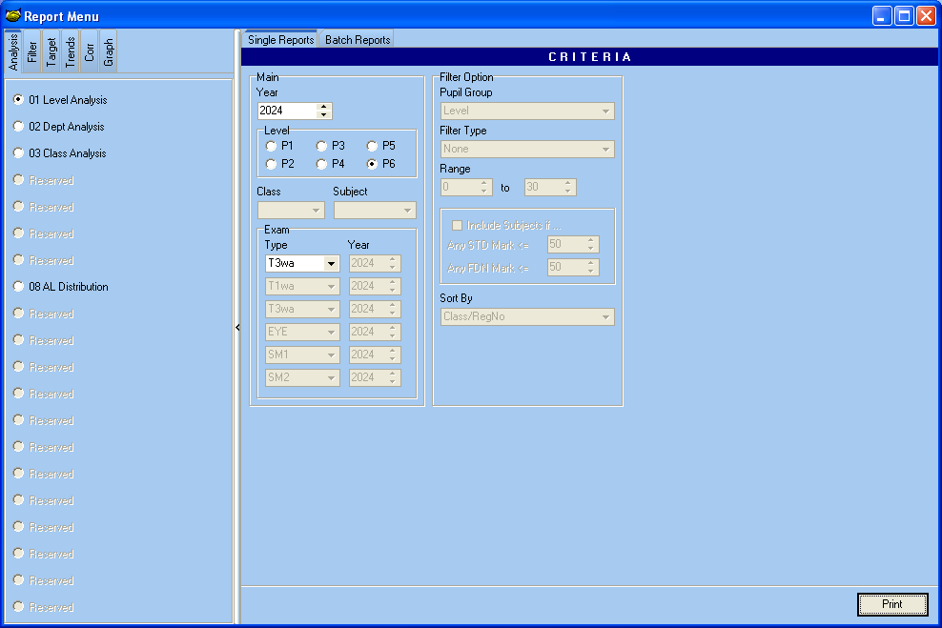

### Reports - Filter

Analyze and List Selected Group of pupils.

Filter Type (can enter a range to include)

* Non (Al Pupils)
* Ave Mark
* AL Scores
* No of Subject Pass
* No of Subject Fail

Sort By

* Class/RegNo
* Ave Mark (Top to Bottom)
* AL Scores (Top to Bottom)

