S1PS

Sec One Posting Management System

Contents
Login 1
Main Menu 2
Setup Teaching Group Parameters and SBB Criteria 3
Setup Class List 4
Setup Subject List 5
Update Teaching Groups 6
Load Mask File 7
Print Report for Planning 8
Load Posting File 9
Update Pupil Info 10
Process Allocation 11
Check Allocation 12
Update Subject Teachers (Intact Class & Teaching Group) 13
Export Excel 14
Print Report 15
Sample Reports – GG Profile 16
Sample Reports – Combi Profile 17
Sample Reports – Enrolment Profile 18
Sample Reports – Class PSLE Profile 19
Sample Reports – PSLE Profile 20
Sample Reports – Subject Profile 23
Sample Reports – Teaching Profile 24
Sample Reports – Individual Subject Slip 25
Sample Reports – Subject Profile 26
Sample Reports – Subject Profile 27
Sample Reports – Teaching Group and SBB 28
Sample Reports – Individual Subject Allocation Slip 29
Sample Reports – SBB Offer Letter 30
Sample Excel 31

Overview

S1PS is a fully OFFLINE Windows based software (Non-Internet). It is SSOE1 and SSOE2 compliance and it can runs on Windows 11. It is also already White Listed by MOE-NCB.

The software and its database reside in your school computer. There is no need to conform to the MOE IT Security Specification.

S1PS is really easy to use. It is FAST and has a friendly user-interface. After all the initial setup, the whole process of allocation should take less than 10 minutes.

Work Flow
The following is the recommended work flow for the S1PS.

Stage | Description
Pre Allocation | - Setup SBB Criteria  - Criteria for offering SBB (EL, MT, SC and MA)  - Criteria for offering HMT (HCL, HML and HTL)  - Setup Teaching Group Parameters  - Block (A and B)  - Setup Label Description  - Setup Sec 1 Classes  - Class Name  - Block (A and B)  - Setup Subjects to be offer  - G0 - Common Curriculum  - G1 - Normal (Technical) Subjects  - G2 - Normal (Academic) Subjects  - G3 - Express Subjects  - Others  - Setup up Subject Teaching Groups  - Assign Default Subjects
Preliminary Planning  Report needed from School Cockpit: RE_PPS_011 | - Load Data from Sec 1 Mask Posting File (CSV Format)  - Print GG Profile  - Print Combi Profile  - Plan Total Teaching Groups needed for each Subject
Allocation | - Load Data from Sec 1 Posting File (CSV Format)  - Update SEN (S1 to S8)  - Pre-assign students to a specific Class (Locked)  - Process Allocation  - Allocate Class to Students  - Allocate Teaching Group to Students
Post Allocation | - Assign Form Teachers to Class  - Assign Subject Teachers to Teaching Group Subjects  - Subject Print Reports  - Subject Profile  - Teaching Group and SBB  - Individual Student Subject List  - Export to Excel

Login

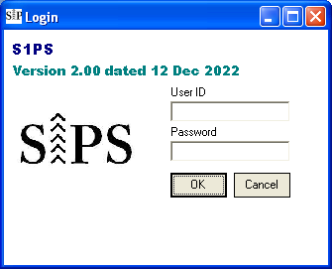
Double-Click to bypass login

Steps
- Enter User ID (system)
- Enter Password (system)
- Click “OK”

Main Menu

Print Report
Menu List

Setup Teaching Group Parameters and SBB Criteria

The default Criteria is based on MOE guideline. However, you may change them based on your school needs.

Menu Access: System Table – Setup Info
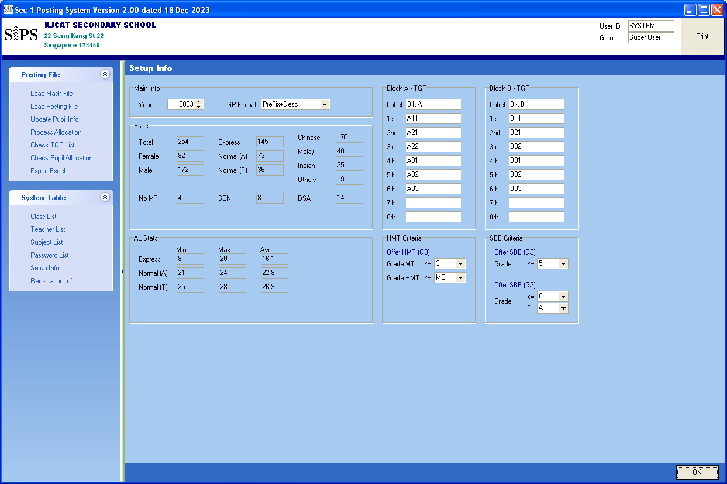
Criteria for offering HMT
Criteria for offering SBB
Teaching Group Parameters

Steps
- Update the info accordingly
- Click “OK”

Setup Class List

The default is 8 classes, 4 in Block A and 4 in Block B. You may change them based on your school needs.

Menu Access: System Table – Class List

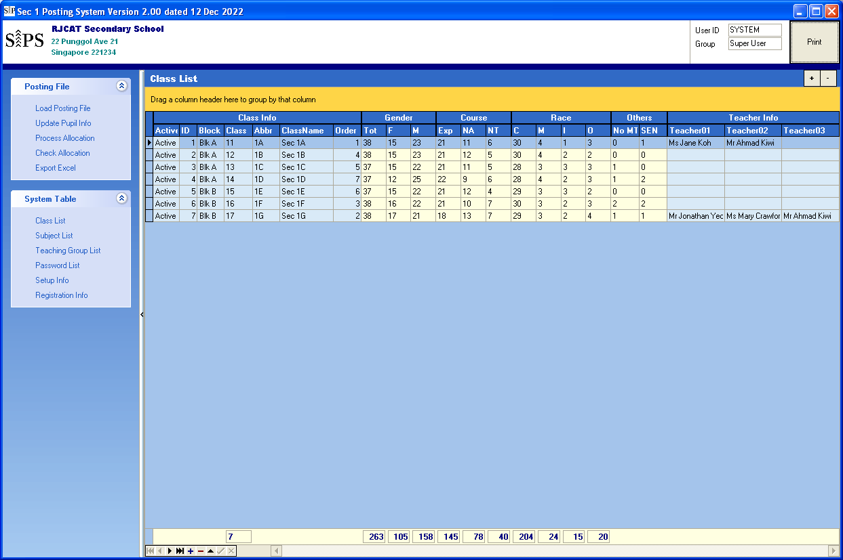
Statistics generated after “Process Allocation”

Steps
Navigator

- Add or Delete Class based on your school needs
- Assign Block A or Block B to Class
- Click another record to save

To Delete existing Record
To Add New Record

Setup Subject List

S1PS will adopt the new subject naming convention: G1, G2 & G3. In addition, G0 will be used for the common curriculum Subjects (ART, & D&T, FCE and Music). Most of the subjects are already included.

There are 2 blocks of teaching groups (Block A and Block B). Each block has up to 6 teaching groups (TGP).
The current teaching groups are defined according to Course (Exp, NA & NT):
- TGP 1 - for NT
- TGP 2-3 - for NA
- TGP 4-6 - for Express
Technically, you may use any group for any Course (Exp, NA & NT). The current setting is basically for easy viewing by Column.

Menu Access: System Table – Subject List
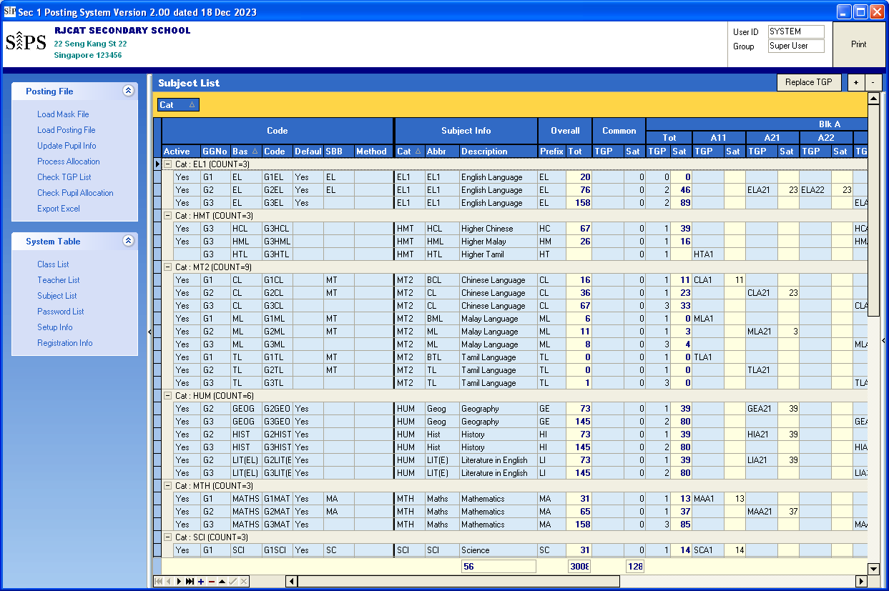
Prefix for Teaching Group

Steps
- Add or Delete Class Subject based on your school needs
- Click another record to save

Update Teaching Groups
Click Replace TGP
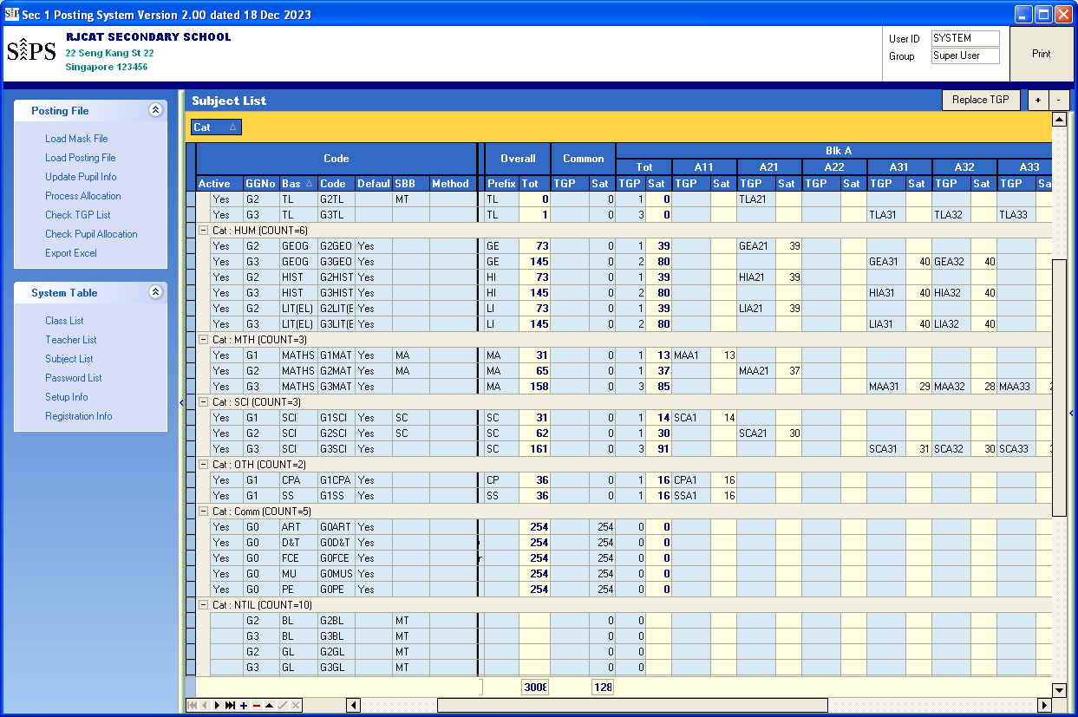
Subject with Prefix but no Teaching Group mean Non-Intact Class
(Conduct Outside School)
Change the Prefix

Steps
- Select a Subject
- Change the Prefix
- Click “Update TGP”

Load Mask File

The Mask File used is CSV format. This is the preliminary posting file for planning purposes.

Menu Access: Posting File – Load Mask File
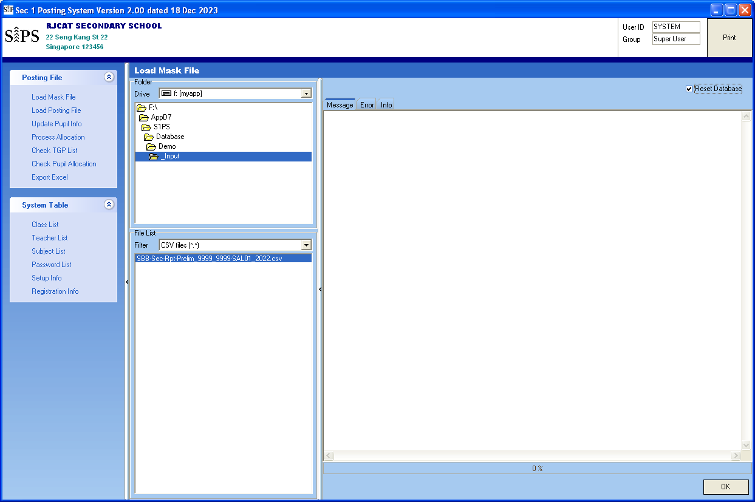
Steps
- Point the folder where you save the Mask File
- Select the Mask File
- Tick Reset Database
- Click “OK”

Print Report for Planning
There are 2 reports you can use for planning purposes
- 01 GG Profile
- 02 Combi Profile
With these 2 reports, you may plan the total teaching groups needed for each subject, pre-allocate group of students to Blk A or Blk B. For example, if there is a small group of students offered G1EL, you may pre-allocate them to Blk A.

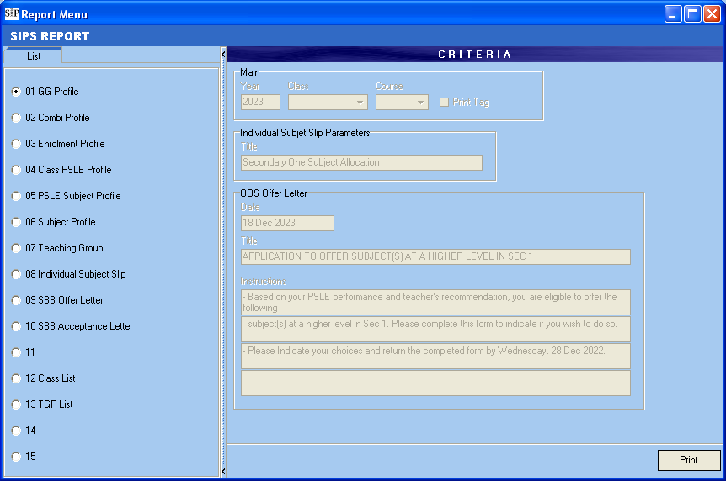

Load Posting File

The posting File used is CSV format.

Menu Access: Posting File – Load Posting File
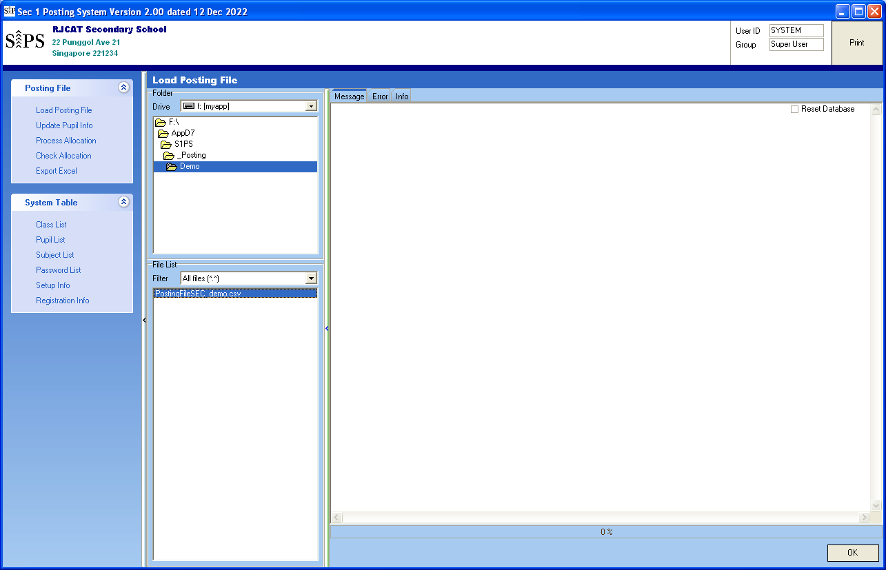
Steps
- Point the folder where you save the Posting File
- Select Posting File
- Click “OK”

Update Pupil Info

Most of the fixed data are loaded from Posting File. S1PS will determine some info based on the Criteria set:
- Offer HMT (HCL, HML or HTL)
- Offer SBB (EL, MT, SC & MA)

Some students may decide not to take up the offer. As such, you need to remove them before “Process Allocation”. In addition, there may be “Extra Subjects” that students may want to take up (Japanese, French, Higher Art, etc)
(For the Draft Allocation, you need use the default first).

Menu Access: Posting File – Subject List
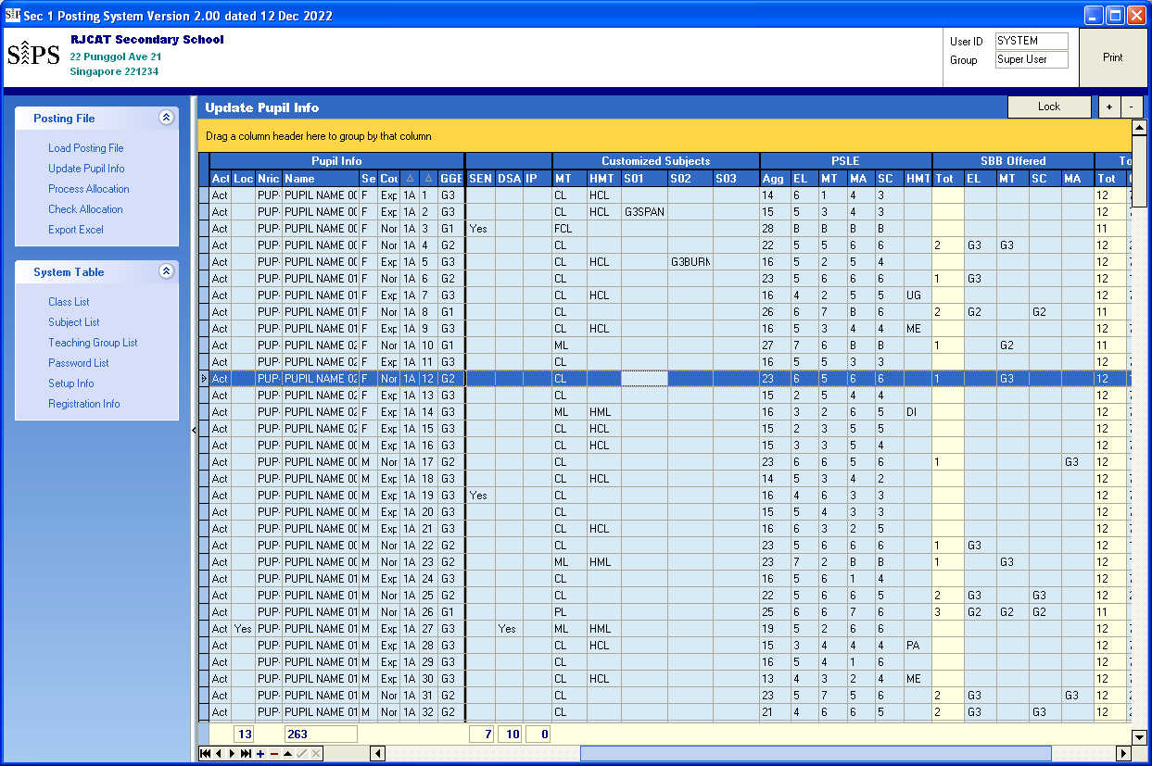
HMT offer
SBB offer
“Extra” Subject
Steps
- Point the student
- Change the value accordingly
- Click another record to save

Process Allocation

There are 2 parts in the Allocation:
- Class Allocation - Assign Class to Students
- Subject Allocation - Assign Subject to Students

For a start, you Process both at the same time.

Menu Access: Posting File – Process Allocation

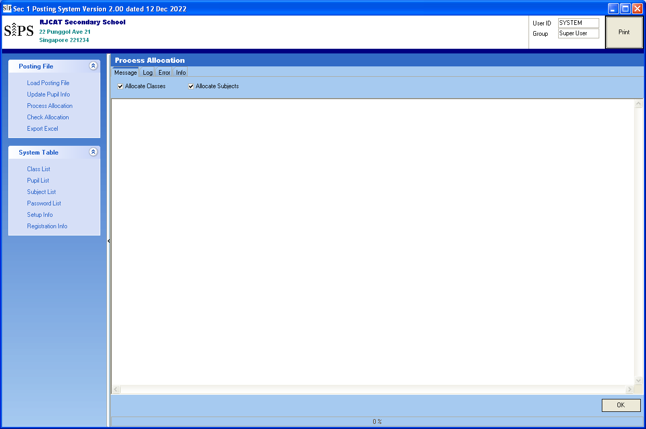

Steps
- Tick “Allocate Class” if need to Allocate Class to students
- Tick “Allocate Subject” if need to Allocate Subjects to students
- Click “OK”

Check Allocation

You can review the Student Allocation here.

Menu Access: Posting File – Check Allocation
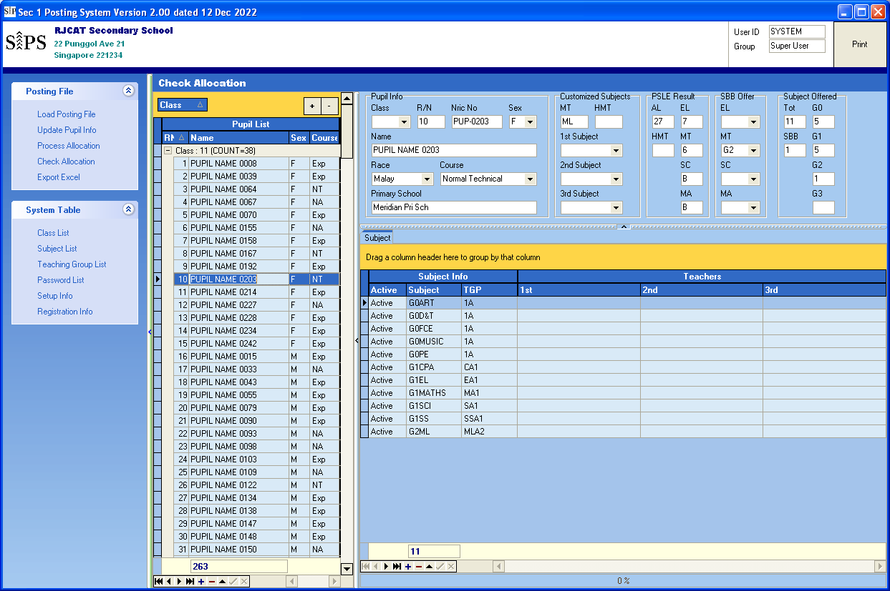
You may manually ADD/Delete or Change the Subject and TGP
Steps
- Point the student
- Select the Subject

Update Subject Teachers (Intact Class & Teaching Group)

Menu Access: System Table – Teaching Group List
You may manually ADD/Delete or Change the Subject and TGP
Steps
- Point the student
- Select the Subject

Export Excel

Menu Access: Posting File – Export Excel

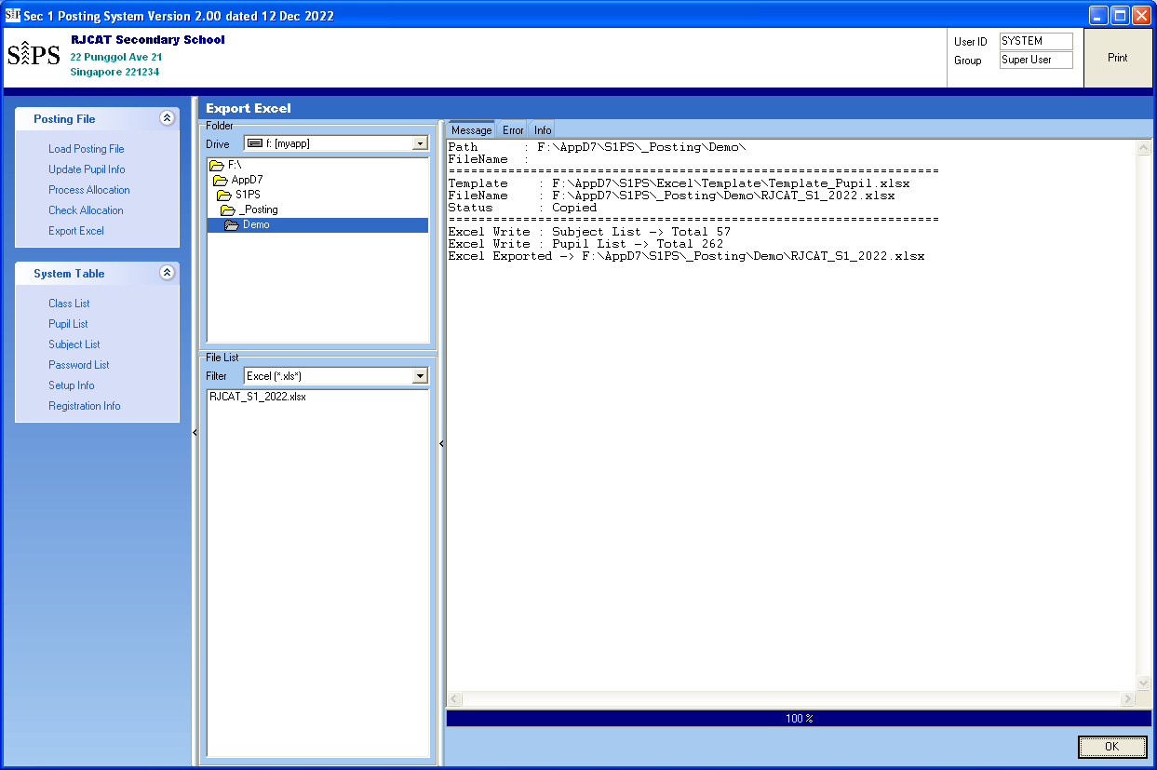
Double-Click to OPEN
Steps
- Point the folder
- Click “OK”

Print Report

All reports can be save as PDF version.

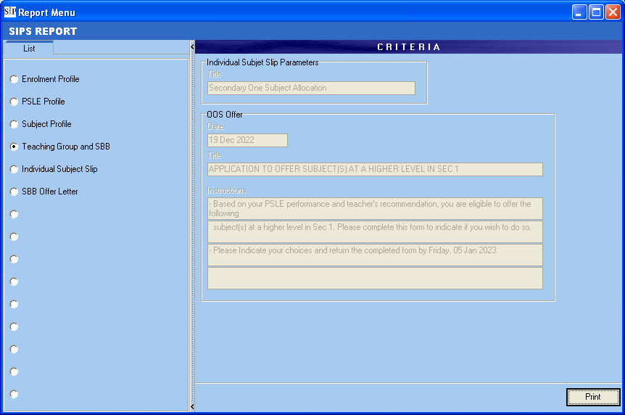

Sample Reports – GG Profile

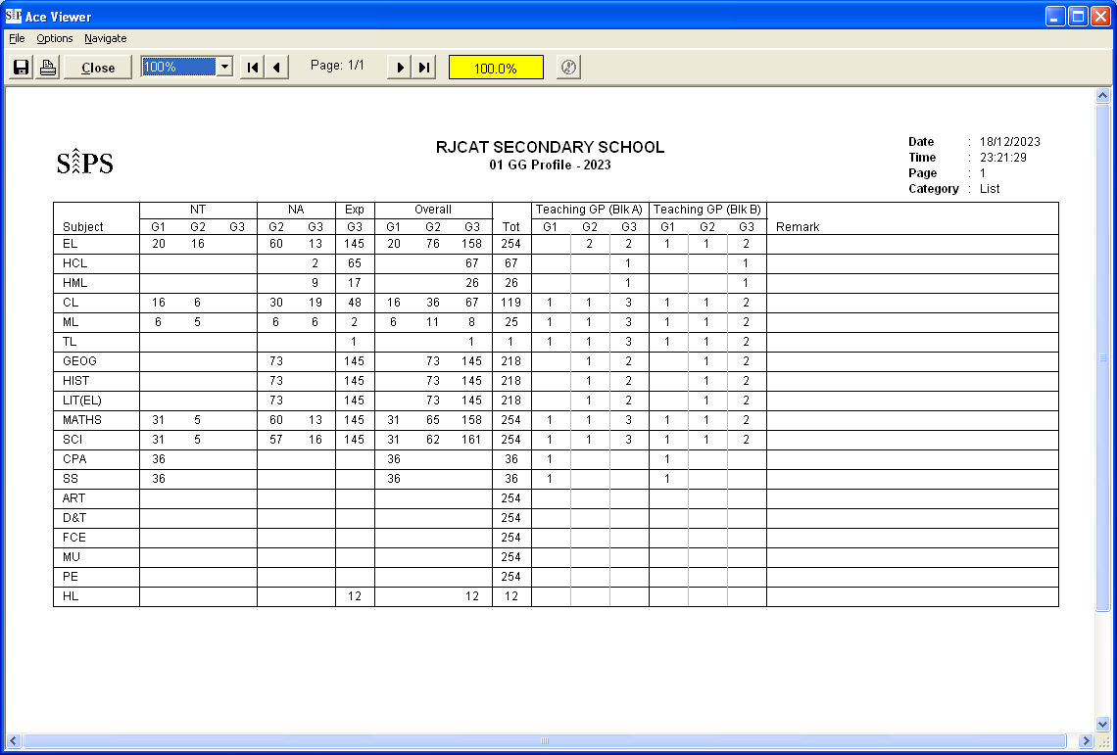

Sample Reports – Combi Profile

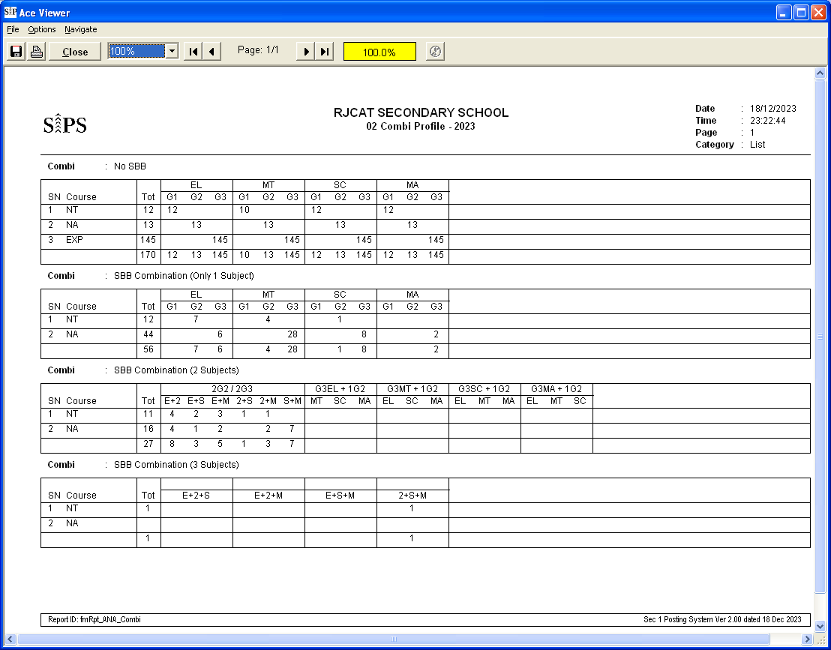

Sample Reports – Enrolment Profile

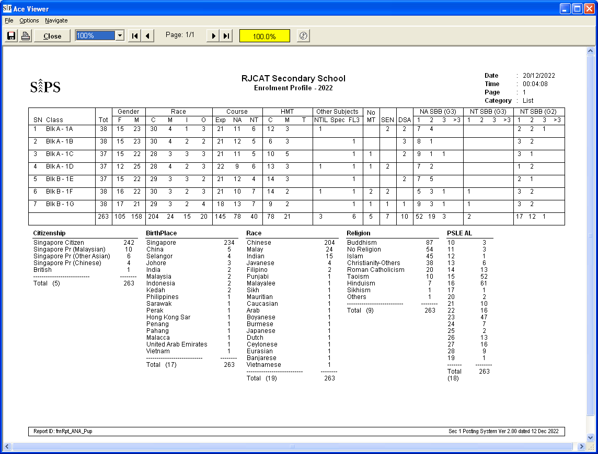

Sample Reports – Class PSLE Profile

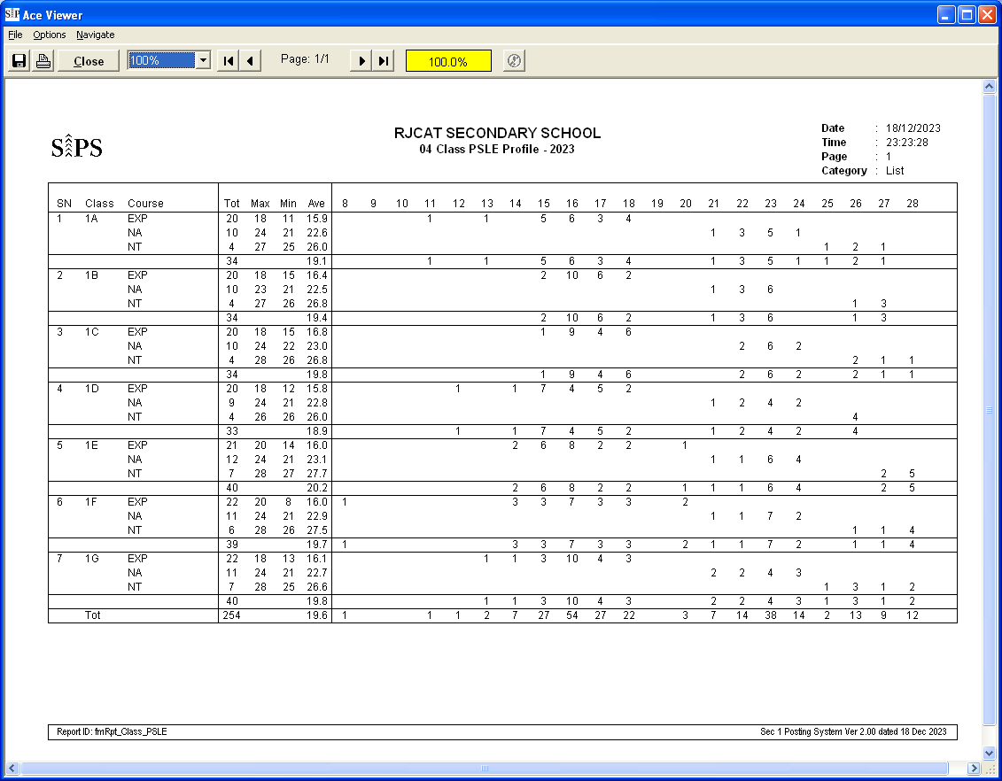

Sample Reports – PSLE Profile

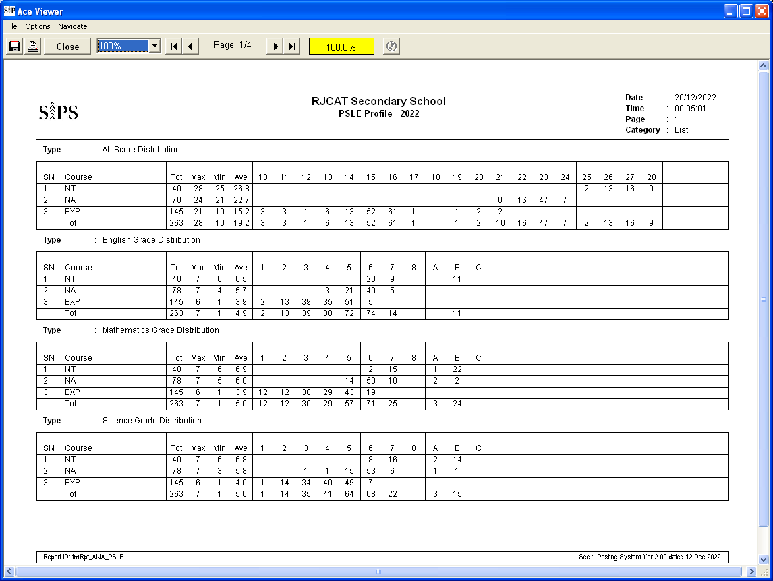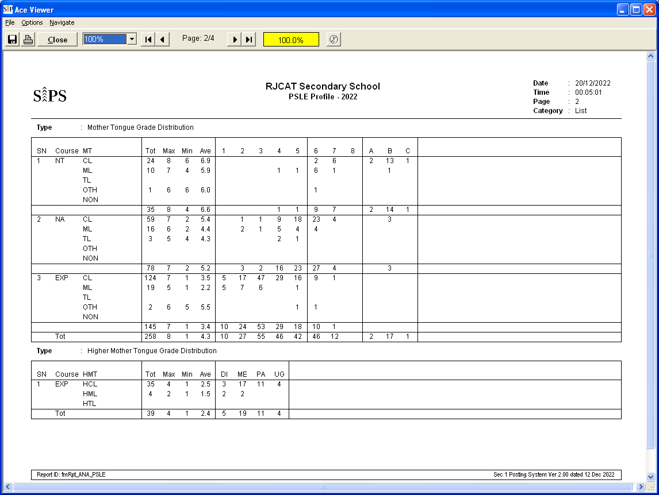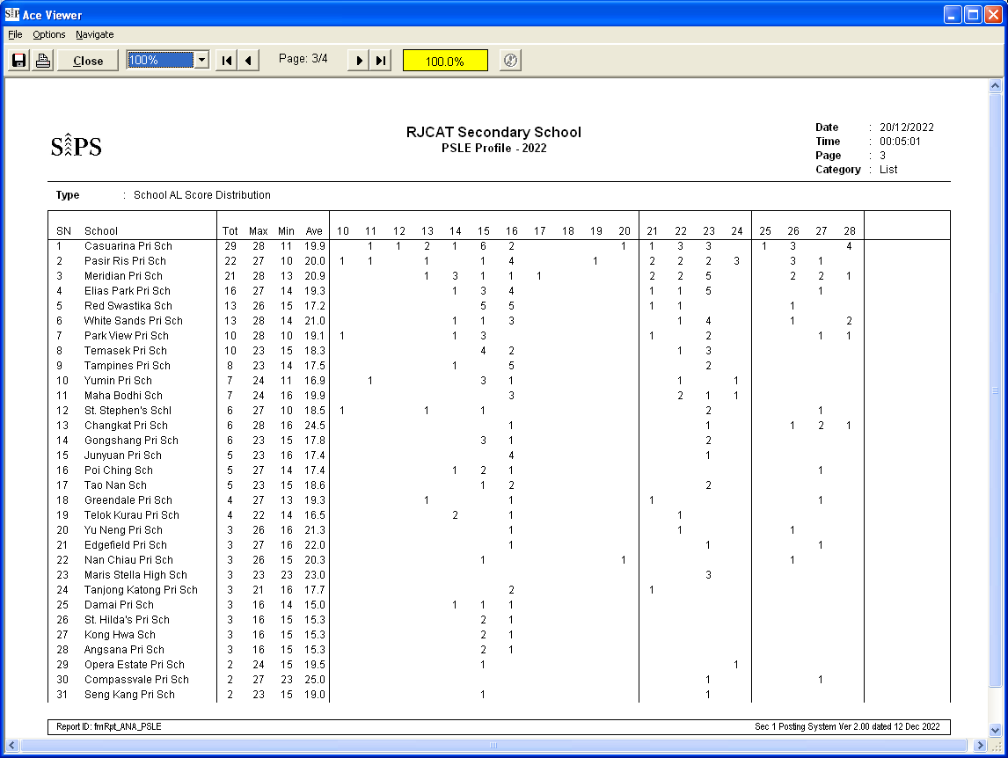

Sample Reports – Subject Profile

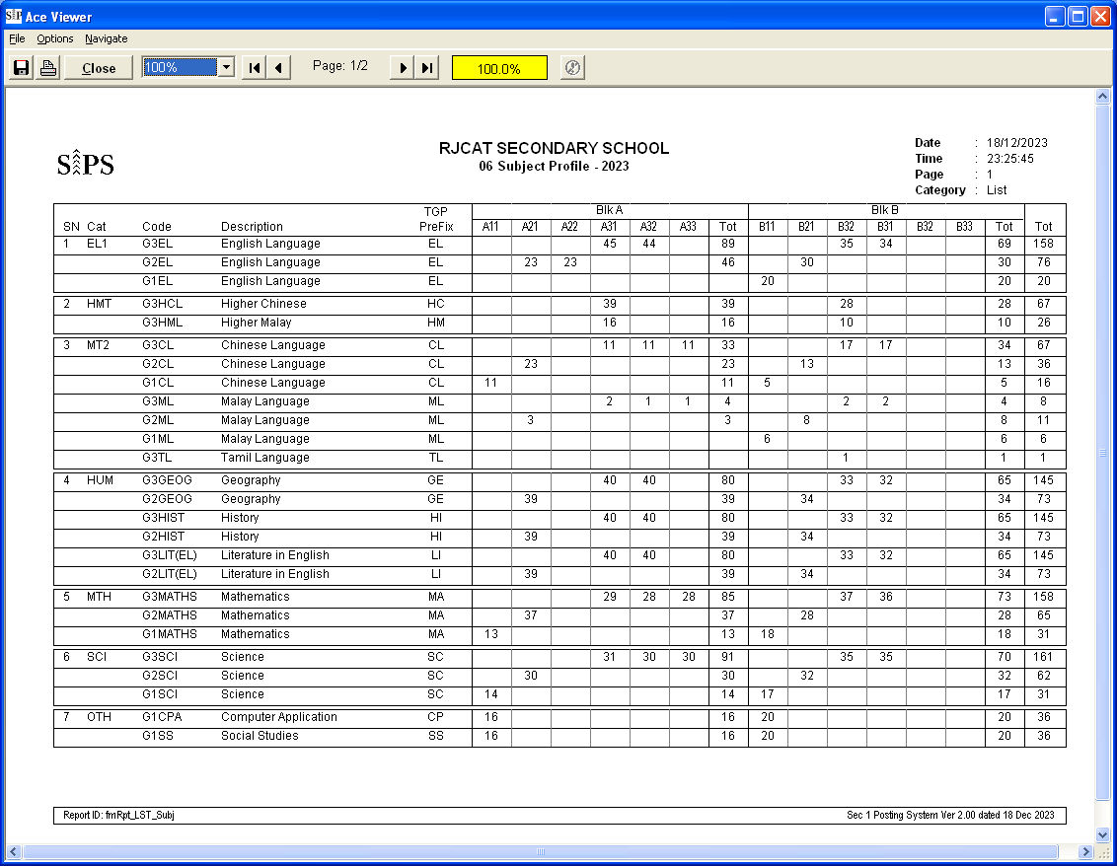

Sample Reports – Teaching Profile

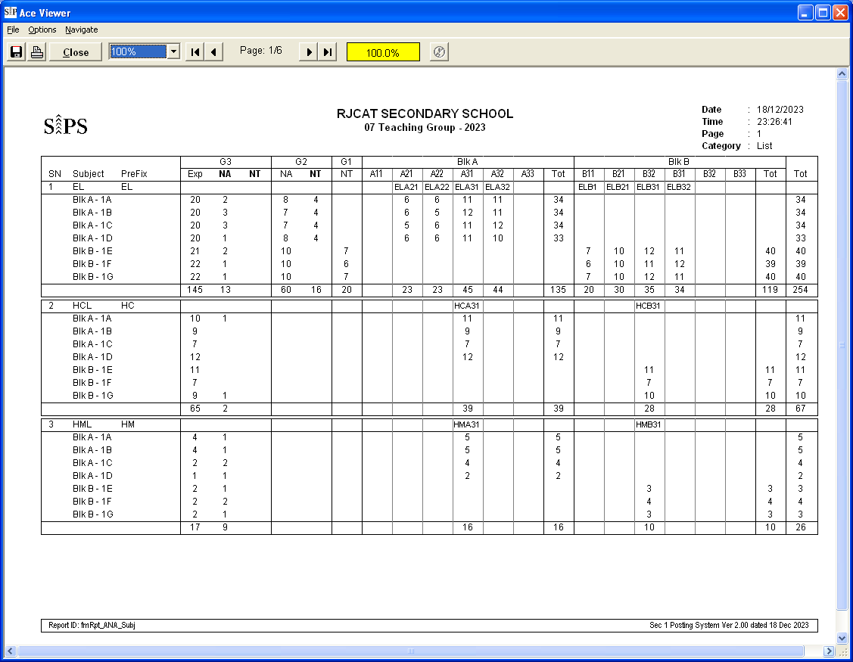

Sample Reports – Individual Subject Slip

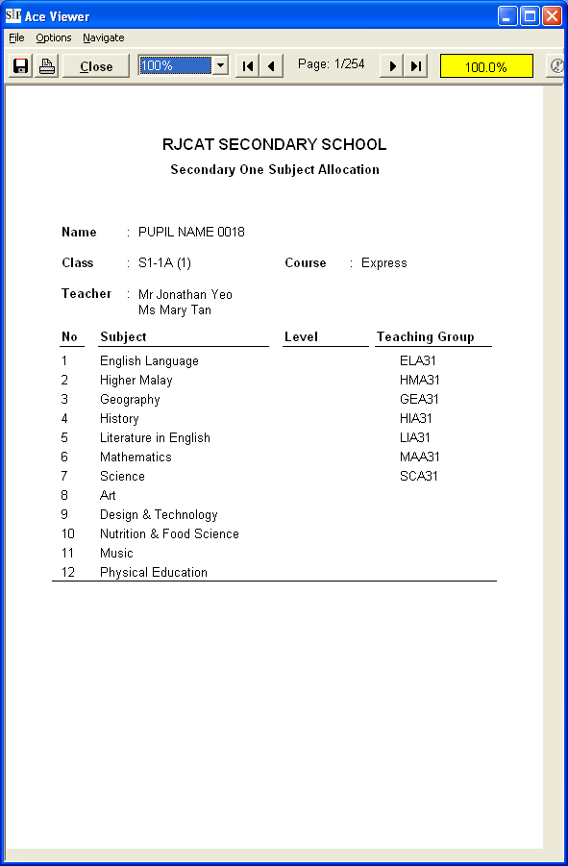

Sample Reports – Subject Profile

Sample Reports – Subject Profile

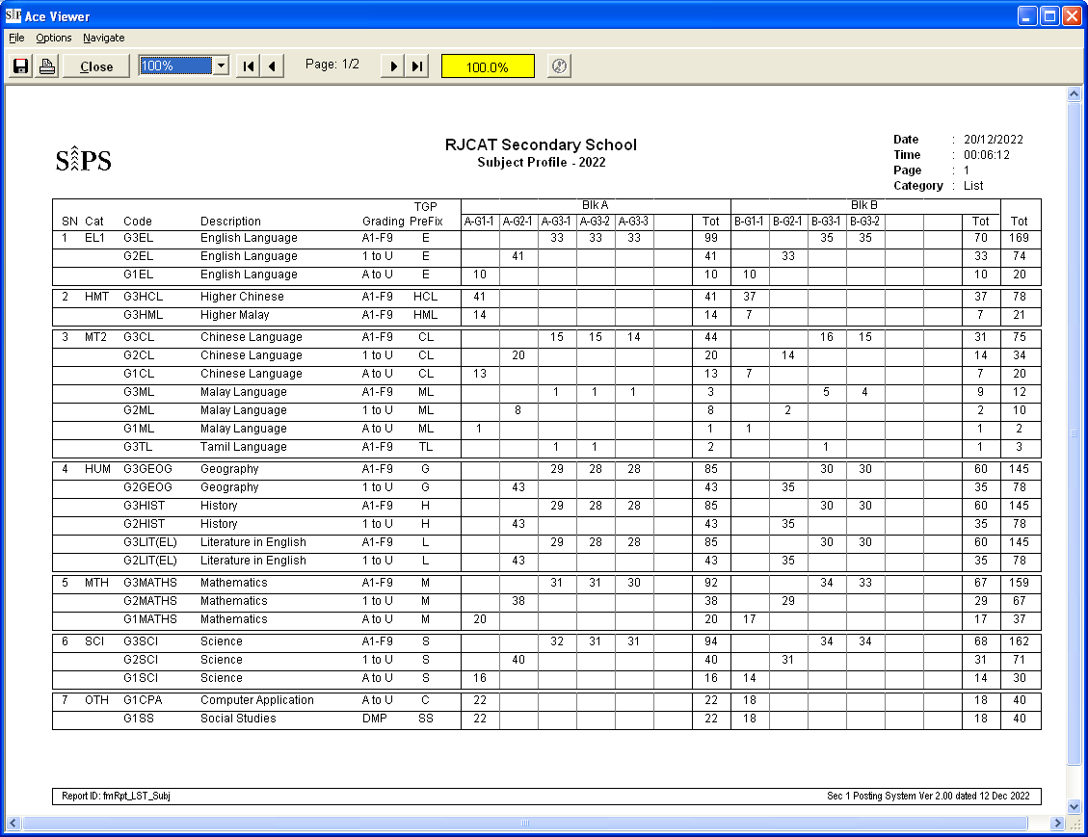

Sample Reports – Teaching Group and SBB

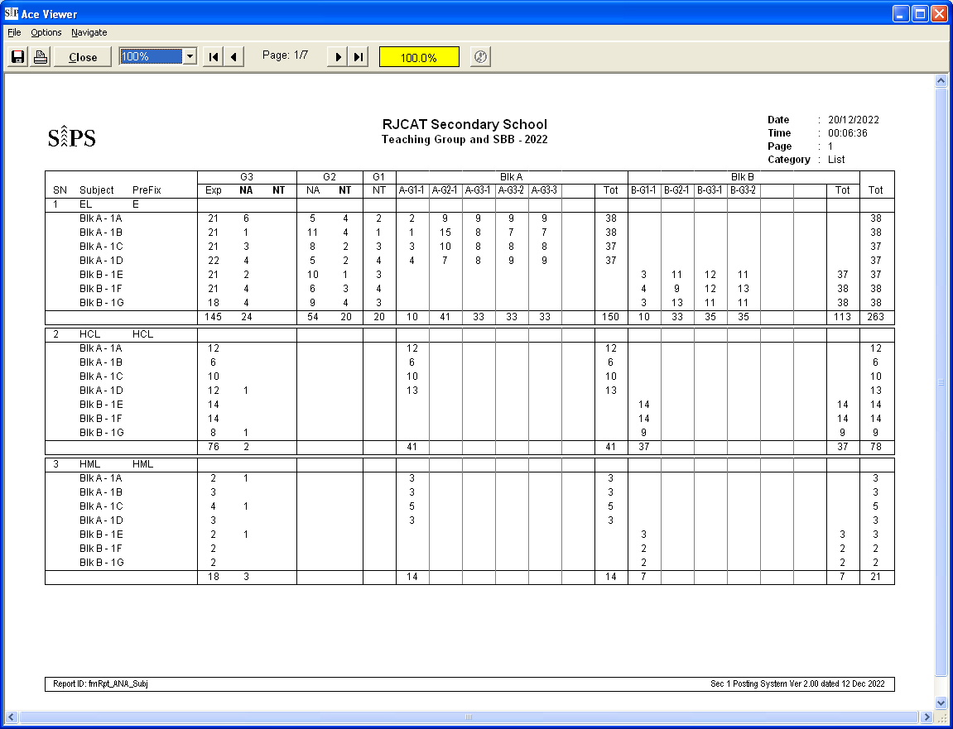

Sample Reports – Individual Subject Allocation Slip

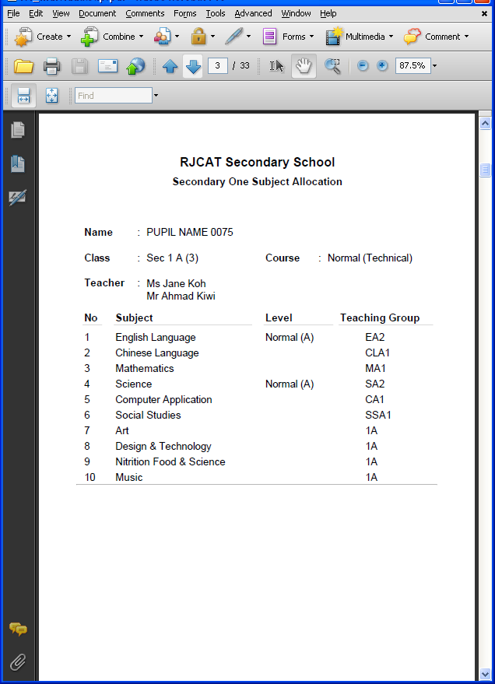
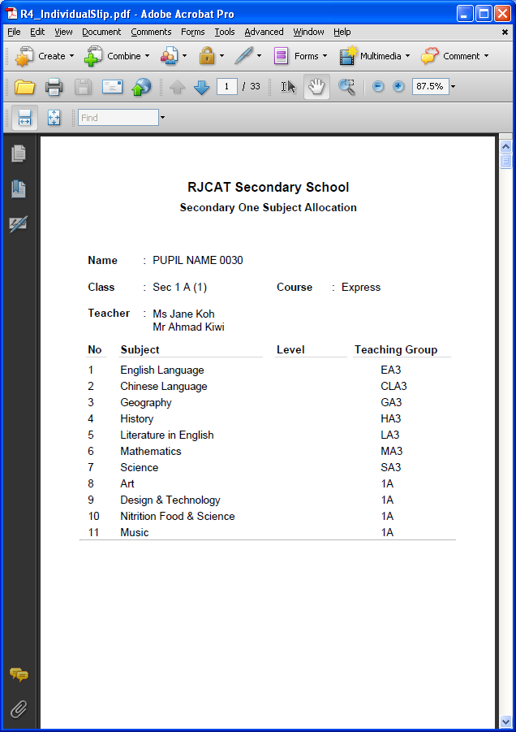

Sample Reports – SBB Offer Letter

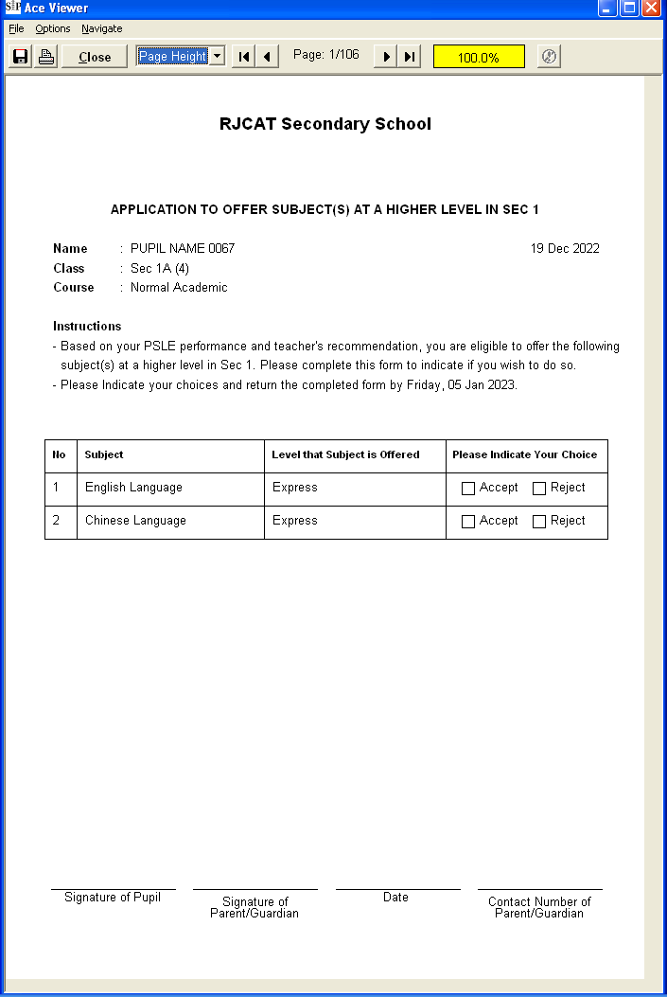

Sample Excel

