**S1PS**

**Sec 1 Posting System**

Contents

Login 1

Main Menu 2

Load Posting File 3

Sample Posting File 4

S1PS DashBoard 5

Enrolment Profile 6

Pupil List 7

Class List 8

Swap Class between 2 pupils 9

Subject List 11

Setup Teaching Group Parameters and SBB Criteria 12

Print Report for Planning 13

Teaching Group List 14

Pupil Allocation 15

Add/Delete Pupil 16

Assign Subject and Teaching Group to Students 17

Cross Check 18

Utilities – Excel Import 19

Utilities – Excel Export 20

Print Report 21

Sample Excel – SCP Class Allocation 22

Sample Excel – SCP Subject Allocation 23

Sample Excel – SCP TGP Allocation 25

Sample Excel – SCP TGP Assignment 26

Sample Excel – S1PS Class List 27

Sample Excel – S1PS Pupil List 28

Sample Excel – S1PS TGP List 29

Sample Report – GG Profile 30

Sample Report – Combi Profile 31

Sample Report – Enrolment Profile 32

Sample Report – Class PSLE Profile 33

Sample Report – PSLE Profile 34

Sample Report – Subject Profile 37

Sample Report – Teaching Profile 38

Sample Report – Individual Subject Slip 39

Sample Report – MDL Offer Letter 40

**Overview**

S1PS is a fully OFFLINE Windows based software (Non-Internet). It is SSOE1 and SSOE2 compliance and it can runs on Windows 11. It is also already White Listed by MOE-NCB.

The software and its database reside in your school computer. There is no need to conform to the MOE IT Security Specification.

S1PS is really easy to use. It is FAST and has a friendly user-interface. After all the initial setup, the whole process of allocation should take less than 10 minutes.

**Work Flow**

The following is the recommended work flow for the S1PS.

|  |  |
| --- | --- |
| **Stage** | **Description** |
| Pre Allocation | 1. Setup MDL Criteria    1. Criteria for offering MDL (EL, MT, SC and MA)    2. Criteria for offering HMT (HCL, HML and HTL) 2. Setup Teaching Group Parameters    1. Block (A and B)    2. Setup Label Description 3. Setup Sec 1 Classes    1. Class Name    2. Block (A and B)    3. Max Class Size for PG1, PG2, PG3 4. Setup Subjects to be offer    1. G0 - Common Curriculum    2. G1    3. G2    4. G3 5. Setup up Subject Teaching Groups |
| Allocation | 1. Load Posting File 2. Update SEN (S1 to S8) 3. Pre-assign students to a specific Class (Locked) 4. Assign Specific Subject (MDL and Non MDL) to Block A or B 5. Allocate Classes to Students 6. Allocate Teaching Group to Students |
| Post Allocation | 1. Assign Form Teachers to Class 2. Assign Subject Teachers to Teaching Group Subjects 3. Subject Print Reports    1. Subject Profile    2. Teaching Group and SBB    3. Individual Student Subject List 4. Export to Excel    1. To be uploaded to Cockpit    2. Subject Profile    3. Subject Profile    4. Teaching Group and SBB 5. Individual Student Subject List |

## Login

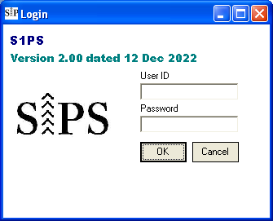

Double-Click to bypass login

Steps

* Enter User ID (system)
* Enter Password (system)
* Click “OK”

## Main Menu

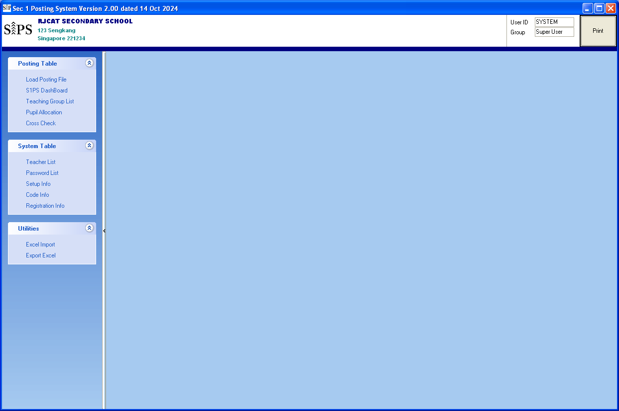

Print Report

Menu List

## Load Posting File

The original posting File is in CSV format. You will need to do the following first:

* Save the CSV as an EXCEL format.
* Copy the Name from RE_PPS_011 to Posting File “STAT-NAME” (Name in Posting File be may not be complete)
* Copy the column “Indicative Level of Most subjects at Start of Sec 1” from RE_PPS_011 to the Posting File “POST-CAT”

Menu Access: Posting Table – Load Posting File

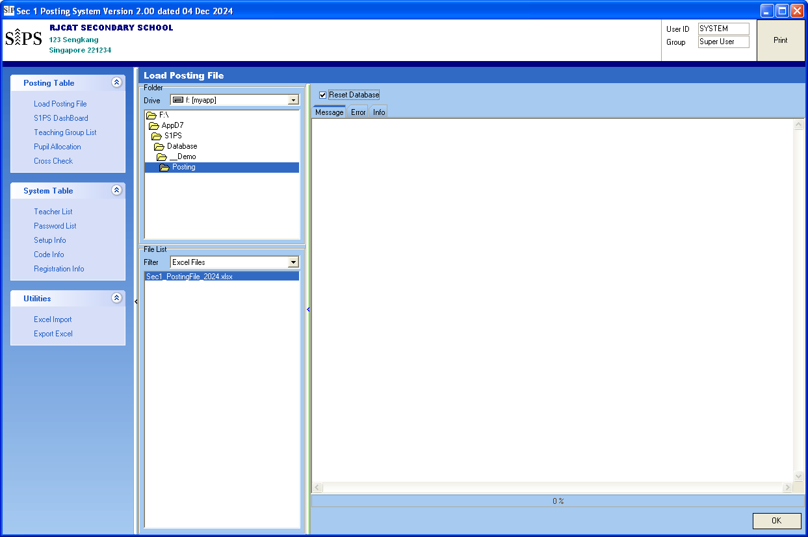

Steps

* Point the folder where you save the Posting File
* Select the Posting File
* Click “OK”

### Sample Posting File

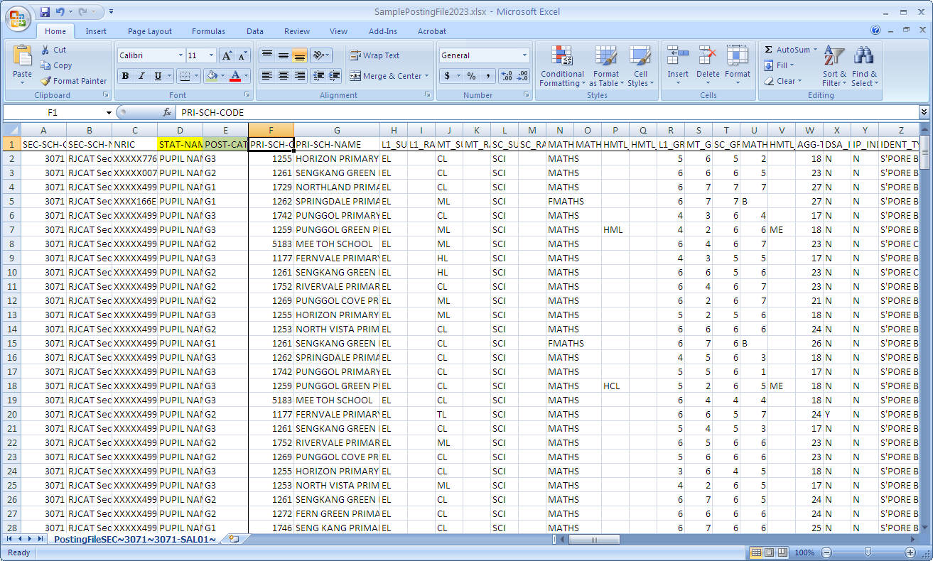

## S1PS DashBoard

All processes are consolidated in the DASHBOARD.

There are 4 main Areas

* Enrolment Profile
* Pupil List
* Class List
* Subject List

### Enrolment Profile

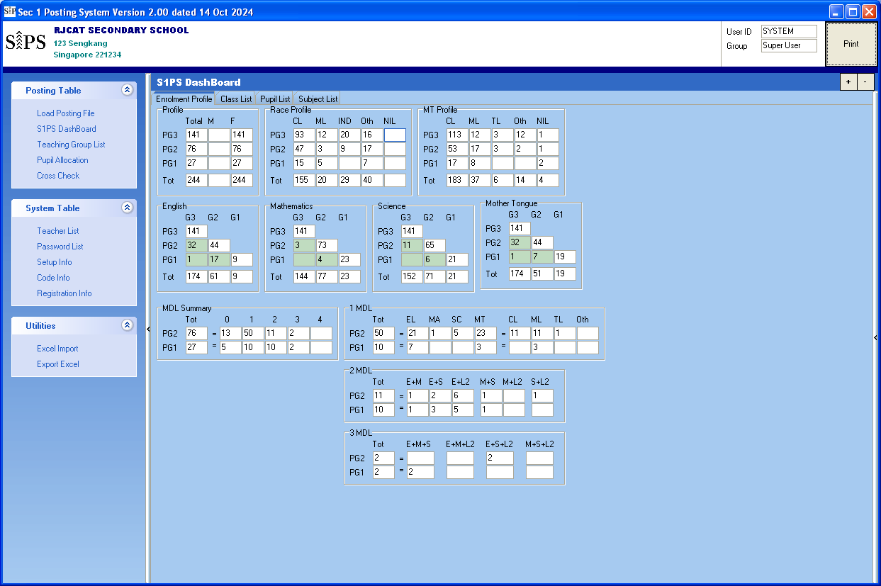

### Pupil List

This is the place where you define SEN and Lock student to a class. In addition, it will display the MDL offered to students.

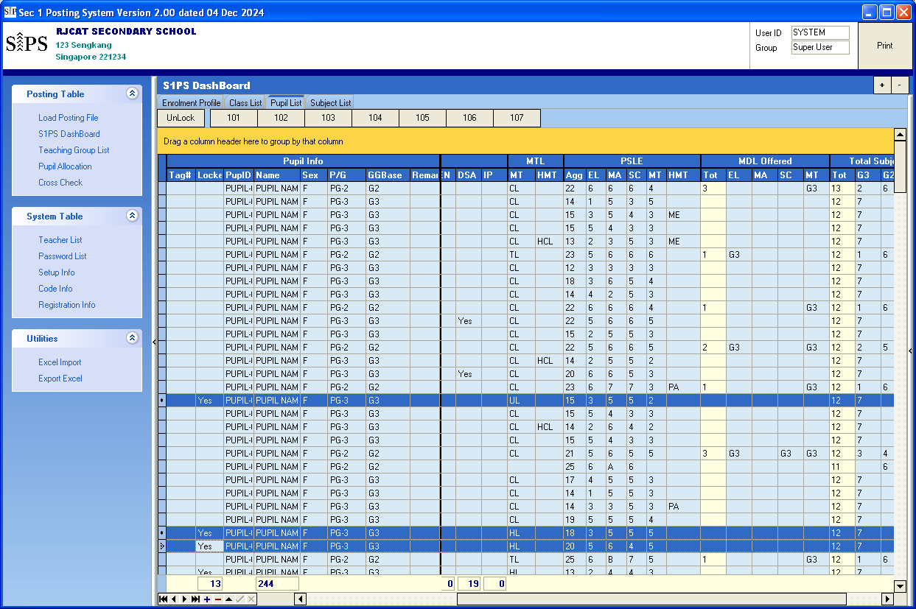

Click the vertical bar if you need to swap class between pupils manually

There are Class Buttons

To Lock Students to a class

* Select Students to Lock, use (CTRL+SHIFT) click
* Click on of the of CLASS buttons

To UnLock Students

* Select Students to Lock, use (CTRL+SHIFT) click
* Click UnLock button

### Class List

This is the place where you define your classes and allocate classes to students.

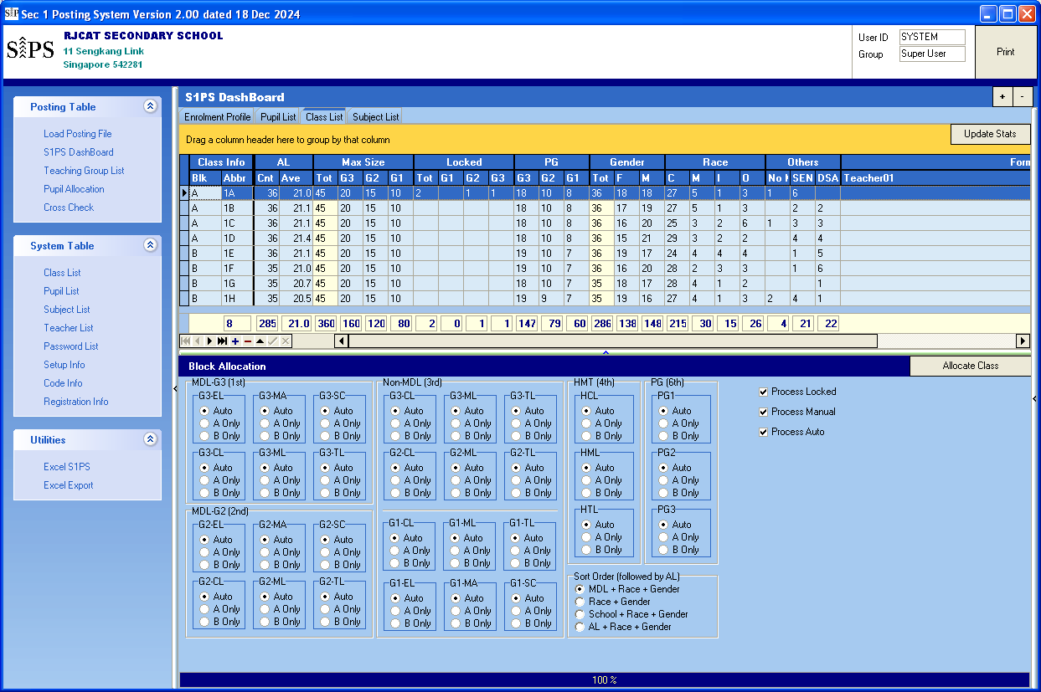

Select Sort Order

Allocate Class to students

There are 3 PROCESSES to Allocate Class

* Process Locked - You may “prelock” students to a class prior to Allocate Class
* Process Manual - You may “Block” All PG1 to Block B

You may “Block” All HCL to Block A

You may “Block” ALL G3-ML to Block B (both MDL and non MDL)

* Process Auto - The rest of the students

Press “Allocate Class” to allocate class to students

### Swap Class between 2 pupils

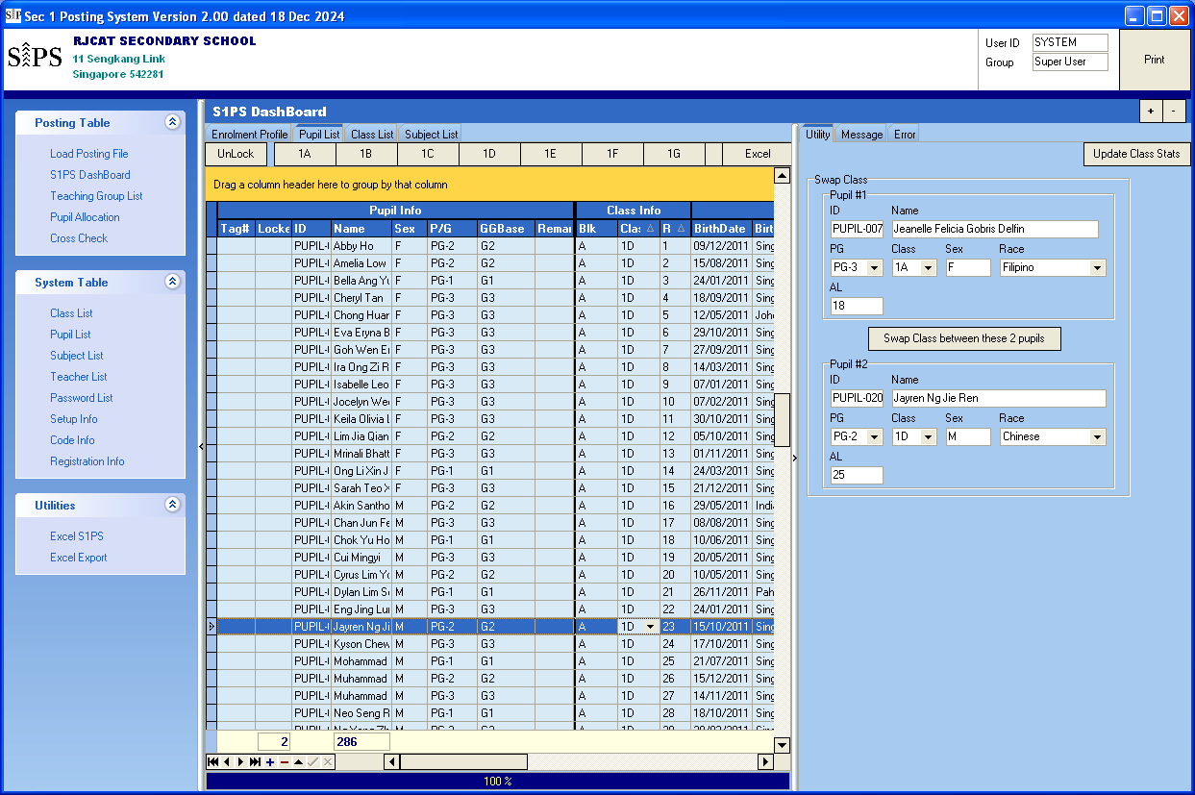

After you are done with the swapping, click “Update Class Stats”

Double-Click Pupil #2

Double-Click Pupil #1

Select Pupil

Select Pupil

Steps

* Select 1st Pupil to Swap
* Click Pupil #1
* Select 2nd Pupil to Swap
* Click Pupil #2
* Click “Swap Class between these 2 pupils”

After you are done with the swapping, click “Update Class Stats”

Update Class Stats will all the relevant statistics in the Class Table

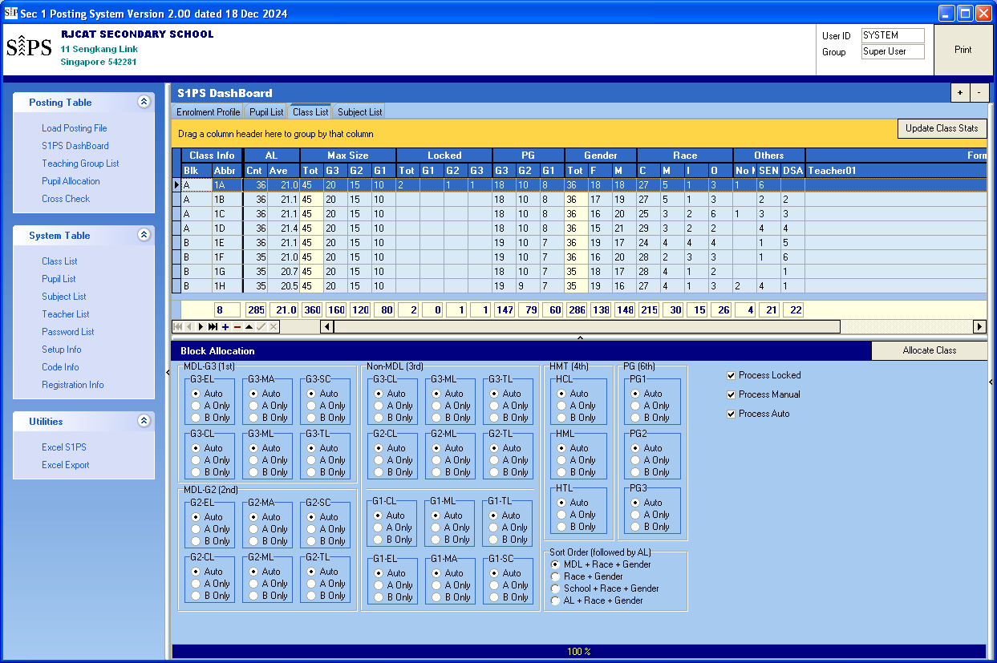

Also can click here to update class statistics.  
(Same Function)

### Subject List

S1PS will adopt the new subject naming convention: G1, G2 & G3. In addition, G0 will be used for the common curriculum Subjects (ART, D&T, FCE, PE and Music). Most of the subjects are already included.

There are 2 blocks of teaching groups (Blk A and Blk B). Each block has up to 6 teaching groups (TGP).

* G1 - One Group
* G2 - Two Groups (G2-1, G2-2)
* G3 - Three Groups (G3-1, G3-2, G3-3)

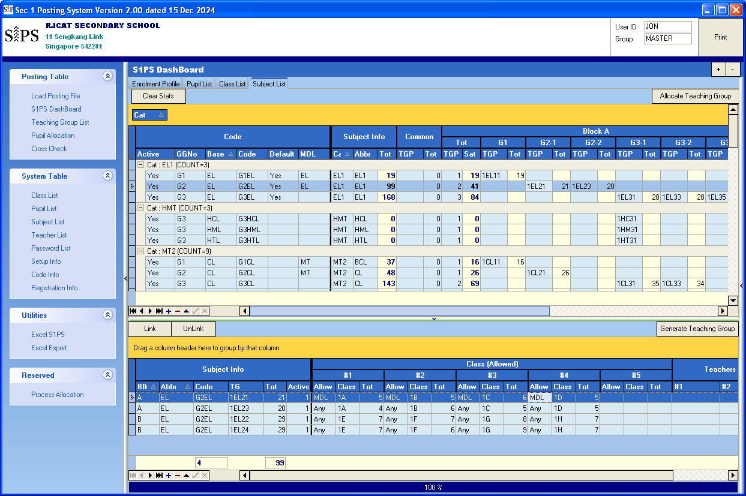

You can define class and (ALL, MDL, or Non-MDL) allowed in each Teaching Group.

The “Tot” will be displayed after Allocate Teaching Group”

Allocate Teaching Group

Generate Teaching Group

The “Tot” will be displayed after Allocate Teaching Group”

Enter Teaching Group

STEPS

* You will enter the Teaching Group Name in each block.
* Click “Generate Teaching Group”
* Update Classes allowed in each Teaching Group (Use Tick)
* Click “Allocate Teaching Group” button

## Setup Teaching Group Parameters and SBB Criteria

The default Criteria is based on MOE guideline. However, you may change them based on your school needs.

Menu Access: System Table – Setup Info

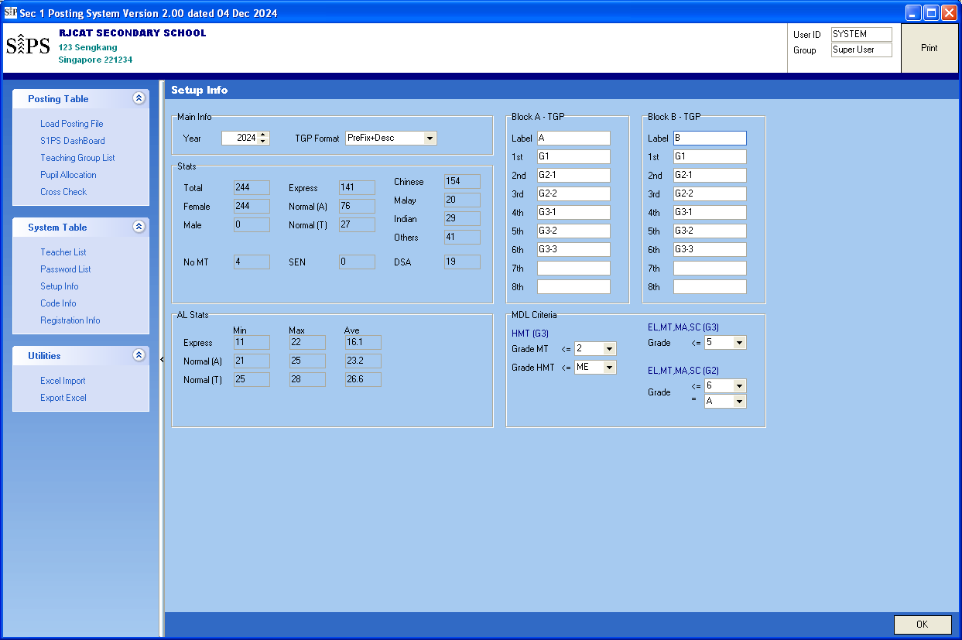

Criteria for offering HMT

Criteria for offering SBB

Teaching Group Parameters

Steps

* Update the info accordingly
* Click “OK”

## Print Report for Planning

There are 2 reports you can use for planning purposes

* 01 GG Profile
* 02 Combi Profile

With these 2 reports, you may plan the total teaching groups needed for each subject, pre-allocate group of students to Blk A or Blk B. For example, if there is a small group of students offered G1EL, you may pre-allocate them to Blk A.

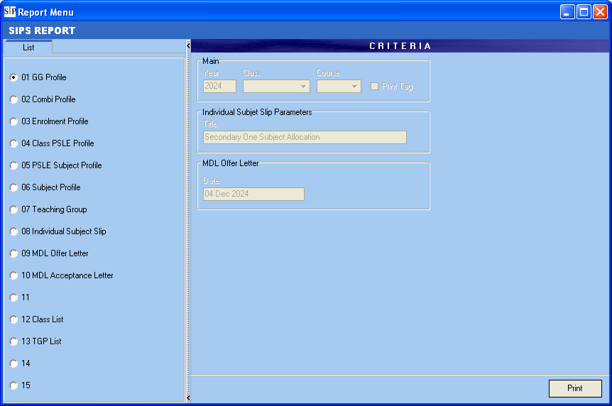

## Teaching Group List

This list will be generated automatically. You can assign Venue and Teacher to Each Teaching Group.

Menu Access: Posting Table – Teaching Group List

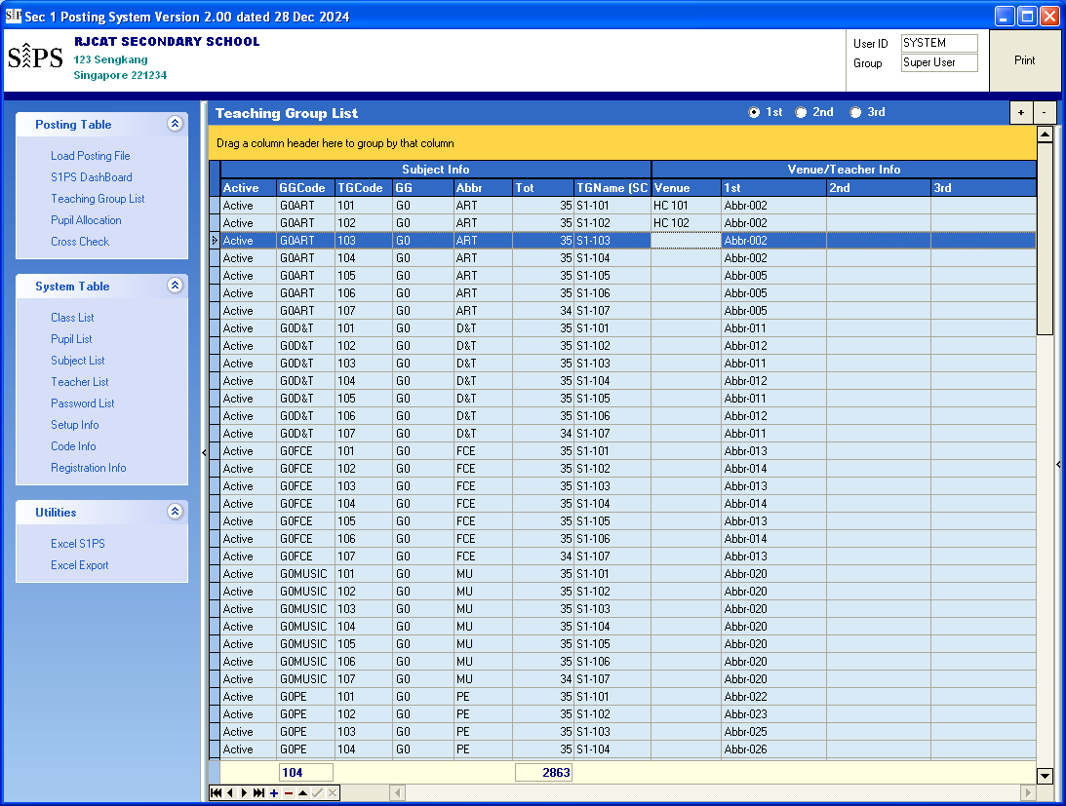

Subject Teachers

Venue

## Pupil Allocation

You can review the Student Allocation here. Under this panel, you can also do the following:

* You can also Add/Delete Students
* You can also Add/Delete Subjects for Students
* Change their Teaching Groups

Menu Access: Posting Table – Pupil Allocation  
  
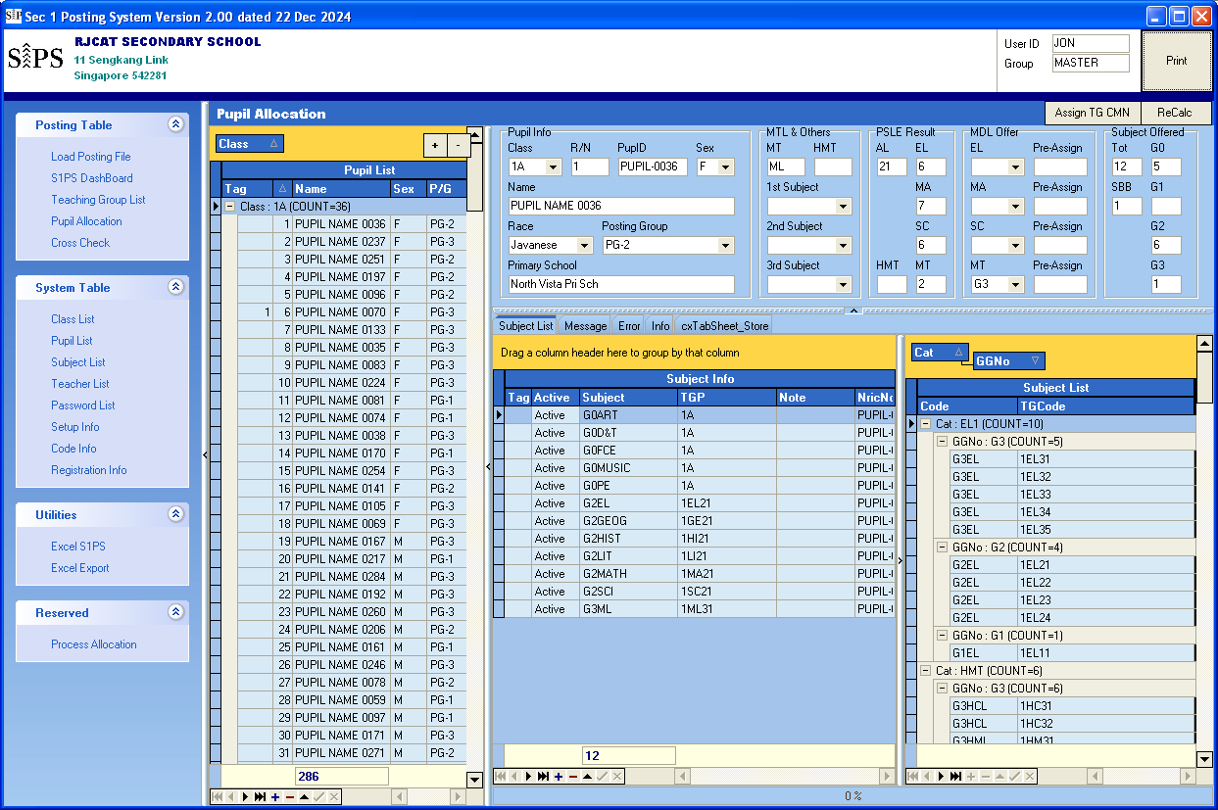

## Add/Delete Pupil

Menu Access: Posting Table – S1PS DashBoard

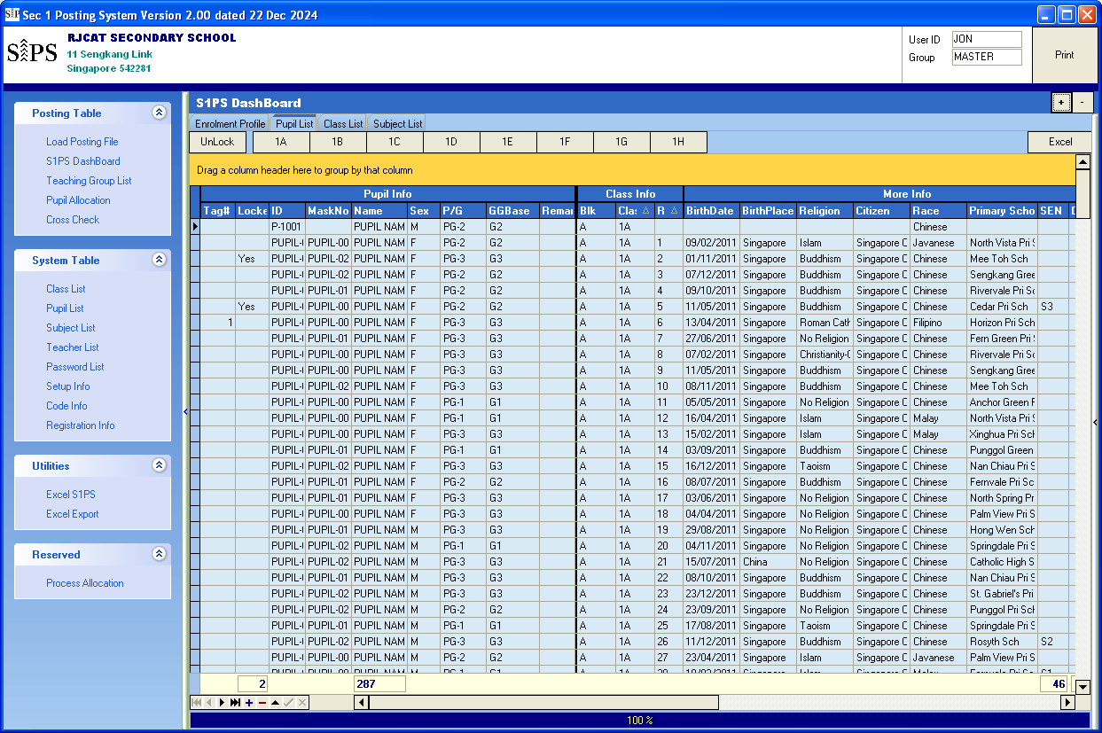

Click “+” icon or Press “INS” Key

Steps

* Click “+” icon as indicated
* Enter Key Info for Pupil (PupID, P/G, GGBase etc)
  + P

Once done, goto “Class List” and Click “Update Class Stats”

### Assign Subject and Teaching Group to Students

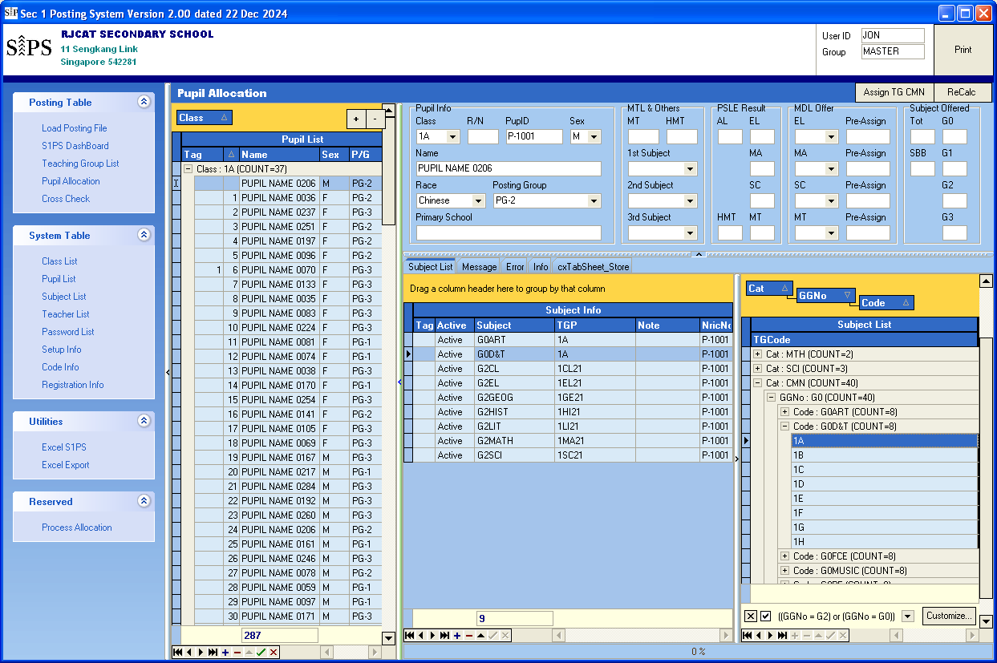  
Steps

Click Recalc after all the changes

Double-Click to Add Subject or change the Teaching Group

* Under the Subject List, select Subject (with the correct Teaching Group) to add to student

Note: Once done, click ReCalc

## Cross Check

You can do a Cross Check here

Menu Access: Posting Table – Cross Check

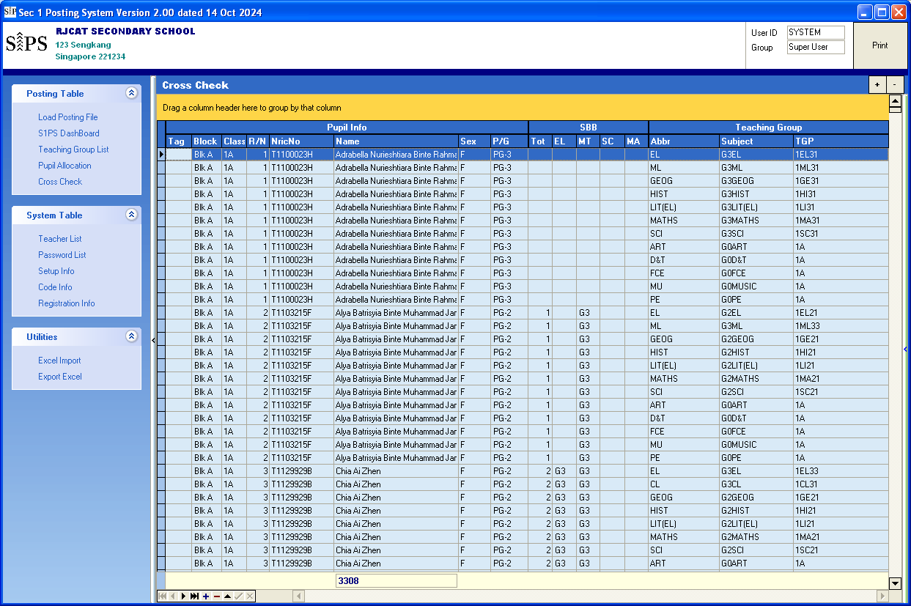

## Utilities – Excel Import

COMING….

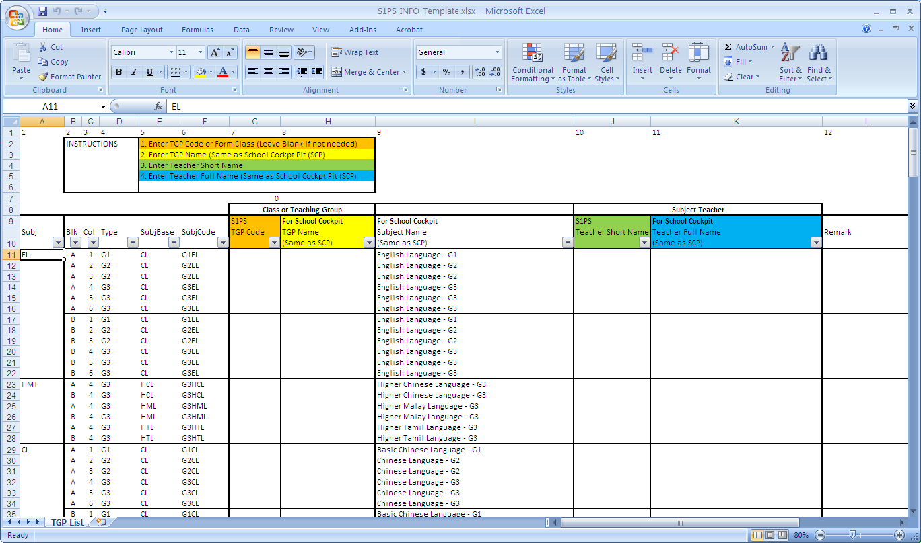

## Utilities – Excel Export

You can export excel to be uploaded to School Cockpit. In addition, there are some excels for internal use.

**School Cockpit**

* SCP Class Allocation
* SCP Subject Allocation
* SCP TGP Allocation
* SCP TGP Assignment

**S1PS (Internal use)**

* S1PS Class List
* S1PS Pupil List
* S1PS TGP List

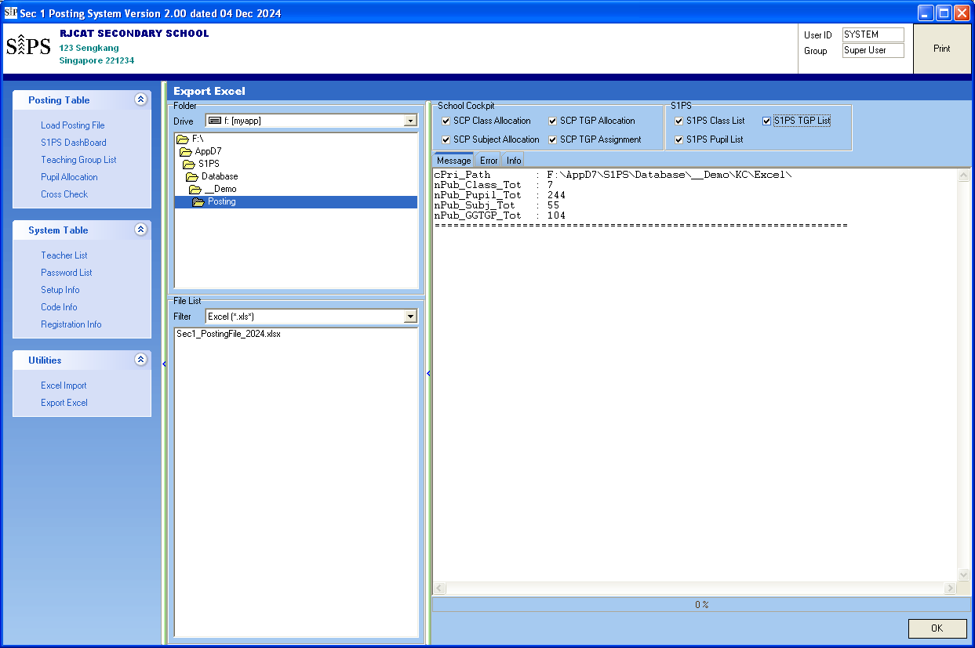

Steps

* Select the Excel File to export
* Click OK

## Print Report

All reports can be save as PDF version.

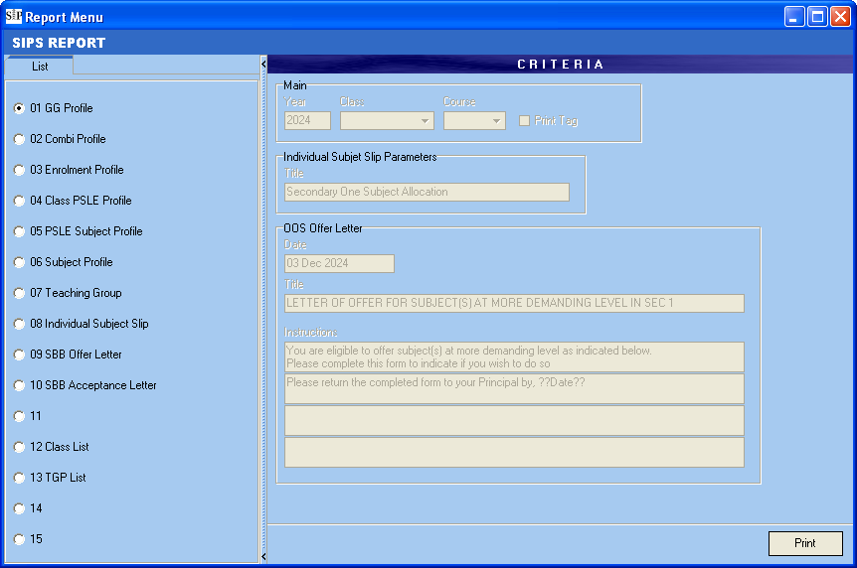

## Sample Excel – SCP Class Allocation

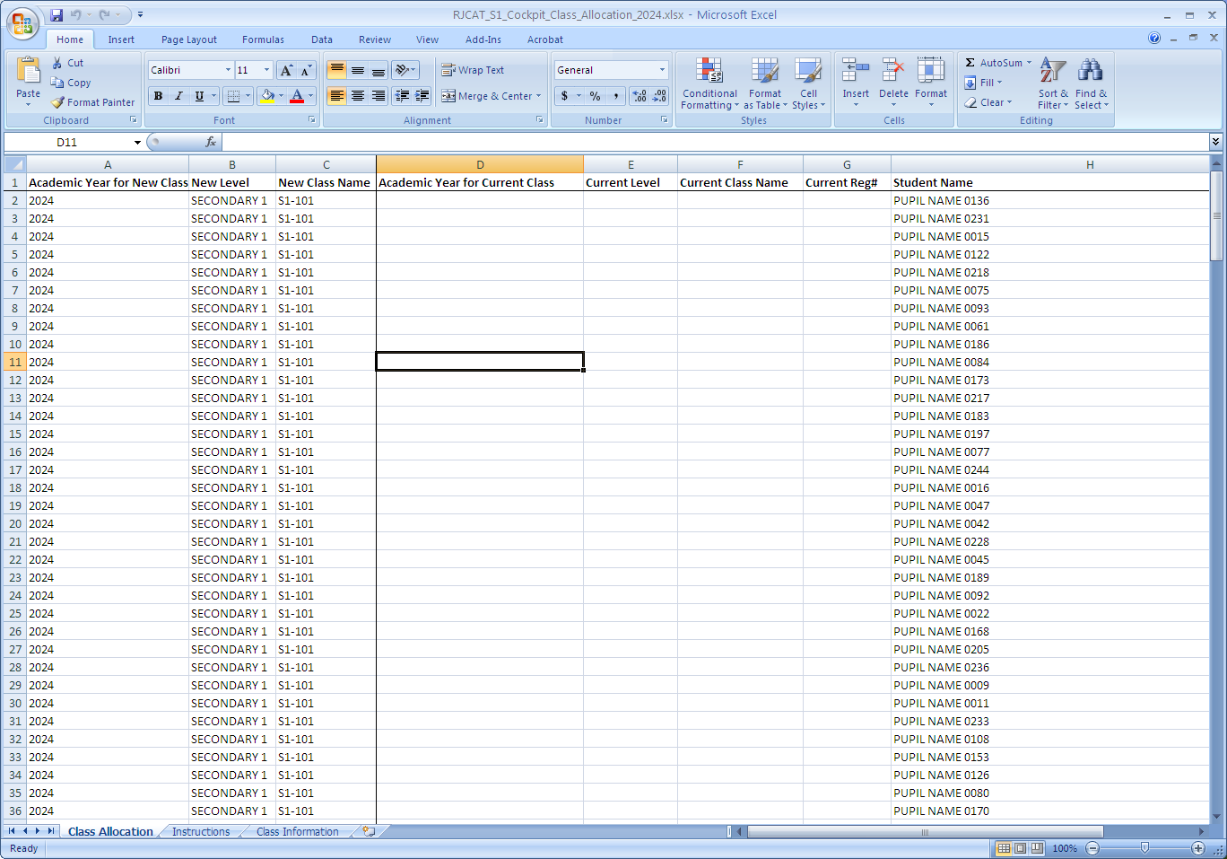

## Sample Excel – SCP Subject Allocation

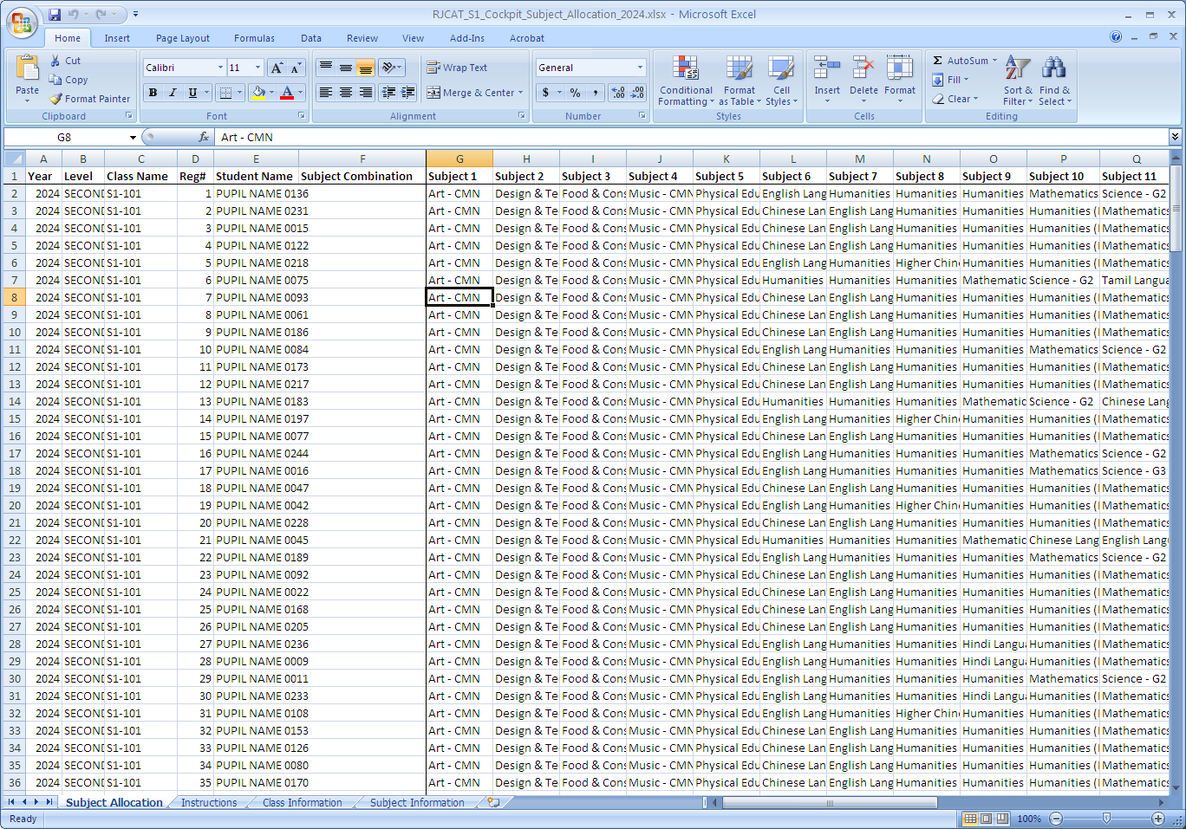

## Sample Excel – SCP TGP Allocation

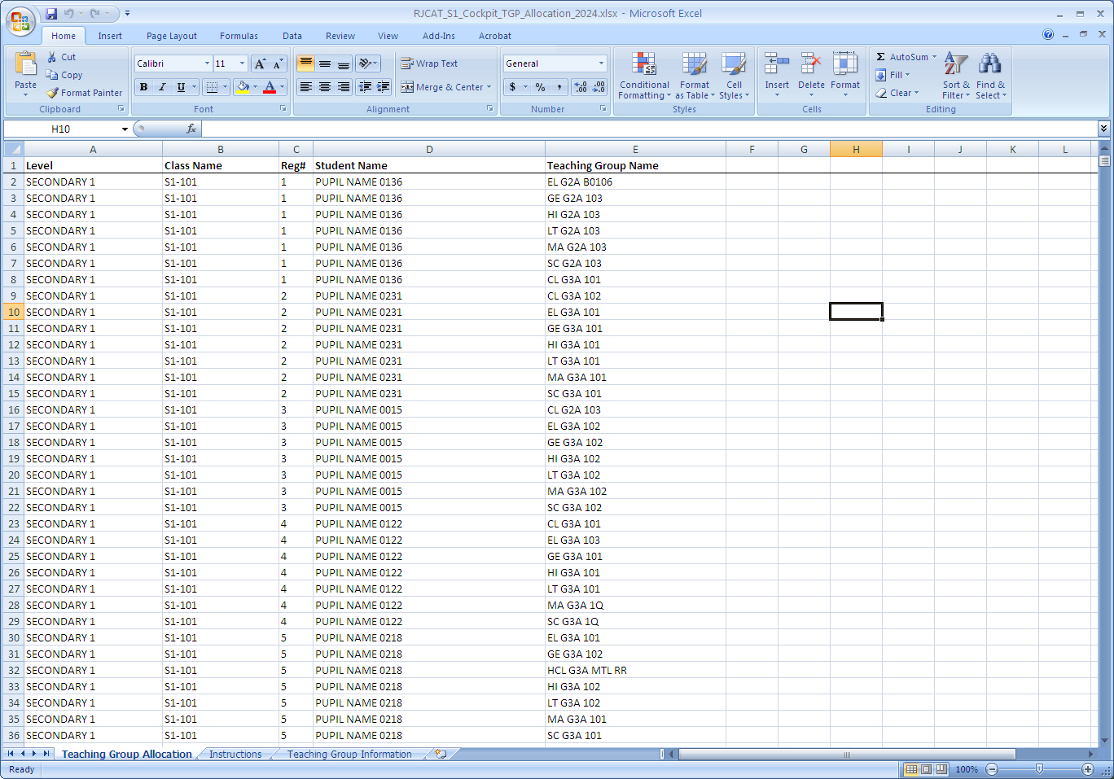

## Sample Excel – SCP TGP Assignment

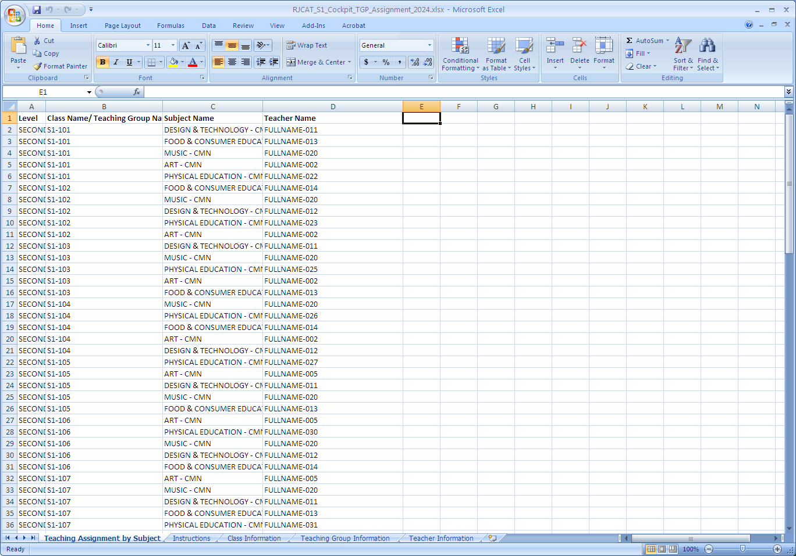

## Sample Excel – S1PS Class List

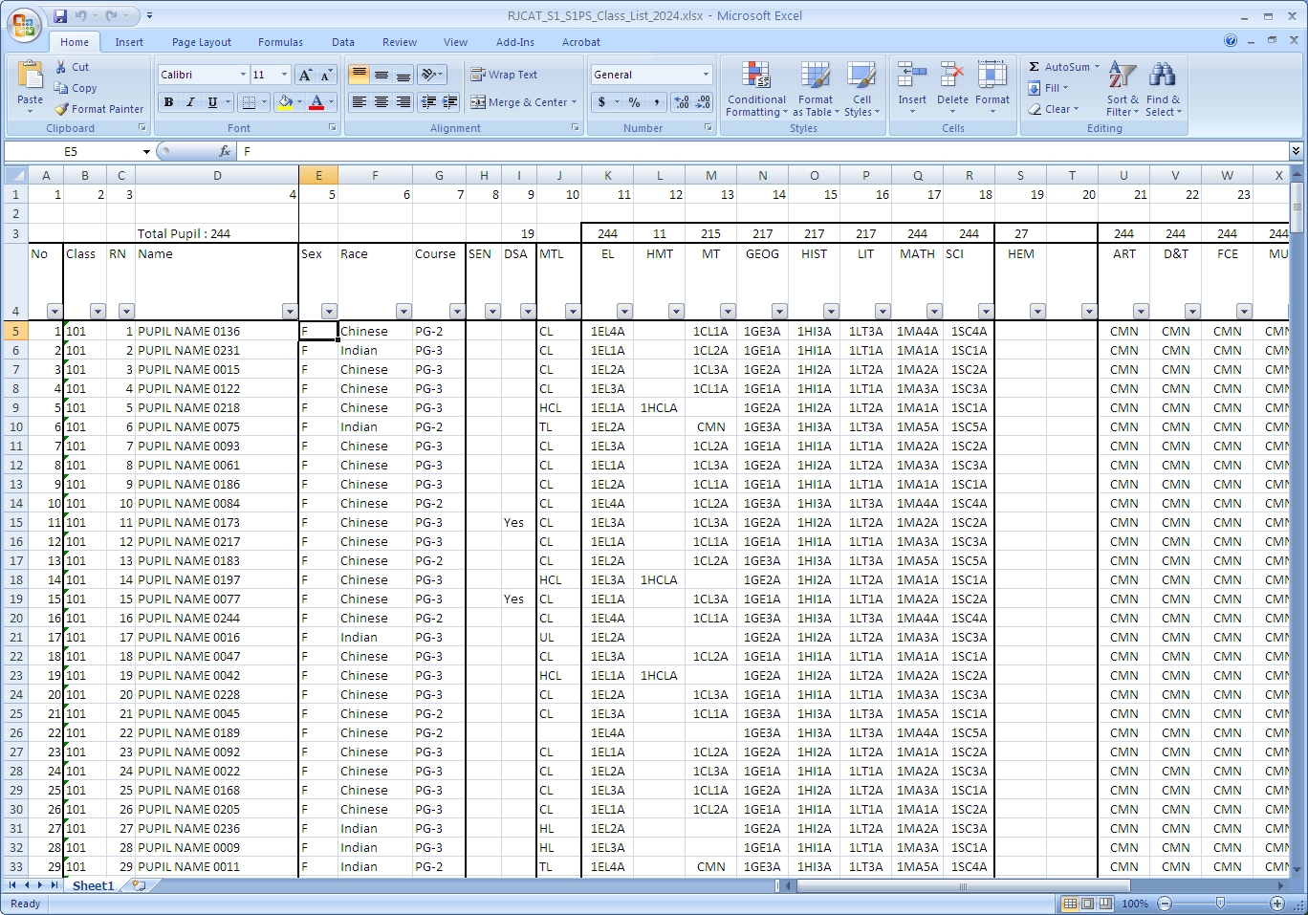

## Sample Excel – S1PS Pupil List

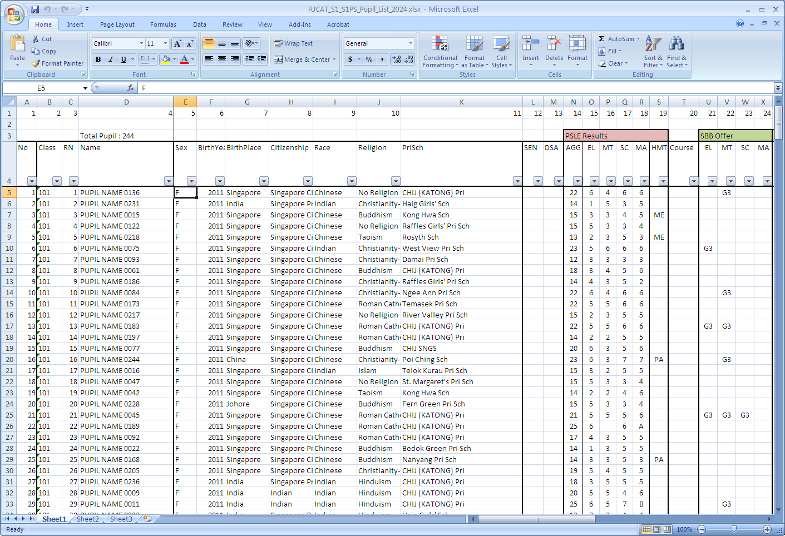

## Sample Excel – S1PS TGP List

## Sample Report – GG Profile

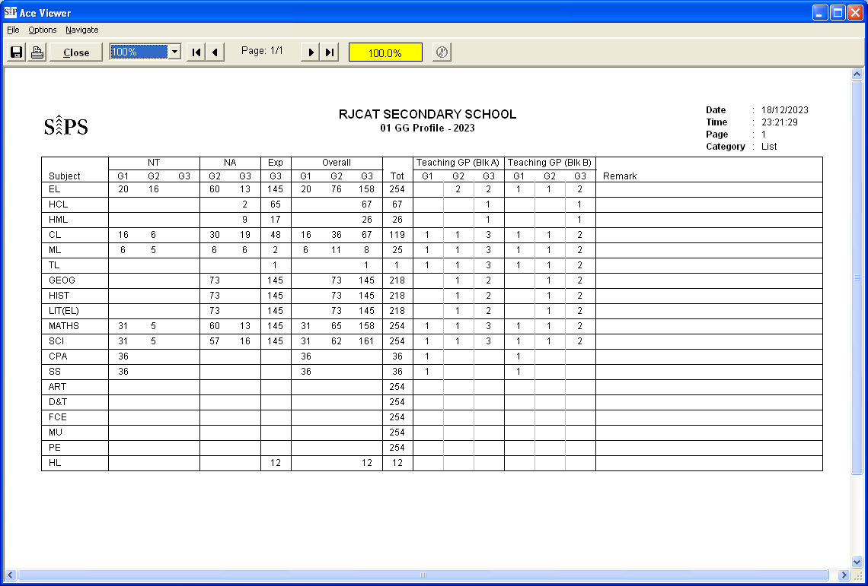

## Sample Report – Combi Profile

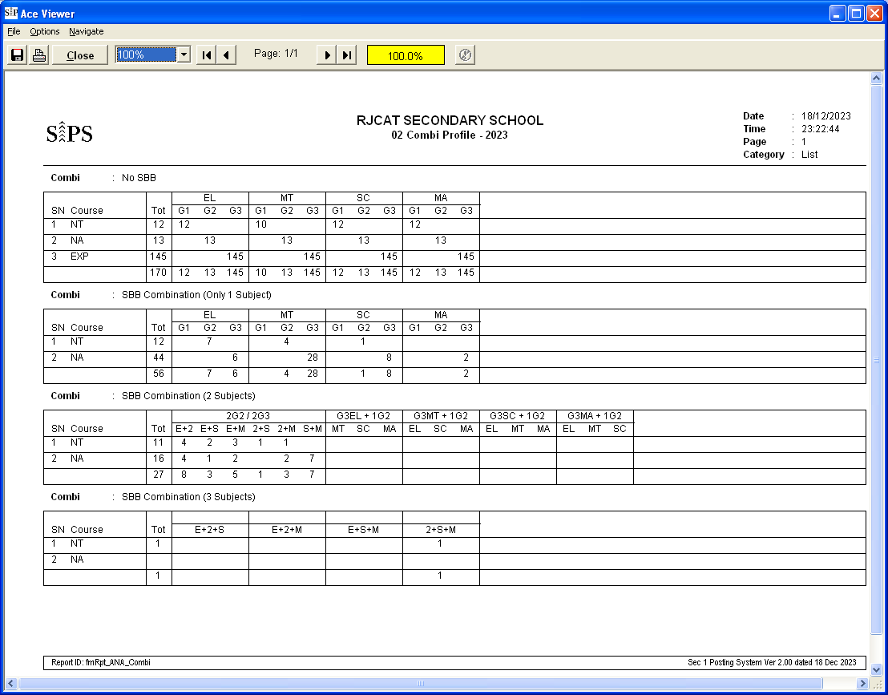

## Sample Report – Enrolment Profile

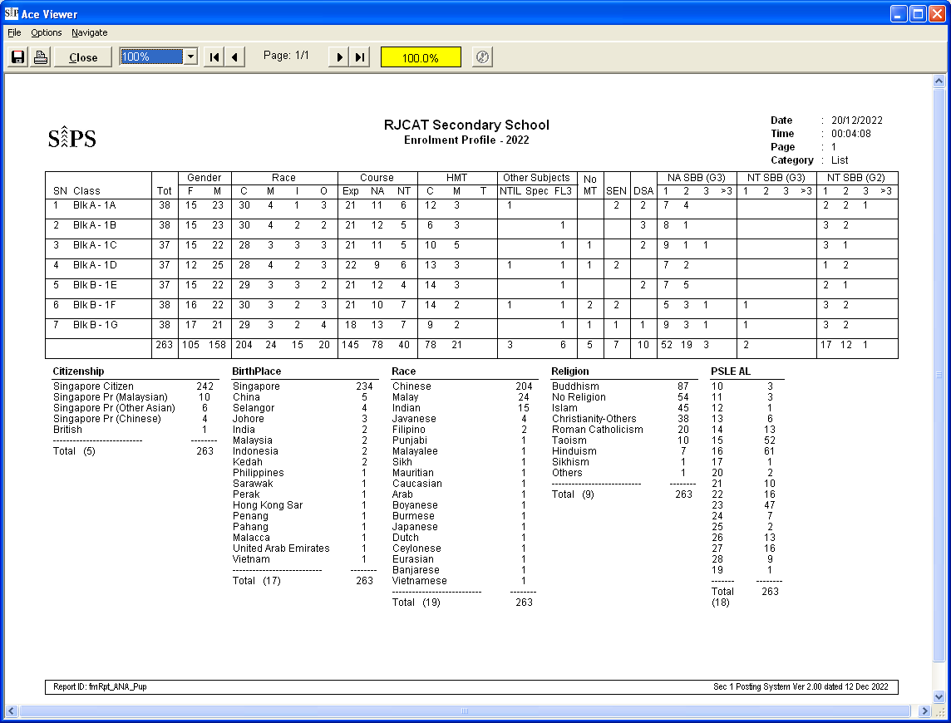

## Sample Report – Class PSLE Profile

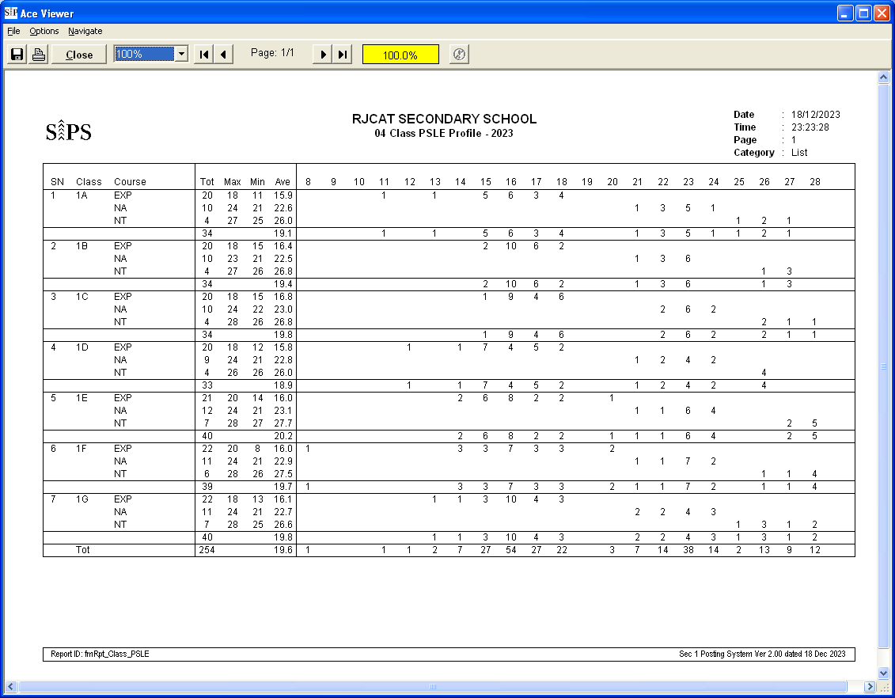

## Sample Report – PSLE Profile

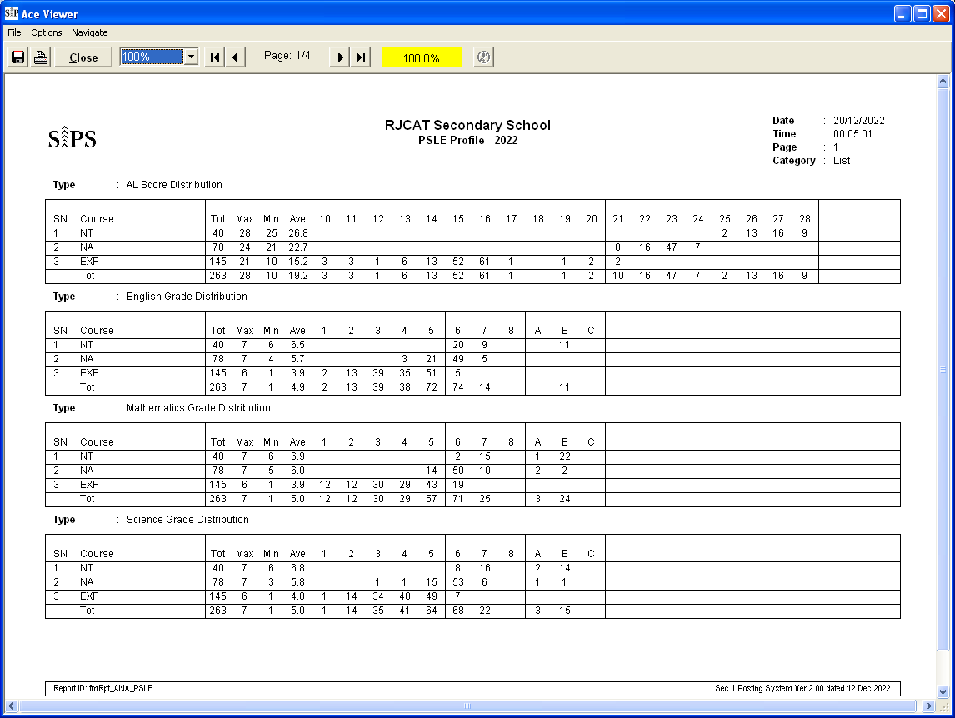 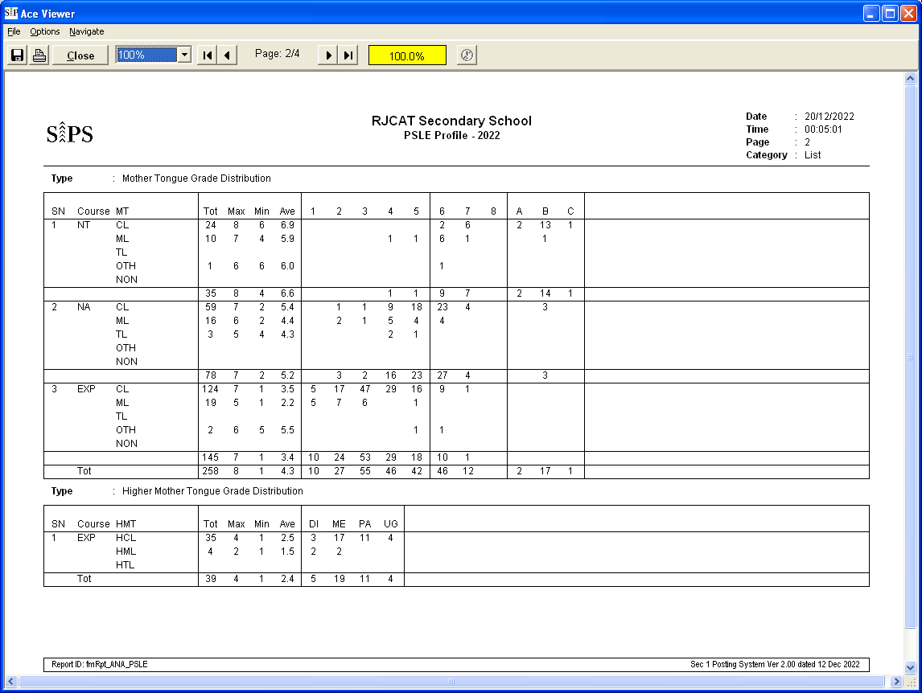 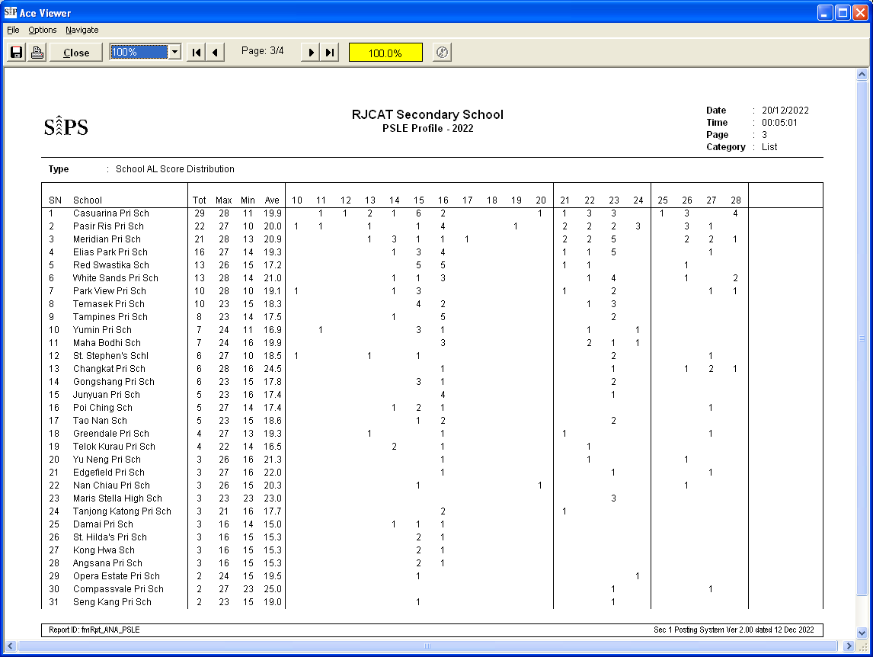

## Sample Report – Subject Profile

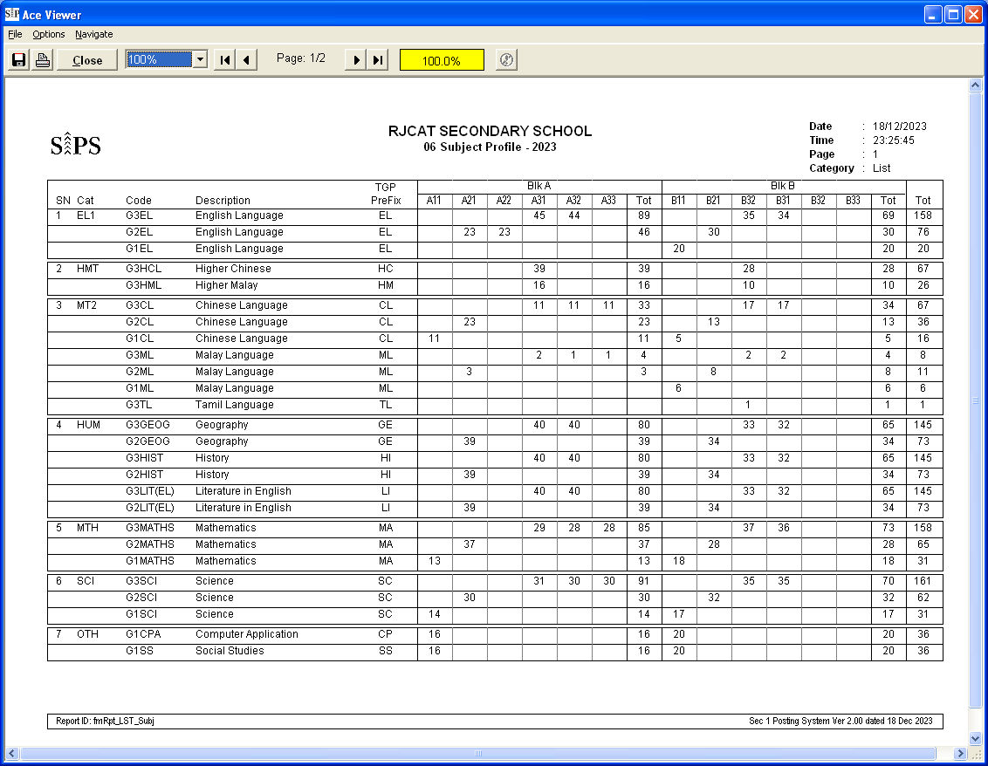

## Sample Report – Teaching Profile

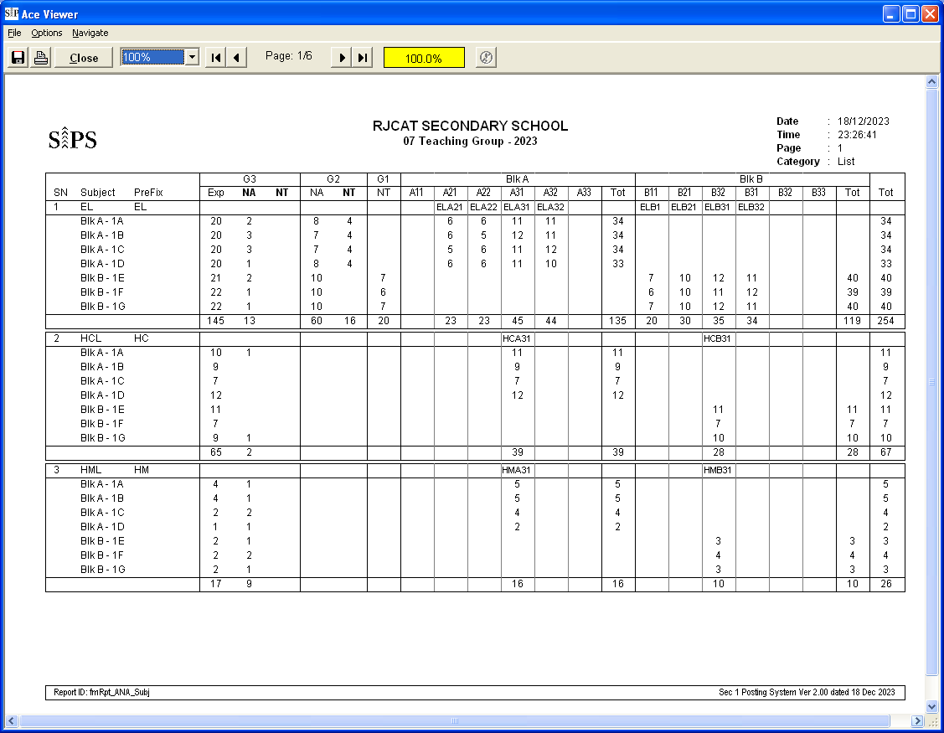

## Sample Report – Individual Subject Slip

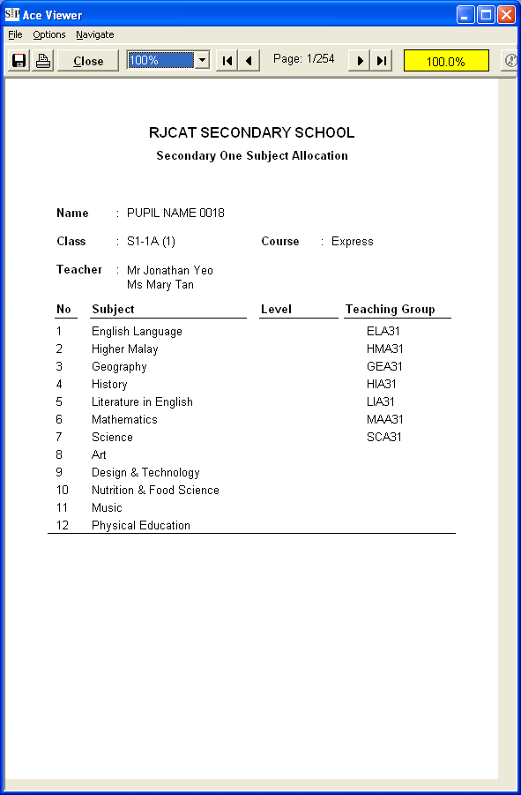

## Sample Report – MDL Offer Letter

For G1, if the PSLE Grade is 5 or better, G2 and G3 will be offered.

