S1PS

Sec One Posting Management System

Contents
Login 1
Main Menu 2
Setup SBB Criteria 3
Setup Class List 4
Setup Subject List 5
Update Teaching Groups 6
Load Posting File 7
Update Pupil Info 8
Process Allocation 9
Check Allocation 10
Export Excel 11
Print Report 12
Sample Reports – Enrolment Profile 13
Sample Reports – PSLE Profile 14
Sample Reports – Combi Profile 15
Sample Reports – Subject Profile 16
Sample Reports – Teaching Group and SBB 17
Sample Reports – Individual Subject Allocation Slip 18
Sample Reports – SBB Offer Letter 19
Sample Reports – SBB Acceptance Letter 20
Sample Excel 21

Overview

S1PS is a fully OFFLINE Windows based software (Non-Internet). It is SSOE1 and SSOE2 compliance and it can runs on Windows 10. It is also already White Listed by MOE-NCB.

The software and its database reside in your school computer. There is no need to conform to the MOE IT Security Specification.

S1PS is really easy to use. It is FAST and has a friendly user-interface. After all the initial setup, the whole process of allocation should take less than 5 minutes.

Work Flow
The following is the recommended work flow for the S1PS.

Stage | Description
Pre Allocation  (Prepare S1PS) | - Setup SBB Criteria (Pre-Setup)  - Criteria for offering SBB (EL, MT, SC and MA)  - Criteria for offering HMT (HCL, HML and HTL)  - Setup Sec 1 Classes  - Class Name  - Block (A and B)  - Form Teachers  - Setup Subjects to be offer (Already Setup)  - G0 - Common Curriculum  - G1 - Normal (Technical) Subjects  - G2 - Normal (Academic) Subjects  - G3 - Express Subjects  - Setup up Subject Teaching Groups
Allocation | - Load Data from Sec 1 Posting File (CSV Format)  - Update Additional Info for Students  - Accept or Reject SBB offered  - Additional Subjects such as Higher Music, Higher Art, MSP, French etc  - Process Allocation  - Allocate Class to students  - Allocate Subjects to Students
Post Allocation | - Print Reports  - Enrolment Profile  - Subject Profile  - Combi Profile  - Teaching Group and SBB  - Individual Student Subject List  - SBB Offer Letter  - SBB Acceptance Letter  - Class List  - Teaching Group Student List  - Export to Excel  - Class Allocation  - Subject Teaching Group  - Export to Cockpit Templates  - Class Allocation  - Teaching Assignment  - Subject Teaching Group

Flow Chart

Sec 1 Posting File

S1PS

Block B
Block A

1G
1E
1C
1A

1H
1F
1D
1B

EL
EL

EL-B31
EL-B1
EL-A31
EL-A1

EL-A22
EL-B32
EL-A32
EL-A21

EL-B21
EL-B22
Export to Cockpit
EL-B33
EL-A33

Teaching
Group
Class
Allocation
Teaching Assignment

Login

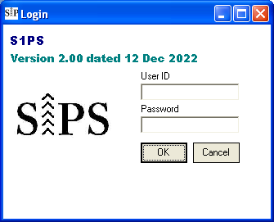
Double-Click to bypass login

Steps
- Enter User ID (system)
- Enter Password (system)
- Click “OK”

Main Menu

Print Report
Menu List

Setup SBB Criteria

The default Criteria is based on MOE guideline. However, you may change them based on your school needs.

Menu Access: System Table – Setup Info
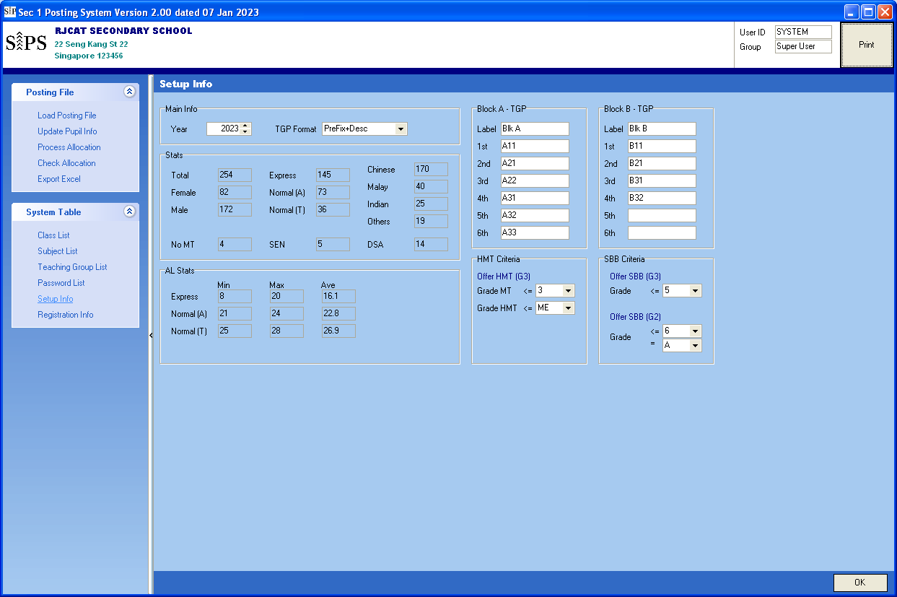
Teaching Group Label
Criteria for offering SBB
Criteria for offering HMT

Steps
- Update the Criteria accordingly
- Click “OK”

Setup Class List

The default is 8 classes, 4 in Block A and 4 in Block B. You may change them based on your school needs.

Menu Access: System Table – Class List

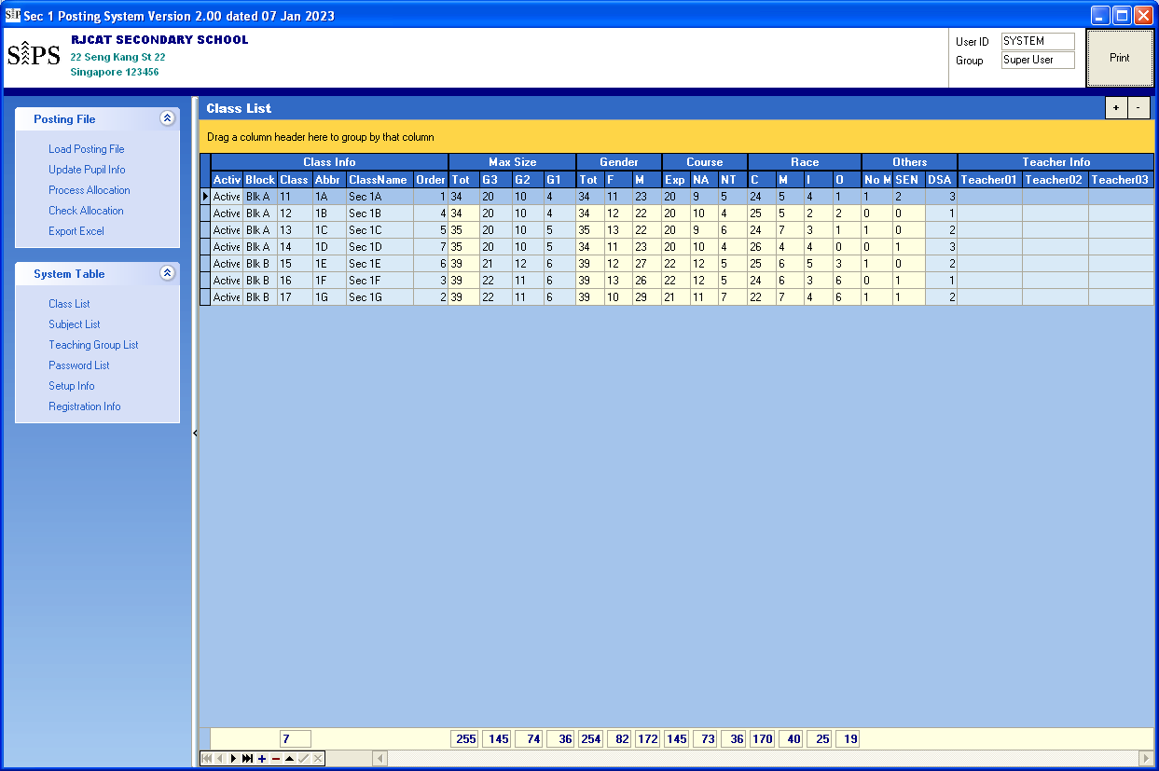
Statistics generated after “Process Allocation”

Steps

“+”- Add
“-“ - Delete
- Add or Delete Class based on your school needs
- Assign Block A or Block B to Class
- Click another record to save

Setup Subject List

S1PS will adopt the new subject naming convention: G1, G2 & G3. In addition, G0 will be used for the common curriculum Subjects (ART, & D&T, FCE and Music). Most of the subjects are already included.

There are 2 blocks of teaching groups (Block A and Block B). Each block has up to 6 teaching groups (TGP).
The current teaching groups are defined according to Course (Exp, NA & NT):
- TGP 1 - for NT
- TGP 2 - for NA
- TGP 3-5 - for Express
- TGP 6 - Reserved
Technically, you may use any group for any Course (Exp, NA & NT). The current setting is basically for easy viewing by Column.

Menu Access: System Table – Subject List
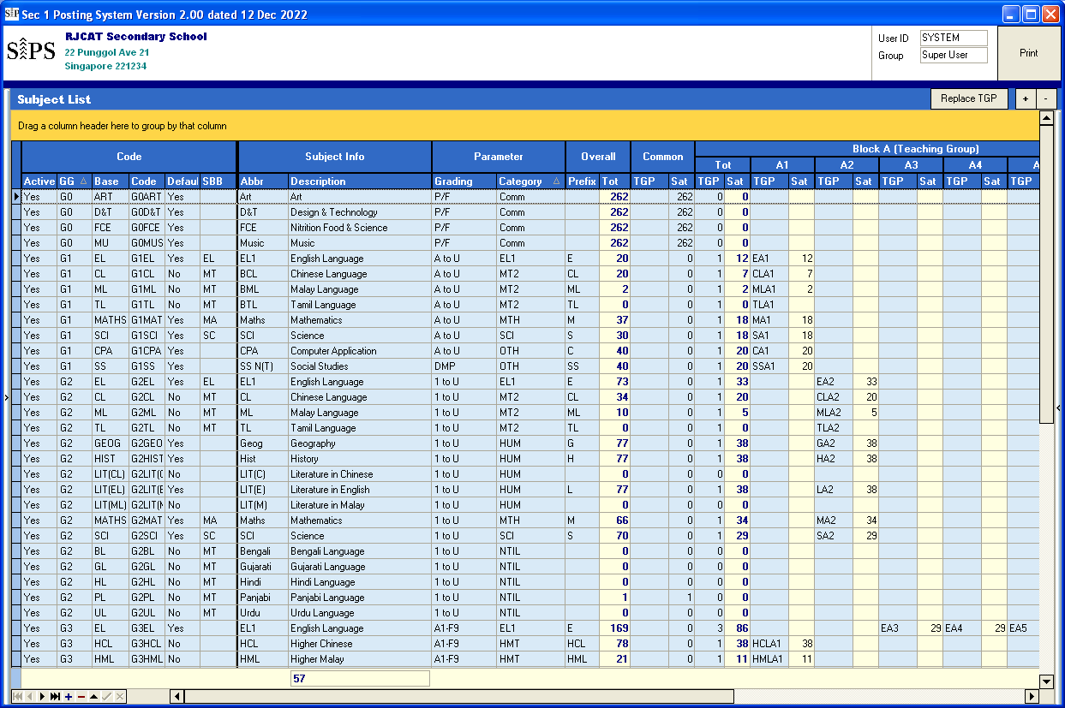
Prefix for Teaching Group

Steps
- Add or Delete Class Subject based on your school needs
- Click another record to save

Update Teaching Groups

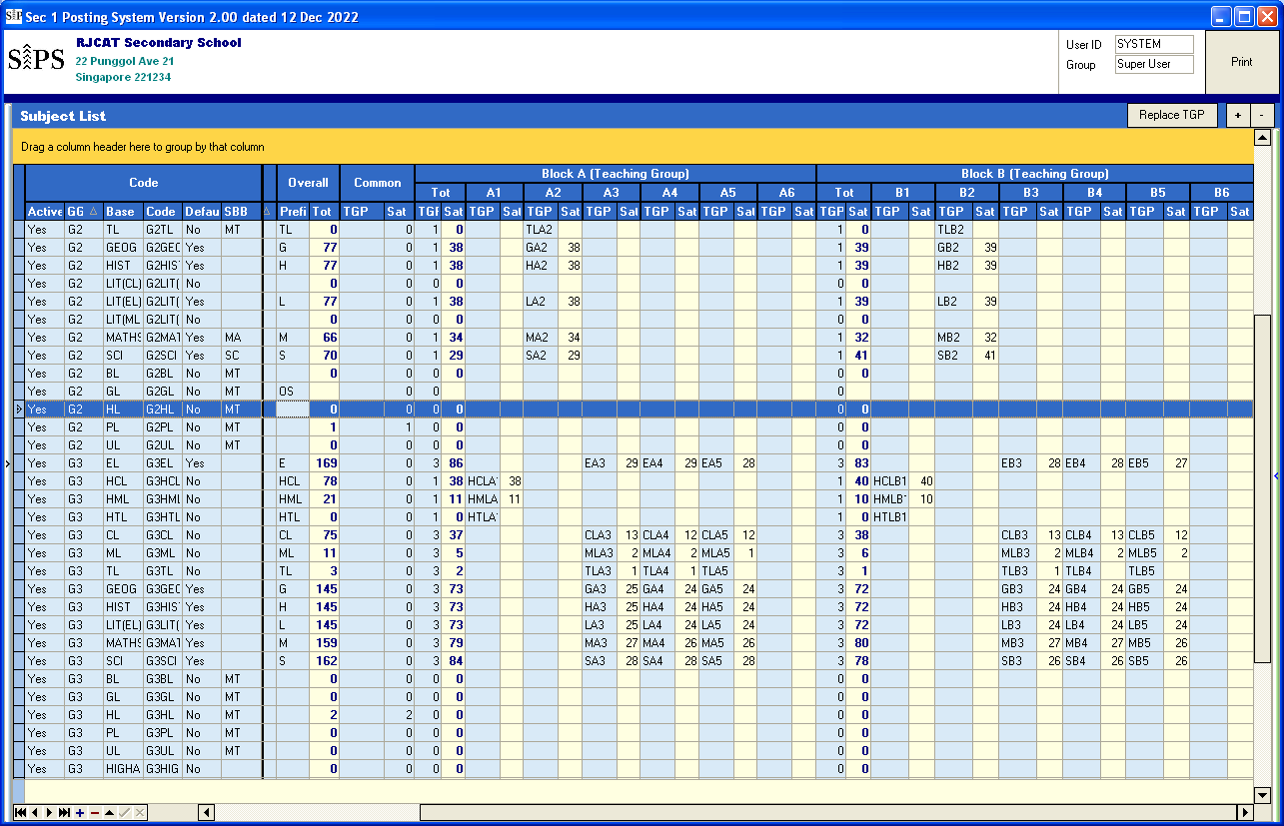
Subject with Prefix but no Teaching Group mean Non-Intact Class
(Conduct Outside School)
Prefix=”Empty” mean Intact Class
Change the Prefix
Click Replace TGP

Steps
- Select a Subject
- Change the Prefix
- Click “Update TGP”

Load Posting File

The posting File used is CSV format.

Menu Access: Posting File – Load Posting File
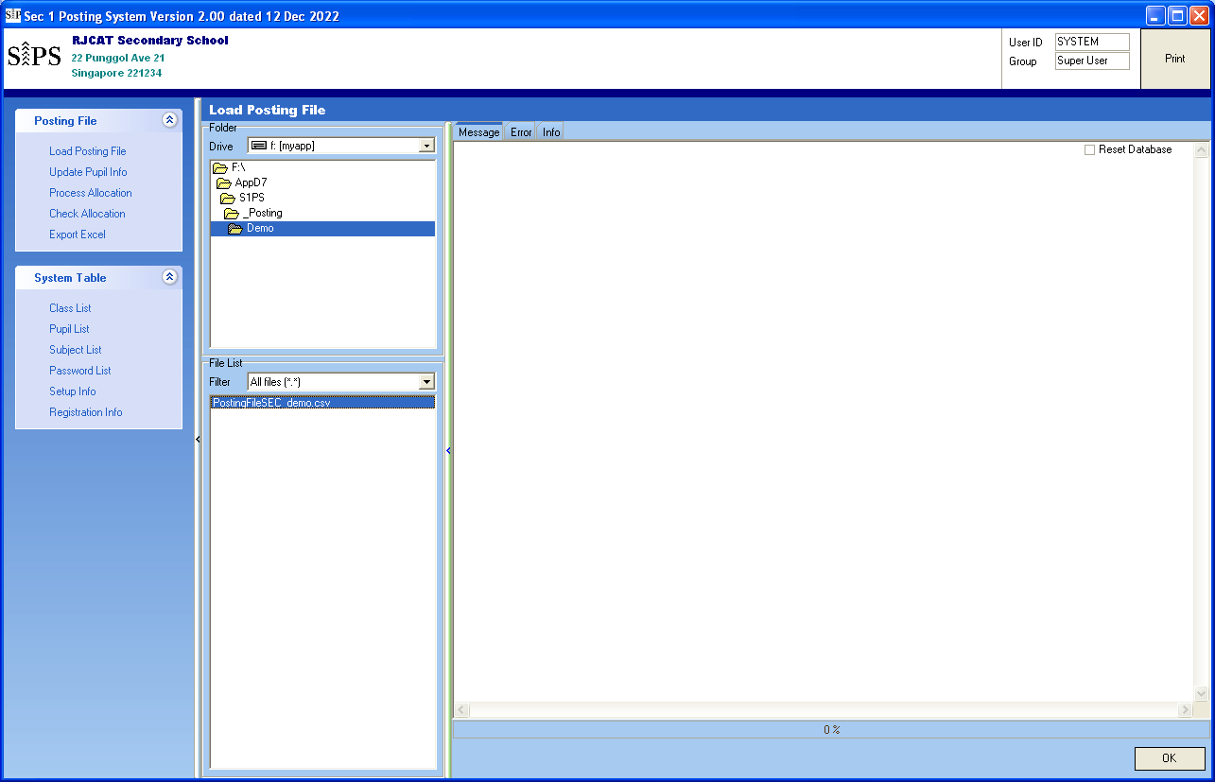
Steps
- Point the folder where you save the Posting File
- Select Posting File
- Click “OK”

Update Pupil Info

Most of the fixed data are loaded from Posting File. S1PS will determine some info based on the Criteria set:
- Offer HMT (HCL, HML or HTL)
- Offer SBB (EL, MT, SC & MA)

Some students may decide not to take up the offer. As such, you need to remove them before “Process Allocation”. In addition, there may be “Extra Subjects” that students may want to take up (Japanese, French, Higher Art, etc)
(For the Draft Allocation, you need use the default first).

Menu Access: Posting File – Subject List
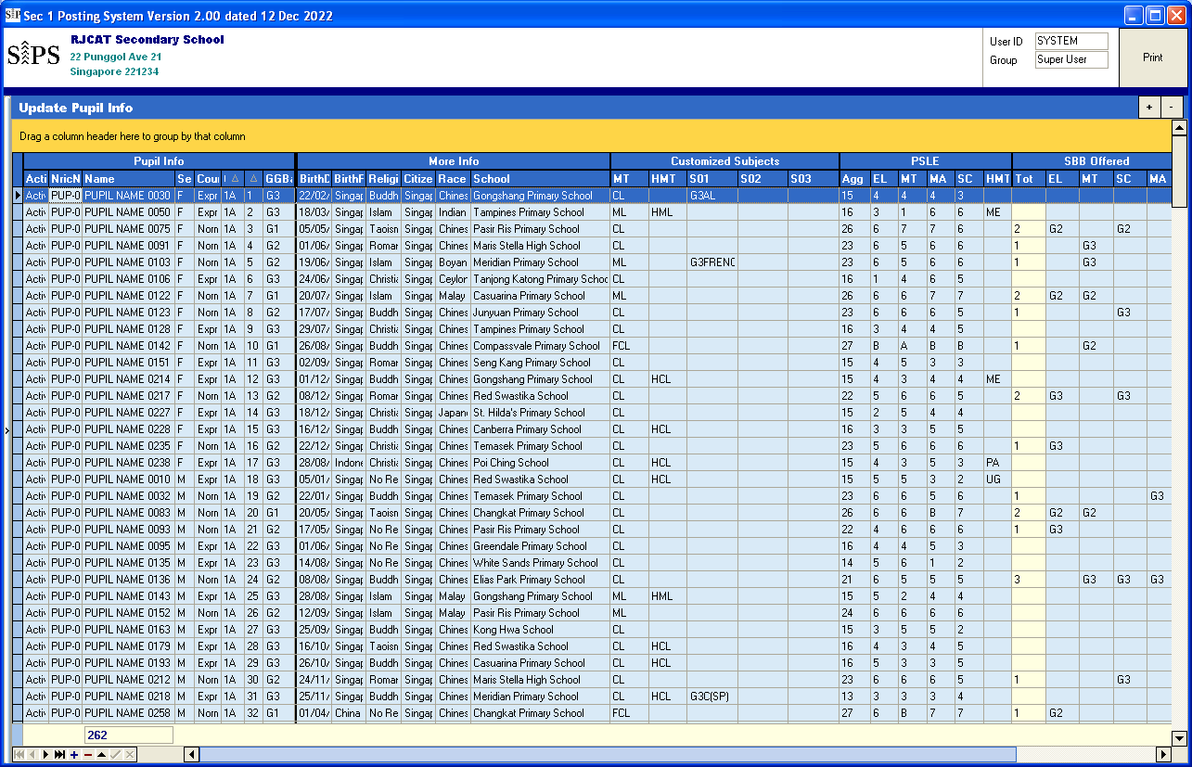
SBB offer
HMT offer
“Extra” Subject
Steps
- Point the student
- Change the value accordingly
- Click another record to save

Process Allocation

There are 2 parts in the Allocation:
- Class Allocation - Assign Class to Students
- Subject Allocation - Assign Subject to Students

For a start, you Process both at the same time.

Menu Access: Posting File – Process Allocation

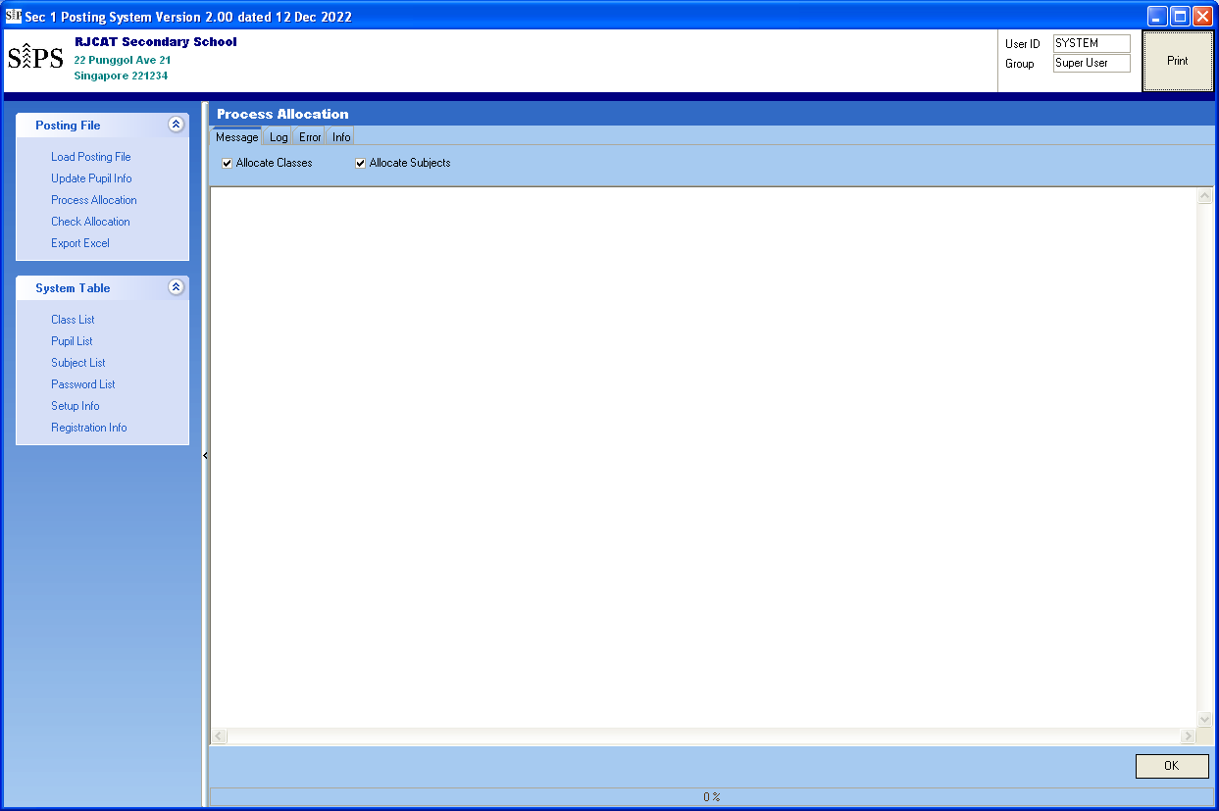

Steps
- Tick “Allocate Class” if need to Allocate Class to students
- Tick “Allocate Subject” if need to Allocate Subjects to students
- Click “OK”

Check Allocation

You can review the Student Allocation here.

Menu Access: Posting File – Check Allocation
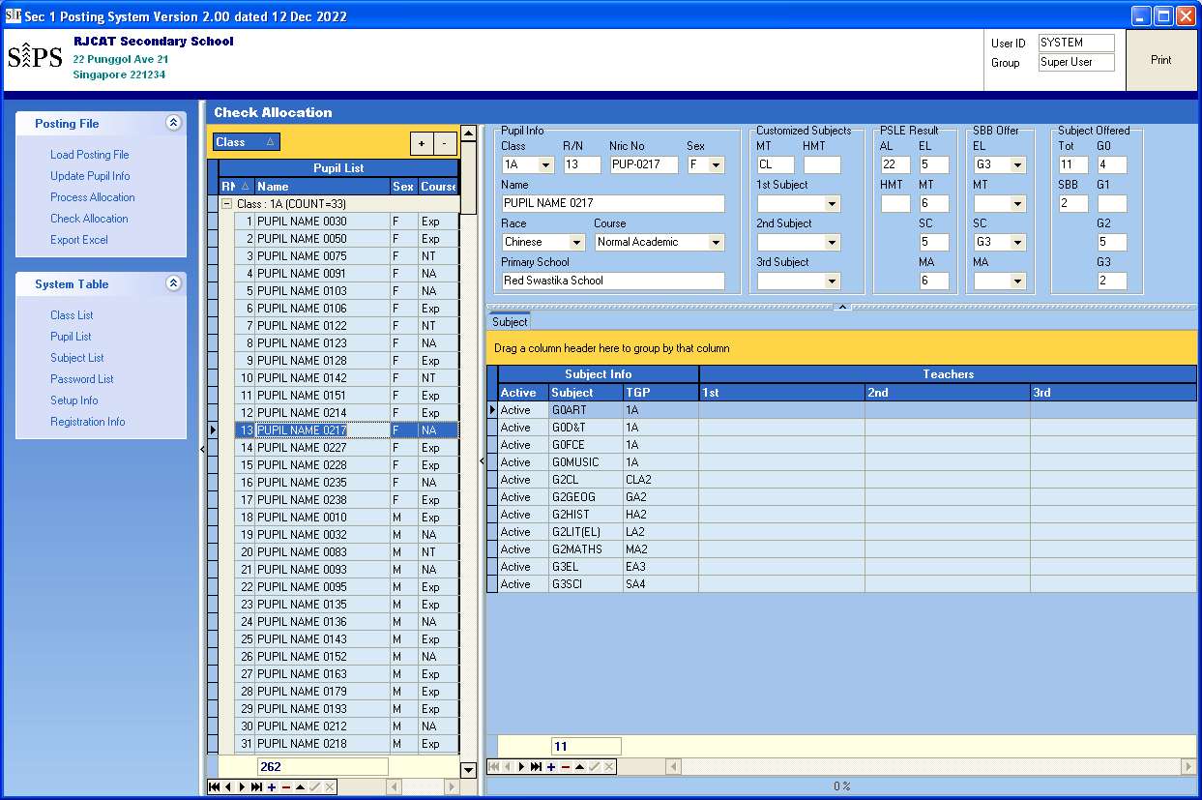
You may manually ADD/Delete or Change the Subject and TGP
Steps
- Point the student
- Select the Subject

Export Excel

There are 4 export file available:
- S1PS Class List
- S1PS Teaching Group List
- SCP Class List (To upload into Cockpit)
- SCP Teaching Group List (To upload into Cockpit)

Menu Access: Posting File – Export Excel
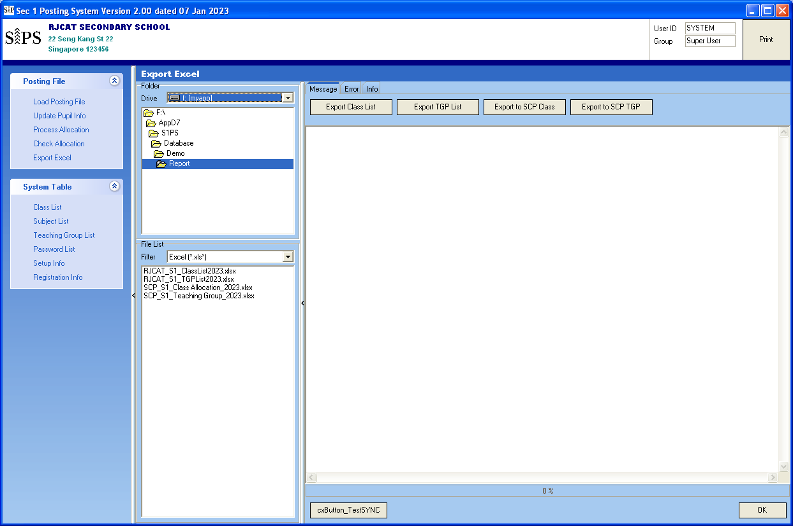
Double-Click to OPEN
Steps
- Point the folder
- Click “OK”

Print Report

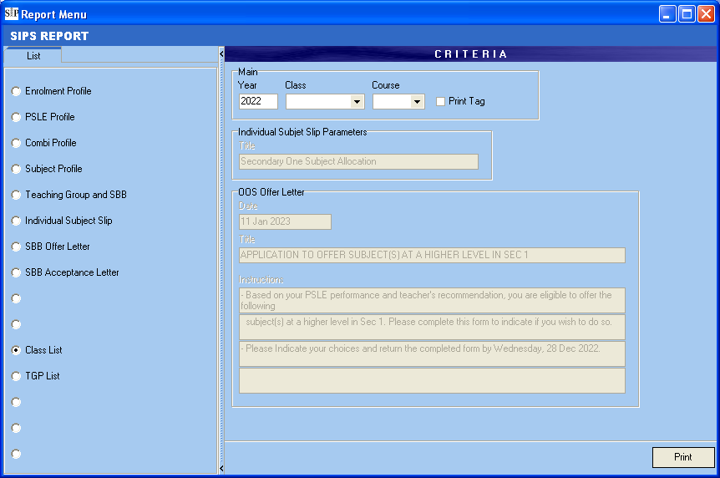

Sample Reports – Enrolment Profile

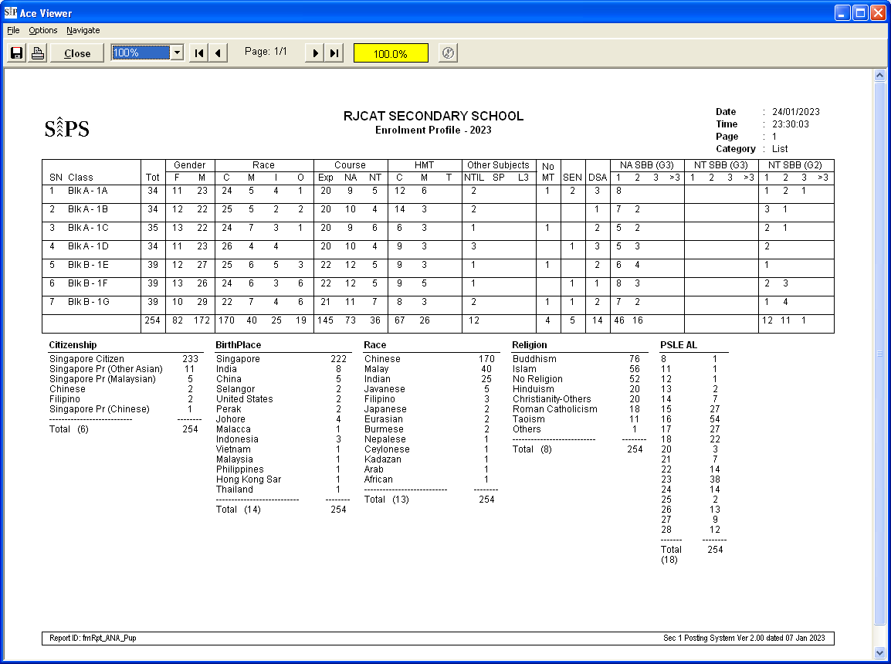

Sample Reports – PSLE Profile

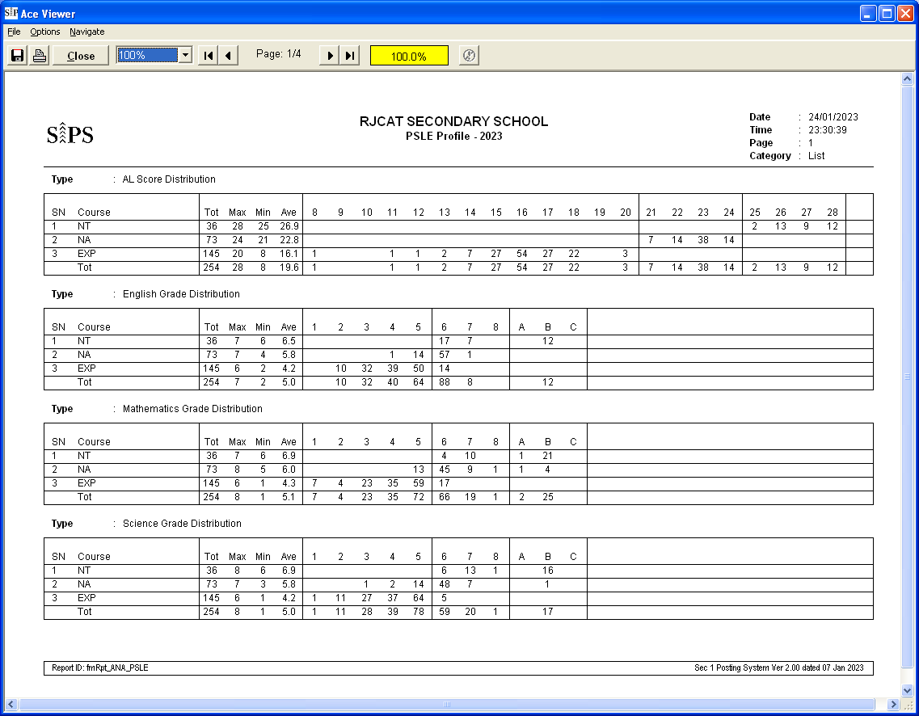

Sample Reports – Combi Profile

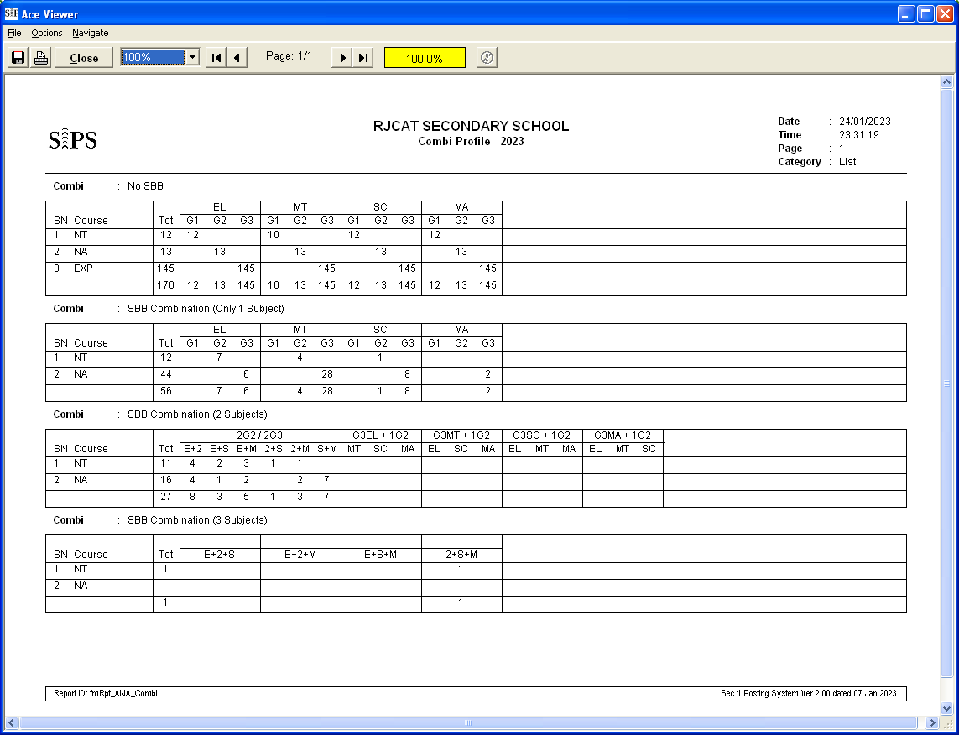

Sample Reports – Subject Profile

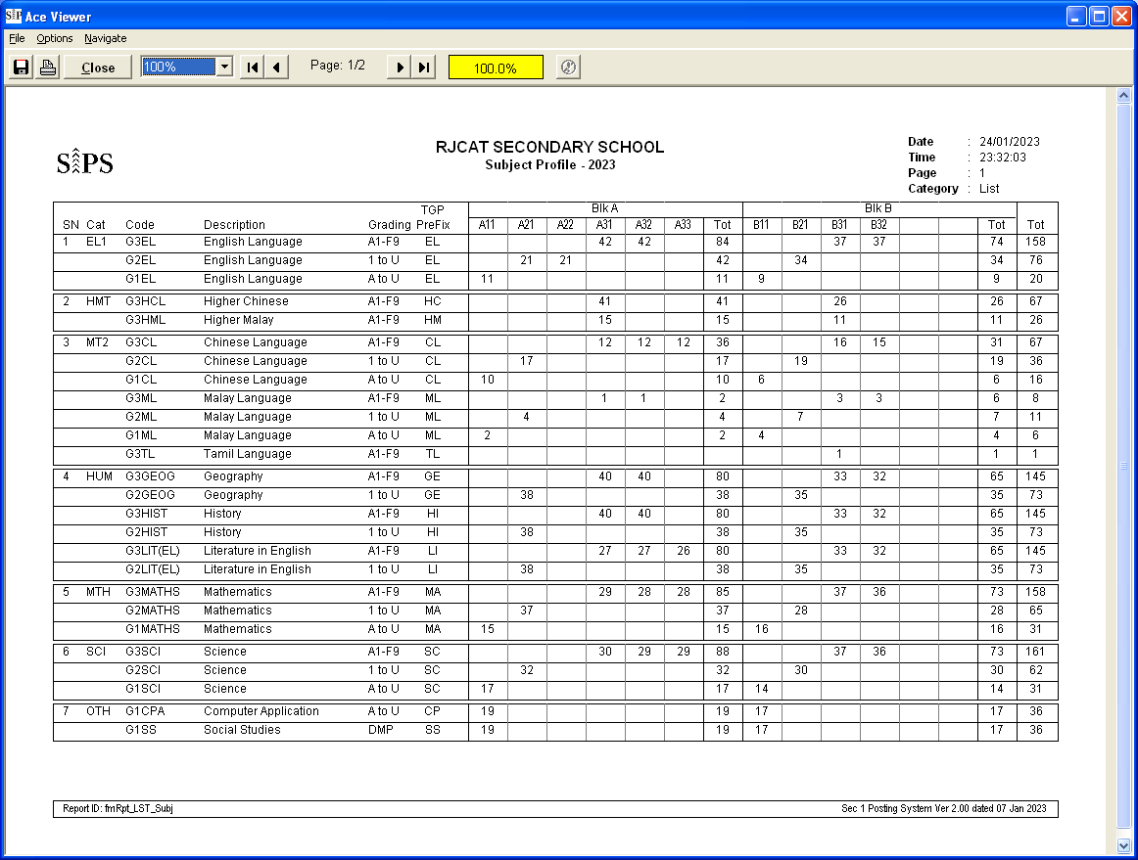

Sample Reports – Teaching Group and SBB

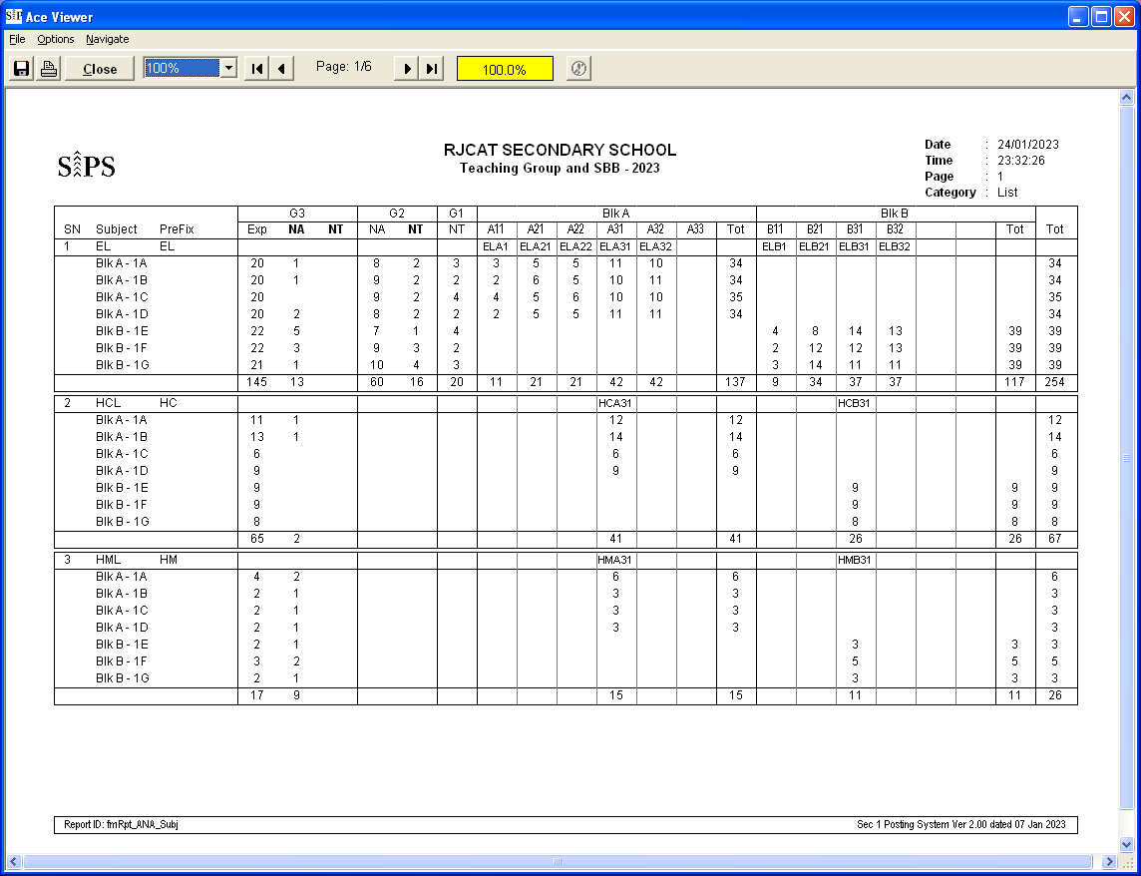

Sample Reports – Individual Subject Allocation Slip

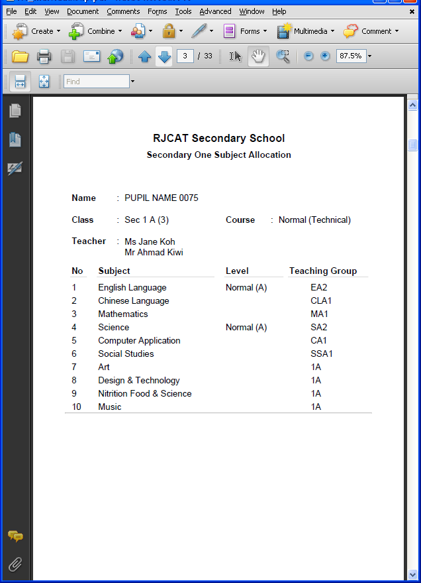
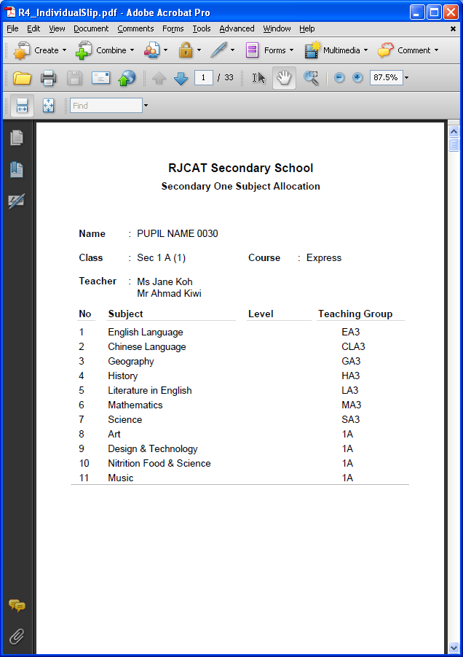

Sample Reports – SBB Offer Letter

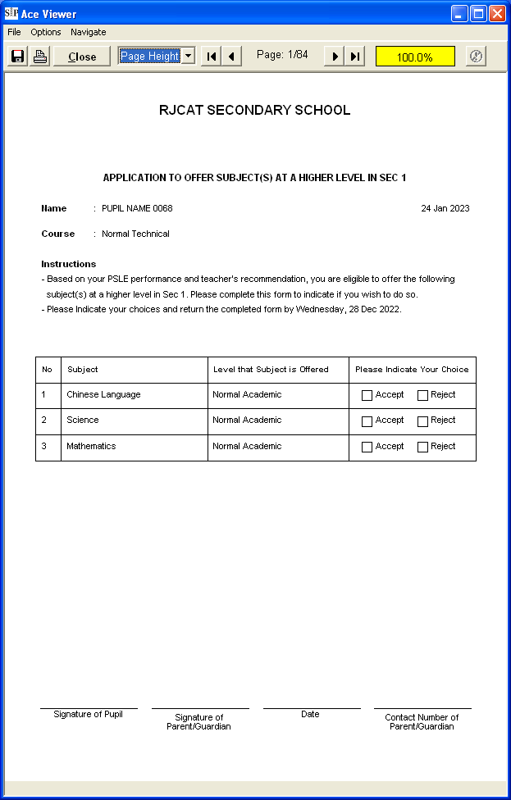

Sample Reports – SBB Acceptance Letter

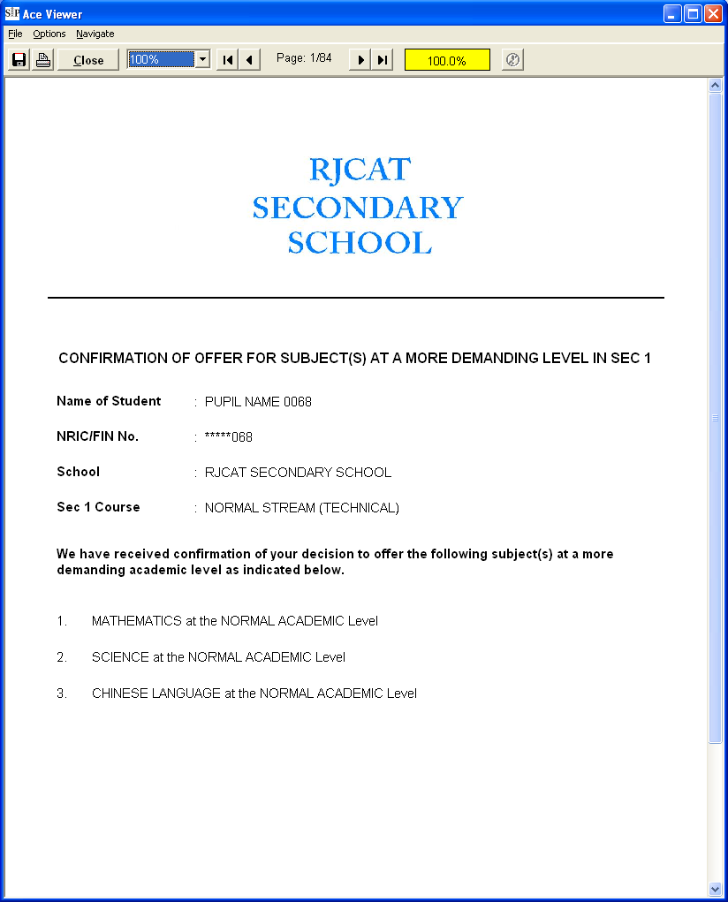

Sample Excel

